|  |
| --- |
| **TELEPHONE CONNECTION SYSTEM** |
| **DISM I-PROJECT** |
|  |
| **Noman ALI** |
| **10/25/2013** |
|  |

*TELEPHONE CONNECTION SYSTEM*

***Certificate of complition***

**This is to certify that**

**NOMAN ALI**

**IRFAN ABBAS**

**ALI AMIR**

**ASNA SARFARAZ.**

*TELEPHONE CONNECTION SYSTEM*

As a part of DISM Requirements

_________________________________________

*AUTHORIZED SIGNATURE*

.

*Table of Contents*

* ***Introduction …………………………………………………… 4***
* ***Acknowledgement …………………………………………… 5***
* ***Preface ………………………………………………………… 6***
* ***Problem Statement ………………………………………… 7***
* ***Customer Requirement …………………………………….. 8***
* ***Hardware/Software …………………………………………… 9***
* ***Project Plan……………………………………………………10***
* ***Snapshots ……………………………………………………… 11-17***
* ***Task Sheet ……………………………………………………… 18-19***
* ***User Guide ………………………………………………………. 20***
* ***Database Diagram ……………………………………………… 21***
* ***Flowchart ……………………………………………………….. 22***

*INTRODUCTION*

The thirst for learning, upgrading technical skills and applying the concepts in real life environment at a fast pace is what the industry demands from IT professionals today. However busy work schedules, far-flung locations, and unavailability of convenient time-slots pose as major barriers when it comes to applying the concepts into realism. And hence the need to look out for alternative means of implementation in the form of laddered approach.

The above truly pose as constraints especially for our students too! With their busy schedules, it is indeed difficult for our students to keep up with the genuine and constant need for integrated application which can be seen live especially so in the field of IT education where technology can change on the spur of a moment. *Well, technology does come to our rescue at such times!!*

Keeping the above in mind and in tune with our constant endeavour to use Technology in our training model, we at Aptech have thought of revolutionizing the way our students learn and implement the concepts using tools themselves by providing a *live and synchronous IProjects learning environment!*

*ACKNOWLEDGEMENT*

*We are thankful to Almighty ALLAH that by His grace we have been successfully submitted our project. We are presenting our project, prepared on Net Beans. We have tried our best to take all relevant important topics in consideration so that this project may become comprehensive.*

*This is our 2nd Semester* ***I project****. We have tried our best & struggled hard for a better outlook to come. This project is prepared on Net Beans. We chose to make Software for Aptech as a project. We found it easy to do our work on Net Beans.*

*We are hopeful that this project will provide all the necessarily information required by the user to fulfill their inspiration. However suggestions and advices for improvement of this project will be thankfully received & acknowledged.*

*PREFACE*

*We start with the name of Allah, the most beneficent, the most merciful who gave us eligibility to complete this project.*

*We are very grateful to our respected Teachers, who contributed with us for the completion of this project. First of all, we would like to thanks our respected Teacher* ***Sir ILYAS*** *of Aptech for his expert advice.*

*Moreover, we would like to thanks all the teachers of Aptech and our classmates for their kind appreciation and moral support.*

*We would like to express our deepest gratitude to our parents and well wishers whose prayers and motivation enabled us to turn our dream into reality. Special thanks to our parents who supported us day and night for our project. Finally our sincere thanks to our teacher*  ***SIR ILYAS*** *for all their assistance, help and support in making a document into reality*

*PROBLEM STATEMENT*

***EQUINOR****’* is a telecommunication company providing services for both Landline and Mobile users. The information about the users is maintained manually, yet such information is not always easily accessible.

There is growing realization that the more widespread use of information technology to increase efficiency and enable changes in telecommunication processes could do much to improve the performance of the system, within the bounds of appropriate measures to protect the confidentiality of information. Hence the higher authorities of company have decided for a computer based user record system includes all the elements that facilitate the capture, storage, processing, communication, security, and presentation of computer-based user record information.

*CUSTOMER REQUIREMENT*

Depending on the decision given by the management on the Computer Based User Information system is to be developed. Following are the requirements based on which the system needs to be developed.

* The system will support registering new user connections

.

* Every user registered should have unique telephone (contact) number been assigned.
* Following information should be stored for each user:
  + Name
  + Telephone Number
  + Address
  + City
  + Mode of Connection (Mobile/Landline etc.)
  + Type of Connection (Prepaid/Postpaid)
* Users of this system can search for telephone numbers by name, city etc.
* Users of this system can search for user details by providing number.
* System should provide report based on Mode of Connection.
* System should provide report based on Type of Connection.
* Perform necessary validations.

*Hardware/ Software*

*Requirements*

**Hardware**

1. A minimum computer system that will help you access all the tools in the courses is a Pentium 166 or better
2. 64 Megabytes of RAM or better
3. Windows 98 (or higher if possible)
4. Java Virtual Machine

**Software**

* Notepad/HTML editor/Java editor
* j2sdk1.4.1_02 (or later)
* SQL Server 2005/2008 RTM
* JDBC Driver

*PROJECT PLAN*

**

**Purpose of Plan: -**

**TELEPHONE CONNECTION SYSTEM** Project Plan will provide the definition of

the project including the project’s Goals and Objectives. Additionally the plan will

serve as an agreement between following parties: -

Project Sponsor, Project Manager, Project Team, Steering Committee and other

person associated with and/or affected by the project.

**The Project Plan defines the following: -**

• Project Purpose

• Business And Project Goals And Objectives

• Score And Expectations

• Roles And Responsibilities

• Assumptions And Constraints

• Project Management Approach

• Ground Rules for the Project

• Project Budget

• Project Timeline

*Snapshots*

*LOGIN PANEL*

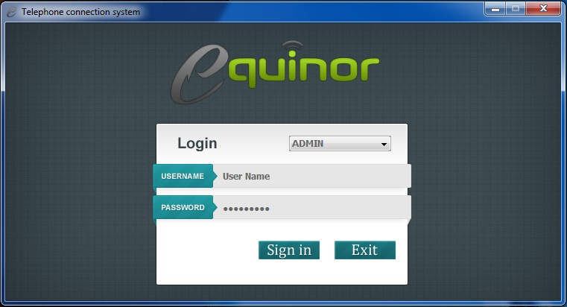

*ADMIN PANLE*

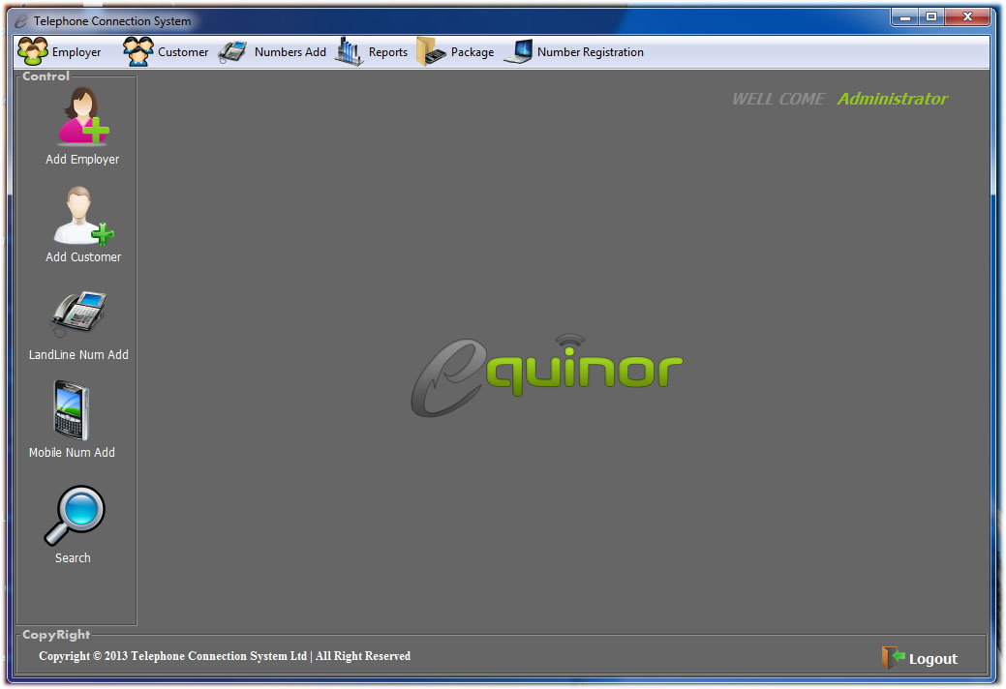

*ADD EMPLOYER*

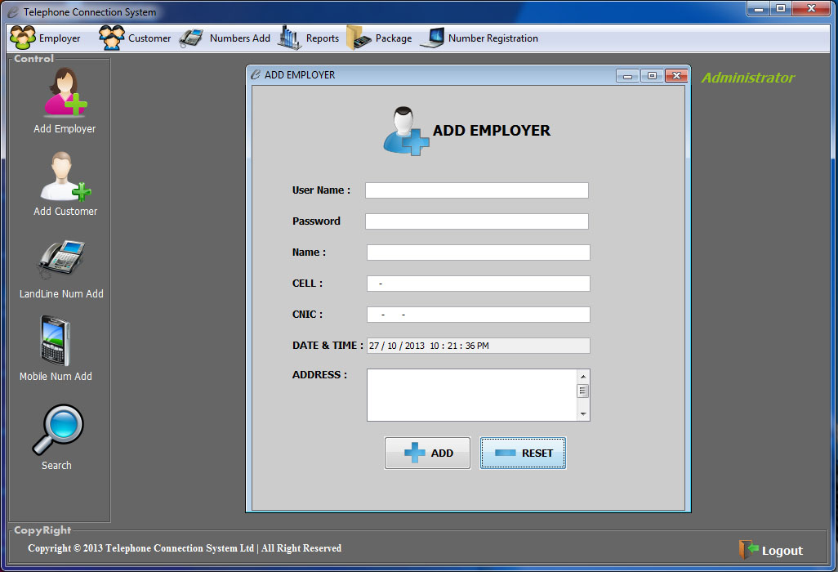

*ADD CUSTOMER*

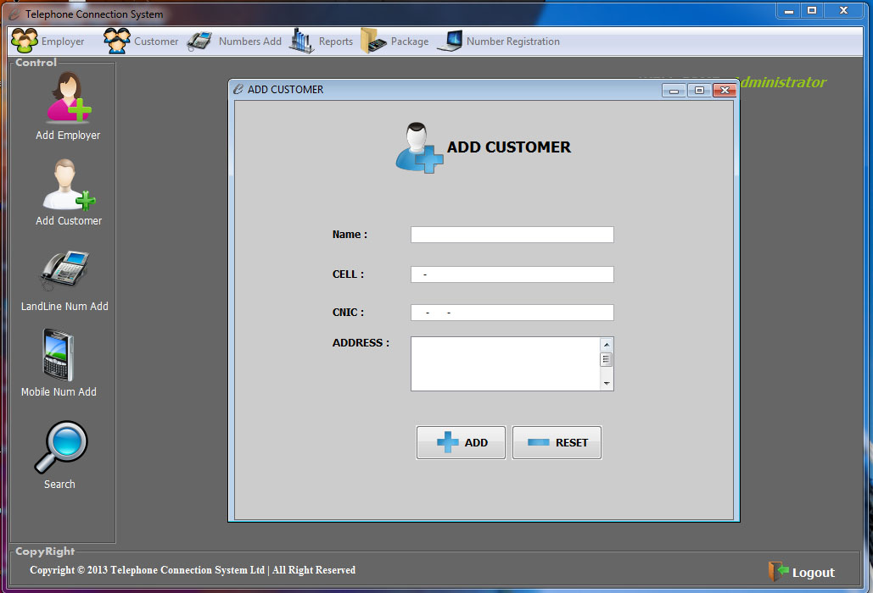

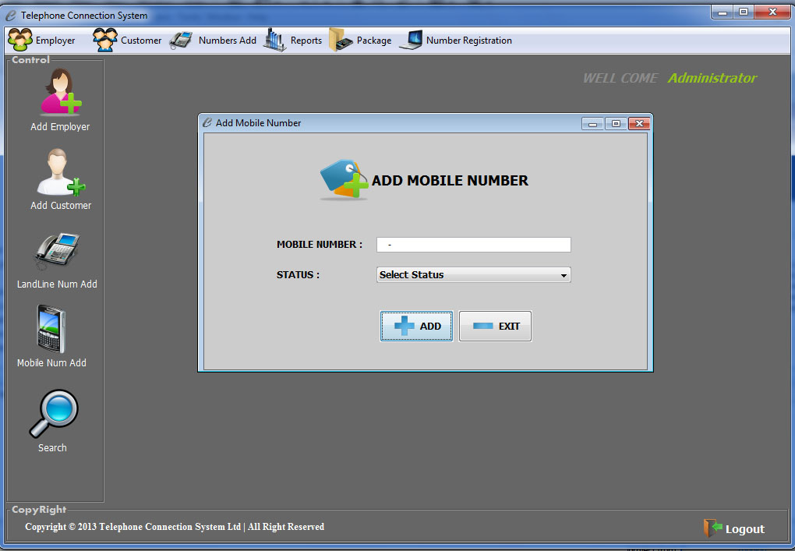 *ADD MOBILE NUMBER*

*REPORT MOBILE CONNECTION SALE*

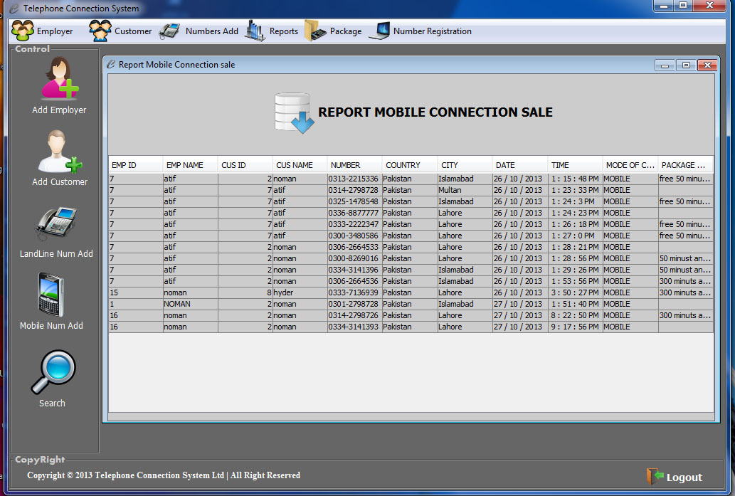

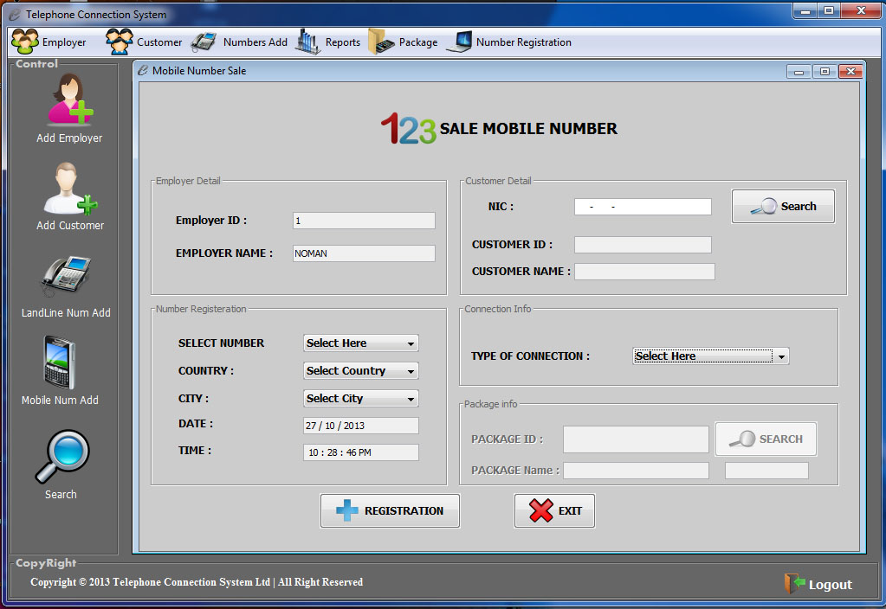 *SALE MOBILE NUMBER*

*Task Sheet*

|  |  |  |  |  |  |  |  |  |  |  |  |  |  |
| --- | --- | --- | --- | --- | --- | --- | --- | --- | --- | --- | --- | --- | --- |
| **Project**  **Reference**  **No.** | |  | **Activity**  **Plan**  **Prepared**  **By:** | **Date Of Preparation**  **of Activity Plan:** | | | | | | | | | |
| S  N  O | Task |  |  | **Actual**  **Start**  **date** | | **Approx**  **End**  **Date** | | **Actual**  **days** | | **Team Mate**  **Names** | | **Status** | |
| 01 | Self  Analysis |  | NOMAN ALI  IRFAN ABBAS  ASNA SARFARZ  ALI AMIR | 26 Sep | | 1 Oct | | 6  Days | | NOMAN ALI  IRFAN ABBAS  ASNA SARFARZ  ALI AMIR | | OK | |
| 02 | Work On  database |  | NOMAN ALI | 2  Oct | | 9 Oct | | 8  Days | | NOMAN ALI | | OK | |
| 03 | Design By: |  | NOMAN ALI | 10  Oct | | 16Oct | | 7  Days | | NOMAN ALI | | OK | |
| 04 | Develop  By: |  | NOMAN ALI | 17  Oct | | 21 Oct | | 5  Days | | NOMAN ALI | | OK | |
| 05 | Testing |  | NOMAN ALI  IRFAN ABBAS  ASNA SARFARZ  ALI AMIR | 22  Oct | | 24Oct | | 3  Days | | NOMAN ALI  IRFAN ABBAS  ASNA SARFARZ  ALI AMIR | | OK | |
| 06 | Documenta  tion |  | IRFAN ABBAS  Noman Ali | | 25 Oct | | 26 Oct | | 1 day | | NOMAN ALI  IRFAN ABBAS  ASNA SARFARZ  ALI AMIR | | OK | |

*User Guide*

|  |  |  |  |
| --- | --- | --- | --- |
| ***Serial*** | ***Items*** | ***Description*** |  |
| ***No.*** |  |
|  |  |  |
|  |  |  |  |
| *1* | *Operating System* | *Windows 98,2000 XP etc* |  |
|  |  |  |  |
| *2* | *RAM (Memory)* | *Minimum 512 MB or better* |  |
|  |  |  |  |
| *3* | *Software* | *Net beans/Notepad/Text pad/SQL/CMD* |  |
|  |  |  |  |

***For Administrator***

*Username : admin*

*Password :12345*

***For User***

*If you are not a member you have to register yourself.*

***For Net Beans***

* *Open Netbeans and open project* ***IPROJECT***
* *Now open* ***Login.java*** *File.*

**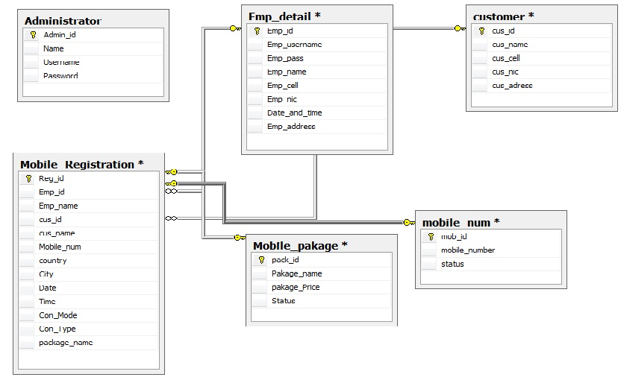***Database Diagram*

*Flow Chart*

Telephone Connection System

Admin

Add Num

Search Cust

Sale num

View Cust

Add Cust

Add Cust

View Emp

Add Landline

Add Mobile Num

Add Emp

Employee