**Table of Contents**

1. Case study 9
2. Method 12
3. Requirments 12
4. System analysis 12
   1. Use case diagram 13

4.2. Activity diagram 15

5.3. Sequence diagram 15

1. System design 22
2. Implementation code 12
   1. (.c) &(.h) files 13

7.2. Makefile 15

7.3. Linkerscript.ld 15

7.4. Startup.c 15

1. Simulation 12
2. SW analysis 12

**Case study**

In this report, a design work for controlling pressure inside the aircraft cabin will be discussed by using a special sensor to measure atmospheric pressure, and the work that we will specialize in doing in that system will be determined based on the following Assumptions:

* The controller setup and shutdown procedure are not modeled.
* The controller maintenance is not modelled.
* The pressure sensor never fails.
* The alarm never fails.
* The controller never focuses on the power cut.

Versioning:

* The keep track of measured value option is not modeled in the first version.

**Method**

We have chosen the system V-cycle as it will provide us with the following factors:

* Easy to set up.
* Productivity improvement.
* Time saving.
* Money saving.
* Improvement of the quality of the delivered product.

**Requirements**

**System analysis**

* **Use case diagram.**

* **Activity diagram.**

* **Sequence diagram**

**System design**

**Implementation code**

* **(****.c) &(.h) files**
* A screenshot of a computer

  Description automatically generated**PS.c**
* **PS.h**

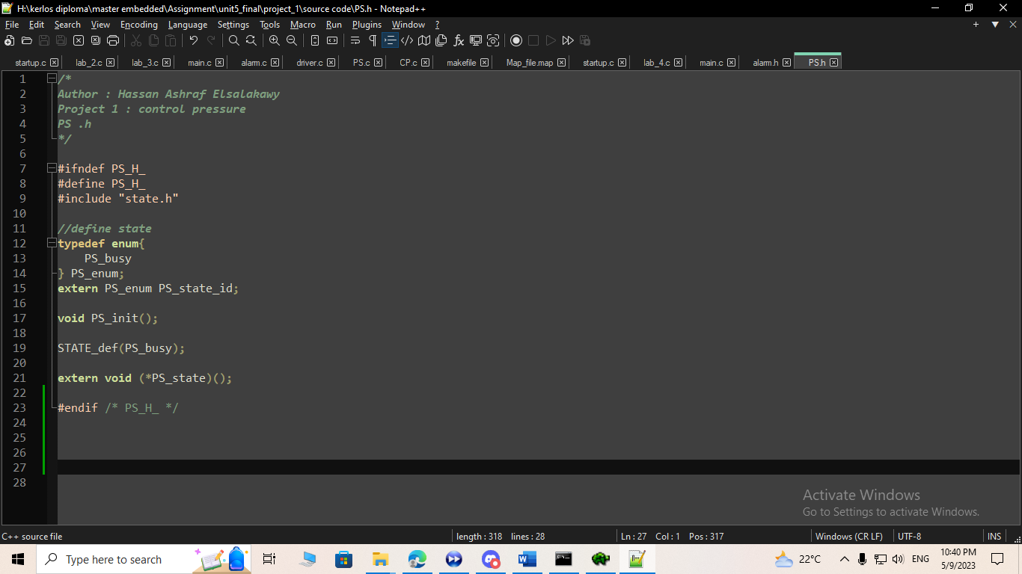

* Text

  Description automatically generated**CP.c**
* **CP.h**

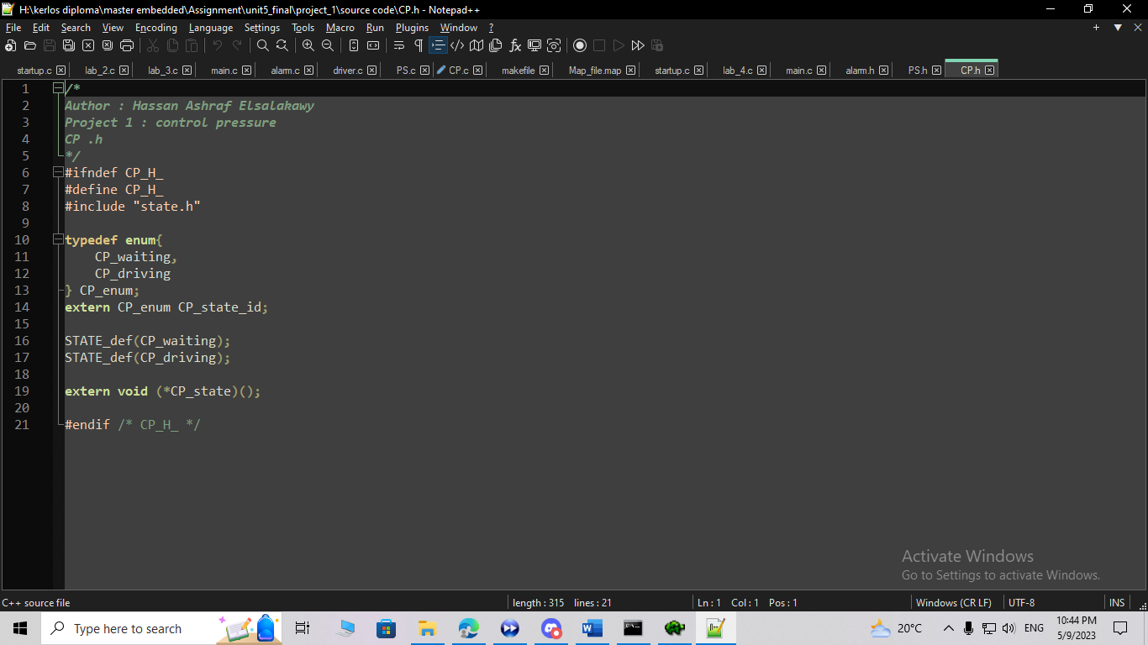

* **alarm.c**

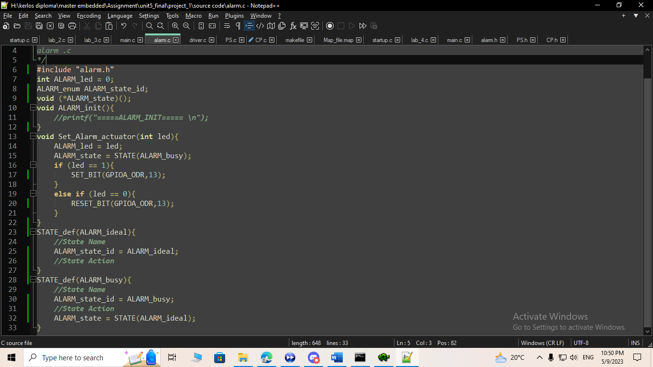

* **alarm.h**

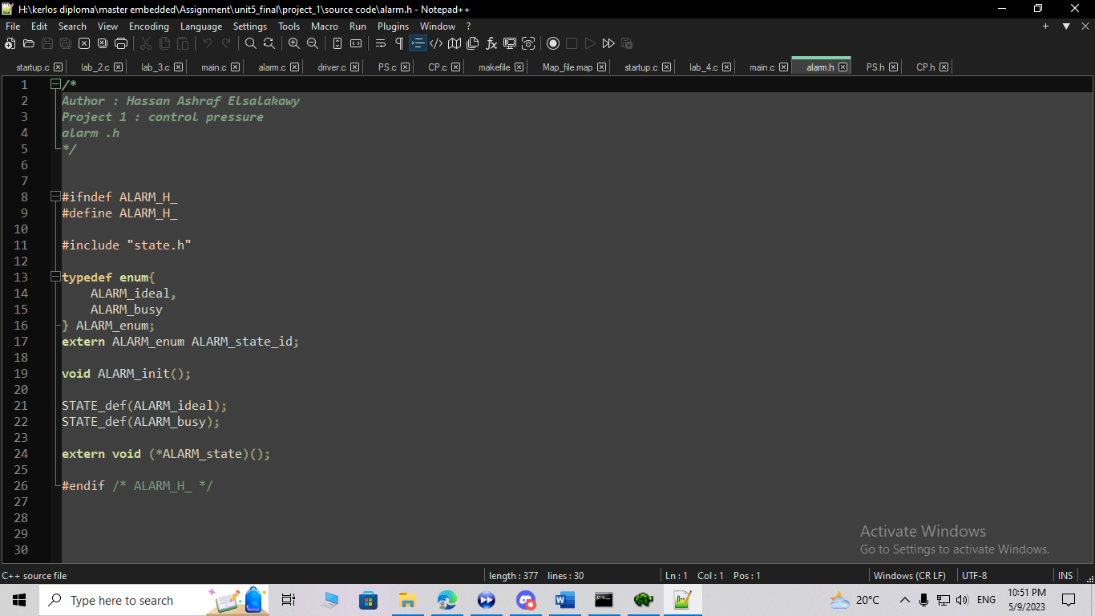

* **driver.c**

* 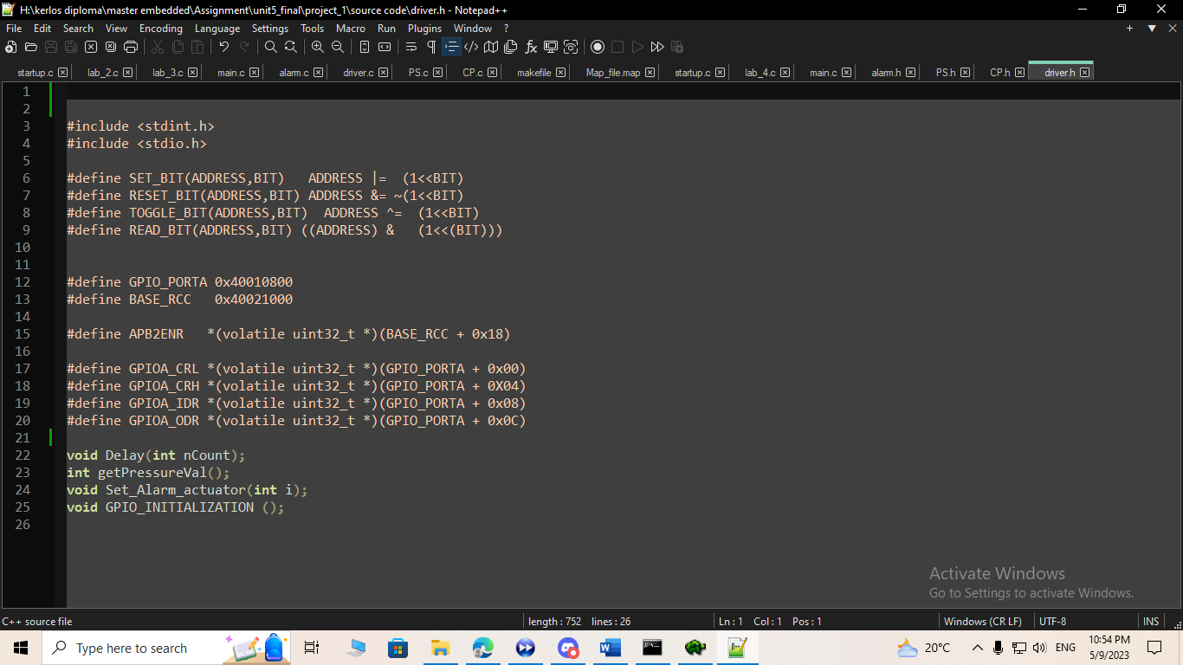**driver.h**
* 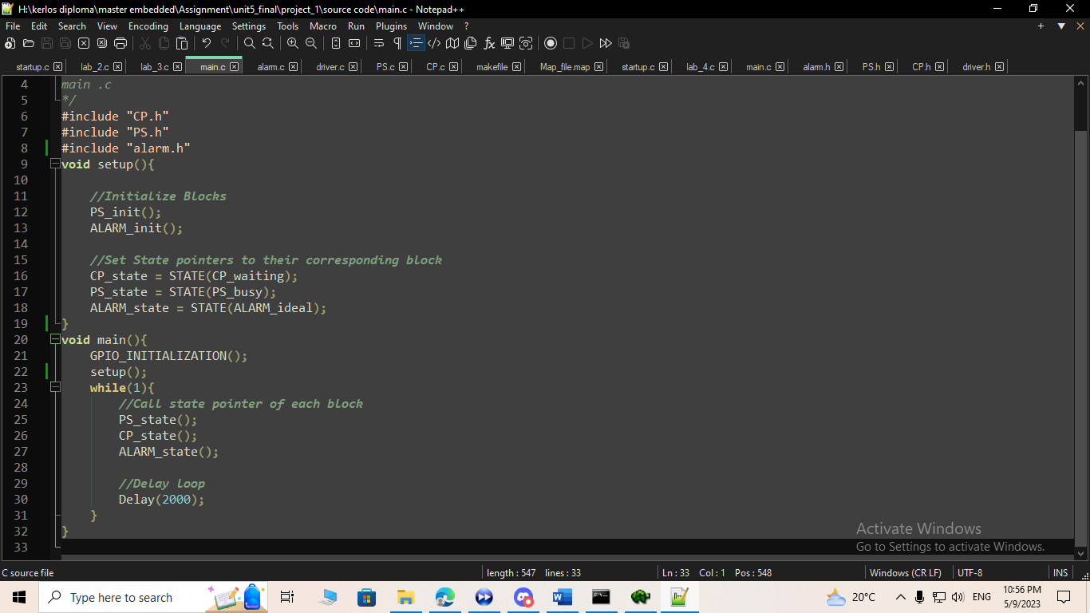**main.c**
* **state.h**

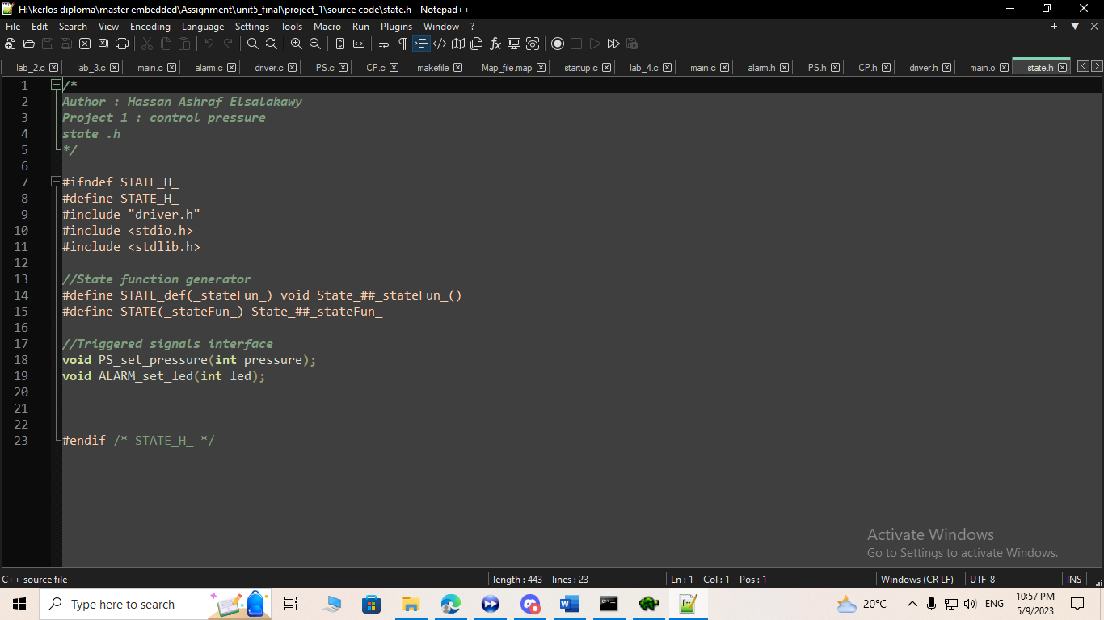

* 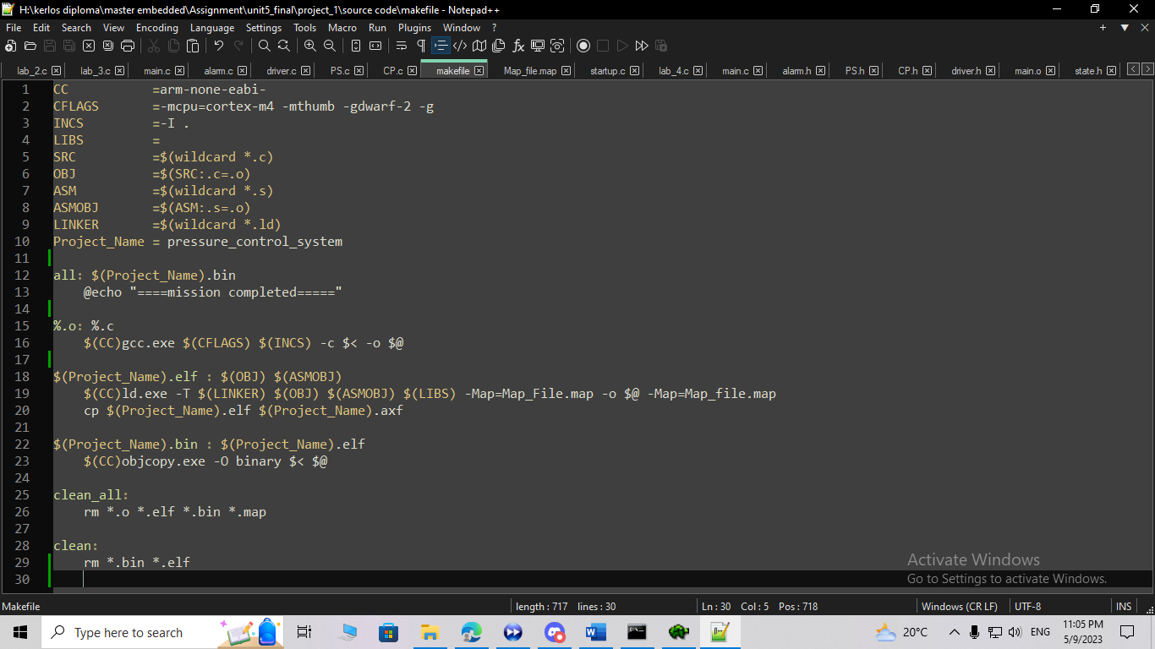**Makefile**
* **Linkerscript.ld**

* **Startup.c**

