**Assignment 4**

Name: Hassan ragab hassan

ID: 20190177

Group: S4

|  |
| --- |
|  |

***Exercise 1: Create a tool to obtain a feature class with preclusive areas***

* Create a new model tool named **“Exercise1”**
* Build a model for the following workflow:
  + **“royal_tombs”** buffered with **3000 m**

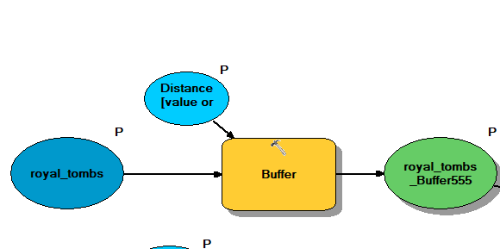

* + **“telemasts_PointsToLine”** buffered with **300 m**

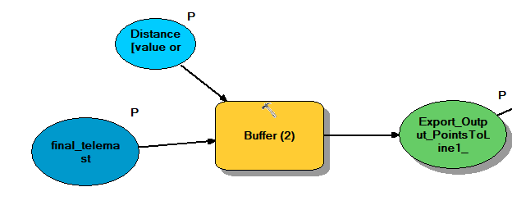

* the both **Output Datasets** should be overlayed with the **“*Merge*”** tool together with the datasets **“preclusive_geomorphology”** and **“preclusive_economic_activities”**
* ***Add Field*** to the Merge Output Dataset named **“Zone”**

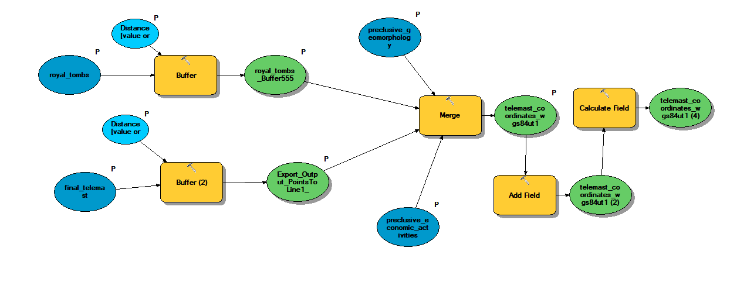

* Use the ***“Calculate Field”*** function to **attribute all features** with **“preclusive”** (field “Zone”)

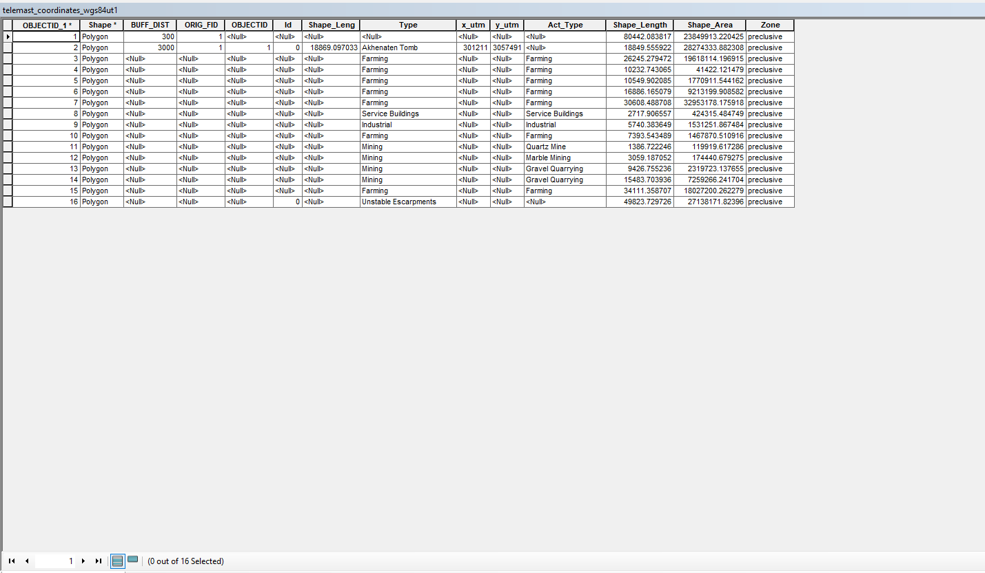

***Exercise 2: Create a tool to obtain a feature class with unfavorable areas***

* Create a new model tool named **“Exercise2”**
* Build a model for the following workflow:
  + “main_wadis_of_importance” buffered with 100 m
  + 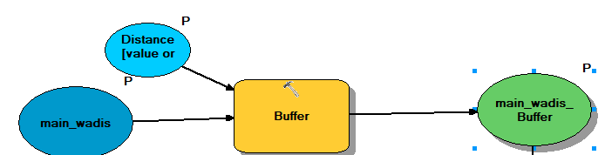“Merge” the Output Dataset with the datasets “less_favorable_geomorphology” and “less_favorable_accessibility”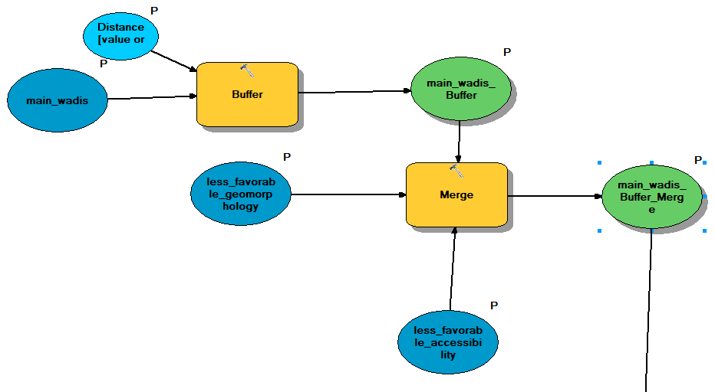
* Add Field to the Merge Output Dataset named “Zone”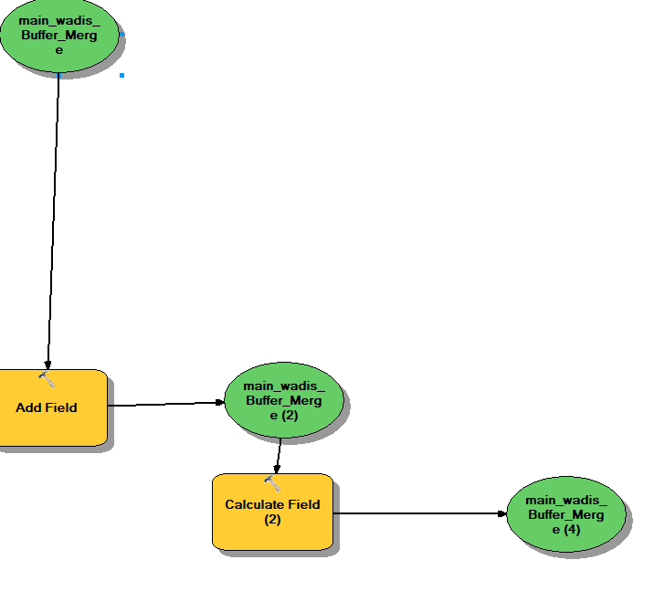
* Use the “Calculate Field” function to attribute all features with “unfavorable” (field “Zone”)

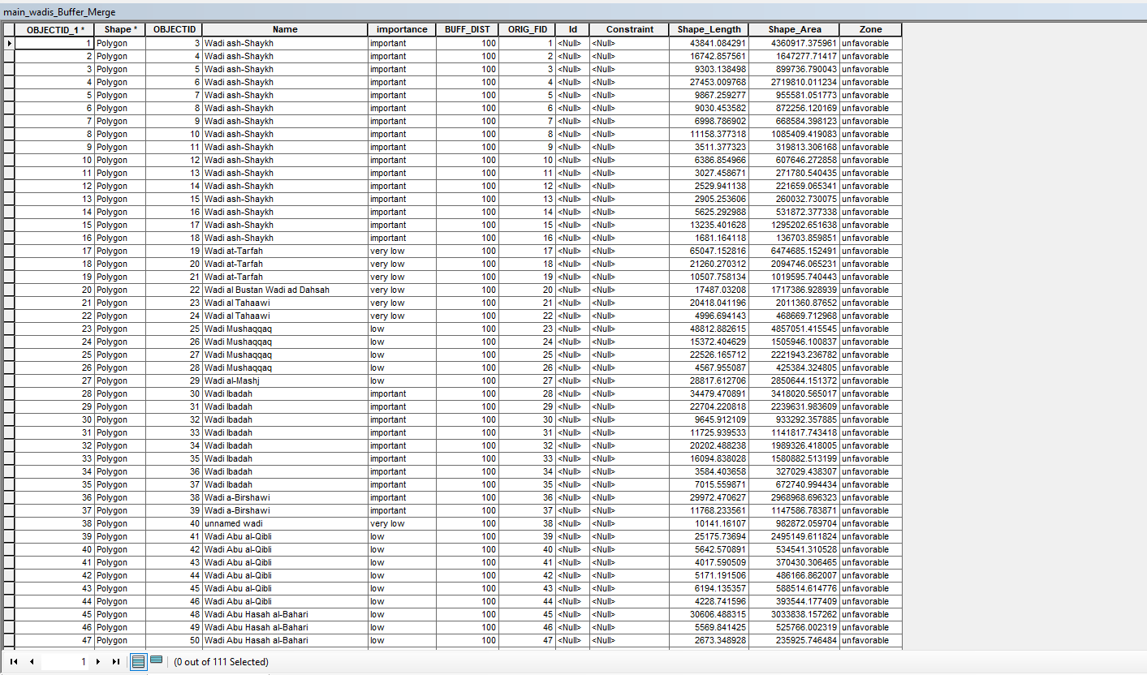

***Exercise 3: Integrating a model within a model Create a tool to obtain a feature class with all preclusive & unfavorable areas:***

* Overlay the Output Datasets of both previous models using the tool “Union”

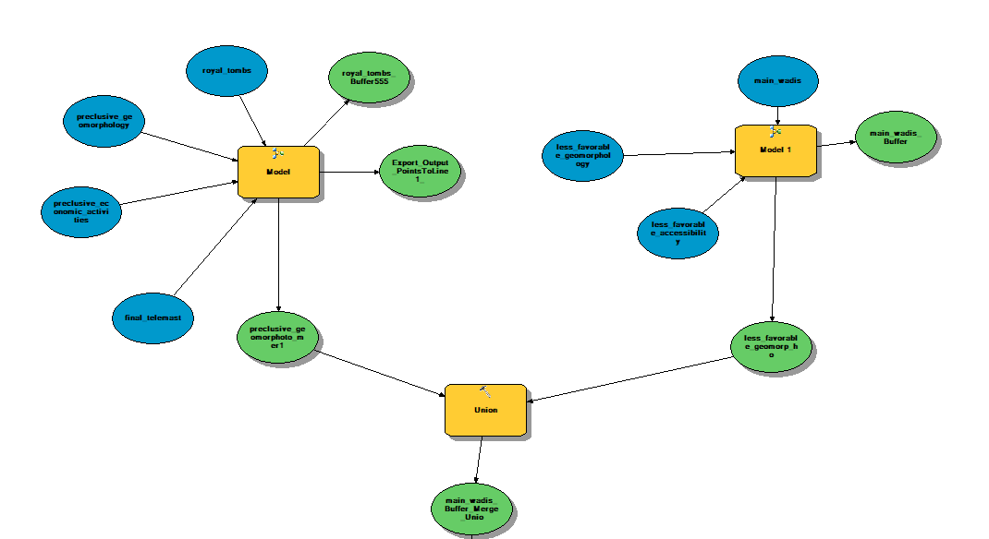

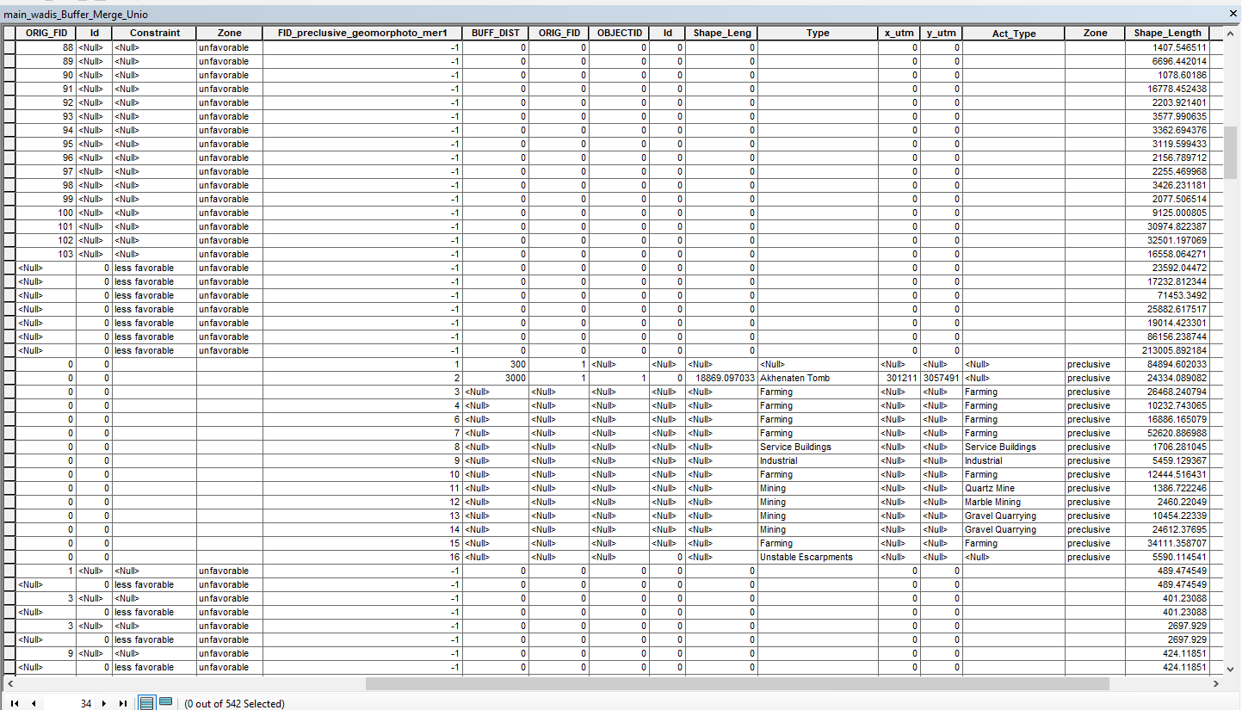

* Clip the Union Output Dataset to the “project_subareas”

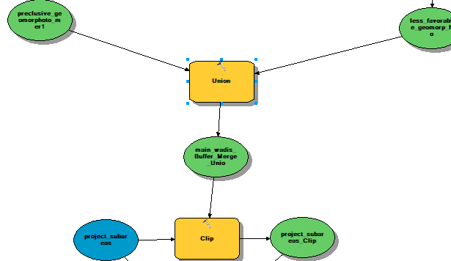

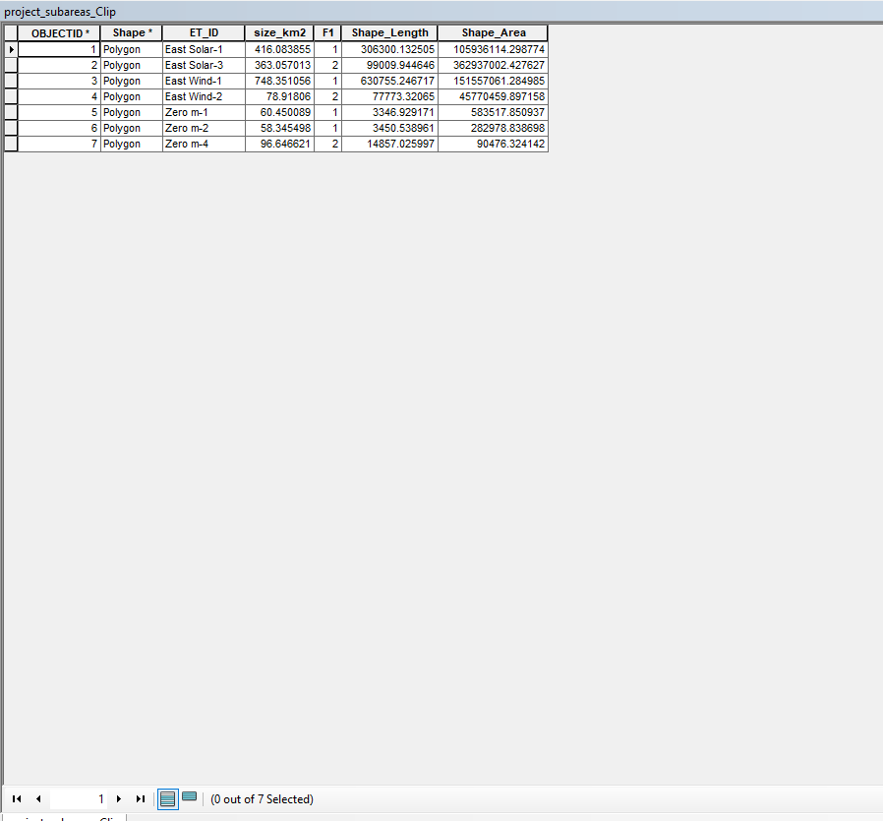

* Add the result to Display

***Erase project-subareas***

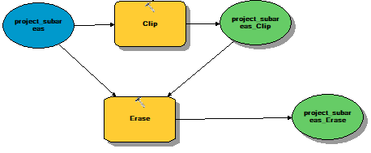

***Solution forward***

