**Geographical Information Systems**

**Assignment 1**

Student Name: Hassan ragab hassan

Student ID:20190177

Group No.: S4

**Q1:**  This graphic represents the *Tools* toolbar. Hover your mouse pointer over each tool to see what it is named. Match the name with each tool’s icon.

|  |  |  |
| --- | --- | --- |
| A) "zoom in" focus on a specific area to view the tiny details depend on your scale  B)"fixed zoom in " with fixed scale details focus on a specific area to view the tiny details  C)"pan" catch the picture to move it  D)"Go back to previous extent" These buttons will step through the last extents  E) "select features" allows you to select features by clicking on the map instead of using the attribute table.  F)"select elements" for see the text in map  G)"find" find geographic feature, place or address"  H) The measure tool is used to measure areas and distances on your map  I)"HTML Popup " launch an HTML Popup by click on feature |  | J) "zoom out" zoom out to see the big picture depend on your scale  K) "fixed zoom out " with fixed scale details and zoom out the specific area to view  L)"full extent" to view full picture  M)"Go to next extent" These buttons will step through the next extents  N) "clear selected features" Clears all selected features in all layers.  O)"identify" displaying the attributes of the feature clicked on.  P)"go to xy" Used to jump to a specific point on the map  Q)"Hyperlink" launch a hyperlink to document or script by click on feature  R)"create viewer window" create new viewer window by dragging rectangle |

**Q2:** According to the Identify tool, what is the area of El Dokki and what is your location in Degrees Minutes, Seconds and in Meters?

Answer:

Area for dokki = 5.092196 km

Location:

In decimal degree

x-coordination=31.20621

y-coordination=30.041464

location in meters =5092196.038718

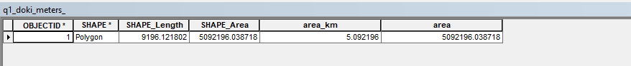

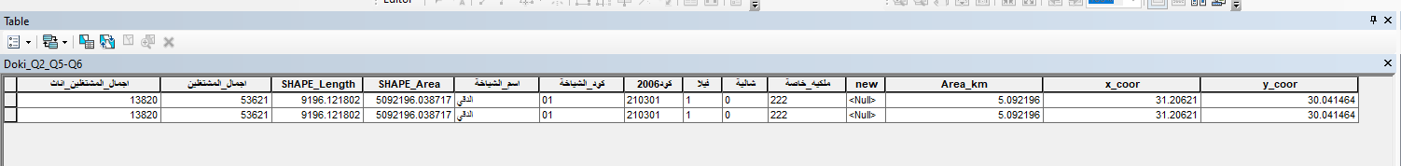

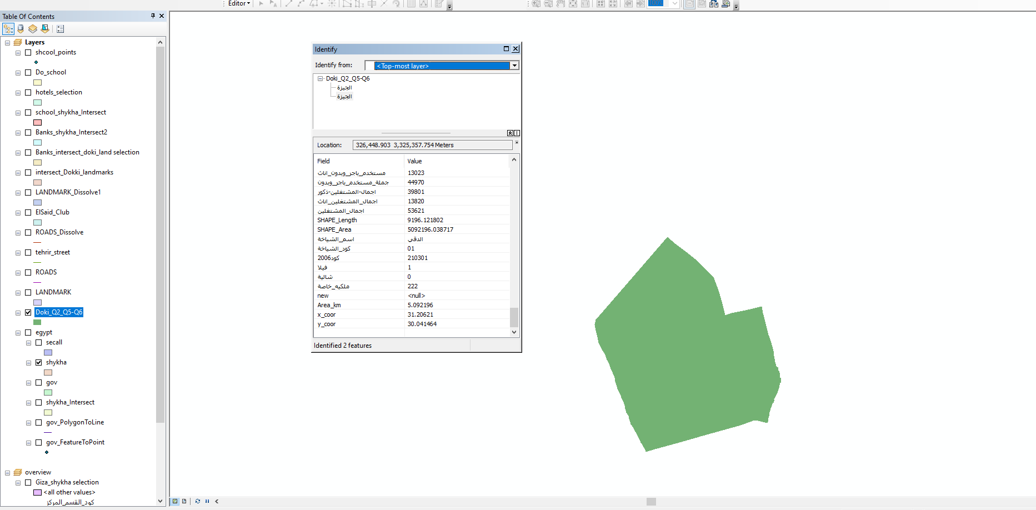

**Q3** Using the line measurement tool, how long is Eltahrir street in Km?

Answer" Length in km=16.719969 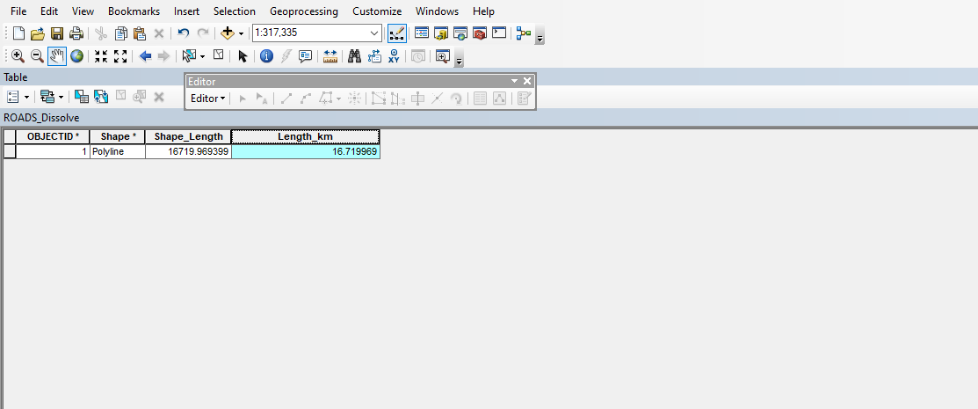

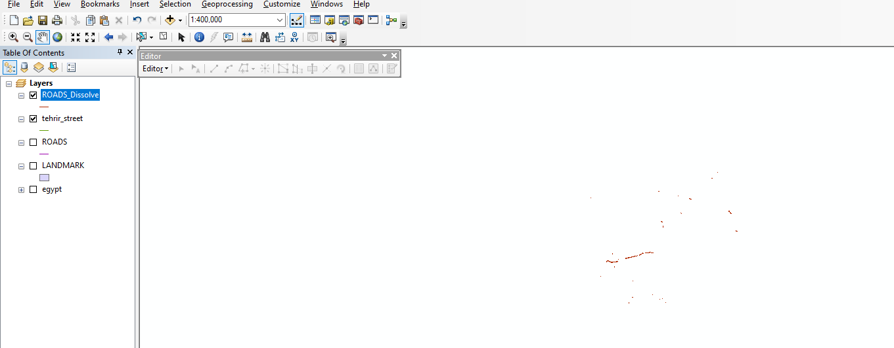

**Q4** Using the polygon measurement tool, what is the Area of “نادى الصيد” in Km square?

Answer:

Area=0.060533 km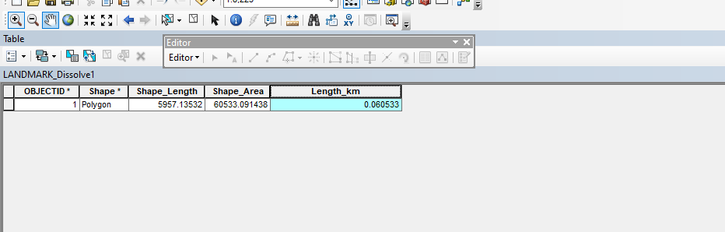

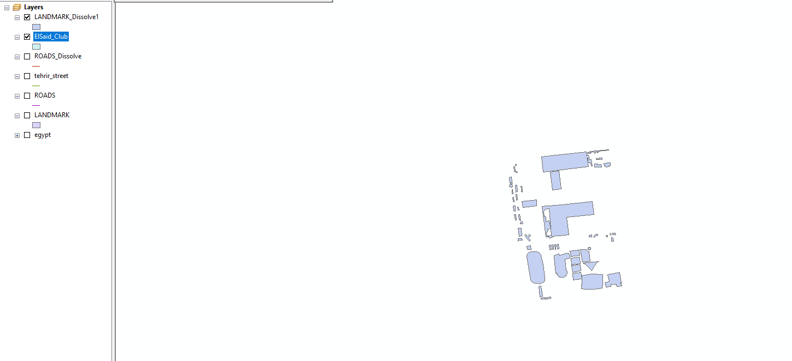

**Q5** The “Shape_area” Field explains the area of each bank in eldokki. How many Banks Located in Eldokki?

Answer:

There are 48 banks in eldokki and there area appear in the table bottom

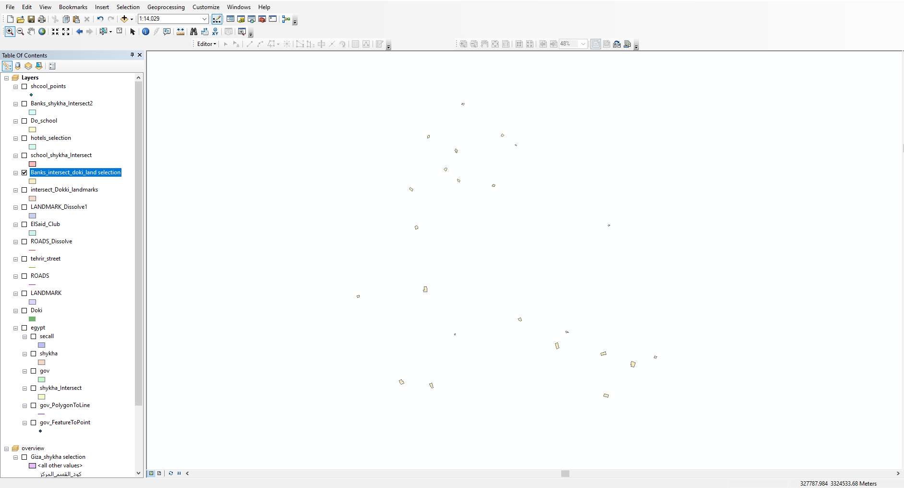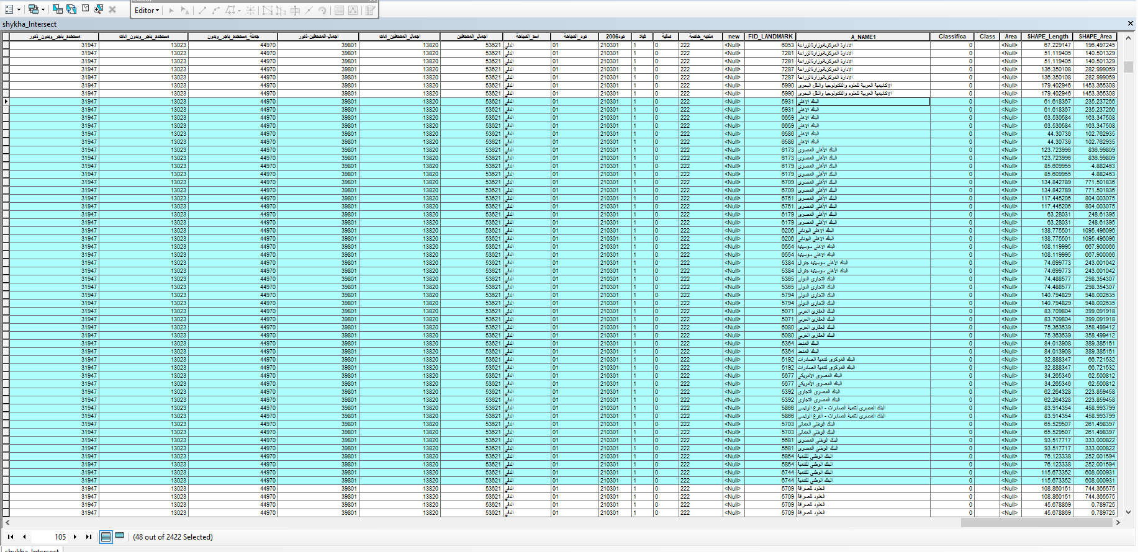

**Q6:** Using the Select Features tool, click on some of the schools on Eldokki. Notice that selected features appear outlined in cyan. Make print screen for this selected school

Answer:

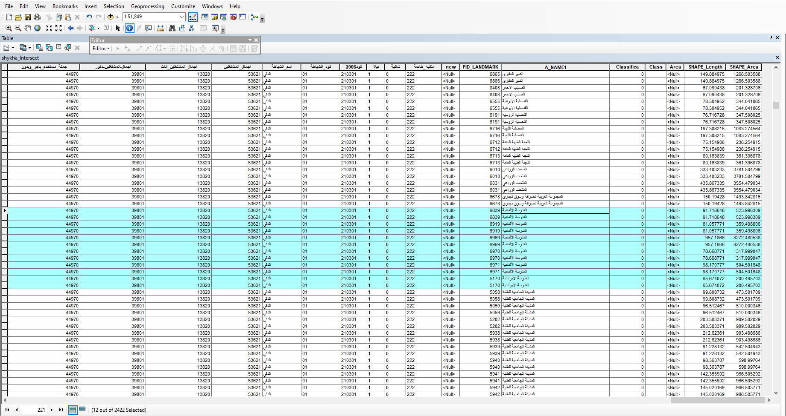

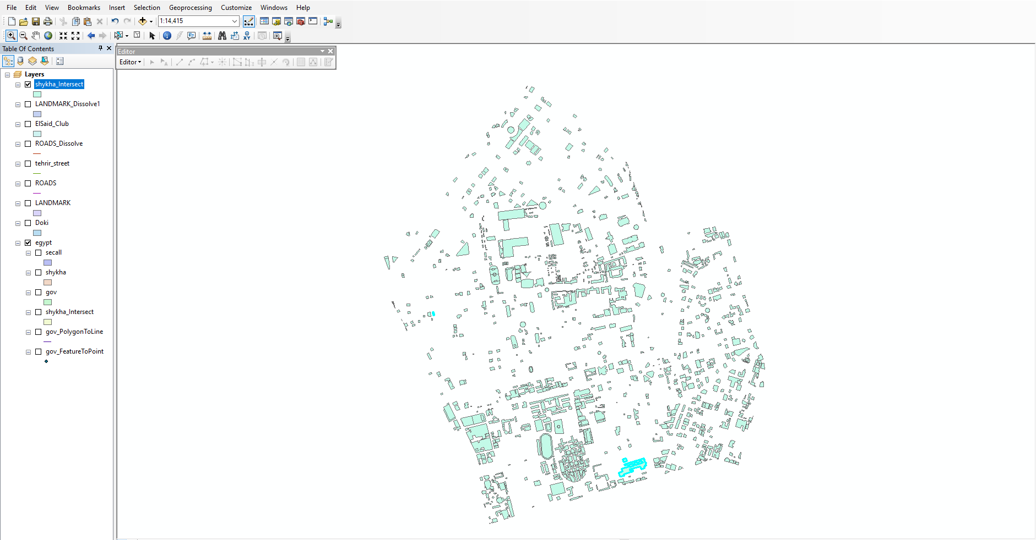

**Q7:** Select all hotels from Landmark layers where the area is >1500m square Print screen of the map with the selecting feature

Answer:

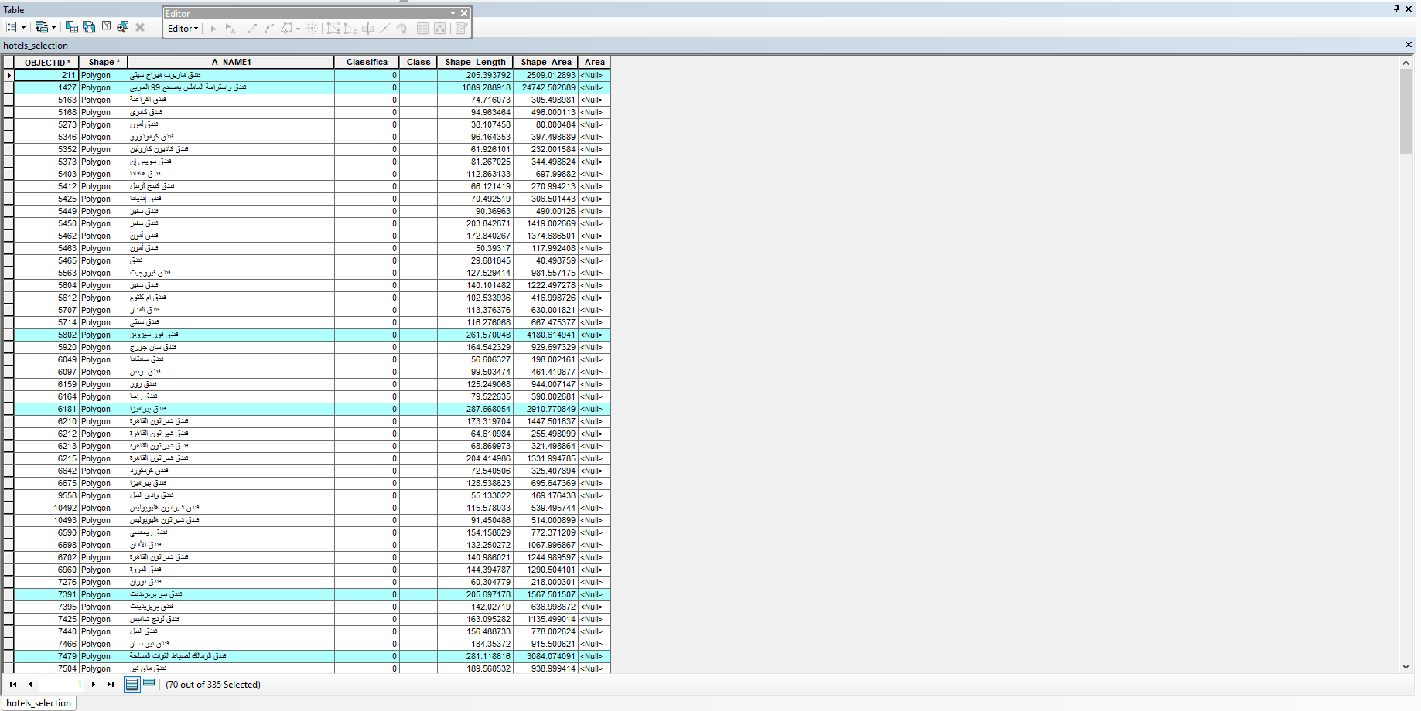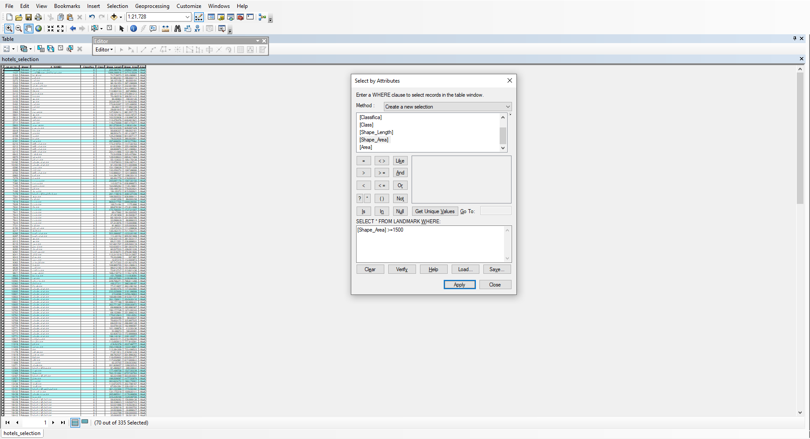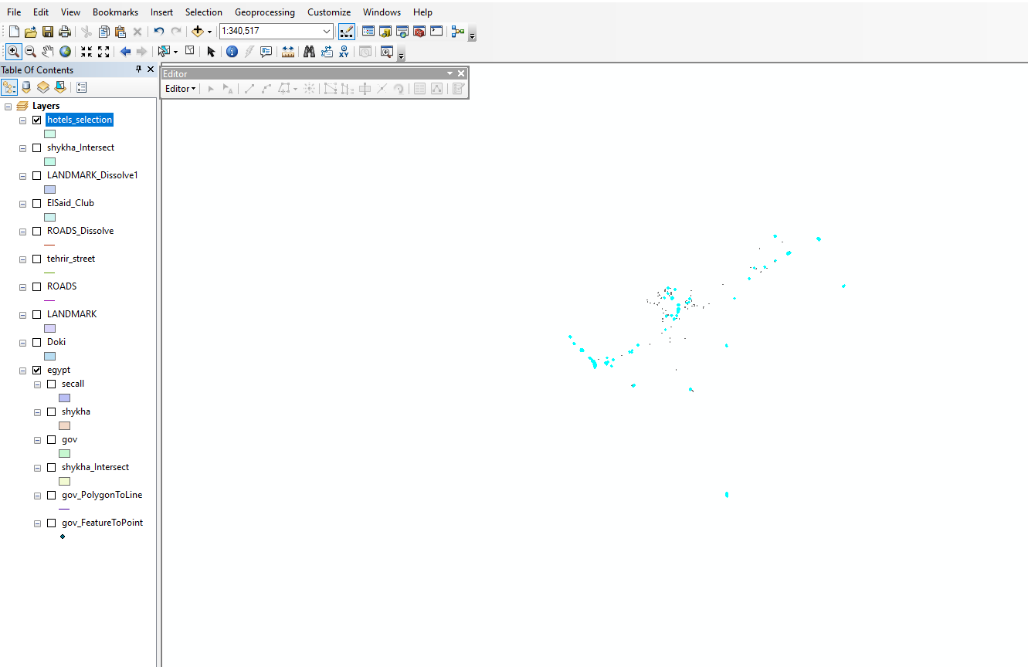

**Q8:** Export your images in JPEG format with resolution 700dpi after putting all map components (verbal scale- north arrow – legend- date of production-Inset and locator map-Neat line-projection-and cartographer)

Answer:

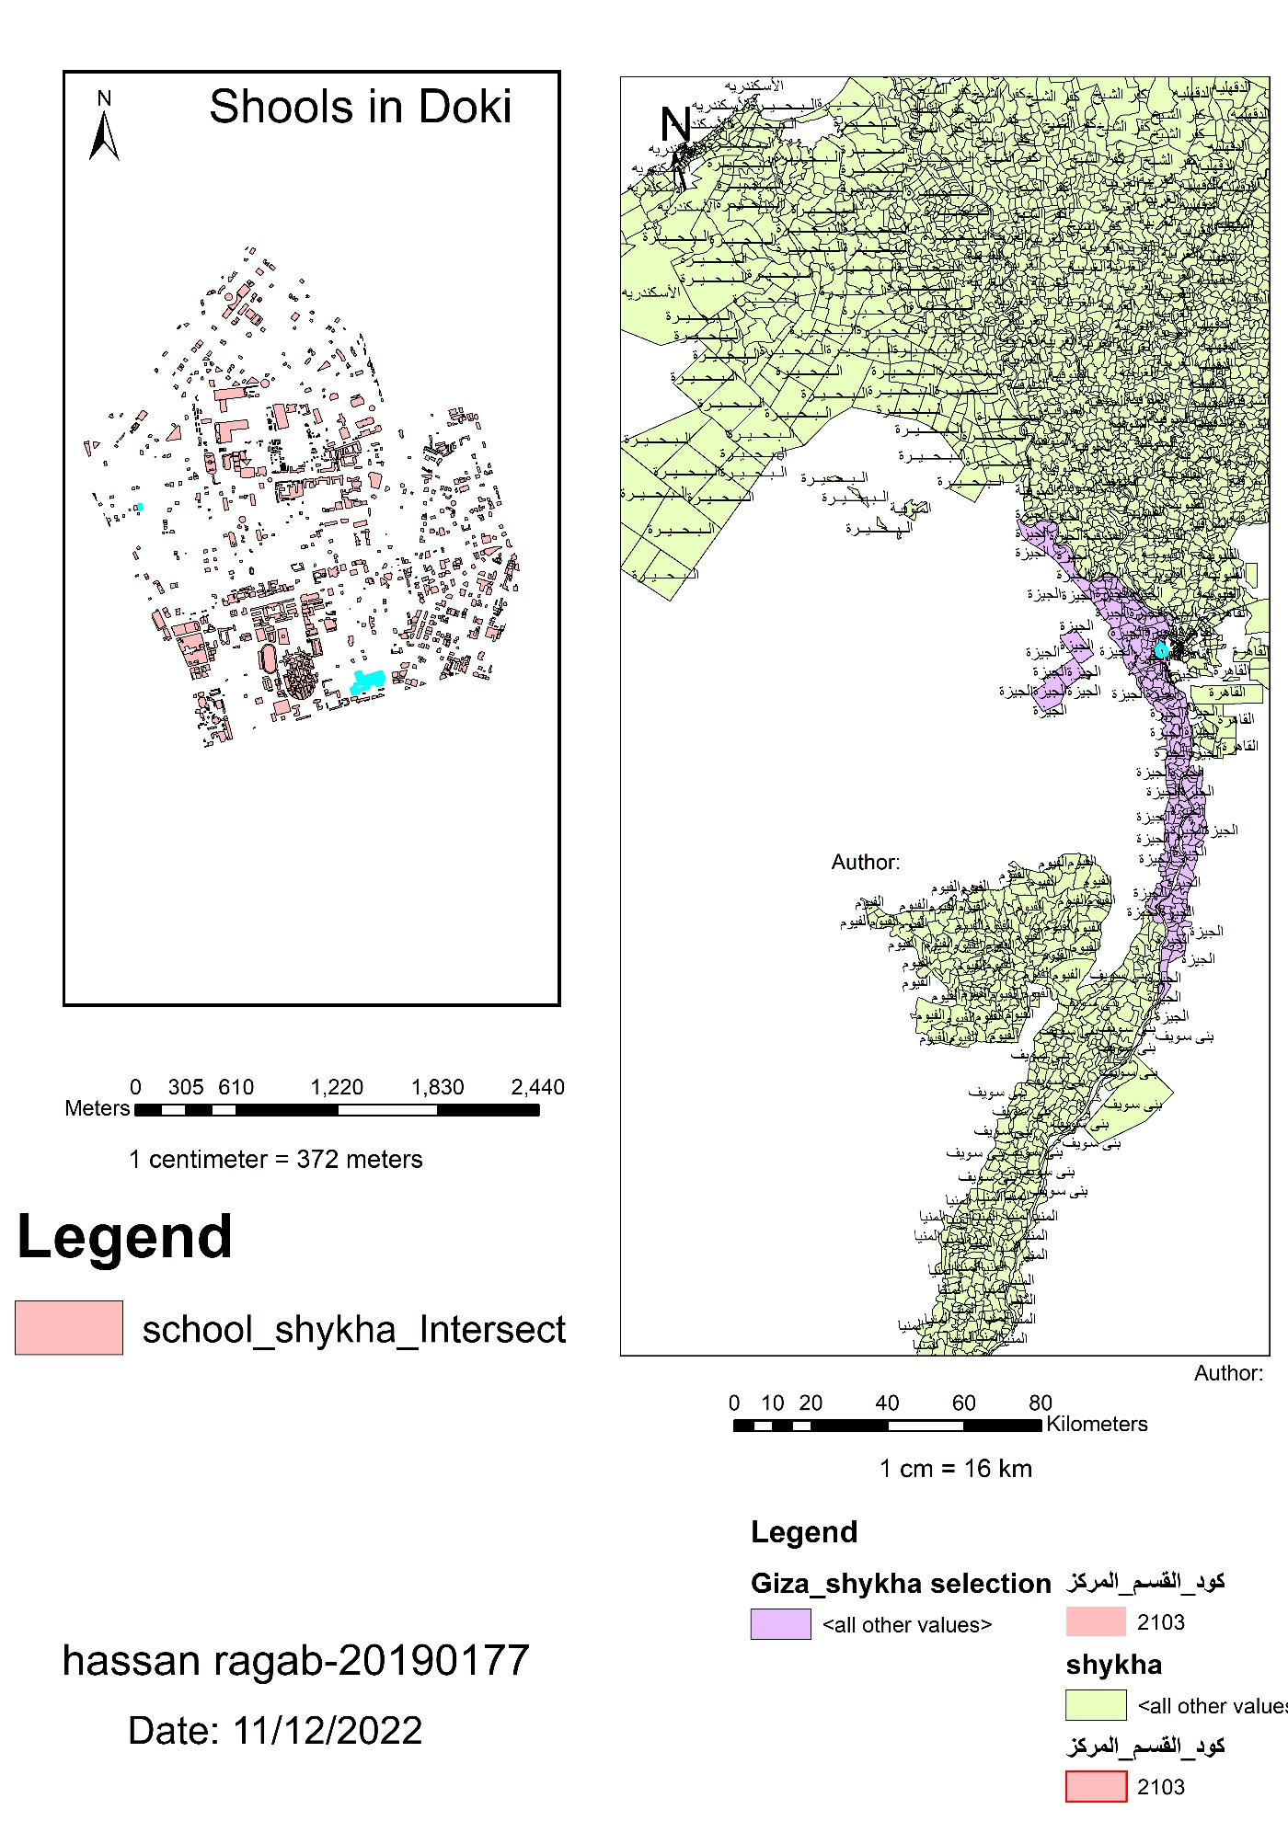

**Q9:** Using ArcToolbox select all school and export it into Do_school layer convert the Do_school layer into point layer and export your map in PDF format with nominal representation

Answer:

