**Assignment 3**

Name: Hassan ragab hassan

ID: 20190177

Group: S4

1) Go to secall layer and make selection on the all sections that belong to 6-october gov

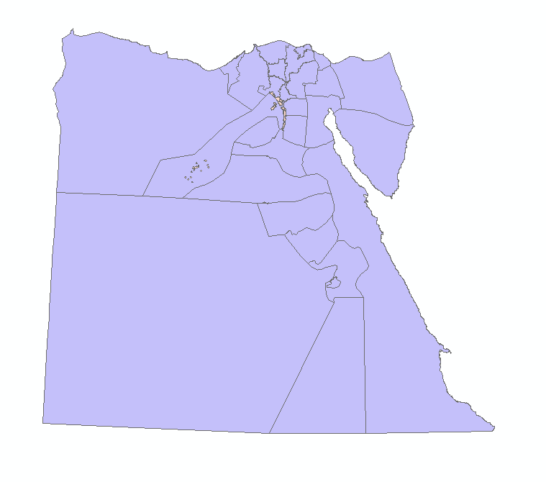

Then isolate it into layer then we make dissolve but make sum aggregation on some attribute

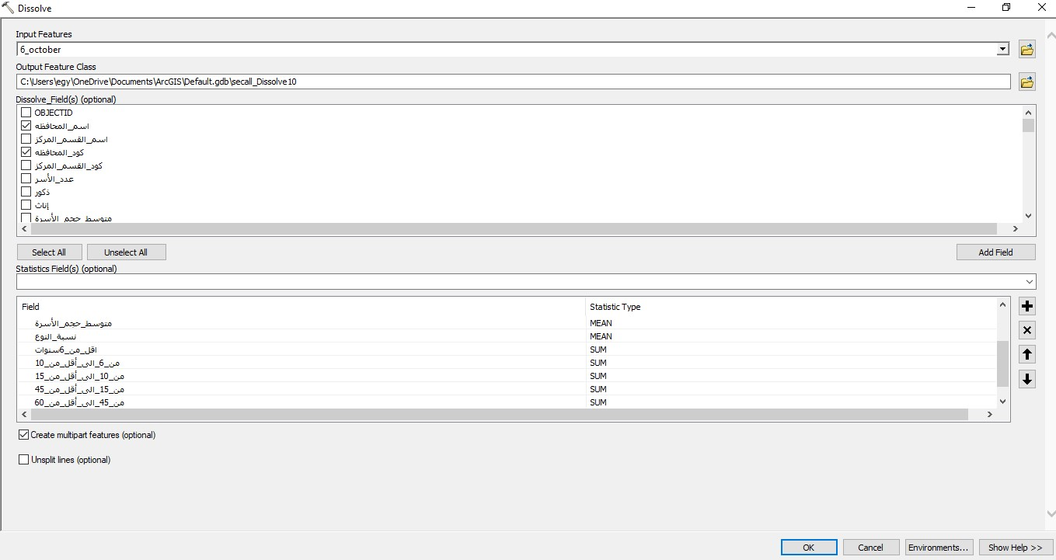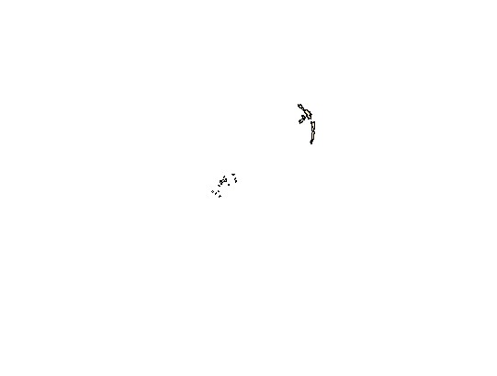

Then make the same steps on the Helwan gov:

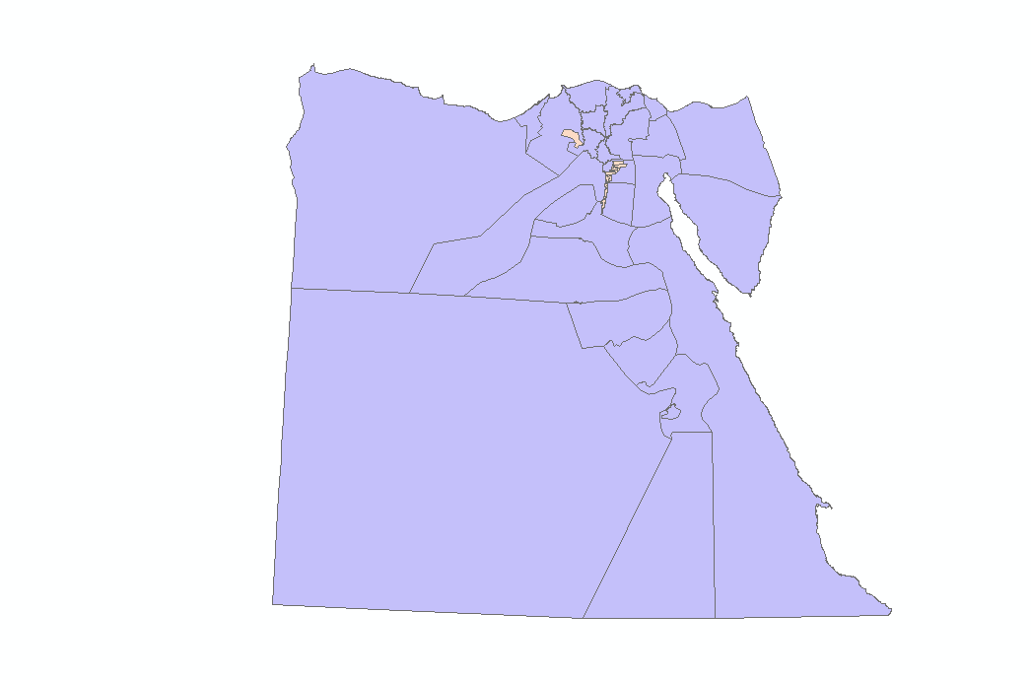

We make dissolve layer

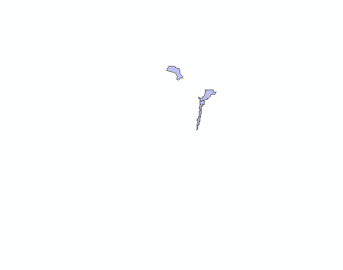

We make a merge between the dissolve layer and the gov layer but make a mapping when we make the merge.

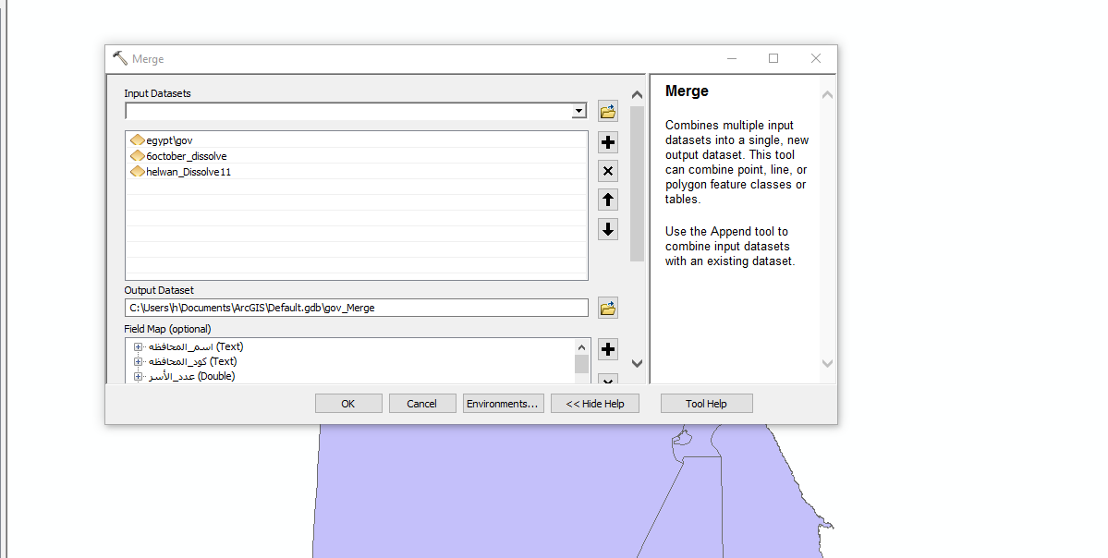

The result of the merge:

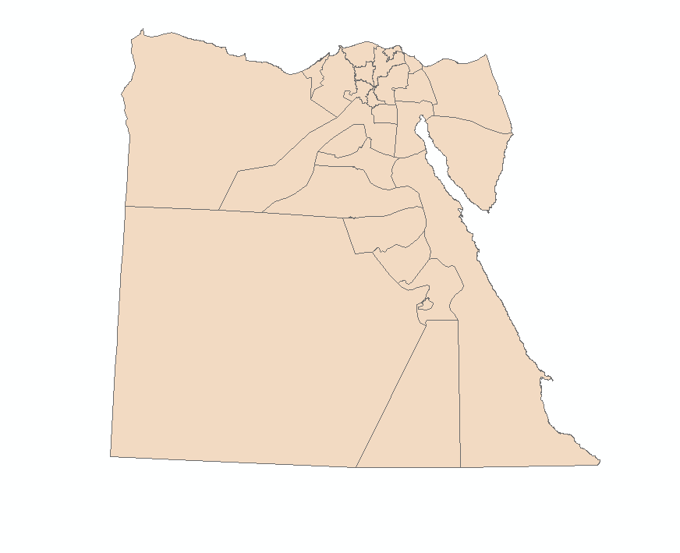

Then we export the map into shaped layer

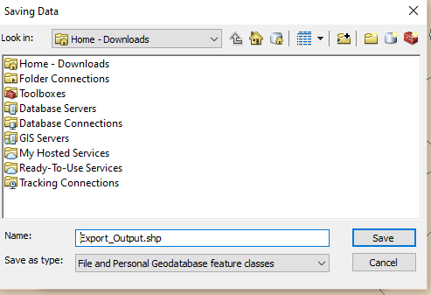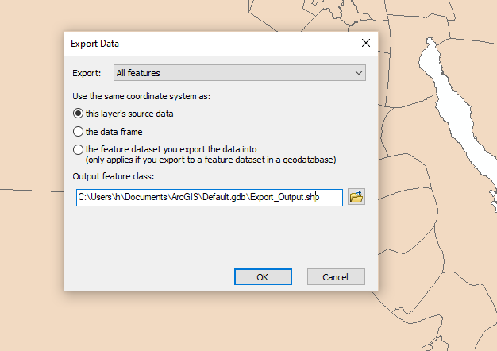

The final map:

