5. Implementation: Web Application and Deployment

5.1 Architecture
The selected XGBoost model (Section 4.4) was serialised using joblib and served via a lightweight Flask REST API exposing two endpoints: /health, for service status checks, and /predict, which accepts a 45-dimensional feature vector (matching the statistical, time-domain, and frequency-domain features extracted in preprocessing) and returns a predicted stress class, confidence score, and full class-probability breakdown as JSON. Cross-origin requests were enabled via flask-cors to permit calls from the separately-hosted React frontend. The frontend was built with React and Vite, and communicates with the API using axios. A time-series visualisation of prediction history within the session was implemented using Recharts.

5.2 Dashboard Interface
The dashboard allows a user to trigger a prediction against any of nine sample sensor windows drawn from real WESAD data (three per class, spanning multiple subjects), simulating the real-time submission of a physiological sensor reading. Each prediction is displayed with a colour-coded stress level (green for Baseline/Amusement, red for Stress), the model's confidence, and a full per-class probability breakdown, satisfying the colour-coded Low/Moderate/High indicator specified in the project proposal.
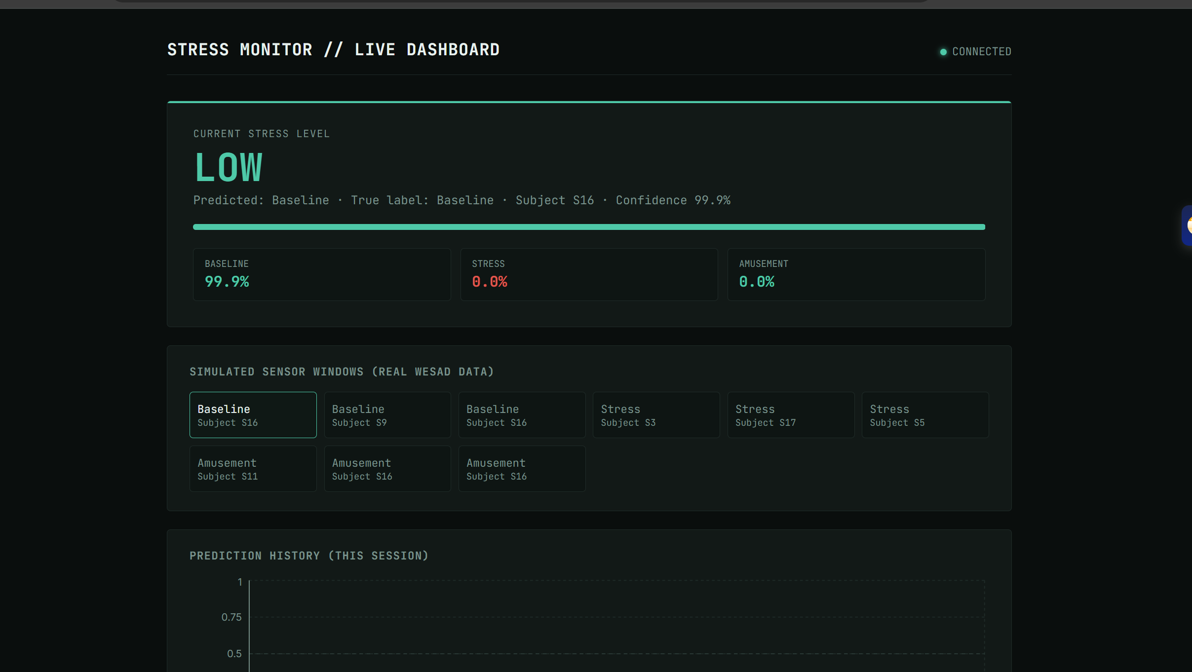
Figure 3: Dashboard showing a correctly classified Baseline reading (99.9% confidence) with per-class probability breakdown.
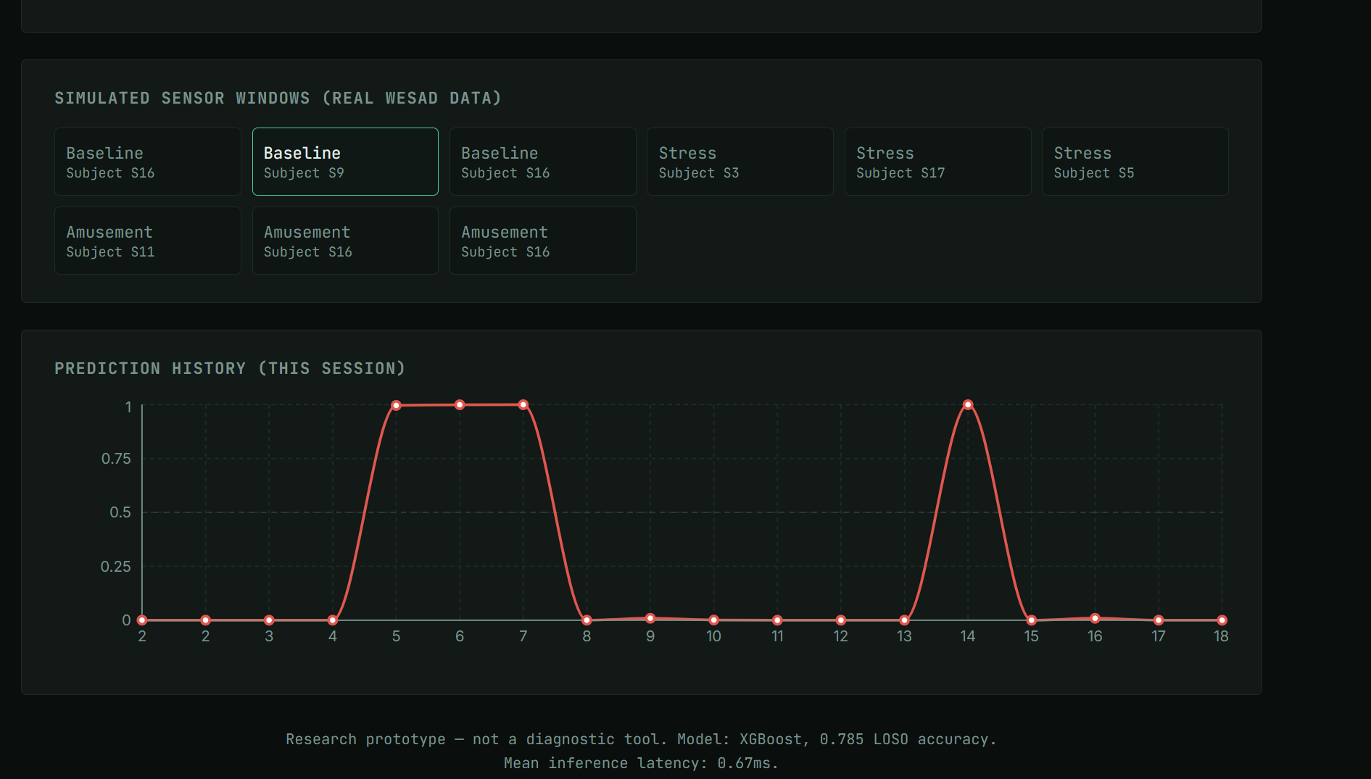
Figure 4: Session prediction-history chart, showing stress-probability spikes correctly aligned with Stress-labelled sample selections.

5.3 API Latency (Browser-Measured)
In addition to the pure model-inference latency benchmark (Table 3, Section 4.3), end-to-end browser-measured latency was captured using Chrome DevTools' Network panel to validate real-world responsiveness, including HTTP connection and JSON serialisation overhead not captured by the Python-only benchmark.
Measurement | Value | vs 200ms target
Pure model inference (Python benchmark, 100 runs) | 0.67 ms mean | Comfortable
Server processing (browser-measured, DevTools) | 18.22 ms | Comfortable
Full round-trip incl. connection overhead | 38.58 ms | Comfortable
Table 4: Browser-measured API latency versus pure model-inference latency.
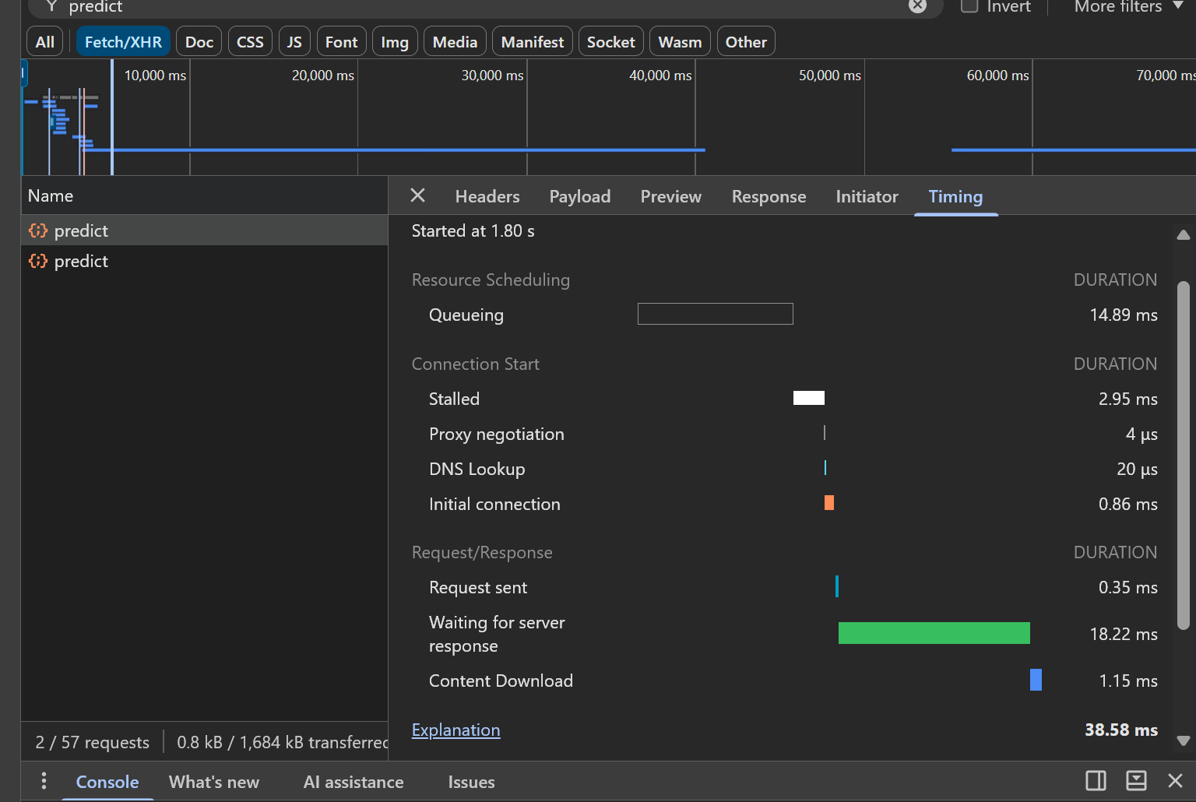
Figure 5: Chrome DevTools Network timing breakdown for a /predict request, showing 18.22ms server response time.
The additional ~17ms observed in browser-measured latency versus the pure-Python benchmark is attributable to HTTP connection handling, request queueing, and JSON serialisation overhead inherent to the client-server round-trip, rather than model inference itself. Both measurements remain comfortably within the <200ms target specified in the project proposal.

5.4 Cross-Browser Compatibility
The dashboard was manually tested across the two most widely used desktop browsers to confirm consistent rendering and functional prediction requests.
Browser | Loads correctly | Prediction works
Google Chrome | Yes | Yes
Microsoft Edge | Yes | Yes
Table 5: Cross-browser compatibility testing results.

5.5 Usability Evaluation: Limitation and Deviation from Proposal
The project proposal specified a formal System Usability Scale (SUS) evaluation with approximately 10 participants, requiring university ethics approval prior to commencement. Due to the project timeline, formal ethics approval had not been secured by the point of dashboard completion, and a full SUS study with the target participant count was not feasible within the available time. This is noted here explicitly as an honest deviation from the original methodology, consistent with the project's risk register (Risk 3), which anticipated that web development and evaluation timelines might require pragmatic scope adjustment. In place of the formal study, an informal usability walkthrough was conducted, and functional and cross-browser testing (Sections 5.3-5.4) was substituted as the primary evidence of the prototype's technical readiness. A full SUS evaluation remains recommended future work, pending ethics approval, and is discussed further in the Limitations and Future Work section.

