**Probability distribution:** A mathematical formula that gives the probabilities of occurrence of possible outcomes of an experiment. For a discrete random variable, it gives the probability of each value of the variable. For a continuous random variable, it is a curve that specifies the probability that a variable falls within a certain interval by way of areas under the curve.

**Normal distribution:** A probability distribution ‘f(small x)’ of a random variable ‘capital X’, given by the formula

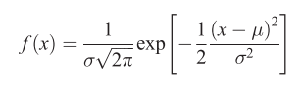

Here (myu) is the mean and (sigma squared) is the variance of the variable ‘small x’.

1. Q plot:

**Student’s t distribution:** The probability distribution of the variable ‘t’ where t is given by:

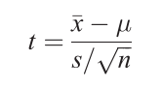

Here ‘x bar’ is the arithmetic mean of n observations from a normal distribution with mean ‘myu’_x0007_and ‘s’ is the sample standard deviation. These are calculated as follows:

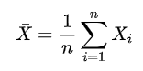

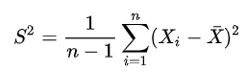

The variable ‘t’ has a Student's t-distribution with n-1 degrees of freedom:

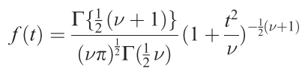

**Chi-squared distribution:** The probability distribution, f(x), of a random variable ‘capital x’ defined as the sum of squares of a number ‘small greek letter nu’ of independent standard normal variables and given by the formula

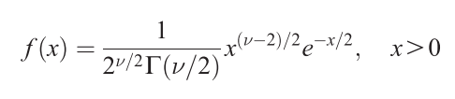

**F distribution:** The probability distribution of the ratio of two independent random variables, each having a chi-squared distribution, divided by their respective degrees of freedom.

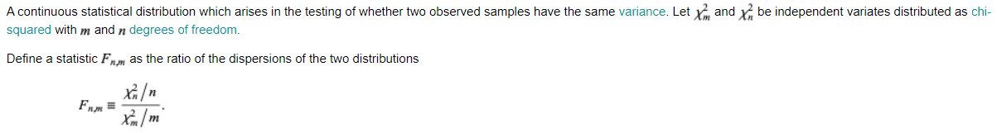

Formula here: <https://mathworld.wolfram.com/F-Distribution.html>

**Null hypothesis:** It is typically the ‘no difference’ or ‘no association’ hypothesis. It is tested against an alternative hypothesis that postulates the opposite, i.e. a non-zero difference or association.

**P value:** Assuming that the null hypothesis is correct, the p-value is the probability of obtaining test results which are at least as extreme as the observed results.

**Significance test:** A statistical procedure that when applied to a set of observations results in a p-value relative to some hypothesis. It is used to test a null hypothesis.

**Type I error:** It occurs when the null hypothesis is falsely rejected.

**Type II error:** It occurs when the null hypothesis is falsely accepted.

**Significance level:** Denoted by (alpha), it is the probability level at which the null hypothesis is rejected. It is usually set to (alpha = 0.05).

**Confidence interval:** A range of values, calculated from the sample observations, that is believed to contain the true parameter value.

**Confidence level:** It is the probability that the true parameter is in the proposed range of the confidence interval.

**Paired Sample T-test:**

https://www.statisticssolutions.com/manova-analysis-paired-sample-t-test/?__cf_chl_jschl_tk__=8add8b726feb28109e0a1c56795c84cbe9a81520-1608065000-0-ASEmetXBsene_QW7zeYsYUCmjMPc6KtLgFLo63RYs-h7L7HMALYJFr4OFODyazKfIMVWuLwFekoN7r4HSRDwLqBYMglLGiofDQPtVLk957c8tJ1ccYVOi_2t_r9MJEBxw_CKovrruOxKXLYMK1ky67R6y3FxUVGZlBXMn0qsgUHNfdgaEfilDimZT6ZkPG_L4kJXFPe0A-dcQozC0d4UKbmtuN7dq0Za0sXCPs57raI6S46kN-y2gozVq4uyXS-195vSbPNN4VGKKyT7LraRnFzJN3DudHf2qOnkCalmNMoqXgzFkFC-hMYX9ggXRHs0Fo-Aojk4ftajHZ3UvrG6ao5pOwHrEqfS8sEj27TdamfZ

Dunno what to include from the webpage above

**Anova:** text here

**Tukey’s Test:** text here