

INSTITUTE OF MANAGEMENT SCIENCES (Pak-Aims)

Title of Synopsis:
Hand Written Urdu Text Recognition Using Deep Learning

Name of Student:
Hassan Arif
Registration Number:
193880
Title of Degree:
MPHIL-CS
Name of Supervisor:
Dr. Tauqeer Ahmed

SYNOPSIS

- Title.
Hand Written Urdu Text Recognition Using Deep Learning
- Introduction
General Problem Area
Deep learning has achieved massive popularity in scientific computing. Many industries are widely used deep learning algorithms to solve complex problems. It uses different types of artificial neural networks to perform specific tasks and also perform sophisticated computations on a very large data. Most of the industries are using deep learning algorithms in different areas such as health care, e-commerce, entertainment and advertising commonly use deep learning.
Handwritten text recognition is an important area of research in the field of deep learning and artificial intelligence. It is the part of Natural Language Processing. In this field, a lot of work has been done on other languages especially for English, but very limited work has done on Urdu language especially for handwritten text recognition due to the cursive nature of Urdu characters and the shape of each character and different writing styles is one of the major issues.
Urdu is the national and official language of Pakistan. Most of the research work has been on other languages but when we talk about Urdu, a very less work has been done especially for handwritten text recognition.
We need a system in Pakistan for our offices that convert all handwritten text into digital format like writing official orders and directives, different type of documents. There is a need for converting handwritten text into machine-understandable because this is digital text safe and we can easily edit and search it. In Pakistan, most of our documents and record of some very sensitive data in handwritten files in our offices .We have a major issue to store all these files and to protect them from losing. If we want to get some information from old files then it is time consuming and much difficult to search from pile of files. But if this data were in digital form it would have been easier to store and to find them.
Background of the Thesis
In the late 2000, the first work on Optical Character Recognition (OCR) of Urdu script was started and published in 2004. After the literature review, it is noted that there is a lack of research efforts in Urdu handwritten text recognition as compared to the recognition of the scripts of other languages. Furthermore, there are some other Urdu OCR systems commercially available for printed text, but for the recognition of Urdu handwritten text there is no proper system available yet. In the field of computer vision and pattern recognition, handwritten text recognition is known as ICR (intelligent character recognition), while for printed text analysis, it is known as OCR (optical character recognition).
A standard handwritten digit dataset named MNIST was proposed in 1989 to build and test different recognition models which contain 10,000 to 60,000 images for training and testing. Each image is centered in a data format of 28×28 grey-scale which is standard data format for many different character datasets. After that many handwritten character datasets with different languages and more characters were used for research purposes. On the basis of these datasets, different types of methods have been analyzed for handwritten character recognition tasks and different machine learning models have been used e.g. k-nearest neighbors (KNN) and support vector machines (SVM).
In 2012, in Image Net Challenge, a deep convolutional neural net named Alex Net managed to achieve a 16% error rate. After that, deep learning models have become the dominant approach in different areas, e.g., time series classification, traffic forecasting, stock prediction, etc. The application of deep learning models greatly improves the efficiency and performance of handwritten character recognition and makes it reliable in practice. Urdu is an official and national language of Pakistan, spoken in different countries, being used by more than 60 million people. Due to the presence of diacritics, Urdu text recognition is also more challenging than any other language. An Urdu sample of more than 900 individuals had taken with a newly released pioneer dataset for handwritten digits and Urdu characters to evaluate the performances of different deep learning models and data augmentation and transfer learning techniques. The recognition accuracy of digits was achieved up to 98.94% and the recognition accuracy of characters was achieved up to 99.08% which was a great improvement from the baselines of 97% and 86.5% respectively.
Importance of OCR in Text Recognition
Optical Character Recognition (OCR) is a technology that picks out handwritten or printed text from digital images of handwritten text or printed text for example scanned documents. Optical Character Recognition used to analyze the digital images and generates a code for the text which can be used to retrieve the text from the image into digital format. OCR is also called text recognition because it is used to convert physical documents into machine-readable text. OCR is basically divided into four different types
- Input acquisition mode (online or offline text)
- Written mode (handwritten or printed)
- Character connectivity (isolated or joined)
- Font constraints (single or Omni font)

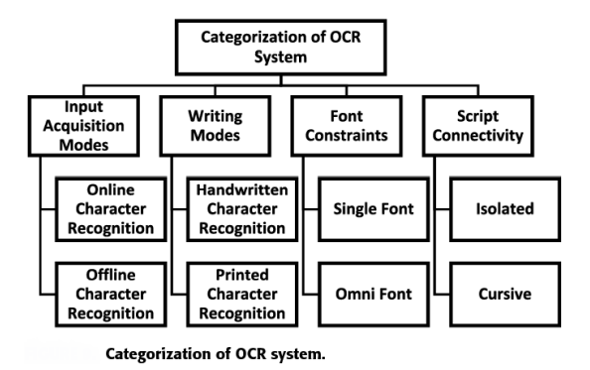
- Input Acquisition Mode:-
It the mode in which two types of input online and offline recognition is given to the optical character recognition.
- Writing Mode:-
It has many different formats for OCR but mostly available in written text which contains tables, headers, footers, borders, etc. and another format can be a handwritten format which has different styles of writing for different people.
- Font Constraints:-
It is specifically developed for one font style. It may fail or partially succeed for text written in another style. Optical Character Recognition that is only for a single font style is known as font constraints OCR.
- Character connectivity:-
Another type of Optical Character Recognition is character connectivity which is isolated or joined characters. Isolated characters are those characters that are not joined with each other, while joined characters are joined and it changes the shape and position of a character.
It is observed that several machine learning models including SVM (support vector machines), ANN (artificial neural network), NB (naive Bayes) etc., were applied for Urdu handwritten text analysis in the literature survey. In extracting information from images having text data, most of the researchers recommend using CNN (convolutional neural networks). After performing some analysis, it is noted that CNN is one of the most commonly-used DNNs (deep neural networks) in the field of image processing while performing some complex tasks like pattern matching, pattern analysis, etc. Furthermore, CNN is equally applicable to the data corpus at either the word or character level, without any prior knowledge of the syntactic (or semantic) structures of the language. The CNN model is equally applicable in a most of the data science-related tasks ranging from computer vision applications to speech recognition and others. These network models used to build the correct mathematical relationship between the given input and the output without analyzing the nature of the model whether it is linear or non-linear. DNN moves information through the underlying layers to calculate the probability of each output. Due to this this feature, DNN is the most reliable and efficient models for solving the complex tasks.
With the wide application of mobile devices and computers, character recognition systems have been universally used in our daily lives. With a digitized image as an input and the desired character as an output is the intuitive functionality of handwritten character recognition. By using the automatic character recognition systems, we can improve the efficiency of work as compared human workers because these systems can work more consistent and accurate than human e.g., recognizing the numbers in the bank check and postcards. However, it is not as simple as today to achieve a reliable recognition performance.
Objectives of the Study
- Understanding the working of various deep learning models.
- Understanding the working of different machine learning models.
- Comparison between machine and deep learning models with respect to Handwritten or Printed Urdu Text Recognition.
- Choose the best deep learning model for Urdu Handwritten Text Recognition.
- Compare selected model with other deep leaning models to find out the best accuracy.
- Understand to solve complex problems using deep learning techniques.
Research Questions
- What is the difference between deep learning and machine learning?
- What are different models used in deep learning?
- How can we increase the accuracy rate effectively using deep learning models?
- What is the best model of deep learning used for the recognition of Urdu Handwritten Text?
- Is deep leaning techniques are better than machine learning techniques?
- Why deep leaning techniques are better than machine learning techniques?
- What are the major challenges in Urdu Handwritten Text Recognition?
- What is the importance of CNN (Convolutional Neural Network) Urdu Handwritten Text Recognition?
- What are the best software tools for text recognition?
- What is the best backend development language used in text recognition?
Research Strategy
In this thesis, I am going to work on Urdu Handwritten Text Recognition using deep learning techniques. In research strategy, I will divide my work on different phases. In the first phase, data will be collected from different authors of different writing styles. In the second phase the suitable deep learning model will be selected to remove the baseline and noise of characters and digits. The selected model will be trained by using the collected dataset and will perform further processing using preferred language to get the desired results. In the third phase, accuracy rate will be calculated by applying formulas and compare the accuracy by previously done techniques. The aim of this thesis work is to improve the accuracy rate with comparison of previous work done.

- Review of literature
Ali et al. (2004) investigated that optical character recognition of handwritten text using basic geometrical stokes contained in the alphabets of a language. They used font independent technique which can also apply to standard fonts. The major idea for this technique is to train the model once. Accuracy achieved after collecting 25 samples of handwritten text is 70% to 80%. This technique has some limitations that it does not work on words contains dots and signs.
Shahzad et al. (2009) proposed a methodology for the recognition of single-character. He introduced set of features based on primary and secondary strokes. He used linear classifier for a total of 190 characters written by different writers, contains 38 Urdu characters. Accuracy achieved after calculating the results was 92.8% for native Urdu writers while non- native writers, only 73% accuracy was achieved. 6% error was detected, due to the similarity of characters.
Haider et al. (2010) proposed a methodology for dividing a set of Urdu characters into groups. He used multiple classifiers for character set recognition. The character set is divided into four groups: single- two-, three- and four-stroke characters and used two methods for comparison: general method, that takes all characters at once and other proposed method that divides the characters into subgroups on the value of a specific feature, the character group is further divided into smaller groups and each one stored to a separate classifier. Both the methods are four step processes: data acquisition, processing, feature extraction and classifier design. He used Correlation based classifier, BPNN based classifier using scalar targets, BPNN based classifier using template vector and PNN based classifier. He tested many classifiers but the average accuracies achieved for two-, three- and four-stroke characters are 95%, 96% and 98% respectively. His working on recognition of half-form Urdu characters is in progress.
Khan et al. (2014) proposed a methodology for classification of Urdu language handwritten single stroke letters in initial half form and classify into sub group which contained 7 letters. This subgroup was classified using back propagation neural network. The classification accuracy for individual character was achieved between 80% to 100% and the overall accuracy was achieved up to 91.6%. During this work he collected preprocessed and refined raw data from 100 writers that was collected with the help of digitizing tablet which included x & y-coordinates of the stroke. His work is in progress for other groups (two-, three-, four strokes).
Hassan et al. (2019) proposed technique for recognition of cursive handwritten Urdu text. He used analytical approach based on implicit character segmentation. They employed a combination of convolutional and recurrent neural networks where features extracted by convolutional layers are fed to a bidirectional long short-term memory network for classification. He used a dataset of 6000 unique text lines for experiment and reported an average character recognition rate more than 83%.
Husnain et al. (2019) proposed a methodology to used CNN (convolutional neural network) in recognizing and classifying Urdu handwritten characters. He generated a novel dataset of Urdu handwritten characters and numerals. He compared the results of different approaches in order to propose recommendations based on parameter tuning while performed experiments on the proposed dataset using CNN. In order to classify the Urdu handwritten numerals, 3/4 of the data was selected as training data and ¼ selected as test data of the 8000. It was observed from the results that CNN worked efficiently by increasing the network scale and one main drawback of the problem of over-fitting due to a longer time incurred while training. The experiments were conducted using variations of the n-fold cross-validation approach to avoid any confusion regarding the ratio of training and testing data. The average accuracy of confusion matrices for Urdu handwritten numerals was achieved up to 92.7% and 95.6%, respectively using 10-fold and 8-fold cross validation. Overall it was observed that his proposed model of CNN showed better predictive accuracy compared with other classification models.
Ahmed et al. (2019) proposed a dataset for handwritten Urdu language named Urdu-Nasta’liq handwritten dataset. According to him, Urdu Nasta’liq font has no standard dataset publicly available for cursive nature. The main purpose of preparing UNHD offline database is to compile Urdu text and make it available free of cost to research community. He collected data from 500 – 1000 individuals. He achieved very good character accuracy, i.e., approximately 6.04–7.93 percent error rate. He evaluated performance of classifier using two-dimensional BLSTM.
Khattak et al. (2020) presented a dataset for Urdu handwritten characters and digits, for automatic recognition task. He collected dataset of handwritten samples from 900 individuals which are randomly divided into train and test sets. He presented a framework for automatic recognition of the handwritten characters and digits. The framework is composed of a three layer auto encoder network and a three layer convolutional neural network trained in a greedy layer wise fashion. He performed training on three different settings of the data, for digits only, for characters only and for digits and characters both. For digits recognition, his proposed framework achieved accuracy up to 97.3% and 96.7%, respectively. For digits and characters, the accuracy achieved up to 82% and 82.8%, respectively. Three layer networks resulted in a better recognition performance.
Nayyar et al. (2020) worked to improve the performance of handwritten digit recognition evaluated variants of a convolutional neural network to avoid complex pre-processing, costly feature extraction and a complex classifier combination approach of a traditional recognition system. He used MNIST dataset for evaluation and used various hyper-parameters for improving the performance of CNN architecture. He achieved a recognition rate up to 99.89% with the Adam optimizer for the MNIST database, which is better than all previously reported results. He increased the number of convolutional layers in CNN architecture on the performance of handwritten digit recognition. He investigated all the parameters of CNN architecture that deliver best recognition accuracy for a MNIST dataset that other researchers could not match this accuracy using a pure CNN model.
Akhter et al. (2020) proposed a comparison analysis of the performance of four deep learning models to classify text documents of Urdu. On three datasets, CNN outperforms the other models while CLSTM performs better than LSTM and BiLSTM. BiLSTM performed better than LSTM on three datasets. Multiple filters of variable size perform better than multiple filters of the same size and single-layer LSTM and BiLSTM models perform better than two-layer models. Deep learning outperformed machine learning models on small as well as large size datasets.
Jiang (2020) proposed a comparison on different deep learning models of Urdu handwritten characters recognition problem. To improve recognition accuracy he used data augmentation and transfer learning techniques. He used both sophisticated and simple deep learning models to compare their performance for Urdu handwritten character recognition. He found that sophisticated models may not outperform simpler models for this problem. On newly released dataset, he worked on recognizing digits and characters with an accuracy of 98.94% and 99.08%, respectively.
Kashif et al. (2021) proposed a ResNet18 model for handwritten text recognition using Urdu Nasta’liq Handwritten Dataset (UNHD) which contains 312000 words written by 500 candidates. He applied ResNet18 framework which has 18 convolution layers on Urdu Nasta’liq Handwritten Dataset (UNHD).
His main purpose was to recognize Urdu handwritten text with higher accuracy than previous work. His proposed model is more significant as it recognized Urdu text more in-depth because of its shape and cursive nature of style. He conducted experiment on Lenovo laptop with an Intel® Core™ i7-10750H CPU @ 2.60GHz, 16 Gigabyte of RAM, with a graphic card NVIDIA GEFORCE GTX 1660 Ti, and Window 10 operating system. Colab was used for coding with Python as a programming language. The UNHD dataset was split as a training set and test set. .

- Research Methodology
There are some Models that we may use for our thesis work for Urdu Handwritten Text Recognition to achieve best accuracy rate.
Deep Learning Models:
- Convolutional Neural Networks (CNNs)
- It is known as ConvNets, having multiple layers that process and extract features from data and we may use it for object detection and image processing. First CNN was developed in 1988 and was named as LeNet, used for recognizing characters like ZIP codes and digits. CNN's are widely used to identify forecast time series, satellite images, process medical images and detect anomalies. To perform the convolution operation, CNN has a convolution layer which has multiple filters and has Rectified Linear Unit (ReLU) to perform operations on elements. Its output is a rectified feature map and also has a pooling layer to reduce feature map dimensions. It converts the resulting two-dimensional arrays from the pooled feature map into a single, continuous, linear vector by flattening it. When the flattened matrix from the pooling layer is fed as an input then a fully connected layer forms which classifies and identifies the images.
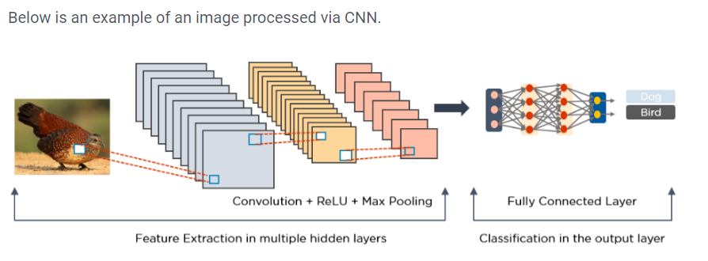
- Long Short Term Memory Networks (LSTMs)
It is a type of Recurrent Neural Network (RNN) that can learn and memorize long-term dependencies. We can use it to recall past information for long periods and retain information over time. It is mainly useful in time-series prediction because they remember previous inputs and have a chain like structure where interacting layers communicate in a unique way. LSTMs are mostly used for speech recognition, music composition, and pharmaceutical development. They forget useless parts of the previous state and they selectively update the cell-state values and finally, the output of certain parts of the cell state. We can use it to keeping the data for long period of time which may be a very useful model in our work.

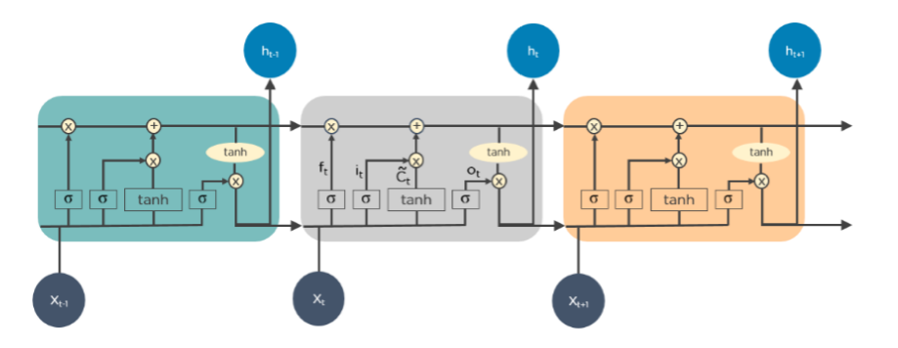
- Recurrent Neural Networks (RNNs)
RNN form directed cycles with the help of connections. Due to its internal memory, the output from the LSTM becomes an input to the current phase and can memorize previous inputs and is mostly used for natural-language processing, handwriting recognition, machine translation, and image captioning and time-series analysis. We can use it in handwritten word image, optimal recognition result is then obtained by integrating the two trained RNN models together with a lexicon.
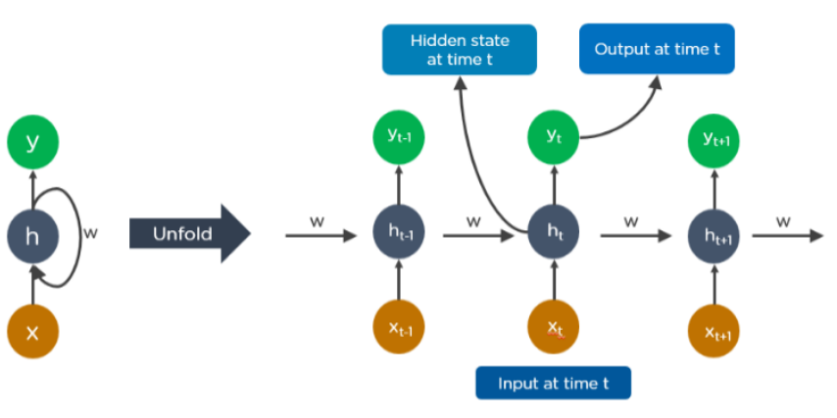

- Generative Adversarial Networks (GANs)
GANs are generative deep learning algorithms that create new instances of data that resemble the training data which contains two components: a generator, which learns to generate fake data, and a discriminator, which learns from that false information. Its usage has increased over a period of time. Mostly they are used to improve simulate gravitational lensing for dark-matter and research astronomical images and video game developers use GANs to upscale low-resolution, 2D textures in old video games by recreating them in 4K or higher resolutions via image training. GANs help generate realistic images and cartoon characters, create photographs of human faces, and render 3D objects. GAN sends the results to the generator and the discriminator to update the model. GAN is useful for translating data from images. For scanned images we can use GAN to get useful data for text recognition purpose.
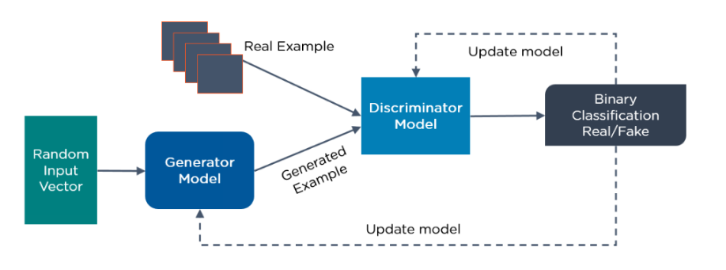
- Radial Basis Function Networks (RBFNs)
RBFNs are special types of feed forward neural networks that use as activation functions for radial basis functions having an input layer, a hidden layer and an output layer and are mostly used for classification, regression and time-series prediction. We can use RBFNs for image normalization. Its structural feature may help us disambiguating confused characters improved the recognition accuracy.
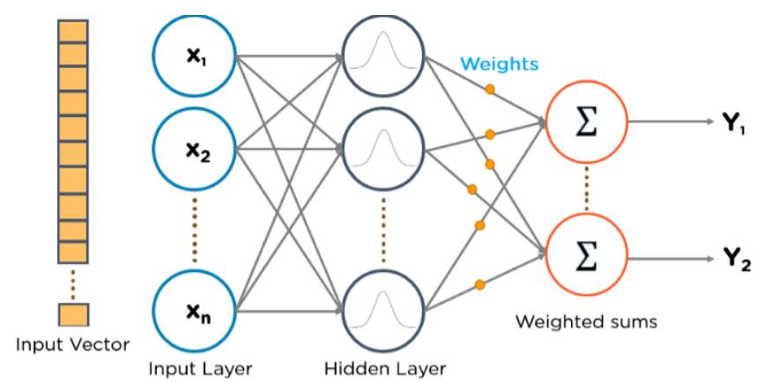
- Auto encoders
Auto encoders are a specific type of feed forward neural network in which the input and output are identical. They are developed in 1980s to solve problems regarding unsupervised learning. They are trained neural networks that replicate the data from the input layer to the output layer. We can use it to encode the image then reduce the input size into smaller representation and then decode the image to generate the reconstructed image. Auto encoders are used for many different purposes such as image processing, popularity prediction and pharmaceutical discovery.
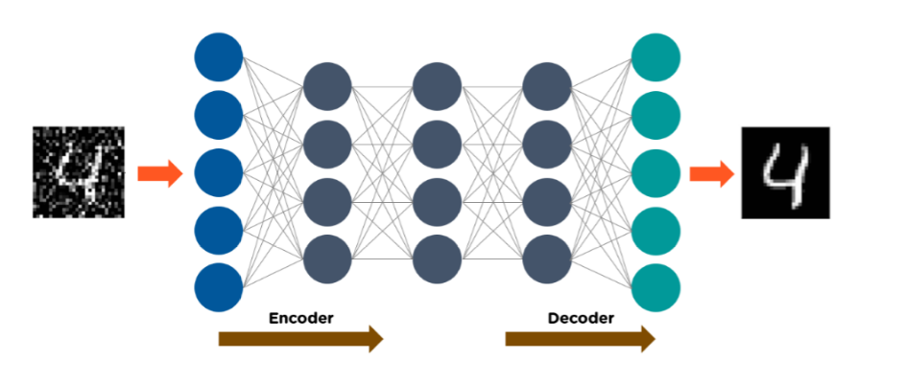
Data Augmentation:
To achieve a best performance, deep learning models usually require a large dataset for training purpose. However in practice, it is expensive and time-consuming to collect high-quality images. Data augmentation is an alternative approach to increase the training set with some image transformation techniques. It shows great improvements for image classification and object detection tasks.
To validate whether data augmentation techniques are useful for Urdu handwritten characters recognition, we will use three data augmentation techniques.
- Rotation: the image is randomly rotated, within a range of -45 to +45 degrees with the center fixed.
- Block Effect: The image is firstly resized into 14×14 to loss some information then to resume the original size, the image is resized back to 28×28.
- Translation: The image is applied with a translation matrix that is randomly selected between -5 to +5 pixels. The original images as well as the generated images after applying these data augmentation techniques on the digits are shown in figure.
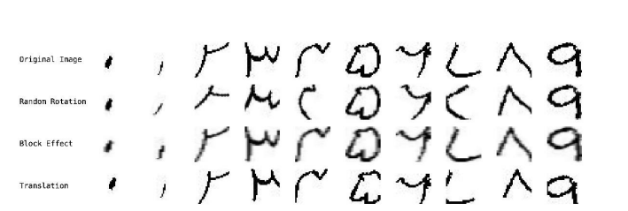
The examples of the data augmentation techniques with digits
Transfer Learning:
When dealing with the small training set, we will use transfer learning. It is when the pre-trained parameters from a larger training dataset.
Evaluation Metrics:
Since the Urdu handwritten text recognition problem is a classification problem, we use accuracy as our major evaluation metrics, which is defined as the percentage of test samples that are correctly classified. Formally, accuracy can be defined as follows:
Accuracy = 𝑇𝑃/ 𝑇𝑃 + 𝑇𝑁
TP means true positive which is the number of samples correctly identified and TN means true negative which is the number of samples incorrectly classified by the model.
Data Collection
In our research, we will try to use a pioneer dataset of Urdu handwritten characters that fills in the gap of a standard dataset for this thesis work and introduces a more diverse range of writing styles, compared to other Urdu-related datasets, e.g., the UCOM dataset. We took a sample dataset consists of digits and characters which is collected from different individuals with different ages from 22 to 60 years and goes through various pre-processing steps, e.g., RGB to grey-scale conversion, noise removal and segmentation. After pre-processing, we will transform images into a data format of 28×28 grey-scale images. And they are further divided into training and test sets. The sample dataset of different digits and characters are shown below

SAMPLE - 1

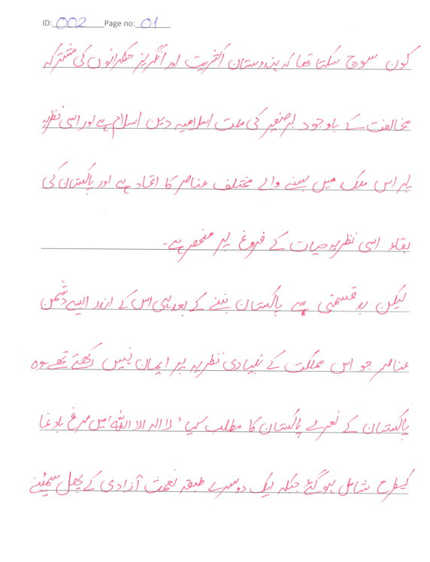

SAMPLE - 2

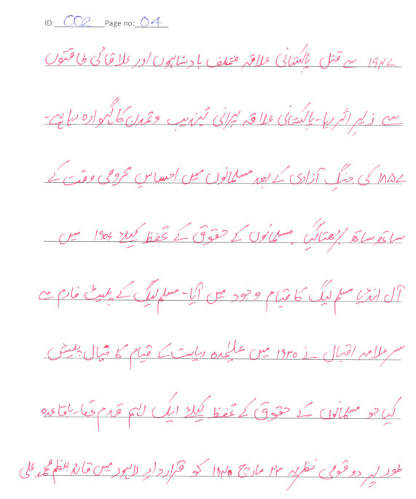
Experiments
We will use Python and its packages of Keras and TensorFlow for the implementation of the deep learning models in Urdu Handwritten Recognition. Another package named OpenCV may also be used to implement the data augmentation techniques. During the training phase, we can also use Adam optimizer for all the models. Adam can be regarded as a combination of RMSprop and stochastic gradient descent with momentum. Compared with other optimizers, Adam has several advantages, e.g., more efficient computation and a lower memory requirement. The model weights with the best validation accuracy are chosen for evaluation on the test set. And to choose these best weights, we may further divide the original training set into training and validation sets with a ratio of 4:1. During all experiments, we may use GeForce RTX 2070 with 8GB RAM or more as our graphical accelerated processing (GPU), for the acceleration of the convolution operations and reduce the training time of deep learning models.

- Bibliography

- Ali, Anjum, Mohmood Ahmad, Nasir Rafiq, Javed Akber, Usman Ahmad, and Shahwar Akmal. "Language independent optical character recognition for hand written text." In 8th International Multitopic Conference, 2004. Proceedings of INMIC 2004., pp. 79-84. IEEE, 2004.
- Shahzad, Nabeel, Brandon Paulson, and Tracy Hammond. "Urdu Qaeda: recognition system for isolated urdu characters." In Proceedings of the IUI Workshop on Sketch Recognition, Sanibel Island, Florida. 2009.
- K. U. Khan and I. Haider, "Online recognition of multi-stroke handwritten Urdu characters," 2010 International Conference on Image Analysis and Signal Processing, 2010, pp. 284-290, doi: 10.1109/IASP.2010.5476113.
- Khan, Kamran Ullah. "Online Urdu handwritten character recognition: Initial half form single stroke characters." In 2014 12th International Conference on Frontiers of Information Technology, pp. 292-297. IEEE, 2014.
- Hassan, Shahbaz, Ayesha Irfan, Ali Mirza, and Imran Siddiqi. "Cursive handwritten text recognition using bi-directional LSTMs: a case study on Urdu handwriting." In 2019 International Conference on Deep Learning and Machine Learning in Emerging Applications (Deep-ML), pp. 67-72. IEEE, 2019.
- Husnain, Mujtaba, Malik Muhammad Saad Missen, Shahzad Mumtaz, Muhammad Zeeshan Jhanidr, Mickaël Coustaty, Muhammad Muzzamil Luqman, Jean-Marc Ogier, and Gyu Sang Choi. "Recognition of Urdu handwritten characters using convolutional neural network." Applied Sciences 9, no. 13 (2019): 2758.
- Ali, Hazrat, Ahsan Ullah, Talha Iqbal, and Shahid Khattak. "Pioneer dataset and automatic recognition of Urdu handwritten characters using a deep autoencoder and convolutional neural network." SN Applied Sciences 2, no. 2 (2020): 1-12.
- Ahlawat, Savita, Amit Choudhary, Anand Nayyar, Saurabh Singh, and Byungun Yoon. "Improved handwritten digit recognition using convolutional neural networks (CNN)." Sensors 20, no. 12 (2020): 3344.
- Akhter, Muhammad Pervez, Zheng Jiangbin, Irfan Raza Naqvi, Mohammed Abdelmajeed, and Muhammad Fayyaz. "Exploring deep learning approaches for Urdu text classification in product manufacturing." Enterprise Information Systems (2020): 1-26.
- Jiang, Weiwei. "Evaluation of deep learning models for Urdu handwritten characters recognition." In Journal of Physics: Conference Series, vol. 1544, no. 1, p. 012016. IOP Publishing, 2020.
- Kashif, Muhammad. "Urdu Handwritten Text Recognition Using ResNet18." arXiv preprint arXiv:2103.05105 (2021).

