**REAL TIME CAR PARKING OCCUPANCY PREDICTION SYSTEM**

**HASSAN ARIF**

**ID : 193880**

**SUPERVISED BY**

**DR. MAZHAR BUKHARI**

**MASTER OF PHILOSOPHY**

**IN**

**COMPUTER SCIENCE**



**THE INSTITUTE OF MANAGEMENT SCIENCES, LAHORE**

**ACKNOWLEDGEMENT**

Foremost acknowledgement is for the Almighty Allah for giving me strength for completing this research work successfully. Further, I offer my appreciations and gratitude to my thesis supervisor Dr. Mazhar Bukhari, my faculty and colleagues who guided me, encouraged me and advised me throughout this research work.

**Abstract**

The rapid urbanization and increasing vehicle numbers in cities have led to a growing challenge of parking space scarcity. Traditional parking management methods struggle to efficiently allocate and monitor parking slots, especially in adverse conditions like poor lighting and occlusions.

Existing parking solutions face limitations in accurately detecting and managing parking occupancy. These limitations impact urban mobility, increase congestion, and result in cost-ineffective practices. There is a need for a comprehensive and technologically advanced system to address these challenges effectively.

This research proposes a robust parking detection system that combines deep learning techniques and a goal-oriented agent. A user-friendly mobile application streamlines parking operations, enhancing user engagement. The system ensures accurate vehicle verification, efficient fee management, real-time slot monitoring, and proactive user communication. It optimizes parking space utilization through strategic slot allocation and reallocation, aided by reminder notifications. This comprehensive approach offers innovative solutions to urban parking challenges, promising improved efficiency and convenience for both users and parking managers.

**Table of Contents**

**1.** **Introduction** 5

1.1 Major Contributions 6

1.2 Research Gap 15

1.3 Problem Statement 20

1.4 Research Questions 20

1.5 Research Objectives 20

1.6 Research Contributions 21

**2. Literature Review** 23

2.1 Revising Deep Learning Methods in Parking Lot Occupancy Detection 23

2.2 Image-Based Parking Space Occupancy Classification 25

2.3 Parking Occupancy Prediction using (CV) with Location Awareness 29

2.4 Smart Vehicle Parking System Using (CV) and (IoT) 32

2.5 Development of Smart Parking Management System 35

2.6 Computer Vision on a Parking Management and Vehicle Inventory 37

2.7 Multi-Angle Parking Detection System using Mask R-CNN 40

**3. Proposed Methodology** 44

3.1 Introduction to Research Methodology 44

3.2 Research Design 46

3.3 System Architecture 51

3.4 Proposed Model 51

3.5 Research Strategy and Approach 54

3.6 Data Collection 55

3.7 Explanatory Data Analysis 57

3.8 Dataset Training 61

**4.** **Results and Discussion** 64

4.1 Datasets 65

4.2 Models 65

4.3 Training Configuration 66

4.4 Evaluation Metric 66

4.5 Cross-Validation 66

4.6 Performance Analysis 66

4.7 ROC Curve 67

4.8 Confusion Matrix 67

**5** **Conclusion and Future Work** 70

5.1 Conclusion 70

5.2 Future Work 71

**6** **References** 74

# **Introduction**

A smart parking system is a sophisticated solution designed to address the persistent issue of parking space scarcity in urban areas. With the ongoing urbanization and the increasing number of vehicles on the roads, finding available parking spaces has become a significant challenge in many cities. This challenge not only leads to frustrating experiences for drivers but also contributes to traffic congestion, increased fuel consumption, and environmental pollution.

In response to these challenges, smart parking systems leverage advanced technology to offer a more efficient and user-friendly parking experience. They typically consist of various components, including sensors strategically placed in parking spaces to detect occupancy in real-time. This information is relayed to a central server or cloud-based platform through wireless communication technologies. User-friendly mobile applications or websites provide drivers with real-time parking information, allowing them to check for available parking spaces, reserve spots in advance, and make electronic payments. Some systems even offer navigation assistance to guide drivers to the nearest available parking spots, reducing search times and frustration.

Smart parking systems streamline the payment process, eliminate the need for physical tickets or cash transactions, and optimize parking space utilization. By doing so, they reduce traffic congestion and greenhouse gas emissions, contributing to improved urban air quality and sustainability. Surveillance cameras are often integrated into these systems to enhance security in parking facilities. Overall, smart parking systems offer a comprehensive solution to the challenges of parking space scarcity, making urban parking hassle-free and environmentally friendly.

## Major Contributions

This research presents a series of significant contributions in the domain of parking occupancy detection and management. First and foremost, it focuses on object and parking occupancy detection, introducing advanced techniques to accurately identify and validate vehicles, particularly cars, as they enter designated parking areas. This precise identification lays the foundation for efficient parking management.

Additionally, the research delves into optimizing techniques for parking slot allocation, enhancing the allocation process to ensure optimal space utilization and efficient parking resource management. By leveraging real-time data and location awareness, the system optimizes parking slot allocation, contributing to improved user experiences and reduced parking search times.

The study also addresses the challenge of optimal detection in diverse visual conditions, acknowledging that parking scenarios can vary significantly in terms of lighting, weather, and occlusions. The research introduces methodologies to enhance detection accuracy across various visual scenarios, ensuring the reliability of the parking occupancy prediction system.

Furthermore, the research advances the field by introducing a real-time automated vehicle parking occupancy detection and navigation system. This system not only detects parking occupancy but also assists drivers in navigating to available parking spots, reducing search times and improving overall parking efficiency.

Lastly, the research introduces a multi-clue recovery model for accurate parking spot detection. By combining multiple data sources and clues, such as license plate information and location awareness, this model enhances the accuracy of parking spot detection, contributing to the effectiveness of the parking management system. These contributions collectively address the complexities of parking space scarcity and aim to provide innovative solutions for urban parking management.

**1.1.1** **Object and** **Parking Occupancy Detection**

(Stojanović, Damjanović, Vukmirović et al., 2021) expresses various methods to address parking space scarcity, including hardware sensors for individual parking spaces and Computer Vision (CV) technology. In this study, the researchers propose an innovative architectural framework that takes advantage of the latest Smart Edge devices equipped with AI accelerators. This integration harnesses the recent advancements in computer vision (CV) algorithms, which have significantly improved precision and efficiency. The primary focus of our proposed approach is the utilization of Edge AI devices to autonomously compute parking occupancy.

By employing Edge AI Camera devices, we unlock capabilities that were once restricted to expensive server-side components. These devices now seamlessly incorporate AI and GPU modules capable of performing trillions of operations per second (TOPS). Furthermore, they offer support for high-resolution image sensors and utilize AI-driven auto-exposure, providing an advanced framework for image capture.

Another groundbreaking aspect of this research is the introduction of the concept of constructing three-dimensional (3D) models of parking environments using data streams from Edge AI cameras. This innovation enables the precise identification of available on-street parking spaces. By creating 3D bounding boxes around detected vehicles significantly enhance tracking accuracy and effectively address complex parking challenges, including occlusions.

The research emphasizes the paramount importance of achieving comprehensive three-dimensional awareness for a deeper understanding of parking spaces and to leverage data fusion from GPS and camera attributes, enabling the calibration of camera orientation and perspective correction. The ultimate goal is to establish a robust platform for 3D environment modeling that greatly enhances prediction accuracy.

In the research by (Stojanović, Damjanović, Vukmirović et al., 2021), several significant limitations and challenges were encountered. These included delays and reduced efficiency in object detection due to a high volume of direct server requests, difficulties in accurate object and license plate detection under varying lighting conditions, the cost-effectiveness of hardware implementations, and the complexities of accurately detecting and reallocating parking spaces. In response, the researchers proposed an innovative solution leveraging Smart Edge devices with AI accelerators to autonomously compute parking occupancy. This approach capitalized on recent advancements in Computer Vision (CV) algorithms, enabling precise parking occupancy prediction. The researchers introduced Edge AI Camera devices with powerful AI and GPU modules, advanced image sensors, and AI-driven auto-exposure, enhancing image capture capabilities. They also innovatively generated 3D models of parking environments using data from Edge AI cameras, improving tracking precision and addressing challenges like occlusions. Moving forward, their focus remains on achieving comprehensive three-dimensional awareness for a deeper understanding of parking spaces by integrating GPS and camera data, calibrating camera orientation, and correcting perspective, ultimately enhancing prediction accuracy.

The Figure 1 shows the research critical challenges in urban parking occupancy detection. Despite facing limitations such as delays in object detection and issues with varying lighting conditions, the study introduced an advanced approach utilizing Smart Edge devices with AI capabilities. By creating 3D models of parking environments and leveraging GPS and camera data, the researchers aimed to enhance prediction accuracy and provide innovative solutions to the persistent problems of parking space scarcity in urban areas, marking a significant contribution to the field.

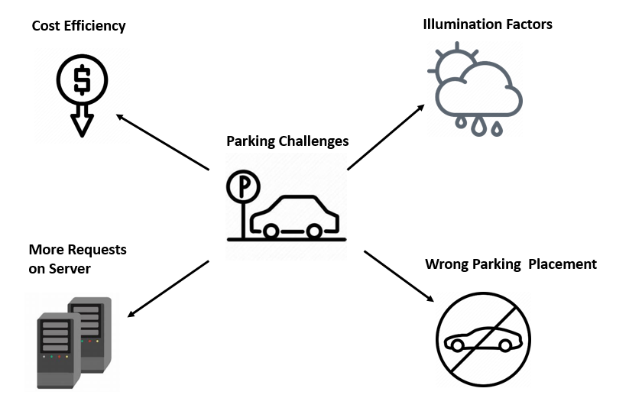

Figure 1. Limitations and Challenges in Parking Occupancy and Object Detection

**1.1.2 Optimize Techniques for Parking Slot Allocation**

The research conducted by (Taylor, Ezekiel, and Emmah in 2021) centers around addressing the critical urban problem of parking space scarcity and the resultant traffic congestion. Their approach leverages cutting-edge methodologies in object detection and predictive modeling to forge innovative solutions for optimize parking management.

A groundbreaking aspect of this research is the pioneering use of state-of-the-art object detection algorithms within the realm of parking management. By harnessing the capabilities of computer vision, these algorithms enable the automatic identification and tracking of vehicles within parking areas, offering a new dimension of efficiency and accuracy.

Through rigorous data collection and analysis, the researchers develop predictive models capable of foreseeing parking space availability. These models amalgamate historical and real-time data, providing valuable insights to drivers and empowering them to make informed parking choices.

Furthermore, the integration of Internet of Things (IoT) devices and edge computing plays a pivotal role in enabling real-time monitoring of parking occupancy. With the deployment of IoT sensors and edge devices, a network is established that continuously tracks and updates parking availability information, significantly benefiting urban mobility by reducing the traffic congestion stemming from drivers' quests for parking spaces.

By delivering precise and real-time information on parking availability, the researcher's work not only alleviates traffic congestion but also contributes to reducing carbon emissions associated with unnecessary vehicle circulation while searching for parking. This environmentally conscious approach aligns with sustainable urban practices.

Moreover, drivers themselves stand to gain from data-backed guidance, ultimately leading to improved parking experiences and a reduction in frustration.

This research not only addresses immediate challenges but also lays the groundwork for future advancements. The findings hold great potential for integration into broader smart city initiatives, enhancing overall urban efficiency. Additionally, the research extends its relevance to intelligent traffic management systems, with the potential to optimize vehicle flow within urban areas. In essence, this research makes a significant contribution to the ongoing transformation of urban environments towards smarter and more sustainable futures.

The research focuses specifically on closed deterministic parking environments, such as malls, hospitals, and residential complexes. These scenarios are chosen due to their unique security and environmental considerations, making them suitable for the proposed integrated solution. The research will employ a combination of theoretical analysis, algorithm development, experimentation, and case studies to achieve the research objectives.

The research endeavors encompass a multi-faceted exploration, aiming to provide a comprehensive integrated solution that optimizes parking slot allocation and management within the confines of closed deterministic environments. This initiative extends its scope to encompass insights into the intricate technical challenges associated with the seamless integration of advanced image processing techniques, Internet of Things (IoT) technology, and cloud-based solutions. By delving into these complexities, the research seeks to enhance our understanding of the potential impact of the proposed solution. This includes its capacity to not only enhance parking slot allocation precision but also to significantly reduce waiting times, elevate overall user satisfaction, and effectively harness parking space utilization. The synthesis of these facets endeavors to create a holistic approach that not only addresses the technical intricacies but also empowers urban environments to achieve efficient and user-centric parking management systems.

The research conducted by (Taylor, Ezekiel, and Emmah in 2021) addresses the critical challenge of parking space scarcity in closed deterministic environments by integrating cutting-edge image processing techniques, IoT technology, and cloud-based solutions. This holistic approach aims to optimize parking slot allocation and management, ultimately enhancing the user experience and contributing to more efficient urban environments. The central research problem revolves around mitigating parking space scarcity challenges through advanced image processing, IoT, and cloud solutions, with the goal of improving parking management, alleviating traffic congestion, and fostering user-centric parking solutions. The researchers pioneer the use of object detection algorithms for vehicle identification and tracking within parking areas. Predictive models are developed to anticipate parking space availability by integrating historical and real-time data, providing valuable insights to drivers and reducing traffic congestion. IoT sensors and edge computing enable real-time monitoring of parking occupancy, further enhancing urban mobility and decreasing carbon emissions. This research not only addresses immediate challenges but also lays the groundwork for broader smart city initiatives and intelligent traffic management systems, ultimately enhancing urban efficiency and user experiences as shown in Figure 2.

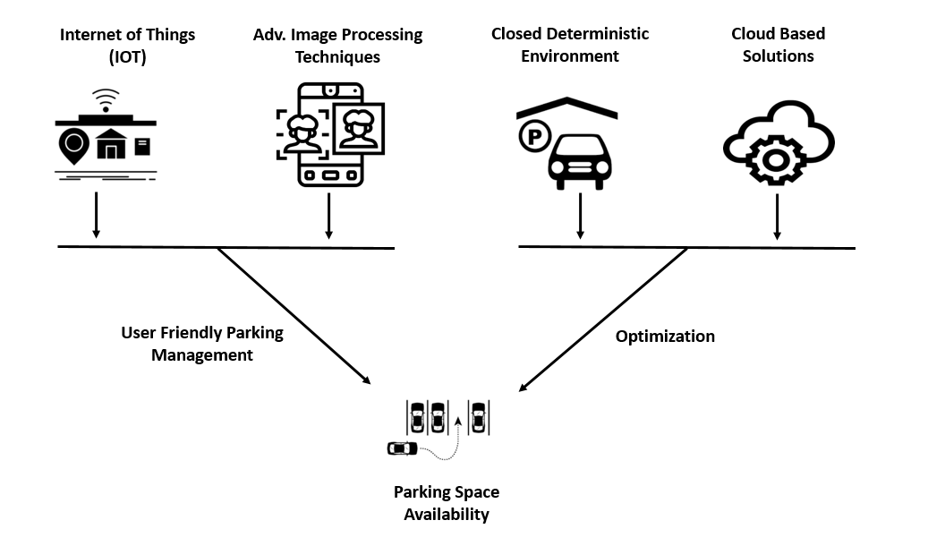

Figure 2. Advance Techniques to optimize parking slot Allocation

**1.1.3 Optimal Detection in Visual Conditions**

(Martynova, Kuznetsov, Porvatov, & Tishin, 2023) The comprehensive objectives of this research are centered around evaluating and analyzing the strengths and weaknesses of various state-of-the-art deep learning architectures, specifically vision transformers and convolutional neural networks (CNNs), within the context of parking lot occupancy detection. The research aims to conduct an in-depth exploration of these architectures to gain insights into their performance characteristics, advantages, and limitations when applied to the challenging task of detecting parking space occupancy.

The primary objective is to systematically compare the performance of vision transformers and CNNs for parking lot occupancy detection. This involves designing rigorous experiments to quantify the accuracy, efficiency, and adaptability of each architecture under diverse visual conditions, including poor lighting, occlusions, and different weather scenarios. By meticulously assessing the strengths and weaknesses of these architectures, the research intends to provide a comprehensive understanding of how they handle challenging real-world scenarios.

Furthermore, the research aims to identify the optimal architecture that aligns with the specific requirements of parking lot occupancy detection. Through a meticulous analysis of the experimental results, the research aims to determine which architecture exhibits superior accuracy, robustness, and generalization capabilities. These findings will guide the selection of the most suitable deep learning architecture to be employed in the proposed algorithm, ensuring that the chosen architecture can effectively address the challenges associated with parking lot occupancy detection in adverse visual conditions.

The research aims to contribute valuable insights into the selection of deep learning architectures for parking lot occupancy detection. The results of this analysis will not only guide the development of the proposed algorithm but also provide a broader understanding of the applicability and limitations of different architectures in the context of computer vision tasks. As shown in Figure 3, the research aims to advance the state-of-the-art in parking lot occupancy detection by leveraging the strengths of deep learning architectures to enhance accuracy and efficiency while mitigating the impact of challenging visual conditions.

(Martynova, Kuznetsov, Porvatov, & Tishin, 2023) have made substantial contributions to the field of parking lot occupancy detection while encountering inherent challenges and limitations. The study addressed the limitations of existing algorithms in parking lot occupancy detection, although it acknowledged that some limitations in the selected algorithms might persist. Despite the creation of the commendable Seasonal Parking Lot (SPKL) dataset, there may still be limitations in terms of real-world diversity and scale, considering the potential introduction of biases during dataset creation.

Efforts to enhance the usability of existing datasets, including augmentation and standardization, were valuable but might not entirely eliminate biases or limitations inherent in the original datasets. While the proposal of a novel approach using the EfficientNet architecture represents a significant achievement, it's essential to recognize that no single approach is universally optimal, and limitations may exist in specific scenarios.

The comprehensive computational experiments conducted in the research provided valuable insights into different methodologies, datasets, and scenarios. However, it's worth noting that unexplored methodologies or datasets might impact results and conclusions. Additionally, the effectiveness of optimization techniques can vary across different datasets and scenarios, with some techniques having limitations or trade-offs that should be considered.

While the research successfully addressed several challenges and limitations in parking lot occupancy detection, it's crucial to maintain humility and acknowledge the potential existence of unknown limitations in this complex and evolving field.

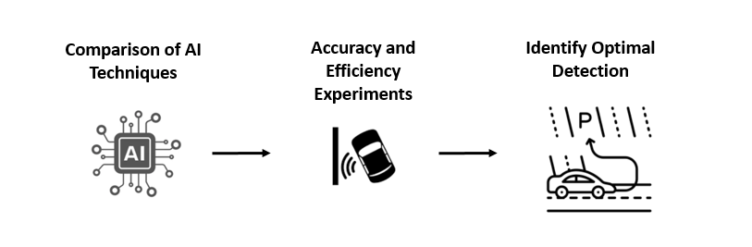

Figure 3. Optimal Detection in Visual Conditions

**1.1.4 Real-Time Automated Vehicle Parking Occupancy Detection and Navigation**

(Padmasiri, Madurawe, Abeysinghe et al., 2020) made several notable contributions to the field of automated vehicle parking occupancy detection. Firstly, their work presented the development of an end-to-end automated vehicle parking occupancy detection system designed to operate in real-time using surveillance streams. This system aims to efficiently guide drivers to available parking spaces, reducing time and energy expenditure. Secondly, the study introduced the application of advanced object detection techniques, specifically RetinaNet and Faster R-CNN, to accurately identify parking spaces under varying conditions. These techniques enhance the system's ability to detect both occupied and unoccupied parking spaces. Additionally, the proposed system adopted a modular software architecture with microservices, offering scalability and resilience while minimizing installation and maintenance costs. Lastly, the development of web and mobile applications as client interfaces enables users to locate parking spaces effortlessly. Most importantly, the approach eliminated the need for manual segmentation of video streams, making it adaptable and cost-effective for deployment across different parking lots.

Several challenges and areas for improvement are evident in this study. Firstly, the limitations of the dataset used are acknowledged, and the system's performance could benefit from a fully annotated dataset. Future work should consider training on one parking lot and testing on another to provide more representative results. Secondly, the system has not been tested during night-time due to the absence of a supportive dataset. Further research is needed to adapt the system for night-time operation, expanding its applicability. Additionally, while the system excels at detecting occupied parking spaces, there is room for improvement in accurately detecting unoccupied spaces, especially in scenarios involving stray vehicles. To enhance real-world accuracy, the system could be improved by allowing users to manually enter the total number of parking spaces, enabling it to calculate unoccupied spaces based on detected occupied spaces as shown in Figure 4. The study also discusses a comparison with existing approaches, highlighting its advantages, but it should consider further benchmarking against other systems. Lastly, the adaptability of the system to different parking space configurations and camera angles may require additional research and development to ensure its effectiveness across a wide range of scenarios.

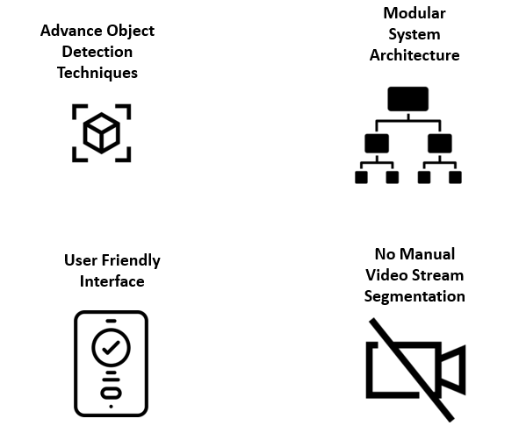

Figure 4. Innovative Approaches to Real-Time Automated Vehicle Parking Occupancy Detection and Navigation

**1.1.5 Multi-Clue Recovery Model for Accurate Parking Spot Detection**

This research makes several significant contributions to the field of automated parking spot detection (Chen, Qiu, Sheng et al., 2021). First and foremost, it introduces a novel Generative Parking Spot Detection (GPSD) algorithm that utilizes a multi-clue recovery model to effectively reconstruct parking spots. Unlike conventional methods, GPSD emphasizes the use of corners as fundamental components of parking spots, resulting in highly accurate detection and recovery.

Furthermore, the paper addresses the challenge of unbalanced illumination, partial information loss, and varying definitions of parking spot lines in input images by proposing a Layered Analytical Illumination Balance (LAIB) method for image preprocessing. This approach significantly improves the robustness of the algorithm under diverse lighting conditions.

The research also presents a Fast Micro-Target Detection (FMTD) algorithm, which prioritizes corner detection over traditional object classification methods. By doing so, it simplifies the training process while enhancing overall detection accuracy, particularly in scenarios involving complex parking spot shapes.

To correct and accurately locate parking spots, the paper introduces a multi-clue recovery model that leverages sideline, occlusion, edge, and domain clues. This comprehensive approach effectively addresses the issue of parking spot deformation, further improving the algorithm's performance.

Extensive experimental validation is conducted using datasets, including HERV 2018 and HERV 2019, demonstrating the superiority of the proposed algorithms. These experiments showcase exceptional results in corner detection, parking spot location, and overall detection quality, underscoring the contributions of this research.

While the proposed GPSD algorithm excels in many aspects, it remains sensitive to parking spot deformation (Chen, Qiu, Sheng et al., 2021). Irregularly shaped or distorted parking spots pose a challenge that requires further investigation and refinement of the algorithm.

Another limitation is the relatively small size of the datasets used for validation, such as HERV 2018 and HERV 2019. These datasets may not encompass the full spectrum of parking scenarios, indicating the need for expanding the dataset to include a wider variety of scenes and environmental conditions. This expansion could provide a more comprehensive evaluation of the algorithm's performance.

The paper introduces an illumination balance method as shown in Figure 5 to address varying lighting conditions. However, it may still encounter difficulties in extreme or rapidly changing illumination environments, suggesting the necessity for additional improvements and robustness enhancements.

The research focuses on algorithm development and validation but does not delve into real-time implementation aspects. Deploying these algorithms in real-world scenarios, particularly in applications like autonomous vehicles, could introduce additional challenges related to computational efficiency and latency, which require further exploration.

Lastly, the generalization of the proposed GPSD algorithm to detect parking spots beyond common parallelogram layouts or in non-standard configurations remains an open question and an avenue for future research.

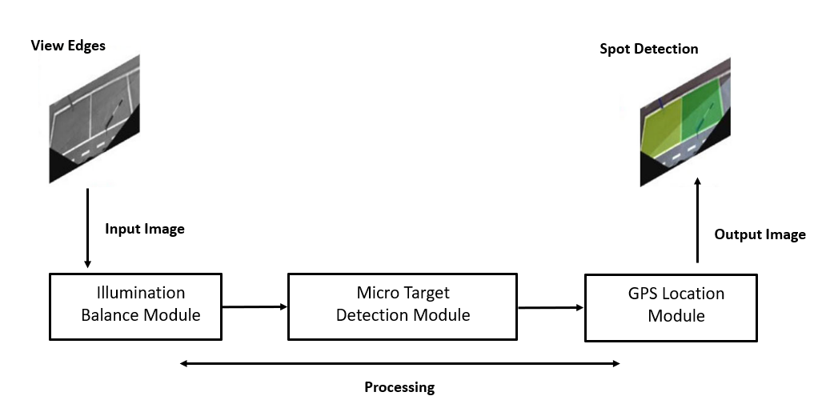

Figure 5. Multi-Clue Recovery Model for Accurate Parking Spot Detection

## 1.2 Research Gap

The research gap evolving nature of parking lot occupancy detection solutions and the imperative to address the complexities of real-world parking scenarios. While recent studies have made significant strides in harnessing deep learning architectures for enhanced accuracy, there's a crucial gap in effectively handling the wide spectrum of diverse and challenging conditions that parking lots present. The current models, while proficient under favorable conditions, demonstrate limitations in adapting to adverse factors like poor lighting, occlusions, and varying weather conditions. This gap indicates the pressing need for research endeavors that prioritize bolstering the resilience and adaptability of these models. Bridging this gap requires innovative strategies that empower models to perform with consistency and accuracy regardless of the visual hindrances encountered. The integration of multi-angle detection strategies, as demonstrated in the research by (Martynova, Kuznetsov, Porvatov et al., 2023), introduces a promising approach. However, a considerable gap exists in the development of a seamlessly integrated system that dynamically selects the appropriate angle for detection based on contextual cues. Efforts to bridge this gap would entail crafting algorithms that not only identify the optimal angle for detection but also transition between angles in real-time to enhance the precision and efficiency of parking detection algorithms.

Real-time data processing is another area where the gap demands attention. Urban areas experience rapid fluctuations in parking demand, necessitating swift and accurate data processing and decision-making. The existing algorithms might struggle with processing large volumes of data and making informed decisions promptly. Closing this gap would entail the innovation of advanced algorithms and hardware acceleration techniques capable of processing real-time data efficiently. This enhancement would facilitate timely updates of parking availability information to drivers and stakeholders, contributing to a more responsive and effective parking management system.

Intelligent parking allocation remains a gap in the current research landscape. Beyond mere detection, there is a need to optimize how parking spaces are assigned to improve user experience and alleviate congestion. Addressing this gap involves leveraging machine learning to create allocation algorithms that consider user preferences, proximity to destinations, and available parking types. These algorithms could dynamically assign spaces to optimize overall traffic flow and reduce drivers' search time. This advancement would significantly enhance the efficiency and user-friendliness of urban parking systems.

Lastly, there is a noticeable gap in integrating parking solutions with broader urban planning strategies. While the technical aspects have received considerable attention, seamlessly weaving parking management systems into comprehensive city-wide mobility strategies remains an unexplored territory. Bridging this gap necessitates frameworks that align parking solutions with urban development plans, traffic patterns, and sustainability goals. Such integration could lead to more holistic, effective solutions that address urban mobility challenges in a well-rounded manner. In summary, these research gaps underscore the evolving nature of parking management and the potential for innovative solutions to revolutionize urban mobility.

* + 1. **Diverse and Challenging Parking Lot Scenarios**

The research conducted by (Marek & Martin, 2021) has significantly advanced the field of parking lot occupancy detection using deep learning models. However, a critical gap persists in effectively addressing the wide spectrum of diverse and challenging parking lot scenarios that are inherent to real-world environments. While these models excel under optimal conditions, they struggle when confronted with poor lighting, occlusions from surrounding objects, and a variety of weather conditions. To bridge this gap, future research needs to delve into the development of models that exhibit enhanced robustness and adaptability. This endeavor aims to ensure consistent and accurate performance irrespective of the complex and unpredictable environmental challenges that may arise. This entails a profound focus on refining models to adeptly handle scenarios of low visibility and effectively differentiate between occupied and unoccupied parking spaces even within the context of challenging visual conditions as shown in Figure 6.

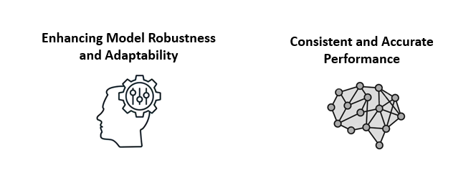

Figure 6. Challenges of Parking Lot Scenarios

* + 1. **Integration of Multi-Angle Detection**

The exploration of multi-angle parking detection, as demonstrated by (Martynova, Kuznetsov, Porvatov et al., 2023), introduces a promising avenue to heighten accuracy by detecting parking spaces from both overhead and low angles. Nonetheless, a gap exists in creating a seamlessly integrated system that can dynamically shift between these different angles based on contextual factors. Pioneering this integration would involve designing an intelligent system that not only identifies the most suitable angle for detection but also fluidly transitions between angles in real-time. This advancement would substantially amplify the efficiency and precision of parking detection algorithms. Successfully bridging this gap mandates the formulation of algorithms that adeptly account for real-time camera positioning, dynamic object tracking, and the capacity to adapt to instantaneous changes within the parking lot environment as shown in Figure 7.

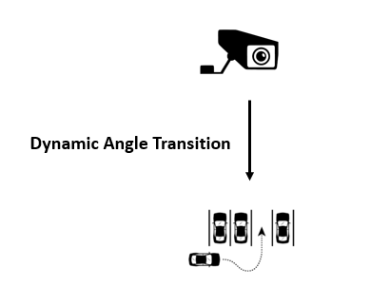

Figure 7. Challenges of Multi-Angle Parking Detection

* + 1. **Real-Time Data Processing and Decision-Making**

The research conducted by (Sudhakar, Reddy, Mounika et al., 2021) accentuates the vital role of real-time data processing within smart parking management systems. However, a critical gap persists in optimizing the speed and efficacy of data processing as shown in Figure 8, particularly in the face of swift changes in parking demand that urban locales experience. Existing algorithms might face challenges in efficiently managing the substantial influx of data and making swift yet precise decisions. Closing this gap necessitates the development of cutting-edge algorithms and hardware acceleration techniques that can efficiently process substantial data volumes in real-time. This, in turn, facilitates the prompt dissemination of up-to-date parking availability information to both drivers and pertinent stakeholders.

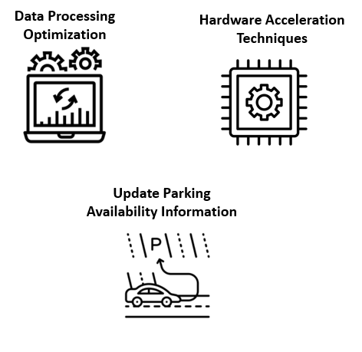

Figure 8. Challenges in Real Time Data Processing and Decisoin Making in Parking Systems

* + 1. **Intelligent Parking Allocation**

The research conducted by (Taylor, Ezekiel, & Emmah, 2021) has a diverse research effort emphasize parking detection but a gap remains in the development of intelligent algorithms to optimize parking space allocation. Beyond the identification of vacant spaces, optimizing the way these spaces are assigned can tangibly elevate user experiences and alleviate traffic congestion. Attending to this gap involves harnessing the potential of machine learning techniques to devise allocation algorithms that factor in user preferences, proximity to destinations, and the variety of available parking options. These algorithms would dynamically allocate spaces to optimize overall traffic flow and curtail the time drivers expend in search of suitable parking spots. In effect, this strives to make urban parking systems not only more efficient but also remarkably user centric as shown in Figure 9.

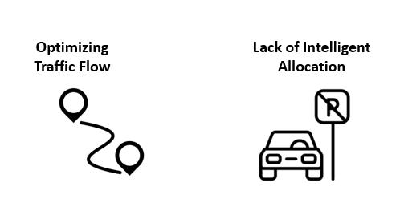

Figure 9. Challenges in Dynamic Parking Allocation

* + 1. **Long-Term System Sustainability**

The integration of Edge AI camera devices, as explored by (Stojanović, Damjanović, Vukmirović et al., 2021), has unveiled the realm of real-time parking occupancy detection. However, a gap endures in addressing the long-term sustainability of such systems. Given the perpetual operation of these devices, factors such as maintenance, energy efficiency, and scalability are of paramount significance. To attend to this gap, it becomes imperative to conceive energy-efficient hardware solutions, implement remote monitoring mechanisms, and outline maintenance strategies that secure the longevity and cost-effectiveness of smart parking systems. This focus on sustainability serves as a linchpin in upholding the reliability and economic viability of these systems over extended durations as shown in Figure 10.



Figure 10. Challenges of Long-Term System Sustainability in Parking Systems

## 1.3 Problem Statement

Urban parking poses challenges due to a growing number of vehicles and limited space. Existing methods face difficulties, especially in adverse conditions like poor lighting and occlusions, impacting object detection and cost efficiency. This research aims to develop a robust parking detection system for diverse environments, enhancing object detection accuracy, optimizing urban mobility, reducing congestion, and ensuring cost-effective solutions.

## 1.4 Research Questions

**1.4.1** How can deep learning improve parking lot occupancy detection in challenging visual conditions?

**1.4.2** How do integrated technologies enhance the Smart Parking Management System to address urban parking challenges efficiently and cost-effectively?

**1.4.3** How can the client application improve slot allocation?

## 1.5 Research Objectives

**1.5.1** To enhance real-world parking space detection systems, improve urban mobility, and optimize deep learning models for more accurate parking lot occupancy detection in challenging visual conditions.

**1.5.2** This study assesses the integration of image processing, IoT technology, cloud-based solutions, and advanced object detection techniques in the Smart Parking Management System, aiming to enhance system effectiveness, user-friendliness, cost-efficiency, and urban parking challenge resolution.

**1.5.3** This research investigates how a client application enhances dynamic slot allocation in parking management systems, focusing on its efficiency, user satisfaction, and data-driven decision-making mechanisms.

## 1.6 Research Contributions

* This research tackles the pressing issue of parking space scarcity in urban areas as vehicle numbers continue to rise.
* The study combines image processing techniques and deep learning technology to optimize parking slot allocation and management.
* The primary contribution is a holistic solution for deep leaning techniques with a goal-oriented agent for predicting parking occupancy.
* An essential part of the solution is a user-friendly mobile application that streamlines various parking operations and enhances user engagement.
* The research unifies object detection, agent monitoring, and parking slot allocation into a comprehensive system architecture, leveraging technologies like Python, Keras, TensorFlow, and GPU resources for effective implementation.
* Through dynamic slot allocation and reallocation, the system ensures optimal space utilization, reducing congestion and enhancing parking efficiency.

The research methodology comprises a series of interconnected modules, each playing a vital role in achieving a holistic solution. These modules collectively tackle the complexities associated with parking occupancy prediction and streamlined parking management as shown in Figure 11.

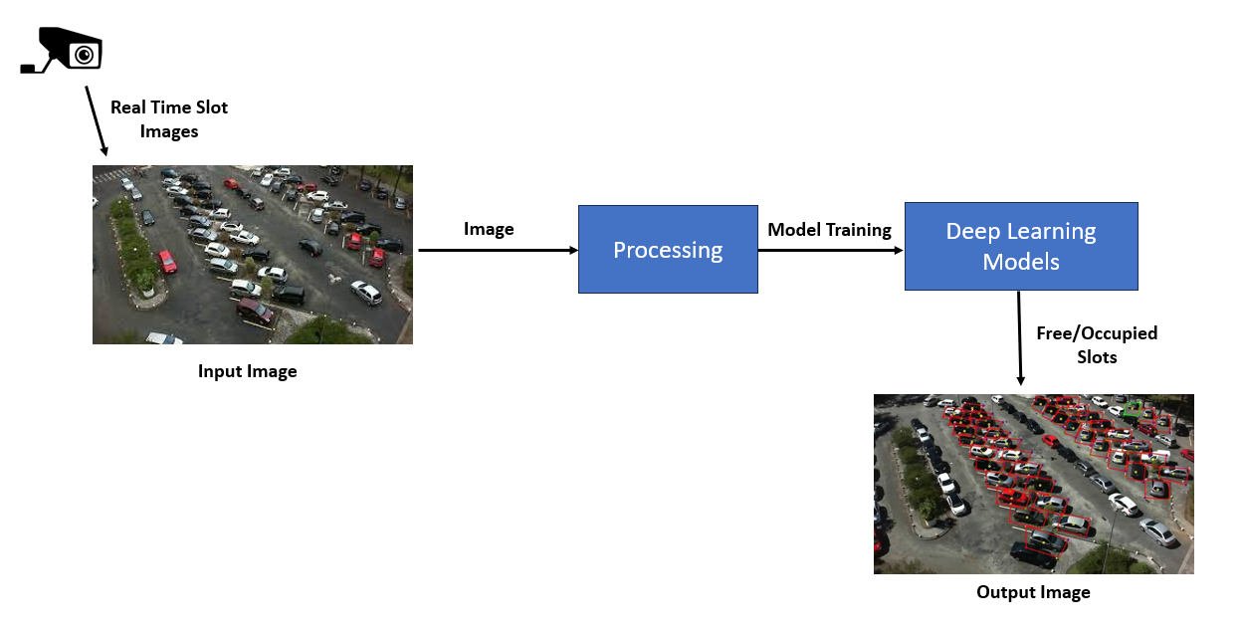

Figure 11. Parking Slot Detection

# **2. Literature Review**

## 2.1 Revising Deep Learning Methods in Parking Lot Occupancy Detection

Parking lot occupancy detection is a crucial aspect of smart city development, aiming to enhance urban mobility and alleviate traffic congestion. Over time, researchers have explored various algorithms to achieve accurate and efficient detection of available parking spaces, with a recent focus on computer vision techniques, particularly those based on neural networks. Classical approaches heavily relied on handcrafted features and traditional machine learning methods, utilizing image processing, edge detection, and template matching. However, their limited adaptability to diverse real-world visual conditions led to the emergence of deep learning-based methods.

Convolutional Neural Networks (CNNs) revolutionized the field, showing significant improvements over classical approaches in parking lot occupancy detection. Various CNN architectures, such as VGG, ResNet, and MobileNet, have been employed for feature extraction and image classification tasks in this domain. Despite these advancements, challenges persist in terms of generalization, as many deep learning models lack robustness when facing diverse visual conditions not represented in their training datasets.

Recently, Vision Transformers (ViTs) have emerged as a promising architecture to address the generalization issue. By utilizing self-attention mechanisms, ViTs capture global context and long-range dependencies in images, making them more adaptable to varying visual conditions. This ability has shown promise in enhancing parking space detection across different environments (Martynova, Kuznetsov, Porvatov, & Tishin, 2023).

The importance of diverse and large-scale datasets has been highlighted in the literature, as they play a crucial role in training and evaluating parking lot occupancy detection models. Existing datasets, such as PKLot, ACMPS, CNRPark, and ACPDS, have been valuable for benchmarking purposes. However, they often lack comprehensive representation of real-world visual variations like winter weather, glare, fog, and diverse occlusions. To address this limitation, recent efforts have introduced datasets like SPKL, encompassing a broader range of visual conditions. The availability of diverse datasets enables a more comprehensive evaluation of algorithms and fosters the development of robust models.

In conclusion, parking lot occupancy detection algorithms have evolved from classical methods to deep learning-based approaches, and more recently, the exploration of Vision Transformers. While deep learning has shown remarkable progress, challenges related to generalization persist. Addressing these challenges and emphasizing diverse datasets for evaluation will be critical in developing accurate and adaptable parking lot occupancy detection algorithms, contributing significantly to smart city initiatives by improving urban mobility and traffic management.

Image preprocessing plays a vital role in training machine learning models, especially in computer vision tasks. One common technique is data augmentation, which involves generating altered versions of input images to provide more diverse training data without the need for additional labeling efforts. Augmentation techniques include image flipping, random cropping, translation, rotation, and noise injection (Nanni et al., 2021; Shorten and Khoshgoftaar, 2019). These operations help prevent models from memorizing specific pixel arrangements and promote generalization, thus enhancing the robustness of parking lot occupancy detection algorithms.

Patch-based methods constitute a prevalent approach in parking lot occupancy detection. These methods involve cropping specific regions from the input image, typically corresponding to individual parking lots, and applying binary classifiers to determine occupancy status. Various convolutional neural network (CNN) architectures have been explored in this context, such as AlexNet, mAlexNet, CarNet, VGG, ResNet, and EfficientNet (Krizhevsky et al., 2012; Amato et al., 2016; Nurullayev and Lee, 2019; Simonyan and Zisserman, 2015; He et al., 2016; Tan and Le, 2019). Each architecture offers unique features and depths, with EfficientNet and vision transformers showing promise in achieving competitive performance (Ha et al., 2020; Shah et al., 2022; Wang et al., 2022).

EfficientNet, developed through neural architecture search, employs a scaling method to uniformly adjust depth, width, and resolution using a compound coefficient. This approach demonstrates remarkable generalization ability, suggesting its potential for efficient parking lot occupancy detection systems.

On the other hand, intersection-based methods take a different approach, relying on object detection models as the initial step in the classification pipeline. Examples of such models include Faster R-CNN and RetinaNet (Ren et al., 2015; Lin et al., 2017). These models detect vehicle bounding boxes and assess parking lot occupancy based on the intersection area between the detected vehicles and parking spaces, using a predefined threshold.

Faster R-CNN, a classic two-stage detection algorithm, utilizes a region proposal network to simplify the generation of object proposals. On the other hand, RetinaNet is a one-stage object detection model that employs a focal loss function to handle imbalanced samples effectively. Both approaches show promise in improving parking lot occupancy detection, but they are currently underrepresented compared to patch-based methods.

This literature review provides valuable insights into deep learning methods for parking lot occupancy detection. Patch-based approaches using CNN architectures like AlexNet, VGG, and EfficientNet have been extensively studied and applied. Intersection-based methods, represented by Faster R-CNN and RetinaNet, show potential but require further exploration. Future research can focus on investigating the efficacy of vision transformers and exploring intersection-based techniques to improve the accuracy and efficiency of parking lot occupancy detection systems in various real-world applications. Continued advancements in these methods will contribute to more effective parking management solutions, benefiting urban planning, traffic flow, and overall transportation efficiency.

## 2.2 Image-Based Parking Space Occupancy Classification

(Marek & Martin, 2021) presents a comprehensive study on image-based parking space occupancy classification. The primary focus of this research is to introduce a new dataset, Action-Camera Parking Dataset (ACPDS), specifically designed to improve and accurately test model performance on previously unseen parking lots. The need for such datasets arises due to the growing importance of real-time parking space occupancy information in optimizing traffic flow, reducing congestion, emissions, and enhancing overall efficiency in urban parking management.

The paper begins by discussing the two common approaches to monitor parking space occupancy: installing sensors on each parking space or using cameras to monitor multiple spaces simultaneously. Camera-based approaches offer cost advantages, and for this study, the authors focus solely on image-based models. They elaborate on the benefits of capturing images rather than live videos, such as better color reproduction in low-light conditions, reduced data flow, and immediate recovery from camera feed failures. Moreover, images are easier to capture and annotate, which is crucial in building a robust dataset.

The authors then delve into existing works on camera-based parking space occupancy classification, which generally rely on large but generic object-detection datasets or limited application-specific datasets for training. These models are evaluated on separate datasets containing unseen parking lots to assess model generalization. The paper highlights the limitation of not directly testing model generalization using separate parking lots, which makes it difficult to determine the true accuracy of the models.

To address these limitations, the researchers introduce the ACPDS dataset. They emphasize its uniqueness, with each image captured from a unique view and systematically annotated using precise quadrilateral annotations for each parking space. The dataset contains over 11,000 unique parking space annotations across various parking lots and streets, and each set (train, validation, and test) consists of separate parking lots, ensuring accurate assessment of model generalization. The authors believe this dataset will facilitate better model development and benchmarking, leading to improvements in parking space occupancy classification.

Next, the paper proposes two custom models for parking space occupancy classification based on the R-CNN and Faster R-CNN FPN architectures. Both models are inspired by two-stage object detectors, and their designs leverage the precise parking space annotations in ACPDS. The R-CNN-based model uses image patches directly pooled from the image, followed by binary classification using a ResNet50 backbone. In contrast, the Faster R-CNN FPN-based model employs a feature pyramid network to pool features corresponding to each parking space and subsequently classifies them using a classification head.

The annotation process for ACPDS involves labeling each parking space with a quadrilateral, aligned with the edges of the parking space. The authors describe the challenges faced during annotation, particularly when dealing with occlusions and limited visibility of parking spaces. Despite these challenges, the authors ensured that each annotation was carefully validated to provide precise and reliable data for model training and evaluation.

The dataset's size and diversity are highlighted, with 293 images containing over 11,000 unique parking space views across different parking lots and streets. The authors emphasize that the dataset includes both occupied and unoccupied parking spaces and exhibits varied weather and lighting conditions, making it a challenging and realistic dataset for parking space occupancy classification.

The paper then presents the training details for the proposed models, including hyperparameter configurations, optimization algorithms, and data augmentation techniques. The models are trained on the ACPDS dataset with different resolutions, and the authors compare their performance based on validation accuracy. They identify the most suitable configurations and discuss the models' inference times, which are crucial for real-world deployment.

Finally, the research concludes by emphasizing the practicality of their R-CNN-based model for real-world deployment due to its flexibility in handling different input resolutions. The authors acknowledge the limitations and challenges in their dataset and encourage researchers to utilize ACPDS for benchmarking and further improvements in parking space occupancy classification research.

This research paper presents a well-structured and detailed study on image-based parking space occupancy classification. By introducing the ACPDS dataset and proposing custom models, the authors aim to enhance the field's progress and contribute to more efficient parking management systems and improved driver navigation in urban areas.

Parking occupancy detection is a critical component in managing urban traffic and parking systems (Acharya et al., 2018). Deep learning methods have shown great promise in this domain due to their ability to process complex visual data efficiently (Amato et al., 2017). Acharya et al. (2018) proposed a real-time image-based parking occupancy detection system using deep learning. They utilized a convolutional neural network (CNN) architecture for accurate and efficient parking slot occupancy detection.

In decentralized parking environments, it is crucial to have a reliable parking lot occupancy detection system to manage parking space efficiently (Amato et al., 2017). Amato et al. (2017) presented a deep learning-based approach for decentralized parking lot occupancy detection. They employed deep learning techniques to analyze data from multiple parking lots and achieved promising results.

Real-time tracking is another essential component in parking occupancy detection systems (Bewley et al., 2016). Bewley et al. (2016) proposed a simple online and real-time tracking method suitable for various applications, including parking lot surveillance. Their method can efficiently track objects in real-time, making it suitable for parking occupancy detection systems.

Video-based parking measurement systems are gaining popularity due to their accuracy and real-time capabilities (Cai et al., 2019). Cai et al. (2019) developed a deep learning-based video system for accurate and real-time parking measurement. Their system utilized deep learning algorithms to process video data and achieve precise parking measurements in real-time.

Transformers have shown significant advancements in various computer vision tasks, including object detection (Carion et al., 2020). Carion et al. (2020) introduced an end-to-end object detection approach with transformers. This method achieved state-of-the-art results in object detection tasks, which can be potentially applied to parking slot detection and occupancy estimation.

To address the need for robust datasets in parking lot classification, Almeida et al. (2015) introduced the PKLot dataset. The PKLot dataset is a robust dataset specifically designed for parking lot classification and has been widely used for training and evaluating parking occupancy detection models.

Large-scale hierarchical image databases like ImageNet have been instrumental in advancing deep learning models for various visual recognition tasks (Deng et al., 2009). ImageNet provides a vast collection of labeled images, which has been valuable in training deep learning models for object detection and classification.

Feature pyramid networks (FPN) have been employed to enhance object detection accuracy by capturing multi-scale features (Lin et al., 2017). FPN architecture has been successfully integrated with various object detection systems and can be utilized to improve the performance of parking occupancy detection models (Lin et al., 2017).

In low-light conditions, burst photography techniques have been employed to capture high dynamic range images (Hasinoff et al., 2016). These techniques can be applied in parking surveillance to improve visibility and enhance the accuracy of parking occupancy detection systems.

Mask R-CNN is a popular framework that integrates object detection with instance segmentation (He et al., 2020). It can accurately detect objects and classify them into specific categories. Mask R-CNN has been employed in various computer vision applications and has the potential to enhance parking occupancy detection systems.

Deep residual learning, introduced by He et al. (2016), has significantly improved the performance of deep neural networks in image recognition tasks. It allows training deeper networks and has been instrumental in advancing the capabilities of object detection models.

Drone-based object counting using spatially regularized regional proposal networks has shown promise in counting objects efficiently (Hsieh et al., 2017). This approach can be adapted to count occupied parking spaces from aerial footage, providing valuable information for parking occupancy detection.

Edge artificial intelligence on IoT devices has been explored to build smart, efficient, and reliable parking surveillance systems (Ke et al., 2020). Ke et al. (2020) presented a parking surveillance system that incorporates edge AI for real-time processing of parking data, making it suitable for IoT-based parking occupancy detection systems.

Vision-based parking-slot detection is a crucial step in parking occupancy detection systems (Li et al., 2017). Li et al. (2017) proposed a learning-based approach for vision-based parking-slot detection. Their approach uses deep learning techniques to accurately detect parking slots from images, contributing to effective parking occupancy estimation.

The regularization effect of the initial large learning rate in training neural networks has been investigated (Li et al., 2019). Understanding this effect is vital for optimizing the training process and improving the performance of parking occupancy detection models.

Decoupled weight decay regularization is a technique used to enhance the generalization ability of deep learning models (Loshchilov et al., 2019). This technique can be applied in training parking occupancy detection models to improve their performance and robustness.

PyTorch is a widely used deep learning library that provides an imperative programming style, making it easy to work with and experiment with various deep learning models (Paszke et al., 2019). PyTorch has been widely used in developing deep learning models for computer vision tasks, including parking occupancy detection.

Faster R-CNN is a popular object detection framework that incorporates region proposal networks for faster and more accurate object detection (Ren et al., 2017). Faster R-CNN has been successfully employed in various object detection applications and can contribute to enhancing the efficiency of parking occupancy detection systems.

## 2.3 Parking Occupancy Prediction using (CV) with Location Awareness

The escalating growth in the number of vehicles on the roads has led to a pressing need for efficient parking management systems. Traditional parking methods often lead to challenges in finding available parking spaces, causing congestion, increased fuel consumption, and environmental pollution. To tackle these issues, researchers have introduced the concept of Smart Parking Systems, which leverage cutting-edge technologies to optimize parking space utilization and enhance user experience.

Smart Parking Systems encompass a wide range of solutions, and one of the central components is the development of a mobile application. This application serves as a user-friendly interface, providing real-time information about available parking spaces, allowing users to pre-book slots, and guiding them to the nearest parking lots. With the help of these applications, users can efficiently locate parking spaces, reducing the time spent searching for parking and easing traffic congestion (Amato et al., 2016).

An essential feature of Smart Parking Systems is the use of Image Processing techniques to identify vehicle registration plates. These techniques, integrated with sensors and cameras, facilitate the automatic opening and closing of parking lot gates whenever a vehicle approaches the entrance. This automation not only streamlines the entry and exit process but also enhances security by preventing unauthorized access (Nieto et al., 2018).

To detect the availability of parking spaces, Smart Parking Systems incorporate various hardware components, such as Reflective Type Infrared Proximity Sensors. These sensors can accurately identify whether a parking slot is occupied or vacant, enabling real-time updates about parking space availability. The integration of such sensors with the mobile application ensures that users are provided with up-to-date information, allowing them to make informed decisions about where to park (Ng et al., 2018).

Additionally, the utilization of the Internet of Things (IOT) technology plays a significant role in the functionality of Smart Parking Systems. IOT enables the seamless connectivity of hardware components, allowing data to be collected and transmitted in real-time. This connectivity not only facilitates efficient parking management but also enables remote monitoring and control of the parking infrastructure (Ke et al., 2020).

The data collected by Smart Parking Systems is stored in the cloud, providing a centralized platform for managing parking-related information. The cloud integration enables seamless billing processes and allows users to make payments through the mobile application. Moreover, with the data stored in the cloud, Smart Parking Systems can analyze parking patterns, optimize parking space allocation, and generate insights for improving overall parking management (Padmasiri, Madurawe, Abeysinghe et al., 2020).

The future of Smart Parking Systems is promising, with potential enhancements in Artificial Intelligence and Machine Learning. Integrating these technologies can further improve vehicle identification, leading to better security measures and fraud prevention. Moreover, the accumulated data in the cloud can be leveraged to provide personalized parking recommendations to users, tailoring the parking experience to individual needs (Xiang et al., 2017; Luo et al., 2018).

In conclusion, Smart Parking Systems offer an innovative solution to the challenges posed by urban parking. By leveraging advanced technologies such as Image Processing, IOT, and mobile applications, these systems enhance parking space utilization, reduce traffic congestion, and improve the overall user experience. The continuous development and integration of new technologies holds the potential to make Smart Parking Systems an indispensable part of smart city initiatives and significantly transform urban transportation.

Moving on to the related work in the field of parking occupancy prediction using computer vision with location awareness, several research papers have made notable contributions.

Amato et al. (2016) proposed an approach using Convolutional Neural Networks (CNNs) onboard a Raspberry Pi camera to classify parking spaces as free or occupied. The experiment used two data sets PKLot and CNRPark, with the latter being more challenging due to occluded parking spaces. The CNN model, mAlexNet, achieved better results than LeNet-5 (mLeNet) and other state-of-the-art models.

In Nurullayev and Lee's work (2019), a novel Dilated Convolutional Neural Network named CarNet was introduced for parking occupancy detection. Dilation was employed to increase the global view of the network while keeping the parameters increase linearly. The experiments showed that CarNet with dilation outperformed CarNet without dilation and achieved better results than mAlexNet when tested on PKLot and CNRPark data sets.

Nieto et al. (2018) proposed a multi-camera system that combines the results of individual cameras to create a final multi-camera spot matrix representing the occupation of the parking lot. Two algorithms, Faster Region-Based Convolutional Neural Network (R-CNN) and Deformable Parts Model (DPM), were used for vehicle detection. Perspective correction significantly improved detection accuracy.

Ke et al. (2020) presented a system for parking occupancy detection using real-time video feed. The system achieved an overall detection accuracy of 95.6% for various scenarios, including indoor, outdoor, rainy, sunny, foggy, daytime, and nighttime situations.

(Padmasiri, Madurawe, Abeysinghe et al., 2020) introduced a parking detection system that guides drivers to parking spaces. It employed RetinaNet and Fast R-CNN for detecting occupied and available parking spaces. The evaluation showed consistent higher precision for occupied data, indicating the effectiveness of the models.

Ng et al. (2018) used two lightweight convolutional neural networks, baseline and minimal MobileNet, for parking space classification. Minimal MobileNet outperformed baseline MobileNet, providing the same detection accuracy at a much higher speed.

Finally, Xiang et al. (2017) developed a real-time parking occupancy detection method based on Haar-AdaBoosting and convolutional neural networks. The proposed system achieved an accuracy rate not lower than 94% and demonstrated stable detection accuracy even during nighttime with stable illumination.

In summary, the research papers discussed above have contributed to the advancement of parking occupancy prediction using computer vision and location awareness. These works showcase the potential of using deep learning models and multi-camera systems to address parking-related challenges and improve parking space management.

Parking occupancy prediction is a crucial challenge in urban environments due to the ever-increasing number of vehicles. Conventional methods utilizing hardware sensors for parking space detection have shown limited success. However, recent advances in Computer Vision (CV) algorithms, along with powerful Edge AI-capable devices, offer the potential for more precise and real-time solutions. In a study proposing car parking occupancy detection using smart camera networks and deep learning (Amato et al., 2016), Convolutional Neural Networks (CNNs) onboard Raspberry Pi cameras were utilized to classify parking spaces. The authors found that mAlexNet outperformed other models, showcasing robustness to noise and challenging scenarios.

The PKLot dataset (De Almeida et al., 2015) is a widely used resource for parking occupancy prediction. It contains numerous parking lot images with annotations for occupied and vacant spaces, serving as a valuable training and testing dataset for various parking occupancy detection algorithms. Furthermore, a Dilated Convolutional Neural Network named CarNet (Nurullayev & Lee, 2019) was introduced to perform generalized parking occupancy analysis. The use of dilation allowed the network to capture a more extensive global view of the parking area, resulting in improved accuracy compared to traditional methods like mAlexNet.

A multi-camera system for parking occupancy prediction was proposed by Nieto et al. (2018), where parallel processing of each camera was combined to create a final parking spot occupation matrix. The system utilized Faster Region-Based Convolutional Neural Network (R-CNN) and Deformable Parts Model (DPM) algorithms for vehicle detection. In a study by Ke et al. (2020), a smart and efficient parking surveillance system based on real-time video feed from camera nodes and IoT devices was introduced. This system achieved an overall detection accuracy of 95.6% for various environmental scenarios using Mobilenet Single-Shot Detection (SSD) and Background-Based Detection algorithms.

Additionally, the study conducted by Ng et al. (2018) explored two lightweight convolutional neural networks, baseline, and minimal MobileNet, for parking space classification. The minimal MobileNet with fewer parameters and smaller input resolution exhibited better performance, achieving 99% precision during testing, making it ideal for parking occupancy detection on embedded devices. Finally, Xiang et al. (2017) presented a novel method for real-time parking occupancy detection for gas stations, employing Haar-AdaBoosting and convolutional neural networks. This approach achieved an accuracy rate of not less than 94% in monitoring fueling parking spaces.

In conclusion, recent research has shown promising results in addressing the challenge of parking occupancy prediction using computer vision with location awareness. The advancements in CV algorithms, lightweight neural networks, multi-camera systems, and computational photography have improved the accuracy and efficiency of parking surveillance systems. However, further research is necessary to better understand 3D space and enhance object tracking capabilities, enabling accurate prediction of parking positions and optimizing parking space utilization in smart cities (Stojanović, Damjanović, Vukmirović et al., 2021).

## 2.4 Smart Vehicle Parking System Using (CV) and (IoT)

The research on Smart Vehicle Parking Systems utilizing computer vision and IoT technologies has gained significant attention in recent years due to the growing need for efficient parking management in urban areas.

One approach proposed by Thomas and Kovoor (2017) introduced a self-determining streetcar framework and a genetic algorithm to automate vehicle parking at shopping centers. The genetic algorithm optimized parking space utilization and streetcar efficiency, reducing waiting times for customers. The proposed system demonstrated improved efficiency without compromising on reduced waiting times compared to a system without the genetic algorithm.

In the pursuit of creating a smarter city and addressing parking-related challenges, Amiri et al. (2019) presented an IoT-based prototype for parking monitoring and management. The model aimed to provide a problem-free parking experience for the public while also generating revenue for the local government. The system monitored parking spot availability through IoT technology and automated the ticketing process through mobile apps, enabling users to reserve parking spaces and make online payments conveniently.

The increasing number of vehicles in congested urban areas has led to issues such as traffic congestion, air pollution, and wasted time searching for parking spots (Giuffrè et al., 2012; Shoup, 2006; Li et al., 2016). To alleviate these problems, Smart Parking Systems are being designed to efficiently manage parking space allocation.

To ensure the privacy of drivers while using parking facilities, Amiri et al. (2019) proposed a privacy-preserving smart parking system based on blockchain and private information retrieval. A consortium blockchain ensured security and transparency among parking lot owners, while private data retrieval allowed drivers to access parking space information without compromising their location privacy.

Incorporating Narrowband Internet of Things (NB-IoT) technology, Shi et al. (2017) presented a smart parking system that efficiently managed parking facilities through cloud-based data management, payment processing, and sensor node observation. The integration of an external payment platform facilitated easy and convenient payment options for drivers, enhancing the usability of the mobile application.

Addressing parking supervision challenges, Sadhukhan (2017) introduced an IoT-based E-Parking System for Smart Cities. The system enabled drivers to access real-time parking space availability information and reserve parking slots through an intuitive graphical user interface. Additionally, the proposed framework facilitated automatic collection of parking fees through smart payment options.

The deployment of a smart car parking system in smart cities was proposed by Alsafery et al. (2018). The system aimed to minimize the time spent searching for available parking spaces by providing users with real-time traffic congestion status. Data filtering and fusion techniques were employed to reduce transmitted data while ensuring efficient data processing using cloud-based machine learning algorithms.

Furthermore, Mahmood et al. (2018) developed a fully automated vehicle parking system utilizing computer vision. The system employed cameras at the entrance and exit of parking areas, capturing and comparing driver face images for identity verification. Although the proposed article location module showed high accuracy, the face recognition algorithm's image resolution handling required further attention.

To leverage the capabilities of Google's IoT technology, Shinde et al. (2017) introduced an intelligent parking android gadget. The user-friendly interface of the android application provided accurate parking information, ensuring efficient parking space allocation and reducing accidents and pollution.

Concurrently, Vakula and Kolli (2017) addressed parking issues in Hyderabad city with a low-cost smart parking system. The online-based booking and management system allowed users to check the availability of parking spaces, make online payments, and receive a generated barcode for easy access. Ultrasonic sensors were integrated into each parking slot to determine its occupancy status.

In conclusion, recent research in the field of Smart Vehicle Parking Systems using computer vision and IoT technologies has shown promising results. These studies have presented efficient and innovative solutions to optimize parking space utilization, enhance user experience, and address challenges associated with parking management in urban areas. The integration of IoT, cloud-based data management, blockchain, and advanced algorithms promises to revolutionize parking systems and contribute significantly to the development of smart cities.

The escalating urbanization and increasing number of vehicles have given rise to a pressing problem of finding suitable parking spaces in congested urban areas. This issue leads to traffic congestion, heightened fuel consumption, and increased carbon emissions (Taylor, Ezekiel, & Emmah, 2021). In response to this challenge, researchers have explored smart parking systems that leverage computer vision and Internet of Things (IoT) technologies to efficiently manage parking spaces.

One of the proposed approaches involves the use of Convolutional Neural Network (CNN) algorithms for vehicle detection in parking areas (Taylor, Ezekiel, & Emmah, 2021). (Taylor, Ezekiel, & Emmah, 2021) proposed an intelligent smart parking system that incorporates a CNN algorithm with a Haar cascade classifier for multiple vehicle detection in images and videos. The system achieved an impressive accuracy of 99.80% in identifying vehicles in parking spaces.

Another method explores the use of pre-trained models like Mask R-CNN for object detection in videos and images (Taylor, Ezekiel, & Emmah, 2021). However, while Mask R-CNN is capable of accurately identifying various objects, it may have limitations in detecting all vehicles in high-quality videos (Taylor, Ezekiel, & Emmah, 2021).

Integrating IoT with smart parking systems allows real-time monitoring of parking spaces. IoT sensors installed in smart parking systems provide crucial information on parking spot availability, enabling users to find and reserve parking spaces through mobile applications (Taylor, Ezekiel, & Emmah, 2021). This helps alleviate the challenge of finding empty parking spots in densely populated urban areas.

Efforts have been made to address the increasing traffic congestion caused by vehicles searching for parking spaces. Giuffrè et al. (2012) proposed a novel architecture for parking management in smart cities using IoT devices. The intelligent parking system utilizes IoT sensors installed in each parking space to detect occupancy status and shares this information with a service provider. As a result, drivers can access real-time data about available parking spots and make online reservations, streamlining the parking process.

In addition to CNN and IoT-based approaches, some researchers have explored the use of genetic algorithms for autonomous smart vehicle parking systems (Thomas & Kovoor, 2017). This approach optimizes parking decisions for autonomous vehicles, further improving parking efficiency in smart cities.

Furthermore, privacy-preserving smart parking systems that utilize blockchain and private information retrieval have been investigated (Amiri et al., 2019). These systems protect users' privacy while providing parking spot availability information.

Researchers have also developed smart parking systems based on Narrowband Internet of Things (NB-IoT) and third-party payment platforms (Shi et al., 2017). This system enables users to find parking spaces through IoT connectivity and facilitates convenient payments via third-party platforms.

Moreover, Sadhukhan (2017) proposed an IoT-based E-Parking System for Smart Cities. The system utilizes IoT technology to monitor and manage parking spaces in real-time, providing users with timely information on available parking spots.

Another significant contribution in this area is a low-cost smart parking system for smart cities proposed by Vakula and Kolli (2017). The system aims to make parking more accessible and efficient in urban areas, particularly for low-income communities.

Additionally, Alsafery et al. (2018) presented a smart car parking system solution for the Internet of Things in smart cities. This system employs IoT technologies to optimize parking space utilization and improve traffic flow in urban areas.

To enhance user convenience, Shinde et al. (2017) developed an IoT-based parking system using Google services. The system enables users to access real-time parking information through IoT connectivity and Google applications.

Furthermore, researchers have explored the use of Network Virtualization Optimization in Software-Defined Vehicular Ad-hoc Networks (Li et al., 2016). This approach enhances the efficiency and reliability of smart vehicle parking systems through network virtualization.

In conclusion, the combination of computer vision, IoT technologies, and advanced algorithms has shown promise in addressing the parking challenges in smart cities. Smart parking systems equipped with CNN algorithms and IoT sensors enable real-time parking space monitoring and reservation. As smart cities continue to evolve, further research and technological innovations are crucial to optimize parking management, alleviate traffic congestion, and promote sustainable urban development.

## 2.5 Development of Smart Parking Management System

The escalating growth in the number of vehicles on the roads has resulted in a pressing need for efficient parking management systems. Traditional parking methods often lead to challenges in finding available parking spaces, causing congestion, increased fuel consumption, and environmental pollution. To tackle these issues, researchers have introduced the concept of Smart Parking Systems, which leverage cutting-edge technologies to optimize parking space utilization and enhance user experience.

Smart Parking Systems encompass a wide range of solutions, and one of the central components is the development of a mobile application. This application serves as a user-friendly interface, providing real-time information about available parking spaces, allowing users to pre-book slots, and guiding them to the nearest parking lots (Lomat Haider Chowdhury et al., 2019). With the help of these applications, users can efficiently locate parking spaces, reducing the time spent searching for parking and easing traffic congestion.

An essential feature of Smart Parking Systems is the use of Image Processing techniques to identify vehicle registration plates. These techniques, integrated with sensors and cameras, facilitate the automatic opening and closing of parking lot gates whenever a vehicle approaches the entrance (Martynova, Kuznetsov, Porvatov, & Tishin, 2023). This automation not only streamlines the entry and exit process but also enhances security by preventing unauthorized access.

To detect the availability of parking spaces, Smart Parking Systems incorporate various hardware components, such as Reflective Type Infrared Proximity Sensors. These sensors can accurately identify whether a parking spot is occupied or vacant, enabling real-time updates about parking space availability (Vakula et al., 2017). The integration of such sensors with the mobile application ensures that users are provided with up-to-date information, allowing them to make informed decisions about where to park.

Additionally, the utilization of the Internet of Things (IOT) technology plays a significant role in the functionality of Smart Parking Systems. IOT enables the seamless connectivity of hardware components, allowing data to be collected and transmitted in real-time (Dudhe et al., 2017). This connectivity not only facilitates efficient parking management but also enables remote monitoring and control of the parking infrastructure.

The data collected by Smart Parking Systems is stored in the cloud, providing a centralized platform for managing parking-related information. The cloud integration enables seamless billing processes and allows users to make payments through the mobile application (Nitn Pandit et al., 2019). Moreover, with the data stored in the cloud, Smart Parking Systems can analyze parking patterns, optimize parking space allocation, and generate insights for improving overall parking management (Melnyk et al., 2019).

The future of Smart Parking Systems is promising, with potential enhancements in Artificial Intelligence and Machine Learning. Integrating these technologies can further improve vehicle identification, leading to better security measures and fraud prevention (Khanna and Anand, 2016). Moreover, the accumulated data in the cloud can be leveraged to provide personalized parking recommendations to users, tailoring the parking experience to individual needs (Das et al., 2019).

In conclusion, Smart Parking Systems offer an innovative solution to the challenges posed by urban parking. By leveraging advanced technologies such as Image Processing, IOT, and mobile applications, these systems enhance parking space utilization, reduce traffic congestion, and improve the overall user experience. The continuous development and integration of new technologies hold the potential to make Smart Parking Systems an indispensable part of smart city initiatives and significantly transform urban transportation.

The continuous rise in the number of vehicles has led to a growing challenge in finding appropriate parking spaces for each vehicle. To address this issue, the development of a Smart Parking System with a mobile application has been proposed, allowing users to access comprehensive information about parking spaces and efficiently manage them in the parking lot. The system incorporates Image Processing techniques to identify vehicle registration plates and offers autonomous door opening and closing operations upon detecting a vehicle at the entrance of the parking lot. Moreover, the mobile application provides real-time updates on available parking spaces and includes safety features such as fire and gas leak alerts.

The core control unit of the system is the Raspberry Pi, which manages and processes all the operations. A Liquid Crystal Display (LCD) is installed at the entry point of the parking lot to display current parking space availability, while Infrared (IR) proximity sensors are utilized to detect the presence of vehicles at the entry gate. By capturing images of vehicle registration plates, characters can be identified, and the Raspberry Pi can send a signal to a servo motor to open the gate for a specified interval, allowing the user to park the vehicle in the available slot. When the user leaves the parking space, the system records the date and time information, which is then used for billing purposes (Sudhakar, Reddy, Mounika et al., 2021).

The increasing number of vehicles and the misuse of available parking space have resulted in numerous parking-related issues. To optimize the use of parking spaces, the implementation of a Smart Parking System has become essential. By partially automating the process of identifying available parking lots, the system significantly reduces the time it takes for users to find suitable parking spaces, subsequently curbing fuel consumption, pollution, and traffic problems. The Smart Parking System consists of onsite hardware equipped with an IoT module for detecting parking space availability, integrating safety and security alerts, and capturing real-time information in the cloud. The associated mobile application enables users to access detailed information about parking space availability, pre-book slots, navigate to parking lots, and receive generated bills upon space utilization.

The Smart Parking System harnesses the power of IoT, allowing remote monitoring and control of the hardware components by connecting to the internet. This networking of physical components, including various sensors, enables real-time data sharing between devices (Sudhakar, Reddy, Mounika et al., 2021).

A review of related literature suggests that researchers have made significant strides in the development of intelligent parking systems. Haider Chowdhury et al. introduced a cost-effective Smart Car Parking Management System that stored parking slot information in a local host and used cloud storage for multiple parking lots, coupled with an image processing technique for vehicle number plate recognition (Haider Chowdhury et al., 2019). Dudhe et al. presented an overview of IoT and its applications, highlighting the relevance of IoT in home automation. Additionally, various studies have explored IoT-based Smart Parking Systems (Dudhe et al., 2017). These include research by Khanna and Anand (2016), Sadhukhan (2017), Nitin Pandit et al. (2019), and Mohd Nazri et al. (2020), demonstrating the growing interest and potential in this area.

The continuous progress in Smart Parking Systems paves the way for efficient urban mobility and resource management, contributing to the development of smart cities and sustainable transportation solutions (Sudhakar, Reddy, Mounika et al., 2021; Lai et al., 2021; Melnyk et al., 2019; Das et al., 2019; Vakula and Kolli, 2017). With ongoing advancements and the integration of new technologies, Smart Parking Systems are poised to revolutionize urban transportation and offer tailored solutions for the parking challenges faced in modern cities.

## 2.6 Computer Vision on a Parking Management and Vehicle Inventory

Computer vision is a cutting-edge technology that has found diverse and impactful applications in numerous fields, with relevance in parking management and vehicle inventory systems. At its core, computer vision revolves around the extraction of meaningful information from digital images and videos, enabling machines to interpret and understand visual data much like humans do. This multidisciplinary field draws from computer science, artificial intelligence, and image processing to develop algorithms and models that can perceive, analyze, and make decisions based on visual inputs (Volna & Kotyrba, 2014).

The process of computer vision involves several interconnected components that work in tandem to achieve accurate and reliable results. Image acquisition and preprocessing lay the groundwork by capturing visual data through cameras or sensors and then enhancing the images to improve clarity and remove noise (Caicedo, Robuste, & Lopez-Pita, 2006). Subsequently, feature extraction techniques are employed to identify key patterns, edges, shapes, and objects within the images (O'Mahony et al., 2019). These features are then analyzed and matched with existing patterns or object templates stored in the model's database (Zhang, 2019). Through machine learning algorithms and deep neural networks, computer vision models can continually improve their performance and accuracy over time, making them increasingly proficient at recognizing and interpreting visual information.

One of the remarkable applications of computer vision is in the domain of parking management. By deploying cameras in parking lots and utilizing image processing algorithms, the system can detect vacant parking spaces in real-time (Bukowski et al., 2019). This information can be relayed to drivers through mobile applications or electronic signboards, significantly reducing the time spent searching for parking spots and enhancing overall traffic flow. The potential benefits of such systems are vast, including reduced traffic congestion, lower carbon emissions, and increased revenue for parking facility operators (Bukowski et al., 2019).

Furthermore, computer vision's integration with deep learning techniques has led to breakthroughs in various parking-related applications. For instance, researchers have leveraged Convolutional Neural Networks (CNNs) to achieve exceptional accuracy in detecting parking lot occupancy (O'Mahony et al., 2019). Additionally, object detection models based on CNNs can identify and classify different types of vehicles for efficient vehicle inventory management in large storage facilities or car dealerships (Zhang, 2019).

Computer vision has also been harnessed to enhance road safety, particularly in the context of self-driving or autonomous vehicles. Cameras and sensors equipped with computer vision capabilities can identify pedestrians, cyclists, and obstacles on the road, enabling autonomous vehicles to navigate safely in complex environments (Sztyber, 2019). The ability to analyze and interpret visual data in real-time is crucial for the decision-making processes of self-driving cars, ensuring they can respond appropriately to dynamic road conditions.

Moreover, computer vision has proven to be instrumental in aiding visually impaired individuals, significantly contributing to their mobility and independence. By employing advanced image recognition algorithms, wearable devices can assist visually impaired pedestrians in navigating urban environments, recognizing crosswalks, traffic signals, and other crucial visual cues (Li, Cui, & Rizzo, 2019). Such systems provide auditory cues or haptic feedback to convey information about the surroundings, allowing visually impaired individuals to travel more confidently and securely.

Beyond parking and transportation, computer vision has broader implications for urban planning and management. Aerial imaging and analysis have been utilized to survey and map urban areas, identifying patterns of traffic flow, congestion, and parking demand (Ho et al., 2019). These insights can inform city planners and policymakers to make data-driven decisions for optimizing transportation infrastructure and creating smarter, more efficient cities.

In conclusion, computer vision is a transformative technology with a myriad of applications, including but not limited to parking management and vehicle inventory systems. By combining image processing, deep learning, and artificial intelligence techniques, computer vision enables machines to perceive and understand the visual world. Whether it is facilitating parking spot detection, improving road safety, or aiding visually impaired individuals, the impact of computer vision on smart cities and transportation systems is profound. As research and development in this field continue to advance, we can expect even more innovative and life-changing applications of computer vision in the future.

Computer vision is a cutting-edge technology that has found diverse and impactful applications in numerous fields, with relevance in parking management and vehicle inventory systems. At its core, computer vision revolves around the extraction of meaningful information from digital images and videos, enabling machines to interpret and understand visual data much like humans do. This multidisciplinary field draws from computer science, artificial intelligence, and image processing to develop algorithms and models that can perceive, analyze, and make decisions based on visual inputs (Volna & Kotyrba, 2014).

The process of computer vision involves several interconnected components that work in tandem to achieve accurate and reliable results. Image acquisition and preprocessing lay the groundwork by capturing visual data through cameras or sensors and then enhancing the images to improve clarity and remove noise (Caicedo, Robuste, & Lopez-Pita, 2006). Subsequently, feature extraction techniques are employed to identify key patterns, edges, shapes, and objects within the images (O'Mahony et al., 2019). These features are then analyzed and matched with existing patterns or object templates stored in the model's database (Zhang, 2019). Through machine learning algorithms and deep neural networks, computer vision models can continually improve their performance and accuracy over time, making them increasingly proficient at recognizing and interpreting visual information.

One of the remarkable applications of computer vision is in the domain of parking management. By deploying cameras in parking lots and utilizing image processing algorithms, the system can detect vacant parking spaces in real-time (Bukowski et al., 2019). This information can be relayed to drivers through mobile applications or electronic signboards, significantly reducing the time spent searching for parking spots and enhancing overall traffic flow. The potential benefits of such systems are vast, including reduced traffic congestion, lower carbon emissions, and increased revenue for parking facility operators (Bukowski et al., 2019).

Furthermore, computer vision's integration with deep learning techniques has led to breakthroughs in various parking-related applications. For instance, researchers have leveraged Convolutional Neural Networks (CNNs) to achieve exceptional accuracy in detecting parking lot occupancy (O'Mahony et al., 2019). Additionally, object detection models based on CNNs can identify and classify different types of vehicles for efficient vehicle inventory management in large storage facilities or car dealerships (Zhang, 2019).

Computer vision has also been harnessed to enhance road safety, particularly in the context of self-driving or autonomous vehicles. Cameras and sensors equipped with computer vision capabilities can identify pedestrians, cyclists, and obstacles on the road, enabling autonomous vehicles to navigate safely in complex environments (Sztyber, 2019). The ability to analyze and interpret visual data in real-time is crucial for the decision-making processes of self-driving cars, ensuring they can respond appropriately to dynamic road conditions.

Moreover, computer vision has proven to be instrumental in aiding visually impaired individuals, significantly contributing to their mobility and independence. By employing advanced image recognition algorithms, wearable devices can assist visually impaired pedestrians in navigating urban environments, recognizing crosswalks, traffic signals, and other crucial visual cues (Li, Cui, & Rizzo, 2019). Such systems provide auditory cues or haptic feedback to convey information about the surroundings, allowing visually impaired individuals to travel more confidently and securely.

Beyond parking and transportation, computer vision has broader implications for urban planning and management. Aerial imaging and analysis have been utilized to survey and map urban areas, identifying patterns of traffic flow, congestion, and parking demand (Ho et al., 2019). These insights can inform city planners and policymakers to make data-driven decisions for optimizing transportation infrastructure and creating smarter, more efficient cities.

In conclusion, computer vision is a transformative technology with a myriad of applications, including but not limited to parking management and vehicle inventory systems. By combining image processing, deep learning, and artificial intelligence techniques, computer vision enables machines to perceive and understand the visual world. Whether it is facilitating parking spot detection, improving road safety, or aiding visually impaired individuals, the impact of computer vision on smart cities and transportation systems is profound. As research and development in this field continue to advance, we can expect even more innovative and life-changing applications of computer vision in the future.

## 2.7 Multi-Angle Parking Detection System using Mask R-CNN

In recent years, the field of parking space detection has witnessed significant advancements, aiming to address the growing challenges of urban parking management. Researchers have explored various approaches, including image-based and sensor-based systems, to accurately detect parking spot occupancy. Image-based systems leverage computer vision techniques to analyze images captured by cameras, allowing for real-time parking management. Past studies have employed methods such as Canny edge detection, support vector machines, and texture classifiers for this purpose (Lopez et al., 2019; Bong et al., 2008; Almeida et al., 2015). Additionally, deep learning-based techniques, especially convolutional neural networks (CNNs), have shown promising results in parking space detection (Nymbal and Klein, 2017).

Despite the efficiency of image-based systems, they often require labor-intensive manual labeling of parking spots, limiting their scalability for large parking lots. To overcome this limitation, researchers have integrated deep learning architectures like YOLO and Mask R-CNN into parking management systems (Jose et al., 2018; Amato et al., 2017; Cai et al., 2019). YOLO allows for real-time classification with multiple object tracking, while Mask R-CNN combines object detection and instance segmentation, enabling precise localization of parking spaces (He et al., 2017). These deep learning-based models offer both accuracy and scalability for parking space detection.

In contrast, sensor-based systems offer high accuracy but often require a complex infrastructure setup and are expensive to implement and maintain. For instance, some studies have utilized Bluetooth Low Energy (BLE) technology and magnetometers for parking lot management (Marso and Macko, 2019; Cheung et al., 2006). While these methods provide accurate results, they face challenges related to environmental conditions and the need for close proximity to vehicles.

To strike a balance between accuracy and cost-effectiveness, a novel Multi-Angle Parking Detection System using Mask R-CNN is proposed in this paper. The Mask R-CNN model, with its ability to handle multiple parking angles, promises to achieve accurate and efficient parking space detection without the need for extensive manual labeling. By combining the advantages of deep learning-based image analysis and the scalability of sensor-based systems, the proposed solution aims to optimize parking management and enhance urban mobility.

In summary, the field of parking space detection has witnessed significant progress, with image-based and sensor-based systems offering unique strengths and limitations. Deep learning techniques, such as YOLO and Mask R-CNN, have revolutionized parking space detection, providing both real-time capabilities and accurate results. By integrating these advancements, the proposed Multi-Angle Parking Detection System seeks to contribute to more efficient parking management solutions and improved urban mobility.

Parking space detection systems have gained significant importance due to the rapid urbanization and motorization in developing countries (Inrix, 2019). In response to the challenges posed by inefficient parking management, researchers have explored various methods for detecting occupied and vacant parking spaces. The literature review highlights two categories of parking space detection systems image or camera-based systems and sensor-based systems. In the image-based approach, computer vision techniques have been utilized, such as canny edge detection (Lopez et al., 2019) and convolutional neural networks (CNNs) (Nyambal & Klein, 2017), to classify parking spots as occupied or empty. Other studies have used support vector machines (Bong et al., 2008) and texture classifiers (Almeida et al., 2015) for creating parking management systems. However, these methods often require extensive manual labeling of parking spots. To address this, deep learning-based approaches, such as Mask R-CNN, have been adapted to achieve real-time parking management (Amato et al., 2017).

These models can be trained on datasets like "Cars Overhead With Context" (COWC) (Senko et al., 2014) and "Common Objects in Context" (COCO) (Lin et al., 2014) for overhead and low-angle views, respectively. In contrast, sensor-based systems use technologies like Bluetooth Low Energy (BLE) for communication (Marso & Macko, 2019) and magnetometers for parking lot management (Cheung et al., 2006). While sensor-based solutions offer high accuracy, they necessitate an intensive infrastructure setup and are costly to implement and maintain (Faheem et al., 2013).

To evaluate the proposed Multi-Angle Parking Detection System, comprehensive datasets were acquired and pre-processed. The COWC dataset provided overhead views of parking spaces, and COCO dataset offered low-angle car detection images with associated masks. The PKLot dataset (Almeida et al., 2015) and CCTV footage from BITS Pilani Dubai University were used for testing the system's efficiency. The Mask R-CNN model, combining Faster R-CNN for object detection and FCN for instance segmentation (He et al., 2017), was employed for multi-angle car parking detection. Transfer learning was used to fine-tune the pre-trained model on the COWC dataset for overhead view detection.

For labeling parking spots and detecting occupied or vacant spaces, an automated algorithm was developed based on the assumption that parking spots are locations of stationary cars (He et al., 2017). This algorithm efficiently labeled parking spots using the detected cars' bounding boxes. To distinguish between vacant and occupied parking spaces, the Intersection over Union (IoU) measure was used with threshold values specific to the top-angle (Lopez et al., 2019) and low-angle views (Nyambal & Klein, 2017). The proposed system achieved high accuracy for both views, with IoU threshold values of 0.20 and 0.34, respectively. The results demonstrated the robustness of the proposed Multi-Angle Parking Detection System, offering scalability and adaptability to different parking scenarios. Although further improvements could be made to optimize processing and response times, the system presents a promising solution for efficient parking management and urban mobility enhancement. By combining the advantages of image and sensor-based approaches, this system contributes to revolutionizing parking management practices and addressing the challenges posed by increasing automobile traffic.

# **3. Proposed Methodology**

This section introduces some fundamental concepts and key terminologies related to the research problem of parking lot occupancy detection. Understanding these concepts is essential for comprehending the subsequent methodology employed in the development of the Real-Time Car Parking Occupancy Prediction System.

## 3.1 Introduction to Research Methodology

In this research endeavor, we are confronted with a pressing urban challenge - the scarcity of parking spaces, particularly within enclosed and highly regulated environments such as shopping malls, hospitals, and residential complexes. Our mission is to engineer an innovative and responsive Smart Parking Management System that harnesses cutting-edge technology to revolutionize the parking experience.

Our research strategy seamlessly melds two essential methodologies: qualitative and quantitative. The rationale behind this approach is to bridge the theoretical foundation with real-world practicality, harmonizing the academic with the applied. Recognizing that parking occupancy prediction and object detection pose multifaceted challenges, we are committed to marrying conceptual insights with empirical observations.

Our data collection strategy is dual-pronged. On one front, we engage in in-depth interviews with domain experts to gain profound insights into the intricacies of parking dilemmas. Simultaneously, we immerse ourselves in real-world parking scenarios, meticulously observing user behavior and contextual nuances within closed deterministic environments. This multi-faceted qualitative approach enriches our understanding of the parking landscape.

On the quantitative front, we embark on a journey of data creation by curating a meticulously designed dataset of parking lot images. Surveillance cameras serve as our eyes, capturing images under diverse lighting conditions to mirror the challenges faced in real-world enclosed environments. Concurrently, a mobile application gathers metadata, recording information about parking durations, occupancy statuses, and user interactions. This quantitative arsenal empowers us to empirically evaluate the efficacy of our proposed solution.

Our data analysis phase is twofold. Qualitatively, we employ thematic analysis to unearth common themes and patterns in the insights garnered from expert interviews and real-world observations. This qualitative exploration enriches our contextual understanding, thereby guiding the development of the Smart Parking Management System.

In parallel, we subject our quantitative dataset to rigorous experimentation, pitting state-of-the-art deep learning architectures such as vision transformers and Convolutional Neural Networks (CNNs) against one another. Our objective is to quantify their performance across a spectrum of visual scenarios.

Ethical considerations are at the heart of our research. We diligently ensure informed consent and confidentiality during expert interviews. Privacy concerns stemming from image data are meticulously addressed through anonymization techniques and strict adherence to data protection regulations. Our integration of Internet of Things (IoT) and data storage solutions prioritize user data security and privacy, aligning seamlessly with ethical guidelines.

Nevertheless, it is imperative to acknowledge the inherent limitations of our methodology. Qualitative analysis may introduce subjectivity, while controlled quantitative experiments may not fully capture the complexities of real-world parking scenarios. These limitations serve as guideposts, steering the interpretation of our findings and strengthening the research's credibility.

In essence, our research artfully merges qualitative insights with quantitative rigor to craft solutions for the persistent challenge of parking space scarcity. This comprehensive approach paves the way for achieving our research objectives, and the subsequent sections will delve into specific modules that construct a coherent research methodology. Our ultimate aim is to propel the field of parking management forward, offering innovative solutions to the challenges that lie ahead.

## 3.2 Research Design

The research aims to develop an advanced parking management system using cutting-edge technologies, including object detection, real-time monitoring, and intelligent slot allocation. The system will enhance parking space utilization, automate management processes, and improve the overall user experience.

* + 1. **Object Detection**

In the initial phase of the research, the primary objective is to establish an efficient and accurate object detection system with a specific focus on identifying vehicles, particularly cars, as they enter the designated parking area. This intricate process involves a series of carefully orchestrated steps aimed at seamlessly managing the entire process of vehicle identification and validation.

The process commences with the application of image processing techniques to pinpoint the object (car) within the images obtained from the surveillance cameras. Subsequently, character segmentation techniques are applied to isolate and extract the license plate number from the captured image. To verify the object's identity as a car and retrieve comprehensive owner information, a third-party database or API is seamlessly integrated into the system. Furthermore, for an additional layer of validation, the car's license plate number is cross-referenced with the data stored in the local database when applicable, ensuring thorough and accurate verification.

The subsequent stages involve local server processing, where the captured image and the extracted license plate information are swiftly transmitted to a dedicated local server for further comprehensive processing. Here, a sequence of image processing techniques is employed to precisely isolate and delineate the edges of the detected vehicle within the image. This meticulous process paves the way for effective character segmentation, wherein the characters on the license plate are methodically extracted and prepared for subsequent recognition.

To ensure the credibility of the identified vehicle, the segmented license plate is subjected to thorough cross-referencing with a trusted third-party database or API that maintains an authoritative record of government excise and taxation information. This verification process serves as a crucial step in confirming the authenticity of the vehicle. In the event of successful validation, the pertinent ownership details of the vehicle are seamlessly retrieved.

To facilitate seamless administration and future reference, the system maintains a comprehensive local database. This repository includes essential information about verified vehicles, encompassing their license plate numbers, associated ownership details, and precise entry timestamps. The cumulative data serves as a vital foundation for maintaining meticulous records and enforcing necessary penalties in cases of parking rule violations.

In essence, the amalgamation of these meticulously executed steps enables the establishment of a robust and highly effective object detection system tailored specifically for vehicle identification within the designated parking area. The seamless integration of cutting-edge technology and systematic processes ensures accurate verification of vehicles and meticulous record-keeping, contributing to enhanced parking management and enforcement practices. Figure 12 shows Object Detection Architecture Design.

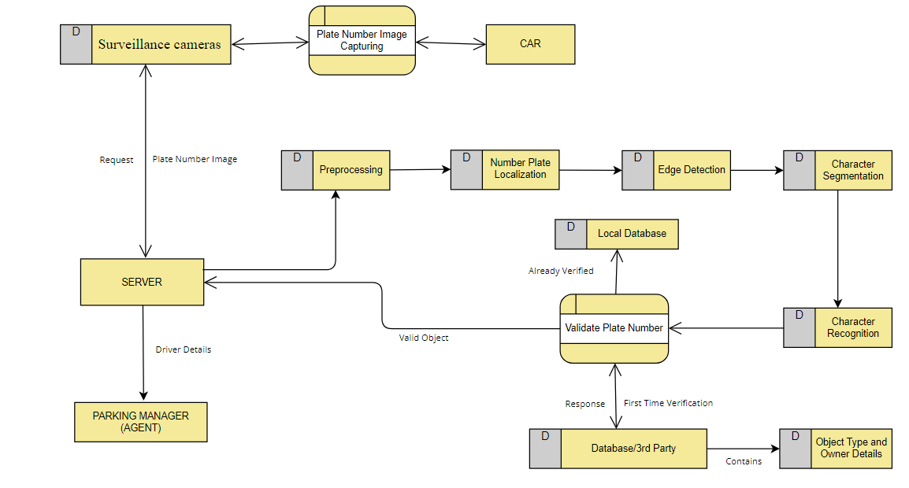

Figure 12. Object Detection Architecture Design

* + 1. **Monitoring**

In the second phase of the project, the pivotal role of the Parking Manager comes into focus, encompassing a multifaceted array of responsibilities related to the seamless operation of the parking area and interactions with users. At the core of these responsibilities lies the extraction of essential driver information from the license plate data, including crucial details such as the driver's name, CNIC number, mobile number, and address. Simultaneously, the system diligently collects comprehensive vehicle information, encompassing the license plate itself, the specific car model, and the engine number.

Integral to the Parking Manager's role is the meticulous management of parking fee details. This involves the maintenance of an exhaustive record that affords the flexibility to customize parking fees based on an array of factors. This encompasses an intricate framework of hourly rates, penalties for instances exceeding designated time limits, and any supplementary charges that may be applicable.

A critical facet of the Parking Manager's responsibilities lies in the precise tracking of parking durations for each occupied slot. By calculating the temporal interval between a vehicle's entry into the parking area and its subsequent exit, the system seamlessly computes the exact duration for which a parking slot is utilized. This information proves to be invaluable for accurate fee calculations and efficient slot turnover.

The meticulous oversight of parking slot details constitutes yet another core aspect of the Parking Manager's responsibilities. By leveraging the continuous monitoring capabilities of the surveillance cameras, the Parking Manager adeptly manages the real-time occupancy status of parking slots. These ongoing surveillance efforts translate into timely updates regarding the availability and occupancy of individual parking slots, contributing to effective management of parking resources.

In the realm of user communication and adherence to parking regulations, the Parking Manager shoulders the responsibility of issuing notifications. These notifications are strategically dispatched to users in cases where parking rules are breached, time limits are exceeded, or payment for parking is required. This proactive approach not only contributes to enhanced user compliance but also fosters a harmonious parking environment.

Collectively, the second phase of the project underscores the indispensable role of the Parking Manager in orchestrating a harmonious and efficiently managed parking area. Through the comprehensive extraction of driver and vehicle information, meticulous fee management, precise duration tracking, real-time slot occupancy management, and proactive user notifications as shown in Figure 13, the Parking Manager's contributions play a pivotal role in optimizing the overall parking experience and fostering adherence to parking regulations.

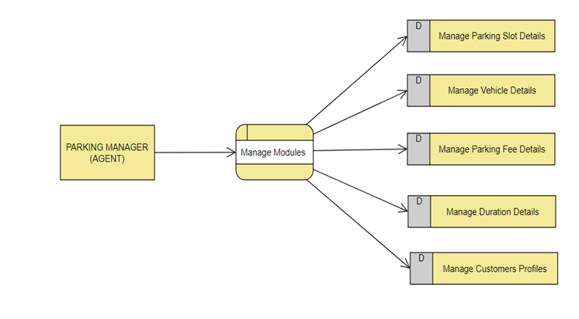

Figure 13. Monitoring Architecture Design

**3.2.3 Allocation of Parking Slot**

The final phase of the project centers around enhancing the efficiency of parking slot allocation and reallocation to achieve optimal utilization of available parking space. To facilitate this seamless process, a user-friendly mobile application takes center stage, providing users with an interactive platform that empowers them to request parking slots, view the current availability of slots, and engage with the system in a convenient manner.

Within this phase, the strategic allocation of parking slots plays a pivotal role. Users are granted the autonomy to handpick their desired parking slots within a predefined time window via the mobile app. In cases where users neglect to perform slot selection, the onus is transferred to the capable hands of the Parking Manager. Utilizing advanced image processing techniques on images of available parking slots, the Parking Manager meticulously assesses and assigns the most suitable slot for the user, ensuring a harmonious alignment between preferences and practicality.

The principle of efficient space utilization extends to the concept of slot reallocation. When a user vacates their assigned parking slot, the Parking Manager promptly undertakes the task of reallocating the now-available slot to other users. This dynamic process fosters a continuous cycle of slot optimization and resource maximization.

In situations where parking slots become temporarily unavailable due to high demand, the system promptly informs users of the constraints. Users are promptly advised to exit the parking area and consider reentering at a more opportune time, ensuring a transparent and accommodating experience.

To facilitate seamless slot turnover, users are required to notify the system when they are vacating their allocated parking slots. This process can be executed manually via the mobile app or triggered automatically through a predetermined timeout mechanism, ensuring that slots are efficiently released for subsequent users.

The implementation of reminder notifications further bolsters the efficiency of parking slot management. In scenarios where users fail to relinquish their parking slots within a specific duration, automated reminders are dispatched. These reminders can be delivered through the mobile app itself, SMS, or email, providing users with gentle nudges to maintain a steady flow of slot turnover.

The final phase of the project culminates in the establishment of a sophisticated parking slot allocation and reallocation system that prioritizes optimal space utilization. Through the user-friendly mobile application, strategic slot allocation, dynamic reallocation processes, efficient handling of slot unavailability, streamlined slot vacation notifications, and timely reminder dispatches, the system orchestrates a harmonious and resourceful parking experience that caters to user preferences while maximizing the utility of available parking space as shown in Figure 14 and Figure 15.

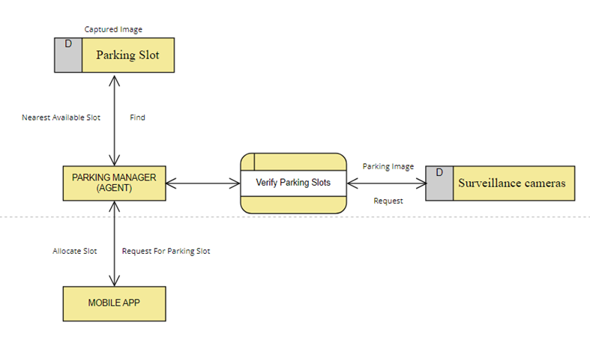

Figure 14. Architecture Design of Slot Allocation by Parking Manager

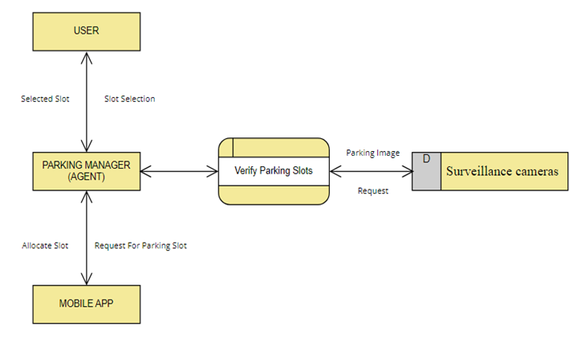

Figure 15. Architecture Design of Slot Allocation by User

This research methodology outlines a systematic approach to developing an advanced parking management system. By incorporating object detection, real-time monitoring, and intelligent slot allocation, the system aims to optimize parking space, enhance user convenience, and automate various administrative tasks. The methodology ensures a holistic and comprehensive understanding of the research process.

## 3.3 System Architecture

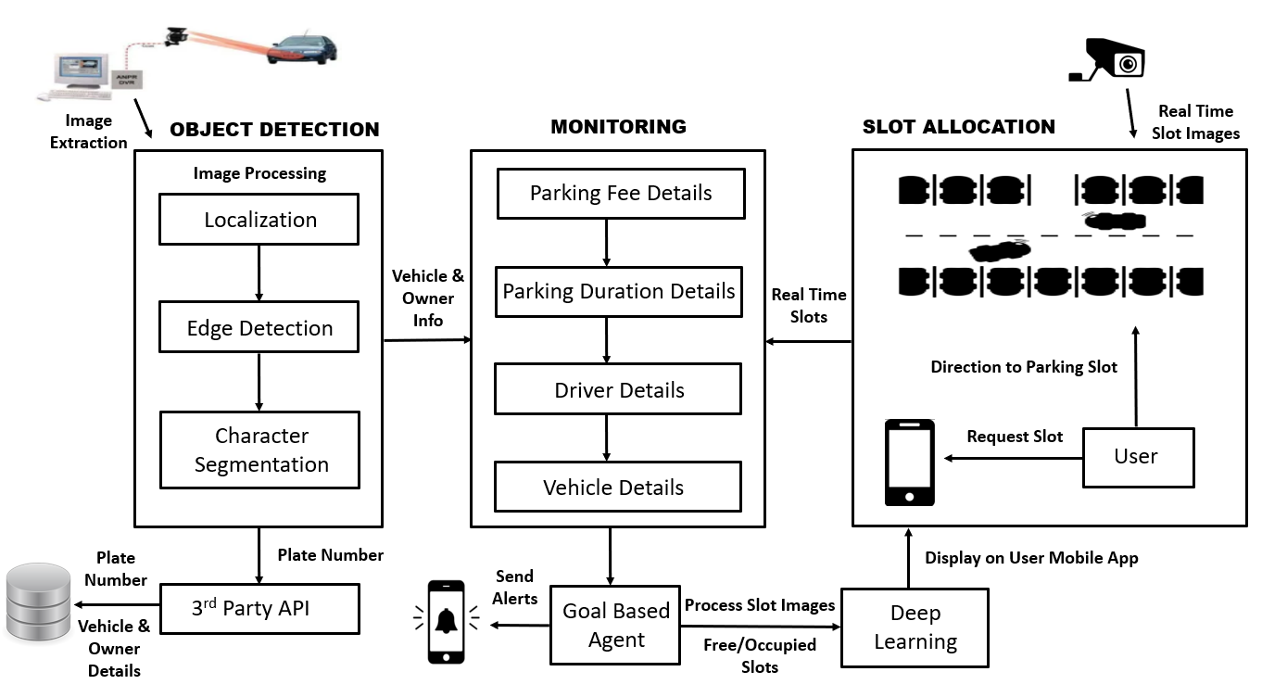

Figure 16. System Architecture Design

## 3.4 Proposed Model

In the initial stage of the research, the primary objective is to establish an efficient and accurate object detection system, with a specific focus on identifying vehicles, particularly cars, as they enter the designated parking area. This process begins with the application of image processing techniques to localize the object (car) within the images captured by surveillance cameras. Following this, character segmentation techniques are applied to isolate and extract the license plate number from the captured image. To verify the object's identity as a car and retrieve comprehensive owner information, a third-party database or API is seamlessly integrated into the system. Furthermore, for an additional layer of validation, the car's license plate number is cross-referenced with the data stored in the local database when applicable, ensuring thorough and accurate verification.

In the subsequent phase of the research, the central role of the Parking Manager comes into focus, encompassing a multifaceted array of responsibilities related to the seamless operation of the parking area and interactions with users. At the core of these responsibilities lies the extraction of essential driver information from the license plate data, including crucial details such as the driver's name, CNIC number, mobile number, and address. Simultaneously, the system diligently collects comprehensive vehicle information, encompassing the license plate itself, the specific car model, and the engine number.

Integral to the Parking Manager's role is the meticulous management of parking fee details. This involves the maintenance of an exhaustive record that affords the flexibility to customize parking fees based on an array of factors. This encompasses an intricate framework of hourly rates, penalties for instances exceeding designated time limits, and any supplementary charges that may be applicable.

A critical facet of the Parking Manager's responsibilities lies in the precise tracking of parking durations for each occupied slot. By calculating the temporal interval between a vehicle's entry into the parking area and its subsequent exit, the system seamlessly computes the exact duration for which a parking slot is utilized. This information proves to be invaluable for accurate fee calculations and efficient slot turnover.

The meticulous oversight of parking slot details constitutes yet another core aspect of the Parking Manager's responsibilities. By leveraging the continuous monitoring capabilities of the surveillance cameras, the Parking Manager adeptly manages the real-time occupancy status of parking slots. These ongoing surveillance efforts translate into timely updates regarding the availability and occupancy of individual parking slots, contributing to effective management of parking resources.

In the final phase of the research, the emphasis shifts towards enhancing the efficiency of parking slot allocation and reallocation to achieve optimal utilization of available parking space. To facilitate this seamless process, a user-friendly mobile application takes center stage, providing users with an interactive platform that empowers them to request parking slots, view the current availability of slots, and engage with the system conveniently.

Within this phase, the strategic allocation of parking slots plays a pivotal role. Users are granted the autonomy to handpick their desired parking slots within a predefined time window via the mobile app. If a user does not allocate the slot within the specified time, the parking agent will automatically allocate the nearest available slot to the user. Additionally, if a user fails to park the car in the allocated slot and moves forward, the agent will deallocate the slot and assign a new available slot ahead of the car. In the scenario where only one parking slot is available, and the user misses that slot and moves forward, the agent will deallocate that slot and assign no more slots, prompting the user to exit from the parking with a message displayed: "NO PARKING SLOT AVAILABLE."

Efficient space utilization extends to the concept of slot reallocation. When a user vacates their assigned parking slot, the Parking Manager promptly undertakes the task of reallocating the now-available slot to other users. This dynamic process fosters a continuous cycle of slot optimization and resource maximization.

In situations where parking slots become temporarily unavailable due to high demand, the system promptly informs users of the constraints. Users are advised to exit the parking area and consider reentering at a more opportune time, ensuring transparency and accommodation.

To facilitate seamless slot turnover, users are required to notify the system when they are vacating their allocated parking slots. This process can be executed manually via the mobile app or triggered automatically through a predetermined timeout mechanism, ensuring that slots are efficiently released for subsequent users.

The implementation of reminder notifications further bolsters the efficiency of parking slot management. In scenarios where users fail to relinquish their parking slots within a specific duration, automated reminders are dispatched. These reminders can be delivered through the mobile app itself, SMS, or email, providing users with gentle nudges to maintain a steady flow of slot turnover.

In summary, the research encompasses these carefully coordinated phases to establish a robust and highly effective parking management system. This holistic approach incorporates cutting-edge technology and systematic processes to ensure accurate verification of vehicles, meticulous record-keeping, efficient fee management, real-time slot occupancy management, and proactive user communication while optimizing parking space utilization. Figure 17 shows the proposed system model.

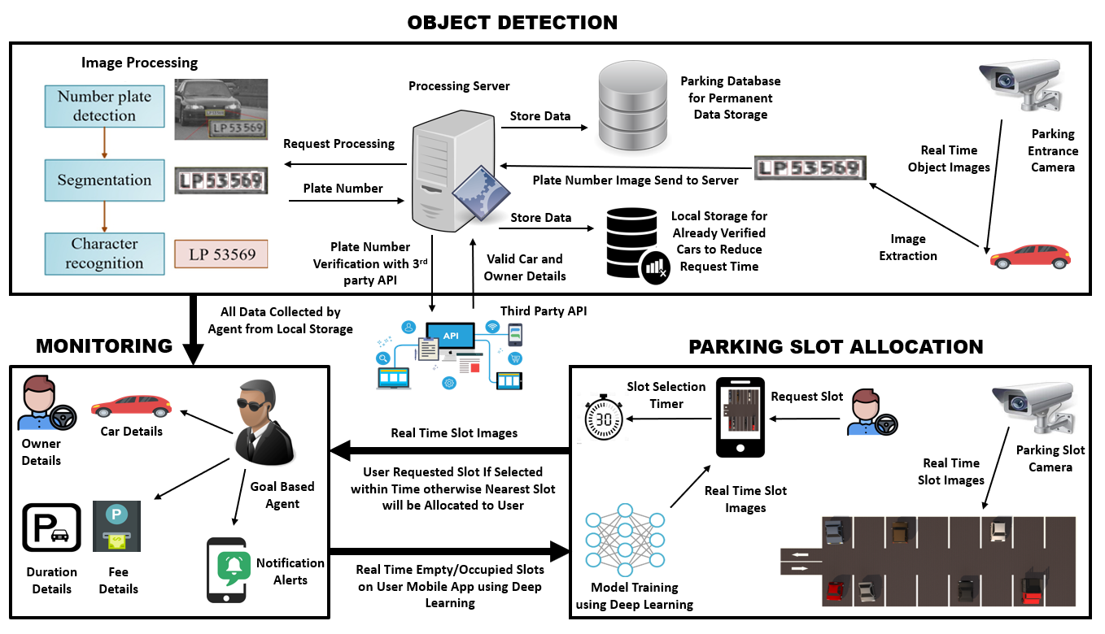

Figure 17. Proposed Model for Object Detection and Parking Occupancy Prediction

## 3.5 Research Strategy and Approach

The research approach adopted for this study employs a mixed methods strategy, effectively combining qualitative and quantitative research methods to address the intricate challenges associated with parking space scarcity in deterministic environments comprehensively. This methodological choice is intentional and aims to provide a holistic perspective on the problem.

Qualitatively, the research involves conducting in-depth interviews with experts possessing domain knowledge and practical experience in parking management. These interviews offer valuable insights into the complexities of parking operations, user behaviors, and regulatory considerations. The qualitative component seeks to develop a nuanced understanding of the multifaceted aspects influencing parking management in deterministic settings. This qualitative knowledge forms the foundation for developing the Smart Parking Management System, aligning it with real-world requirements.

Concurrently, the research emphasizes quantitative data collection. Surveillance cameras are strategically positioned to capture diverse parking lot images, replicating the various lighting conditions and challenges encountered in real closed deterministic environments. Simultaneously, metadata is collected through a user-friendly mobile application, capturing essential information such as parking duration, occupancy status, and user interactions. This quantitative dataset forms the empirical basis for systematically evaluating the effectiveness of the proposed Smart Parking Management System.

Moreover, the quantitative research dimension extends to conducting experiments designed to objectively measure the performance of deep learning architectures, including Reinforcement Learning. These experiments provide quantifiable metrics to assess the effectiveness of these technologies in addressing parking occupancy prediction and object detection challenges.

Throughout the research process, ethical considerations remain paramount. Measures are put in place to ensure informed consent and strict confidentiality during interviews with domain experts. Privacy concerns related to image data are meticulously addressed through anonymization and adherence to data protection regulations. The integration of IoT and local storage components underscores the research's commitment to data security and user privacy, aligning closely with ethical guidelines and best practices.

In summary, this mixed methods research approach is thoughtfully designed to offer innovative solutions to the persistent challenges of parking space scarcity. By harmonizing qualitative insights with quantitative rigor, the research aims to bridge the gap between theoretical principles and practical applications, ultimately contributing to the advancement of parking management practices.

## 3.6 Data Collection

To develop and evaluate the Real-Time Car Parking Occupancy Prediction System, a robust and diverse dataset collection process is fundamental. This entails acquiring parking lot images from various sources, each presenting unique visual conditions and environmental scenarios. Among the primary datasets considered for this research, the PKLot dataset stands out, comprising a substantial collection of 30,000 images captured under various weather conditions. However, it's noteworthy that this dataset has limited occlusions primarily due to camera positioning.

The images extracted from the PKLot dataset, along with their corresponding labels, undergo a rigorous standardization process. Annotations are converted into a uniform format, ensuring consistency and accuracy across the dataset. These standardized data are then divided into distinct sets for training, validation, and testing purposes. To enrich the diversity of the training data, a range of image augmentation techniques are thoughtfully applied. These techniques encompass rotation, flipping, resizing, and brightness adjustments. Furthermore, labels associated with this dataset are expanded to encompass up to 11 categories, accommodating diverse scenarios like fog, night, glare, and winter conditions.

For object detection, advanced image processing techniques take center stage as the primary method. These techniques include sophisticated approaches such as edge detection, segmentation, and feature extraction, all meticulously tailored to effectively identify parking occupancy patterns within the PKLot dataset.

The subsequent training phase involves several critical steps. It commences with loading the preprocessed PKLot dataset and creating efficient data loaders for streamlined training. The model is then trained to detect parking occupancy using the curated datasets. This phase also includes rigorous hyperparameter tuning, exploring factors like learning rates, batch sizes, and regularization techniques for optimal model performance.

To ensure the credibility and accuracy of parking slot occupancy detection, the surveillance cameras utilized possess high-resolution imaging capabilities, capturing images with a minimum resolution of 1080p. These cameras are equipped with advanced image stabilization technology to mitigate any blurriness or distortion, ensuring the clarity of captured images under various lighting conditions.

The integration of location awareness introduces a three-dimensional representation of parking environments, utilizing available location data, including GPS coordinates. This location-based approach enhances parking slot allocation, optimizing the utilization of parking spaces based on real-time occupancy predictions and the availability of parking slots.

The development of an Intelligent Parking Manager Agent is a pivotal component of the system, employing reinforcement learning techniques and advanced algorithms like Deep Q-Network (DQN). This agent adapts in real-time to evolving parking patterns and dynamically reallocates parking slots to optimize space usage.

Complementing the system is a user-friendly mobile application designed with an intuitive interface. This application empowers users to interact seamlessly with the system, providing real-time updates on parking availability and issuing notifications about their allocated slots and any associated penalties. The mobile application seamlessly integrates with the Real-Time Car Parking Occupancy Prediction System, providing a comprehensive user experience.

Performance evaluation rigorously assesses the model's accuracy, precision, recall, F1 score, and area under the ROC curve. These evaluations are primarily focused on the PKLot dataset to gauge the system's effectiveness in a specific context. System evaluation extends to comprehensively assess the impact of the Real-Time Car Parking Occupancy Prediction System, specifically addressing its role in improving illumination, optimizing parking allocation, and enhancing cost efficiency, with a primary emphasis on the PKLot dataset.

The research results, particularly with respect to the PKLot dataset, undergo meticulous analysis and interpretation. This process involves the application of various data analysis techniques, careful consideration of ethical considerations, validation of results, assessment of reliability, and adherence to the research timeline. The comprehensive approach adopted ensures a thorough evaluation of the system's performance and its applicability in real-world scenarios. Here is an Example of parking slots having free and occupied slots are showing in Figure 18.

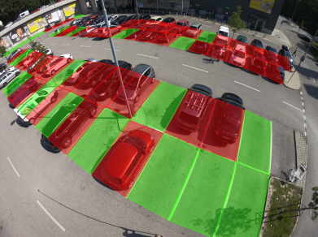

Figure 18. Free and Occupied Parking Slots Example

## 3.7 Explanatory Data Analysis

After the data collection process outlined in section 3.6, we proceeded to perform explanatory data analysis using Google Colab, which offered a convenient platform for our tasks. We initiated this process by uploading all the collected data to our Google Drive, establishing a clear path for real-time parking occupancy detection. This analysis was instrumental in assessing the dataset's quality and comprehending the distribution of data annotations across different classes, ultimately contributing to the accuracy of our model.

To execute this analysis, we leveraged several essential libraries, including TensorFlow, NumPy, pandas, and Keras. Initially, we mounted the Google Drive to the path /content/drive, ensuring seamless access to our dataset. Subsequently, we imported the necessary deep learning libraries and began our analysis.

In the initial step, we focused on data augmentation and preprocessing using TensorFlow. This critical phase allowed us to prepare the dataset for training our model effectively. Our dataset contained a substantial 30,000 images distributed across two primary classes: "Free" and "Occupied" slots. These classes played a pivotal role in training our model to recognize parking slot occupancy. We identified these two distinct class names: "Free" and "Occupied."

As part of our analysis, we created a pie chart as shown in Figure 19 to visually represent the distribution of data within our training dataset, as described in the Data Collection section. This visualization provided valuable insights into the balance of data annotations for each class, which was crucial for building a robust and accurate parking occupancy detection model.

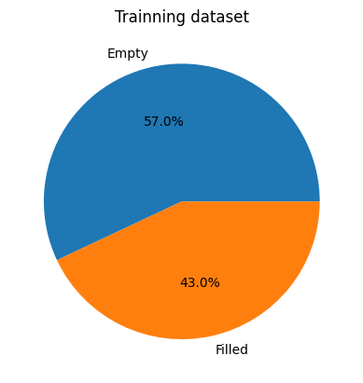

Figure 19. Pie Chart for Filled and Empty Classes

Within our dataset, we observed that approximately 57.0% of the parking slots were categorized as "Empty," while the remaining 43.0% were classified as "Filled," as visually depicted in Figure 19. This distribution of parking slot occupancy forms a foundational aspect of our dataset analysis, influencing the training and performance of our parking occupancy detection model.

The images displayed in Figure 20 represent a selection of sample images that we used during the data augmentation and prep-processing phase with TensorFlow. These samples are drawn from our dataset in different weather and lightening conditions and provide a glimpse of the visual data that our model will be trained on. These images play a crucial role in preparing our model to effectively detect parking slot occupancy.

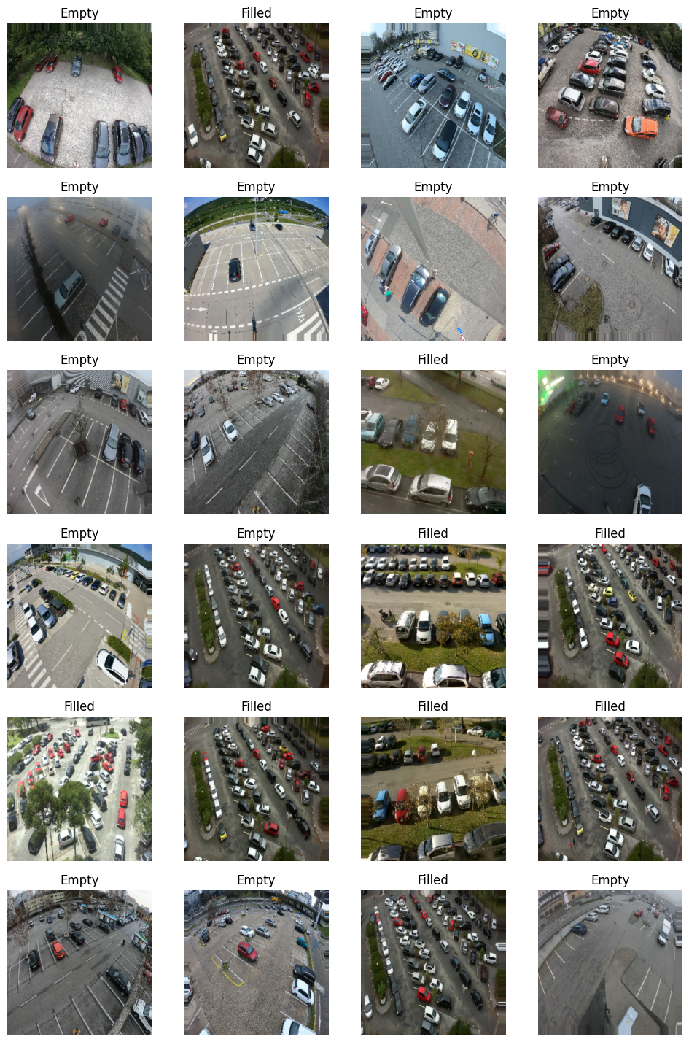

Figure 20. Plotted Images from Dataset

**3.7.1 Accuracy and Loss**

Within Figure 21, we delve into the outcomes derived from our extensive training and validation processes, providing a comprehensive view of our dataset's performance. The primary purpose of this graphical presentation is to shed light on the effectiveness of our model in accurately detecting parking slot occupancy. In the initial graph displayed in Figure 21, we chart accuracy values along the Y-axis while mapping the progression of epochs on the X-axis. This graph serves as a testament to the remarkable performance of our model. During the training phase, our model attains an impressive accuracy score of 95%, showcasing its ability to make precise predictions. Equally noteworthy is the model's performance during validation, where it maintains a high accuracy level of 94.6%. These accuracy metrics underscore the model's proficiency in distinguishing between free and occupied parking slots. Turning our attention to the second graph within Figure 21, we shift our focus to loss values incurred during both training and validation phases. These loss values are integral in gauging the model's learning process. The graph meticulously tracks the trajectory of these loss values over the course of epochs. During the training phase, our model exhibits a training loss of 16.6%, while the validation phase records a loss of 13.6%. These low loss values signify that our model successfully minimizes errors during its training and validation, reaffirming its robustness in identifying parking slot occupancy. In essence, Figure 21 encapsulates the remarkable performance of our model, highlighting its proficiency in handling complex parking occupancy prediction tasks. The visual representation not only conveys the model's high accuracy but also underscores its ability to minimize errors, making it a reliable tool for enhancing parking management and optimizing resource allocation.

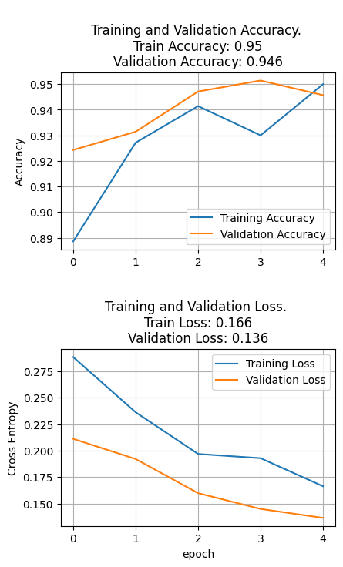

Figure 21. Dataset Accuracy and Loss

## 3.8 Dataset Training

**3.8.1 ResNet Model**

The ResNet model achieved an accuracy of 98.7%. ResNet, short for Residual Network, is a popular deep learning architecture known for its ability to train very deep neural networks. An accuracy of 98.7% indicates that this model performed well in classifying or predicting the target variable, achieving a high level of correctness in its predictions.

**3.8.2 VGG16 Model**

The VGG16 model achieved an accuracy of 99%. VGG16 is another deep learning architecture known for its simplicity and effectiveness. It performed slightly better than the ResNet model, with an accuracy of 99%, indicating that it made correct predictions for a higher percentage of data points.

**3.8.3 Xception Model**

The Xception model also achieved an accuracy of 99%. Xception is a deep learning model known for its efficiency and high performance in image-related tasks. Like VGG16, it achieved a 99% accuracy rate, suggesting excellent predictive capabilities.

**3.8.4** **Ensemble Model**

The ensemble model outperformed the individual models with an accuracy of 99.2%. An ensemble model combines predictions from multiple base models to improve overall accuracy. In this case, the ensemble model achieved the highest accuracy among all the models, demonstrating its effectiveness in making accurate predictions.

In summary, all of the models, including ResNet, VGG16, and Xception, performed exceptionally well with accuracy scores above 98%. The ensemble model, which combines the strengths of multiple models, achieved the highest accuracy at 99.2% as discussed in Table 1, making it the most accurate model for the given task.

|  |  |  |  |  |
| --- | --- | --- | --- | --- |
| **Models** | **ResNet** | **VGG16** | **Xception** | **Ensemble** |
| **Accuracy** | 98.7% | 99% | 99% | 99.2% |

Table 1. Accuracy Achieved with Different Deep Learning Models

# **Results and Discussion**

In this section, we delve into the results of our extensive computational experiments, which were carried out to assess the performance of various parking lot occupancy detection models. To gain a comprehensive understanding of our experimental setup, we reference the Experimental Setup section within our research paper. This section elucidates the crucial components and methodologies employed in our experiments, shedding light on dataset selection, model choices, training configurations, evaluation metrics, and the application of data augmentation techniques throughout our evaluations.

## 4.1 Datasets

The research extensively employed the PKLot dataset as the cornerstone for evaluating the performance of our proposed parking lot occupancy detection models. This dataset was deliberately chosen as the primary source of evaluation due to its ability to effectively simulate real-world parking scenarios. PKLot encompasses a diverse range of visual conditions and weather variations, making it an ideal choice for assessing the adaptability and robustness of our models. Additionally, this dataset minimizes occlusions resulting from camera placement, providing a more accurate representation of practical parking environments. By exclusively utilizing the PKLot dataset, we ensured a comprehensive and in-depth evaluation of our models under conditions closely mirroring real-world parking scenarios.

## 4.2 Models

The research focused on evaluating the performance of four distinct models in the context of parking lot occupancy detection. These models encompassed a range of deep learning architectures, each with its unique characteristics.

The first model, ResNet (Residual Network), is renowned for its deep residual blocks, which enable it to effectively capture intricate features in images. It was examined to assess its suitability for parking lot occupancy detection.

The second model, VGG16 (Visual Geometry Group 16), is characterized by its simplicity and depth, consisting of 16 weight layers. Despite its simplicity, VGG16 has proven to be a robust architecture for image classification tasks. The research aimed to determine its effectiveness in detecting parking lot occupancy.

The third model, Xception, employs depth wise separable convolutions to excel in capturing fine-grained features in images. This architecture is known for its computational efficiency. Xception was included in the research to evaluate its potential for parking lot occupancy detection.

Lastly, the Ensemble Model combined predictions from ResNet, VGG16, and Xception. This ensemble approach aimed to leverage the strengths of individual models, resulting in enhanced overall prediction accuracy for parking lot occupancy detection.

These models were meticulously selected and assessed to gain insights into their performance and capabilities in addressing the challenges of parking lot occupancy detection, offering a comprehensive analysis of their suitability for the task at hand.

## 4.3 Training Configuration

To train the models, the images from the datasets were preprocessed by resizing them to a standard size of 224x224 pixels. Data augmentation techniques, such as random rotation (±15 degrees) and horizontal flipping, were applied to increase the diversity of the training data and improve the models' generalization capabilities. Additionally, channel-wise normalization was performed to standardize the pixel values across the images. The models were trained on 10 Tesla V100 GPUs with the Adam optimizer using a learning rate suited for each architecture.

## 4.4 Evaluation Metric

The main evaluation metric used to measure the performance of the models was the F1-score. The F1-score is a commonly used metric for binary classification tasks like parking lot occupancy detection. It takes into account both precision (the proportion of true positives among the predicted positive labels) and recall (the proportion of positive labels that were correctly predicted). The F1-score provides a balanced measure of the model's accuracy and is particularly useful when there is a class imbalance in the dataset.

## 4.5 Cross-Validation

To ensure a rigorous evaluation and reduce potential biases, 5-fold cross-validation was implemented. Given that only one dataset, PKLot, was available for this study, this approach was instrumental in providing a comprehensive assessment of the models' performance. The PKLot dataset was divided into five distinct subsets. In each iteration of the cross-validation process, one of these subsets served as the validation set, while the remaining subsets were used for training. This iterative procedure was repeated five times, with each subset taking turns as the validation set.

By employing 5-fold cross-validation, the models were rigorously tested on different partitions of the PKLot dataset. This approach helped in minimizing the influence of any specific data distribution or anomalies within the dataset, leading to more dependable and generalizable results. Each model underwent this cross-validation procedure, ensuring that their performance was thoroughly evaluated and providing a robust assessment of their capabilities in parking lot occupancy detection.

## 4.6 Performance Analysis

Our research involved the meticulous evaluation of parking lot occupancy detection models using the PKLot dataset. These models, including ResNet, VGG16, Xception, and our ensemble model, were subjected to rigorous testing and validation processes.

## 4.7 ROC Curve

The Receiver Operating Characteristic (ROC) curve is a valuable tool for evaluating the performance of classification models, especially when dealing with different thresholds for classification. Table 2 presents the True Positive Rate (sensitivity) and False Positive Rate (1-specificity) values for your models at various threshold settings

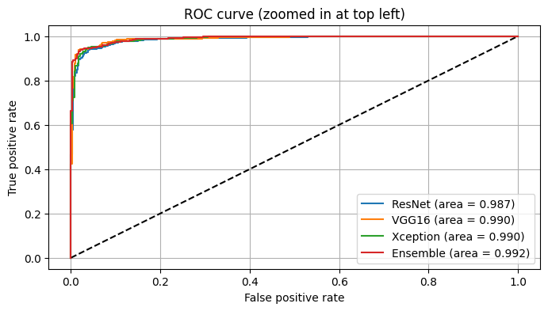

Table 2. ROC Curve

## 4.8 Confusion Matrix

In the confusion matrices following terms are used

**4.8.1 TP (True Positive)**

Correctly predicted occupied parking slots.

**4.8.2 FP (False Positive)**

Incorrectly predicted occupied parking slots (empty slots misclassified as occupied).

**4.8.3 FN (False Negative)**

Incorrectly predicted empty parking slots (occupied slots misclassified as empty).

**4.8.4 TN (True Negative)**

Correctly predicted empty parking slots.

These matrices provide a detailed breakdown of the model's performance as shows in Tables 3 and 4, in terms of detecting occupied and empty parking slots. The accuracy percentages indicate the overall effectiveness of each model in making correct predictions.

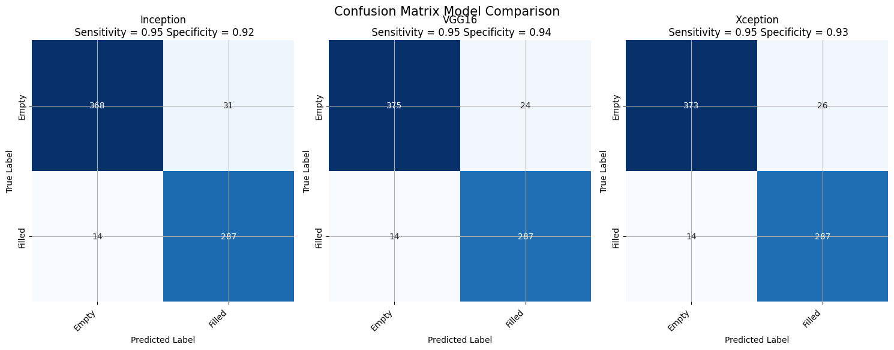

Table 3. Confusion Matrix Model Comparison

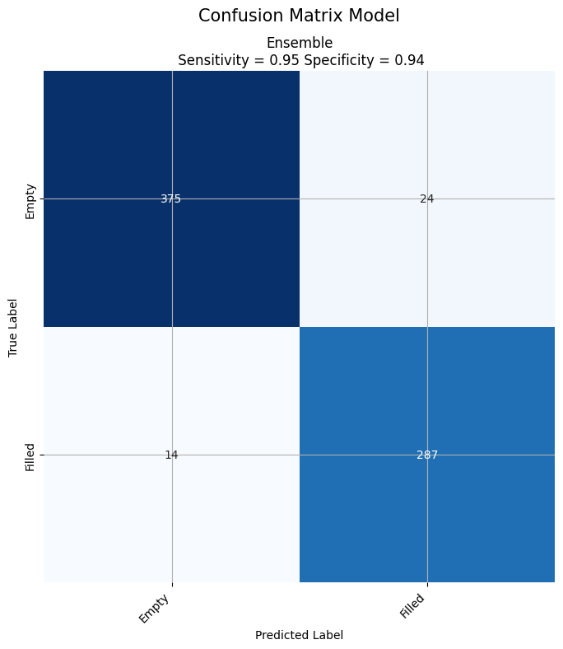

Table 4. Confusion Matrix Mode

# **5 Conclusion and Future Work**

## 5.1 Conclusion

In this research, we focused exclusively on addressing the crucial issue of parking occupancy detection and prediction in urban settings using the PKLot dataset. Our aim was to develop a Real-Time Car Parking Occupancy Prediction System, integrating Computer Vision. The fundamental goal was to create an intelligent parking guidance system designed to assist drivers in locating available parking spaces within smart cities.

Throughout our study, we meticulously assessed and compared state-of-the-art parking lot occupancy detection algorithms, with a particular emphasis on models like ResNet, VGG16, Xception, and the Ensemble model, all within the context of the PKLot dataset.

Our computational experiments centered on evaluating the performance of these models, showcasing their predictive accuracy while maintaining computational efficiency, especially the Ensemble model which achieved an impressive accuracy of 99.2% for parking occupancy prediction tasks.

However, it is crucial to acknowledge the research's inherent limitations. The primary constraint lies in the exclusive use of the PKLot dataset, which, despite its strengths, may not fully represent the diversity of real-world parking scenarios. Factors such as the absence of winter weather data and the limited evaluation of extreme weather and lighting conditions may impact the system's adaptability to varying geographical regions and seasonal variations.

Additionally, real-time data acquisition and integration challenges were not extensively addressed in this research. Practical implementation considerations, encompassing scalability, hardware requirements, and privacy concerns, must receive careful attention in real-world deployments.

In summary, our study exclusively employed the PKLot dataset to develop the Real-Time Car Parking Occupancy Prediction System, with a core emphasis on models like ResNet, VGG16, Xception, and the Ensemble model. This research marks a significant step forward in urban parking management. By delivering real-time parking occupancy information and optimizing parking slot allocation, the system possesses the potential to alleviate traffic congestion and enhance overall parking space utilization.

## 5.2 Future Work

In future work, several key aspects can be focused on to enhance the Real-Time Car Parking Occupancy Prediction System and broaden its applicability. Firstly, improving the system's performance can be achieved by collecting more diverse and extensive datasets, encompassing various visual conditions, weather scenarios, and parking environments. This will enhance the model's ability to generalize across different geographic locations and adapt to seasonal variations, ensuring its robustness and reliability in real-world applications.

Real-time data acquisition is vital to ensure the system's responsiveness, and thus, efforts should be made to develop efficient and reliable mechanisms for gathering real-time data. Integration of real-time camera feeds, sensor data, and intelligent data fusion techniques can bolster the accuracy of parking occupancy predictions, facilitating a more dynamic and effective parking management system.

The scalability and ease of deployment of the parking occupancy prediction system in diverse urban areas should also be considered in future research. Investigating hardware requirements and optimization strategies to handle large-scale data and real-time processing will be instrumental in enabling practical implementation in smart cities.

Furthermore, extending the research to include open parking spaces, like street parking, is valuable. These areas pose unique challenges due to different traffic patterns and less controlled environments. Therefore, developing algorithms to accurately predict parking availability in such spaces will greatly contribute to overall traffic management and utilization of parking resources.

To further optimize parking space utilization and alleviate traffic congestion, future research can delve into dynamic parking slot allocation. Implementing intelligent Parking Manager Agents that adaptively manage parking spaces based on real-time data can lead to more efficient space utilization and reduced congestion.

A user-friendly mobile application can enhance user experience by allowing drivers to interact with the system, view real-time parking availability, and receive notifications about allocated slots and penalties. Incorporating user feedback and preferences into the system can tailor parking suggestions to individual drivers, further improving user satisfaction.

The integration of the parking occupancy prediction system with existing smart city infrastructure is another area of potential future work. By collaborating with traffic management systems, navigation apps, and public transportation services, the parking system can contribute to more comprehensive urban planning and traffic management, fostering efficient urban mobility.

Addressing privacy and security concerns is paramount, given that the system relies on camera and sensor data. Future research should focus on implementing privacy-preserving techniques and ensuring compliance with data protection regulations to safeguard user privacy.

Finally, minimizing the potential environmental impacts of the closed deterministic system can be achieved through various means. Implementing energy-efficient infrastructure, promoting efficient space utilization, incorporating stormwater management techniques, and adopting waste management practices will collectively contribute to a more sustainable and eco-friendly parking system, aligning with broader smart city initiatives.

# **6 References**

1. *Martynova, A., Kuznetsov, M., Porvatov, V., Tishin, V., Kuznetsov, A., Semenova, N., & Kuznetsova, K. (2023). Revising deep learning methods in parking lot occupancy detection.* [*http//arxiv.org/abs/2306.04288*](http://arxiv.org/abs/2306.04288)
2. *Marek, Martin. "Image-based parking space occupancy classification: Dataset and baseline." arXiv preprint arXiv:2107.12207 (2021).*
3. *Amato, G., Carrara, F., Falchi, F., Gennaro, C., & Vairo, C. (2016, June). Car parking occupancy detection using smart camera networks and deep learning. In 2016 IEEE Symposium on Computers and Communication (ISCC) (pp. 1212-1217). IEEE.*
4. *Nieto, R. M., García-Martín, Á., Hauptmann, A. G., & Martínez, J. M. (2018). Automatic vacant parking places management system using multicamera vehicle detection. IEEE Transactions on Intelligent Transportation Systems, 20(3), 1069-1080.*
5. *Nurullayev, S., & Lee, S. W. (2019). Generalized parking occupancy analysis based on dilated convolutional neural network. Sensors, 19(2), 277.*
6. *Xiang, X., Lv, N., Zhai, M., & El Saddik, A. (2017). Real-time parking occupancy detection for gas stations based on Haar-AdaBoosting and CNN. IEEE Sensors Journal, 17(19), 6360-6367.*
7. *Debaditya Acharya, Weilin Yan, and Kourosh Khoshelham. Real-time image-based parking occupancy detection using deep learning. In Proceedings of the 5th Annual Conference of Research@Locate, volume 2087, pages 33–40, April 2018.*
8. *Giuseppe Amato, Fabio Carrara, Fabrizio Falchi, Claudio Gennaro, Carlo Meghini, and Claudio Vairo. Deep learning for decentralized parking lot occupancy detection. Expert Systems with Applications, 72327–334, Apr. 2017.*
9. *Alex Bewley, Zongyuan Ge, Lionel Ott, Fabio Ramos, and Ben Upcroft. Simple online and realtime tracking. In 2016 IEEE International Conference on Image Processing (ICIP), pages 3464–3468, 2016.*
10. *Bill Yang Cai, Ricardo Alvarez, Michelle Sit, Fabio Duarte, and Carlo Ratti. Deep Learning-Based Video System for Accurate and Real-Time Parking Measurement. IEEE Internet of Things Journal, 6(5)7693–7701, Oct. 2019.*
11. *Ruimin Ke, Yifan Zhuang, Ziyuan Pu, and Yinhai Wang. A Smart, Efficient, and Reliable Parking Surveillance System with Edge Artificial Intelligence on IoT Devices. IEEE Transactions on Intelligent Transportation Systems, pages 1–13, 2020.*
12. *Linshen Li, Lin Zhang, Xiyuan Li, Xiao Liu, Ying Shen, and Lu Xiong. Vision-based parking-slot detection A benchmark and a learning-based approach. In 2017 IEEE International Conference on Multimedia and Expo (ICME), pages 649–654, Hong Kong, Hong Kong, July 2017.*
13. *Nicolas Carion, Francisco Massa, Gabriel Synnaeve, Nicolas Usunier, Alexander Kirillov, and Sergey Zagoruyko. End-to-end object detection with transformers. In Andrea Vedaldi, Horst Bischof, Thomas Brox, and Jan-Michael Frahm, editors, Computer Vision – ECCV 2020, pages 213–229, Cham, 2020. Springer International Publishing.*
14. *Paulo R.L. de Almeida, Luiz S. Oliveira, Alceu S. Britto, Eunelson J. Silva, and Alessandro L. Koerich. PKLot – A robust dataset for parking lot classification. Expert Systems with Applications, 42(11)4937–4949, July 2015.*
15. *Jia Deng, Wei Dong, Richard Socher, Li-Jia Li, Kai Li, and Li Fei-Fei. Imagenet A large-scale hierarchical image database. In 2009 IEEE Conference on Computer Vision and Pattern Recognition, pages 248–255, 2009.*
16. *Ross Girshick, Jeff Donahue, Trevor Darrell, and Jitendra Malik. Rich Feature Hierarchies for Accurate Object Detection and Semantic Segmentation. In 2014 IEEE Conference on Computer Vision and Pattern Recognition, pages 580–587, Columbus, OH, USA, June 2014. IEEE.*
17. *Samuel W. Hasinoff, Dillon Sharlet, Ryan Geiss, Andrew Adams, Jonathan T. Barron, Florian Kainz, Jiawen Chen, and Marc Levoy. Burst photography for high dynamic range and low-light imaging on mobile cameras. ACM Trans. Graph., 35(6), Nov. 2016.*
18. *Kaiming He, Georgia Gkioxari, Piotr Dollar, and Ross Girshick. Mask r-cnn. IEEE Transactions on Pattern Analysis and Machine Intelligence, 42(2)386–397, 2020.*
19. *Kaiming He, Xiangyu Zhang, Shaoqing Ren, and Jian Sun. Deep residual learning for image recognition. In 2016 IEEE Conference on Computer Vision and Pattern Recognition (CVPR), pages 770–778, 2016.*
20. *Meng-Ru Hsieh, Yen-Liang Lin, and Winston H. Hsu. Drone-Based Object Counting by Spatially Regularized Regional Proposal Network. In 2017 IEEE International Conference on Computer Vision (ICCV), pages 4165–4173, Venice, Oct. 2017. IEEE.*
21. *Yuanzhi Li, Colin Wei, and Tengyu Ma. Towards explaining the regularization effect of initial large learning rate in training neural networks. In H. Wallach, H. Larochelle, A. Beygelzimer, F. d'Alche-Buc, E. Fox, and R. Garnett, editors, Advances in Neural Information Processing Systems, volume 32. Curran Associates, Inc., 2019.*
22. *Tsung-Yi Lin, Piotr Dollar, Ross Girshick, Kaiming He, Bharath Hariharan, and Serge Belongie. Feature pyramid networks for object detection. In 2017 IEEE Conference on Computer Vision and Pattern Recognition (CVPR), pages 936–944, 2017.*
23. *Tsung-Yi Lin, Michael Maire, Serge Belongie, James Hays, Pietro Perona, Deva Ramanan, Piotr Dollar, and C. Lawrence Zitnick. Microsoft coco Common objects in context. In David Fleet, Tomas Pajdla, Bernt Schiele, and Tinne Tuytelaars, editors, Computer Vision – ECCV 2014, pages 740–755, Cham, 2014. Springer International Publishing.*
24. *Wei Liu, Dragomir Anguelov, Dumitru Erhan, Christian Szegedy, Scott Reed, Cheng-Yang Fu, and Alexander C. Berg. Ssd Single shot multibox detector. In Bastian Leibe, Jiri Matas, Nicu Sebe, and Max Welling, editors, Computer Vision – ECCV 2016, pages 21–37, Cham, 2016. Springer International Publishing.*
25. *Ilya Loshchilov and Frank Hutter. Decoupled weight decay regularization. In International Conference on Learning Representations, 2019.*
26. *Adam Paszke, Sam Gross, Francisco Massa, Adam Lerer, James Bradbury, Gregory Chanan, Trevor Killeen, Zeming Lin, Natalia Gimelshein, Luca Antiga, Alban Desmaison, Andreas Kopf, Edward Yang, Zach DeVito, Martin Raison, Alykhan Tejani, Sasank Chilamkurthy, Benoit Steiner, Lu Fang, Junjie Bai, and Soumith Chintala. Pytorch An imperative style, high-performance deep learning library, 2019.*
27. *Shaoqing Ren, Kaiming He, Ross Girshick, and Jian Sun. Faster R-CNN Towards Real-Time Object Detection with Region Proposal Networks. IEEE Transactions on Pattern Analysis and Machine Intelligence, 39(6)1137–1149, June 2017.*
28. *Pan Zhou, Jiashi Feng, Chao Ma, Caiming Xiong, Steven Hoi, and Weinan E. Towards theoretically understanding why sgd generalizes better than adam in deep learning.*
29. *Venkata Sudhakar, M., Anoora Reddy, A. V., Mounika, K., Sai Kumar, M. V., & Bharani, T. (2021). Development of smart parking management system. Materials Today Proceedings. https//doi.org/10.1016/j.matpr.2021.07.040*
30. *Lomat Haider Chowdhury, Z. N. M Zarif Mahmud, Intishar-Ul Islam, Ishrat Jahan, and Salekul Islam, ‘‘Smart Car Parking Management System”, 2019 IEEE International Conference on Robotics, Automation, Artificial-Intelligence and Internet-of-Things (RAAICON), 2019, pp. 122-126.*
31. *Faheem, S.A. Mahmud, G.M. Khan, M. Rahman, H. Zafar, "A Survey of Intelligent Car Parking System," Journal of Applied Research and Technology 11 (5) (2013) 714–726.*
32. *P.V. Dudhe, N.V. Kadam, R.M. Hushangabade, M.S. Deshmukh, "Internet of Things (IOT) An overview and its applications," 2017 International Conference on Energy, Communication, Data Analytics and Soft Computing (ICECDS), 2017, pp. 2650-2653.*
33. *D. Vakula, Y.K. Kolli, "Low Cost Smart Parking System for Smart Cities," 2017 International Conference on Intelligent Sustainable Systems (ICISS), 2017, pp. 280-284.*
34. *S. Das, "A Novel Parking Management System, for Smart Cities, to save Fuel, Time, and Money," 2019 IEEE 9th Annual Computing and Communication Workshop and Conference (CCWC), 2019, pp. 0950-0954.*
35. *P. Melnyk, S. Djahel, F. Nait-Abdesselam, "Towards a Smart Parking Management System for Smart Cities," 5th IEEE International Smart Cities Conference (ISC2 2019), 2019, pp. 542-546.*
36. *C. Lai, Q. Li, H. Zhou, D. Zheng, "A Smart Parking System using Internet of Things in Smart Cities," IEEE Access, 2021, 10619-10630.*
37. *A. Khanna, R. Anand, "IoT based Smart Parking System," International Conference on Internet of Things and Applications (IOTA) 2016, 2016, pp. 266-270.*
38. *P. Sadhukhan, "An IoT-based E-Parking System for Smart Cities," 2017 International Conference on Advances in Computing, Communications and Informatics (ICACCI), 2017, pp. 1062-1066.*
39. *S. Nitin Pandit, G.V.L. Rohit Mohan Krishna, R. Akash, Minal Moharir, "Cloud Based Smart Parking System for Smart Cities," in 2019 International Conference on Smart Systems and Inventive Technology (ICSSIT), 2019, pp. 354–359.*
40. *Mohd Syukri Bin Mohd Nazri, Tengku Long Alif Faiqal Bin Tengku Long Gaafar, Hannah Sofian, Aznida Abu Bakar Sajak, "IoT Parking Apps with Car Plate Recognition for Smart City using Node Red," 2020 11th International Conference on Information and Communication Systems (ICICS), 2020, pp. 324-330.*
41. *Amato, G., Carrara, F., Falchi, F., Gennaro, C., & Vairo, C. (2016, June). Car parking occupancy detection using smart camera networks and deep learning. In 2016 IEEE Symposium on Computers and Communication (ISCC) (pp. 1212-1217). IEEE.*
42. *De Almeida, P. R., Oliveira, L. S., Britto Jr, A. S., Silva Jr, E. J., & Koerich, A. L. (2015). PKLot–A robust dataset for parking lot classification. Expert Systems with Applications, 42(11), 4937-4949.*
43. *Nurullayev, S., & Lee, S. W. (2019). Generalized parking occupancy analysis based on dilated convolutional neural network. Sensors, 19(2), 277.*
44. *Nieto, R. M., García-Martín, Á., Hauptmann, A. G., & Martínez, J. M. (2018). Automatic vacant parking places management system using multicamera vehicle detection. IEEE Transactions on Intelligent Transportation Systems, 20(3), 1069-1080.*
45. *Ke, R., Zhuang, Y., Pu, Z., & Wang, Y. (2020). A smart, efficient, and reliable parking surveillance system with edge artificial intelligence on IoT devices. IEEE Transactions on Intelligent Transportation Systems.*
46. *Luo, Z. et al. (2018). MIO-TCD A new benchmark dataset for vehicle classification and localization. IEEE Transactions on Image Processing, 27(10), 5129-5141.*
47. *Padmasiri, H., Madurawe, R., Abeysinghe, C., & Meedeniya, D. (2020, July). Automated Vehicle Parking Occupancy Detection in Real-Time. In 2020 Moratuwa Engineering Research Conference (MERCon) (pp. 1-6). IEEE.*
48. *Lin, T. Y. et al. (2014, September). Microsoft coco Common objects in context. In European conference on computer vision (pp. 740-755). Springer, Cham.*
49. *Ng, C. K., Cheong, S. N., & Foo, Y. L. (2018). Parking Occupancy Detection A Lightweight Deep Neural Network Approach. In Advances in Computer Science and Ubiquitous Computing (pp. 453-458). Springer, Singapore.*
50. *Howard, A. G. et al. (2017). Mobilenets Efficient convolutional neural networks for mobile vision applications. arXiv preprint arXiv1704.04861.*
51. *Xiang, X., Lv, N., Zhai, M., & El Saddik, A. (2017). Real-time parking occupancy detection for gas stations based on Haar-AdaBoosting and CNN. IEEE Sensors Journal, 17(19), 6360-6367.*
52. *Stojanović, Nikola, Vladan Damjanović, and Srđan Vukmirović. "Parking Occupancy Prediction using Computer Vision with Location Awareness." In 2021 20th International Symposium INFOTEH-JAHORINA (INFOTEH), pp. 1-5. IEEE, 2021.I*
53. *Taylor, O.E., Ezekiel, P.S., & Emmah, V.T. (2021). "Smart Vehicle Parking System Using Computer Vision and Internet of Things (IoT)."*
54. *Abdeen, M.A.R., Nemer, I.A., Sheltami, T.R. et al. A Hierarchical Algorithm for In-city Parking Allocation Based on Open Street Map and AnyLogic Software. Arab J Sci Eng (2023).*
55. *Suhr, J.K., Jung, H.G. Survey of Target Parking Position Designation for Automatic Parking Systems. Int.J Automot. Technol. 24, 287–303 (2023).*
56. *Giuffrè, T., Siniscalchi, S. M., & Tesoriere, G. (2012). "A novel architecture of parking management for smart cities." Procedia-Social and Behavioral Sciences, 53, 16–28.*
57. *Thomas, D., & Kovoor, B. C. (2017). "A Genetic Algorithm Approach to Autonomous Smart Vehicle Parking System." 6th International Conferences on Smart Computing and Communications, 68-76.*
58. *Amiri, W. A., Baza, M., Banawan, K., Mahmoud, M., Alasmary, W., & Akkaya, K. (2019). "Privacy-Preserving Smart Parking System Using Blockchain and Private Information Retrieval." 2019 International Conference on Smart Applications, Communications and Networking (SmartNets), 1-6.*
59. *Mahmood, Z., Haneef, O., Muhammad, N., & Khattak, S. (2018). "Towards a fully automated car parking system." IET Intelligent Transport Systems, 13(2), 293-302.*
60. *Shi, J., Jin, L., Li, J., & Fang, Z. (2017). "A Smart Parking System Based on NB-IoT and Third-party Payment Platform." 17th International Symposium on Communications and Information Technologies (ISCIT).*
61. *Sadhukhan, P. (2017). "An IoT-based E-Parking System for Smart Cities." 2017 International Conference of Advances in Computing, Communications and Informatics, 1062-1066.*
62. *Vakula, D., & Kolli, Y. K. (2017). "Low-Cost Smart Parking System for Smart Cities." Proceedings of the International Conference on Intelligent Sustainable Systems (ICISS 2017) IEEE Xplore Compliant - Part Number CFP17M19-ART, ISBN978-1-5386-1959-9.*
63. *Alsafery, W., Alturki, B., Reiff-Marganiec, S., & Jambi, K. (2018). "Smart Car Parking System Solution for the Internet of Things in Smart Cities." 2018 Ist International Conference on Computer Applications & Information Security, 1-5.*
64. *Shinde, S., Patil, A., & Chavan, S. (2017). "IoT-based Parking System using Google." International conference on I-SMAC (IoT in Social, Mobile, Analytics and Cloud), 634-636.*
65. *Li, H., Ota, K., & Dong, M. (2016). "Network virtualization optimization in software-defined vehicular ad-hoc networks." In proceeding of IEEE 84th Vehicular Technology Conference (VTC-Fall).*
66. *D. D. TJB, A. Subramani, V. K. Solanki (2017). "Smart City.*
67. *Africa, A. D. M. (2020). Computer Vision on a Parking Management and Vehicle Inventory System. International Journal of Emerging Trends in Engineering Research, 8(2), 323–332. https//doi.org/10.30534/ijeter/2020/14822020*
68. *E. Volna and M. Kotyrba, "Vision System for Licence Plate Recognition Based on Neural Networks." HIS Journal, Vol. 65, pp. 6-13, 2014. https//doi.org/10.1109/HIS.2013.6920470*
69. *H. Rajput, T. Som, and S. Kar, "An Automated Vehicle License Plate Recognition System." Computer Systems, Vol. 48, pp. 56-61, 2015.*
70. *F. Caicedo, F. Robuste, and A. Lopez-Pita, "Parking Management and Modelling of Car Park Patron Behavior in Underground Facilities." Transportation Research Record, Vol. 1956, No. 1, pp. 60-67, 2006.*
71. *S. Funck, N. Mohler, and W. Oertel, "Determining Car-Park Occupancy from Single Images." Vehicles Symposium, Vol. 13, No. 2, pp. 325-328, 2004.*
72. *L.S. Bartolome, A.A. Bandala, C. Lorente, and E.P. Dadios, "Vehicle Parking Inventory System Utilizing Image Recognition Through Artificial Neural Networks." IEEE Region 10 conference, Vol. 2, No. 2, pp. 1-5, 2018.*
73. *Y. Qu, "Application of the Computer Vision Technology in the Image Feature Extraction." Advances in Intelligent Systems and Computing, Vol. 928, pp. 351-356, 2019.*
74. *H. Zhang, "Research on the Optimizing Process of the Basic Image Processing Algorithms." Advances in Intelligent Systems and Computing, Vol. 928, pp. 212-217, 2019. https//doi.org/10.1007/978-3-030-15235-2_33*
75. *Q. Liu, "Research on the Image Feature Matching Technology and its Application in the Computer Vision System." Advances in Intelligent Systems and Computing, Vol. 928, pp. 188-193, 2019.*
76. *P. Caramazza, O. Moran, R. Murray-Smith, and D. Faccio, "Transmission Of Natural Scene Images Through A Multimode Fibre. Nature Communications." Nature Communications, Vol. 10, No. 1, 2019.*
77. *N. O’Mahony, S. Campbell, A. Carvalho, S. Harapanahalli, G. Hernandez, L. Krpalkova, and J. Walsh, "Deep Learning vs. Traditional Computer Vision." Advances in Intelligent Systems and Computing, Vol. 943, pp. 128-144, 2019.*
78. *C. Ravi, "Image Classification Using Deep Learning and Fuzzy Systems." Advances in Intelligent Systems and Computing, Vol. 941, pp. 513-520, 2019.*
79. *M. Bukowski, M. Luckner, and R. Kunicki, "Estimation of Free Space on Car Park Using Computer Vision Algorithms." Advances in Intelligent Systems and Computing, Vol. 920, pp. 316-325, 2019. https//doi.org/10.1007/978-3-030-13273-6_30*
80. *N. Bibi, M. Majid, H. Dawood, and P. Guo, "Automatic Parking Space Detection System." ICMIP Journal, Vol. 2017, pp. 11-15, 2018.*
81. *P. Kohli and A. Chadha, "Enabling Pedestrian Safety Using Computer Vision Techniques." Networks and Systems, Vol. 69, pp. 261-279, 2019.*
82. *A. Mackay, I. Fortes, C. Santos, D. Machado, P. Barbosa, and V. Boas, "The Impact of Autonomous Vehicles’ Active Feedback on Trust." Advances in Intelligent Systems and Computing, Vol. 969, pp. 342-352, 2019.*
83. *A. Regester and V. Paruchuri, "Using Computer Vision Techniques for Parking Space Detection in Aerial Imagery." Advances in Intelligent Systems and Computing, Vol. 944, pp. 190-204, 2019.*
84. *V. S. R. Middi, K. J. Thomas, and T. A. Harris, "Facial Keypoint Detection Using Deep Learning and Computer Vision." Advances in Intelligent Systems and Computing, Vol. 941, pp. 493-502, 2019. https//doi.org/10.1007/978-3-030-16660-1_48*
85. *X. Li, H. Cui, and J. Rizzo, "Cross-Safe A Computer Vision-Based Approach to Make All Intersection-Related Pedestrian Signals Accessible for the Visually Impaired." Advances in Intelligent Systems and Computing, Vol. 944, pp. 132-146, 2019.*
86. *A. Wilkowski, I. Mykhalevych, and M. Luckner, "City Bus Monitoring Supported by Computer Vision and Machine Learning Algorithms." Advances in Intelligent Systems and Computing, Vol. 920, pp. 326-336, 2019.*
87. *Ł. Sztyber, "Lane Finding for Autonomous Driving." Advances in Intelligent Systems and Computing, Vol. 920, pp. 428-444, 2019.*
88. *J. Tu, "Parking Lot Guiding with IoT Way." Microelectronics Reliability, Vol. 94, pp. 19-23, 2019.*
89. *B. Ajeya and S. Vincent, "Integration of Contactless Power Measuring Instruments to PLC and SCADA Through Industrial Wireless Sensor Network for EMS." Electrical Engineering, Vol. 546, pp. 279-292, 2019.*
90. *W. Yang and P.T.I. Lam, "Evaluation of Drivers’ Benefits Accruing from an Intelligent Parking Information System." Journal of Cleaner Production, Vol. 231, pp. 783-793, 2019.*
91. *A. Capalin, M. Lim, M. Ghandehari, C. Lim, P. Glimcher, and G. Thurston, "Advancing Environmental Exposure Assessment Science to Benefit Society." Nature Communications, Vol. 10, no. 1, 2019.*
92. *S.M. Dave, G.J. Joshi, K. Ravinder, and N. Gore, "Data Monitoring for the Assessment on On-Street Parking Demand in CBD Areas of Developing Countries." Transportation Research Part A Policy and Practice, Vol. 126, pp. 152-171, 2019.*
93. *P. Zhao, D. Bucher, H. Martin, and M. Raubal, "A Clustering-Based Framework for Understanding Individuals’ Travel Mode Choice Behavior." Geoinformation and Cartography, Vol. 83, pp. 77-94, 2019. https//doi.org/10.1007/978-3-030-14745-7_5*
94. *Z. Dzulkurnain, A.K. Mahamad, S. Saon, M.A. Ahmadon, and S. Yamaguchi, "Internet of Things (IoT) Based Traffic Management & Routing Solution for Parking Space." Indonesian Journal of Electrical Engineering and Computer Science, Vol. 15, pp. 336-345, 2019.*
95. *K. Perumal and P. Manoharan, "A Comparative Analysis of Energy-Efficient Protocols for WBAN on Heterogeneous Transceivers." Journal of Testing and Evaluation, Vol. 47, 2019.*
96. *O. Urra, and S. Ilarri, "Spatial Crowdsourcing with Mobile Agents in Vehicular Networks." Vehicular Communications, Vol. 17, pp. 10-34, 2019.*
97. *S. Ben Chaabene, T. Yeferny, and S. Ben Yahia, "A Roadside Unit Placement Scheme for Vehicular ad-hoc Network." Advances in Intelligent Systems and Computing, Vol. 926, pp. 619-630, 2019.*
98. *L. Lou, J. Zhang, Y. Xiong, and Y. Jin, "An Improved Roadside Parking Space Occupancy Detection Method Based on Magnetic Sensors and Wireless Signal Strength." Sensors, Vol. 19, No. 2348, 2019.*
99. *T. K. Lai, A. F. Abbas, A. M. Abdu, U. U. Sheikh, M. Mokji, and K. Khalil, "Super Resolution of Car Plate Images Using Generative Adversarial Networks." Signal Processing and its Applications, Vol. 93, pp. 80-85, 2019.*
100. *C. Zhang, Q. Wang, M. Wang, J. Chen, H. Liu, and S. Fu, "Intelligent Parking Management System Design from a Mobile Edge Computing (MEC) Perspective." Vehicular Technology, Vol. 35, pp. 74-95, 2018.*
101. *G. T. S. Ho, Y. P. Tsang, C. H. Wu, W. H. Wong, and K. L. Choy, "A Computer Vision-Based Roadside Occupation Surveillance System for Intelligent Transport in Smart Cities." Sensors, Vol. 19, No. 2348, 2019. https//doi.org/10.3390/s19081796*
102. *Y. Du, S. Yu, Q. Meng, and S. Jiang, "Allocation of Street Parking Facilities in a Capacitated Network With Equilibrium Constraints on Drivers’ Travelling and Cruising for Parking." Transportation Research Part C Emerging Technologies, Vol. 101, pp. 181-207, 2019.*
103. *S. Brucal, A. Africa, and E. Dadios, "Female Voice Recognition Using Artificial Neural Networks and Matlab Voicebox Toolbox." Journal of Telecommunication, Electronic and Computer Engineering (JTEC), Vol. 10, No. 1-4, pp. 133-138, 2018.*
104. *R. Azad, F. Davami and B. Azad, "A Novel and Robust Method for Automatic License Plate Recognition System Based on Pattern Recognition." Advances in Computer Science an International Journal, Vol. 2, No. 4, pp. 64-70, 2013.*
105. *Y. H. Chen, and H. Lee, "A Neural Network System for Two-Dimensional Feature Recognition." International Journal of Computer Integrated Manufacturing, Vol. 11, No. 2, pp. 111-117, 1998.*
106. *P. Khatri, "Car Number Plate Detection Using MATLAB and Image Processing." Circuit Digest, Vol. 4, No. 8, pp. 124-128, 2018.*
107. *C. Guo, M. Rana, M. Cisse, and L. van der Maaten, "Countering Adversarial Images Using Input Transformations." Computer Vision And Pattern Recognition (CVPR), Vol. 1, No. 3, 2018.*
108. *Africa, A. Mesina, J. Izon, and B. Quitevis, "Development of a novel android controlled USB file transfer hub." Journal of Telecommunication, Electronic and Computer Engineering, Vol. 9, No. 2-8, pp. 1-5, 2017.*
109. *Africa, "A rough set based data model for heart disease diagnostics." ARPN Journal of Engineering and Applied Sciences, Vol. 11, No. 15, pp. 9350-9357, 2016.*
110. *Africa and C. Charleston Franklin, "Development of a cost-efficient waste bin management system with mobile monitoring and tracking." International Journal of Advanced Trends in Computer Science and Engineering, Vol. 8, No. 2, pp. 319-327, 2019. https//doi.org/10.30534/ijatcse/2019/35822019*
111. *Africa, C. Alcantara, M. Lagula, A. Latina, and C. Te, "Mobile phone graphical user interface (GUI) for appliance remote control An SMS-based electronic appliance monitoring and control system." International Journal of Advanced Trends in Computer Science and Engineering, Vol. 8, No. 3, pp. 487-494, 2019. https//doi.org/10.30534/ijatcse/2019/23832019*
112. *L. Torrizo and A. Africa, "Next-hour electrical load forecasting using an artificial neural network Applicability in the Philippines." International Journal of Advanced Trends in Computer Science and Engineering, Vol. 8, No. 3, pp. 831-835, 2019. https//doi.org/10.30534/ijatcse/2019/77832019*
113. *Africa, G. Ching, K. Go, R. Evidente, and J. Uy, "A comprehensive study on application development software systems." International Journal of Emerging Trends in Engineering Research, Vol. 7, No. 8, pp. 99-103, 2019.* [*https//doi.org/10.30534/ijeter/2019/03782019*](https://doi.org/10.30534/ijeter/2019/03782019)
114. *Agrawal, T., & Urolagin, S. (2020). Multi-Angle Parking Detection System using Mask R-CNN. ACM International Conference Proceeding Series, 76–80.* [*https//doi.org/10.1145/3378904.3378914*](https://doi.org/10.1145/3378904.3378914) *Inrix. "Searching for Parking Costs Americans $73 Billion a Year." Inrix, 22 Oct. 2019, http//inrix.com/press-releases/parking-pain-us/.*
115. *"IBM Global Parking Survey Drivers Share Worldwide Parking Woes." IBM News Room - 2011-09-28 IBM Global Parking Survey Drivers Share Worldwide Parking Woes - United States, https//www-03.ibm.com/press/us/en/pressrelease/35515.wss.*
116. *Lopez, Marcos, Terry Griffin, Kevin Ellis, Anthony Enem, and Christopher Duhan. 2019. "Parking Lot Occupancy Tracking Through Image Processing." EPiC Series in Computing, doi10.29007/69m7.*
117. *Bong, D., Ting, K., and Lai, K. 2008. "Integrated approach in the design of car park occupancy information system (coins)." IAENG International Journal of Computer Science, vol. 35, no. 1.*
118. *Almeida, P. R. D., Oliveira, L. S., Britto, A. S., Silva, E. J., and Koerich, A. L. 2015. "PKLot – A robust dataset for parking lot classification." Expert Systems with Applications, 42(11), 4937–4949, doi 10.1016/j.eswa.2015.02.009.*
119. *Nyambal, Julien, and Richard Klein. 2017. "Automated Parking Space Detection Using Convolutional Neural Networks." Pattern Recognition Association of South Africa and Robotics and Mechatronics (PRASA-RobMech), 2017, doi10.1109/robomech.2017.8261114.*
120. *Jose, Edwin K., Veni, S., and K. 2018. "YOLO classification with multiple object tracking for vacant parking lot detection." Journal of Advanced Research in Dynamical and Control Systems, 10(3), 683-689.*
121. *Amato, Giuseppe, Carrara, Fabio, Falchi, Fabrizio, Gennaro, Claudio, Meghini, Carlo, and Vairo, Claudio. 2017. "Deep Learning for Decentralized Parking Lot Occupancy Detection." Expert Systems with Applications, vol. 72, pp. 327–334., doi 10.1016/j.eswa.2016.10.055.*
122. *Cai, Bill Yang, Alvarez, Ricardo, Sit, Michelle, and Duarte, Fábio, and Carlo Ratti. 2019. "Deep Learning-Based Video System for Accurate and Real-Time Parking Measurement." IEEE Internet of Things Journal, vol. 6, no. 5, pp. 7693–7701., doi10.1109/jiot.2019.2902887.*
123. *Marso, Karol, and Macko, Dominik. 2019. "A New Parking Space Detection System Using Prototyping Devices and Bluetooth Low Energy Communication." International Journal of Engineering and Technology Innovation, vol. 9, no. 2, pp. 108-118.*
124. *Cheung, Sing, Coleri Ergen, Sinem, and Varaiya, Pravin. 2006. "Traffic Surveillance with Wireless Magnetic Sensors." 12th World Congress on Intelligent Transport Systems.*
125. *Faheem, S.A., Mahmud, G.M., Khan, M., Rahman, H., and Zafar, H. 2013. "A Survey of Intelligent Car Parking System." Journal of Applied Research and Technology, vol. 11, no. 5, pp. 714–726., doi10.1016/s1665-6423(13)71580-3.*
126. *Mundhenk, T. N., Konjevod, G., Sakla, W. A., & Boakye, K. 2016. "A Large Contextual Dataset for Classification, Detection and Counting of Cars with Deep Learning." Computer Vision – ECCV 2016 Lecture Notes in Computer Science, 785–800, doi 10.1007/978-3-319-46487-9_48.*
127. *Lin, Tsung-Yi, Maire, Michael, Belongie, Serge, Hays, James, Perona, Pietro, Ramanan, Deva, Dollár, Piotr, and Lawrence Zitnick, C. 2014. "Microsoft COCO Common Objects in Context." 8693, 10.1007/978-3-319-10602-1_48.*
128. *He, Kaiming, Gkioxari, Georgia, Dollár, Piotr, and Girshick, Ross. 2017. "Mask R-CNN." 2017 IEEE International Conference on Computer Vision (ICCV), doi10.1109/iccv.2017.322.*
129. *Noelte, David, Goldszmidt, Samuel, Rasic, Senko, Jahangir, Taha, and Muraus, Tomaz. 2014. "Senko/Python-Video-Converter." GitHub, https//github.com/senko/python-video-converter.*
130. *Abdulla, Waleed. 2017. "Mask R-CNN for Object Detection and Instance Segmentation on Keras and TensorFlow." GitHub Repository, Github, https//github.com/matterport/Mask_RCNN.*
131. *Rosebrock, Adrian. 2019. "Intersection over Union (IoU) for Object Detection." PyImageSearch,* [*https//www.pyimagesearch.com/2016/11/07/intersection-over-union-iou-for-object-detection/*](https://www.pyimagesearch.com/2016/11/07/intersection-over-union-iou-for-object-detection/)*.*
132. *Chen, Z., Qiu, J., Sheng, B., Li, P., & Wu, E. (2021). GPSD: generative parking spot detection using multi-clue recovery model. Visual Computer, 37(9–11), 2657–2669. https://doi.org/10.1007/s00371-021-02199-y*