FFC
FAUJI FERTILIZER COMPANY LIMITED — GOTH MACHHI
ICT HELPDESK & IT ASSET MANAGEMENT SYSTEM
Project Proposal, System Design & Technical Documentation
Prepared by: Hassanat Ali Moazzam
Government College University, Faisalabad
Information Systems Department · FFC Goth Machhi Plant Site
August 2026

1. Executive Summary
FFC Goth Machhi currently relies on SAP and a set of centrally developed applications to run its core plant processes, alongside informal channels — phone calls, WhatsApp messages, and walk-ins — for day-to-day ICT support requests and for tracking the IT hardware and network equipment spread across the site. This works, but it leaves no searchable record of what was reported, who fixed it, how long it took, or which asset was involved.
This project proposes and implements a lightweight ICT Helpdesk & IT Asset Management System: a single, centralised web application where any employee can log a support ticket, IS staff can triage and resolve it, and both tickets and assets (servers, switches, PCs, printers) are tracked with full history, priority, and warranty status. It complements — rather than replaces — SAP, focusing specifically on the ICT helpdesk and asset-tracking workflows that SAP does not cover in the same lightweight way.
The system was built end-to-end and is fully functional: a Python (Flask) backend, an SQLite database, and a server-rendered HTML/CSS frontend with live dashboard charts. It runs entirely offline once installed, which matters for a plant site where uninterrupted internet access to external services cannot always be assumed.

2. Why This Project Helps FFC
- Faster support — every request becomes a trackable ticket with priority, category and an assigned owner, instead of an informal message that can be forgotten.
- Measurable service levels — the dashboard shows open/critical ticket counts and average resolution time in real time, the same kind of metric already reported in IT-GM's own support statistics (1,900+ users supported, 1,038+ tickets year to date, under 3 hours average resolution).
- A single asset register — servers, network devices, PCs and printers are recorded with IP address, location, status and warranty date in one place, instead of scattered spreadsheets, with automatic flags for equipment whose warranty has expired or is expiring soon.
- Traceability — every ticket can be linked to the specific asset it concerns, so recurring problems with a particular server, switch or printer become visible over time instead of being handled as one-off incidents.
- No licensing cost and no internet dependency — built entirely on open-source tools (Python, Flask, SQLite) with all frontend libraries bundled locally, so it can run on the plant's internal network without external service costs or connectivity risk.
- A realistic starting point — the codebase is small and readable enough to be extended by FFC's own IS team (e.g. integrating it with the existing Active Directory, or the ICT helpdesk process already in place) rather than being a closed, one-off tool.

3. Objectives & Scope

Objectives
- Provide a single point for logging and tracking ICT support tickets across the plant.
- Maintain a searchable inventory of IT assets with ownership, location and warranty visibility.
- Give IS management a live, at-a-glance view of support workload and resolution performance.
- Demonstrate a clean, extensible architecture that FFC's own team could build on.

In Scope
- Ticket lifecycle: creation, categorisation, prioritisation, assignment, commenting, resolution.
- Asset lifecycle: registration, status and warranty tracking, and linkage to related tickets.
- A role-aware login (admin / IS staff / end user) and a summary dashboard with charts.

Out of Scope (see Section 9, Future Enhancements)
- Integration with FFC's live Active Directory / domain (the prototype uses its own local user table).
- Automated email or SMS notifications.
- Mobile app version (the web interface is responsive but no native app was built).

4. System Architecture
The system follows a simple three-tier architecture: a browser-based client, a Flask application handling routing, authentication and business logic, and an SQLite database for persistence. Static assets (CSS and a locally vendored copy of Chart.js) are served directly by Flask, so the whole system runs from a single Python process with no external dependencies at runtime.
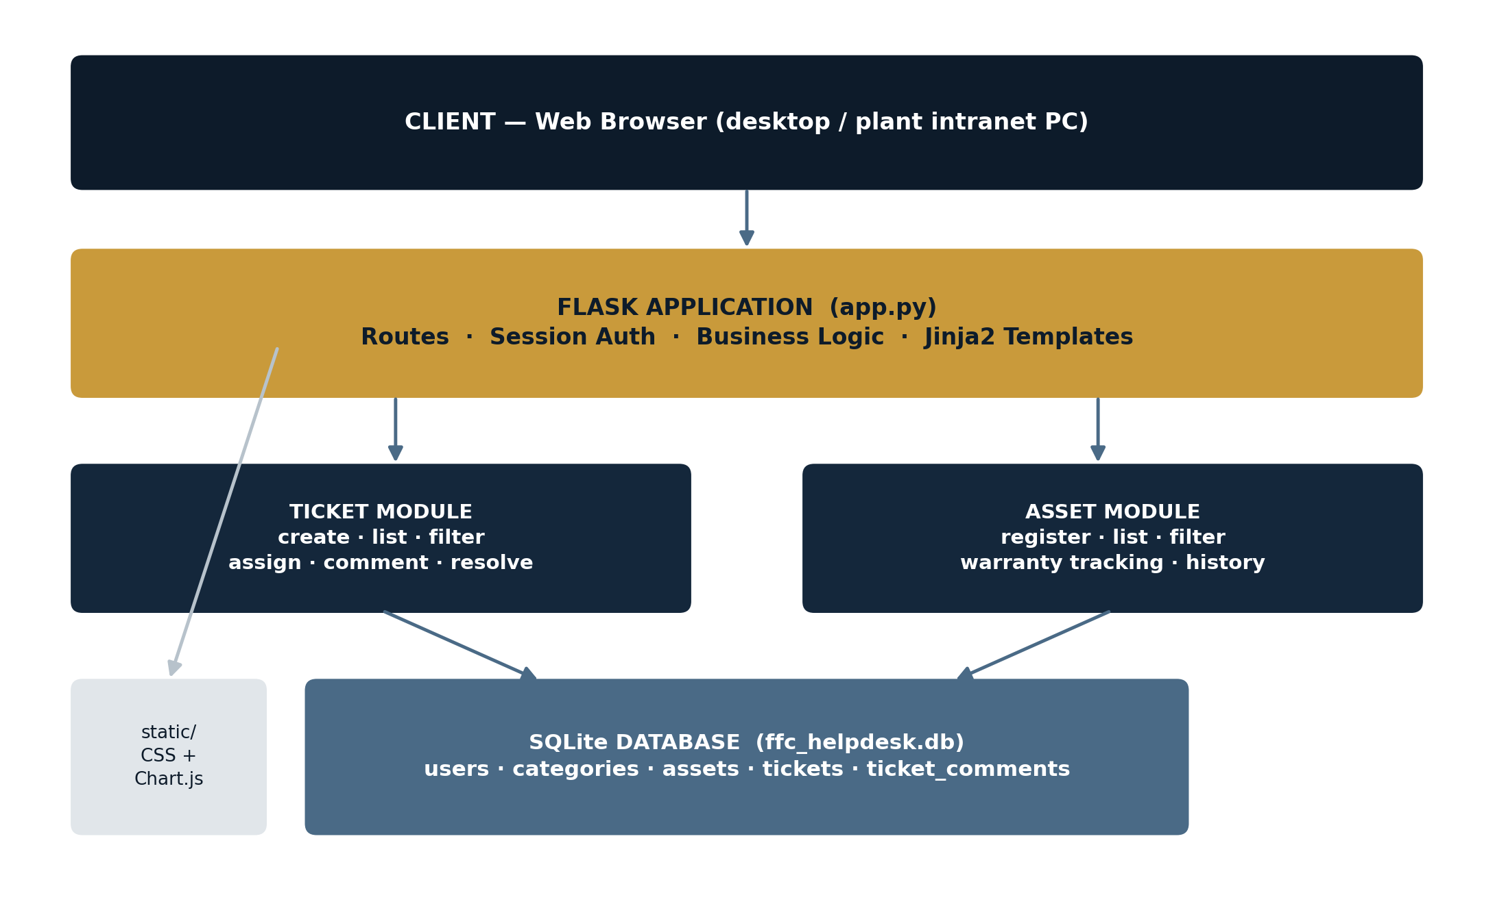
Figure 1 — System architecture: browser client, Flask application layer, and SQLite data layer.

Technology Stack
Field | Type | Notes
Backend | Python 3 + Flask | Routing, session-based authentication, business logic, Jinja2 templates
Database | SQLite (via Python's built-in sqlite3) | Zero-configuration, file-based — no separate database server to install
Frontend | HTML5 + CSS3 (custom stylesheet) | Server-rendered pages; no build step or JavaScript framework required
Charts | Chart.js 4.4 (vendored locally) | Bundled into static/ so the dashboard works without internet access
Auth | Werkzeug password hashing + Flask sessions | Passwords are hashed, never stored in plain text

5. Database Design
The database uses five tables: users, categories, assets, tickets, and ticket_comments. Categories are shared between assets and tickets so that support requests and equipment use the same classification (Network, SAP/ERP, Hardware, Security, etc.). Every ticket may optionally reference the asset it concerns, and every ticket may have any number of follow-up comments.
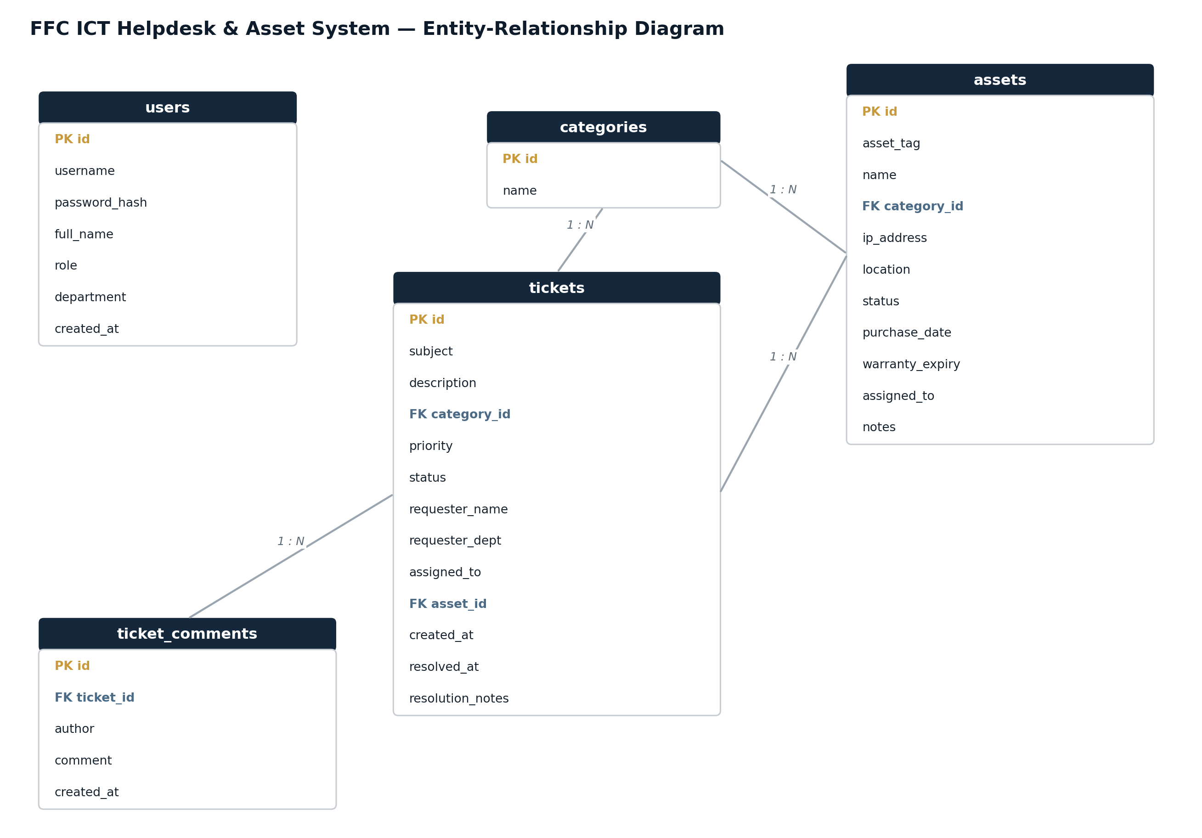
Figure 2 — Entity-relationship diagram of the five core tables.

tickets — key fields
Field | Type | Notes
subject / description | TEXT | What the user reported
category_id | INTEGER (FK) | Links to categories — Network, SAP/ERP, Hardware, etc.
priority | TEXT | Low / Medium / High / Critical
status | TEXT | Open / In Progress / Resolved / Closed
asset_id | INTEGER (FK, nullable) | Optional link to the specific asset involved
created_at / resolved_at | TEXT (ISO datetime) | Used to calculate average resolution time on the dashboard

assets — key fields
Field | Type | Notes
asset_tag | TEXT (unique) | Human-readable ID, e.g. SRV-DB-01
ip_address | TEXT | For network-connected assets
status | TEXT | Active / In Repair / Retired / Spare
warranty_expiry | TEXT (date) | Drives the "expired / expiring soon" flag on the asset list

6. Module Descriptions

6.1 Authentication
Users log in with a username and password (hashed with Werkzeug's security helpers, never stored in plain text). A Flask session then carries the user's role (admin, staff or user) for the rest of the visit, and protected routes redirect back to the login page if the session is missing.

6.2 Dashboard
The landing page after login. It shows four headline statistics (total tickets, open/in-progress tickets, unresolved critical tickets, and average resolution time in hours), two Chart.js visualisations (tickets by category, tickets by status), and a table of the six most recently logged tickets for quick triage.

6.3 Ticket Management
Any logged-in user can raise a ticket with a subject, description, category, priority and — optionally — the specific asset involved. IS staff can filter the ticket list by status, priority or a text search; open a ticket to see its full description, comment thread, and details panel; and update its status, assignee and resolution notes from the same page.

6.4 Asset Management
IS staff can register a new asset with its tag, category, IP address, location, status, purchase date and warranty expiry. The asset list automatically flags anything whose warranty has already expired or expires within 90 days, so ageing hardware doesn't go unnoticed. Each asset's detail page shows every ticket ever raised against it.

7. Application Walkthrough

7.1 Login
A focused login screen scoped to the Goth Machhi plant site, with demo credentials shown for evaluation purposes.
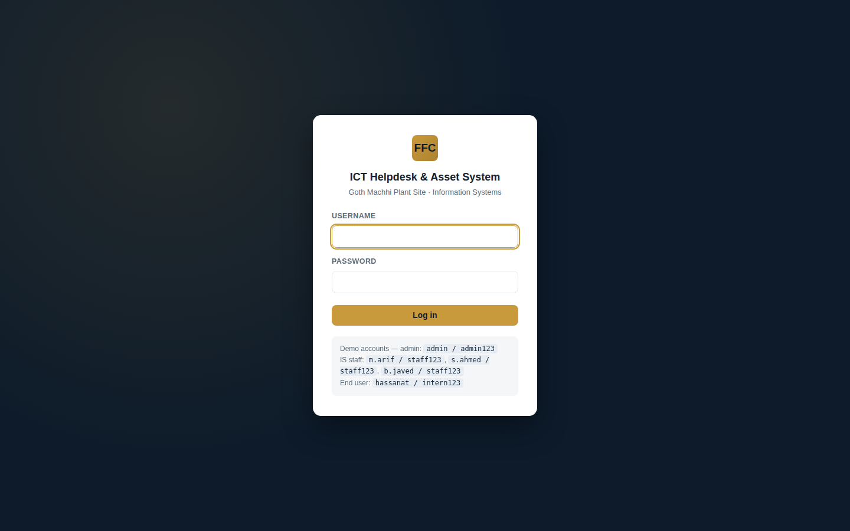
Figure 3 — Login screen.

7.2 Dashboard
At-a-glance ticket volume, category and status breakdowns, and the most recent activity.
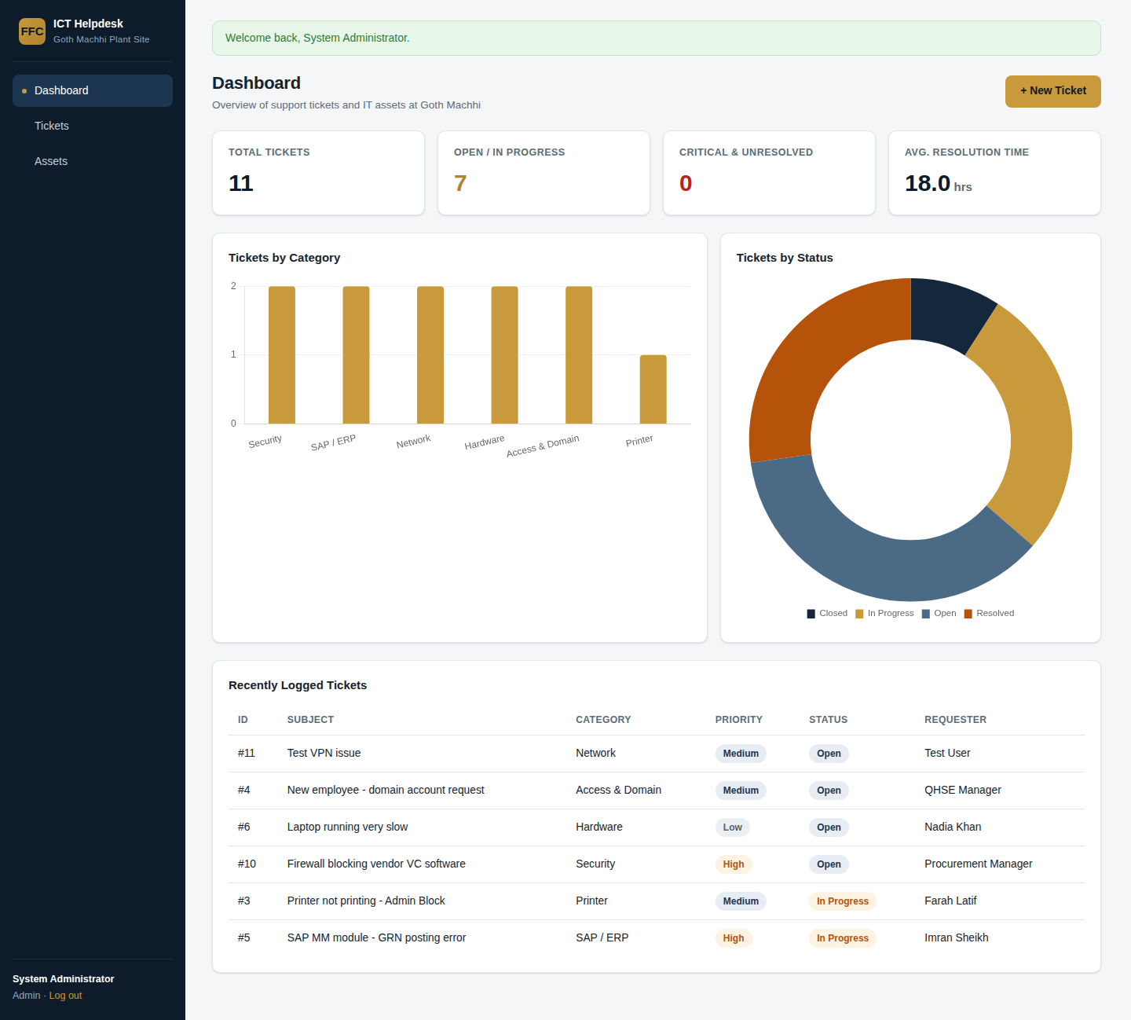
Figure 4 — Dashboard with live Chart.js visualisations.

7.3 Ticket List & Detail
Tickets can be filtered by status and priority, or searched by subject/requester. Opening a ticket shows its description, comment thread, linked asset (if any), and an update panel for status, assignment and resolution notes.
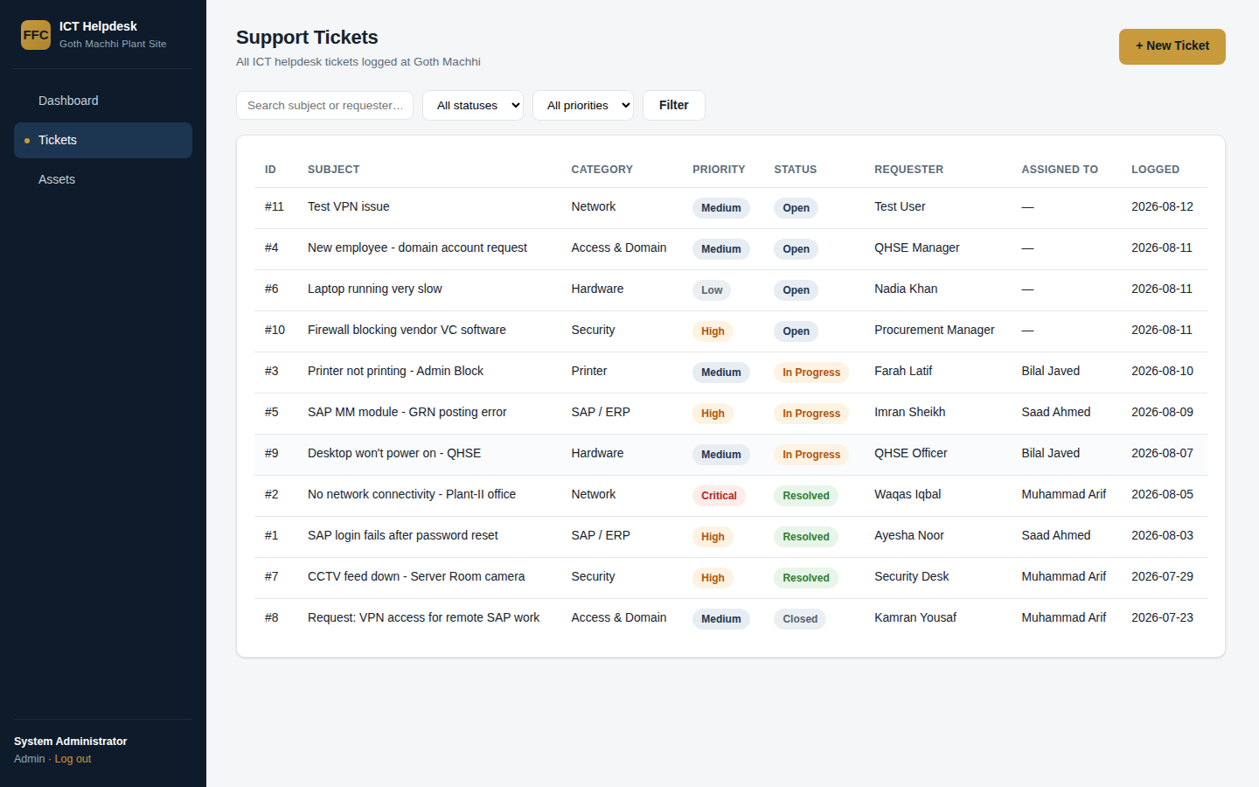
Figure 5 — Filterable ticket list.
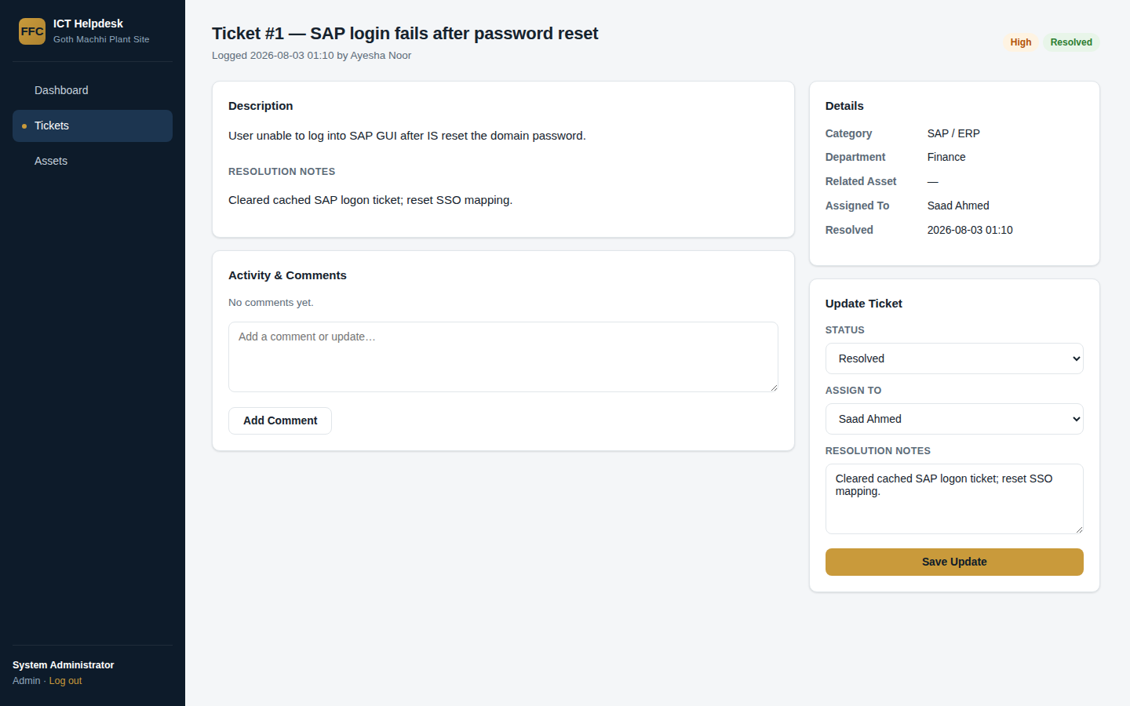
Figure 6 — Ticket detail view with comments and status update.

7.4 Asset Inventory
The full IT asset register, with automatic warranty-expiry flags shown in red (expired) — visible here on several plant devices whose warranty has already lapsed.
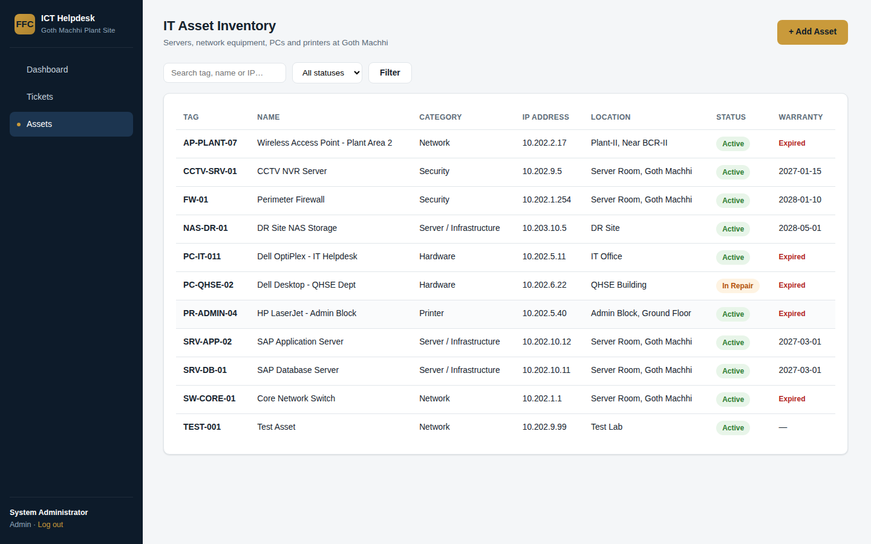
Figure 7 — IT asset inventory with warranty status.

7.5 New Ticket Form
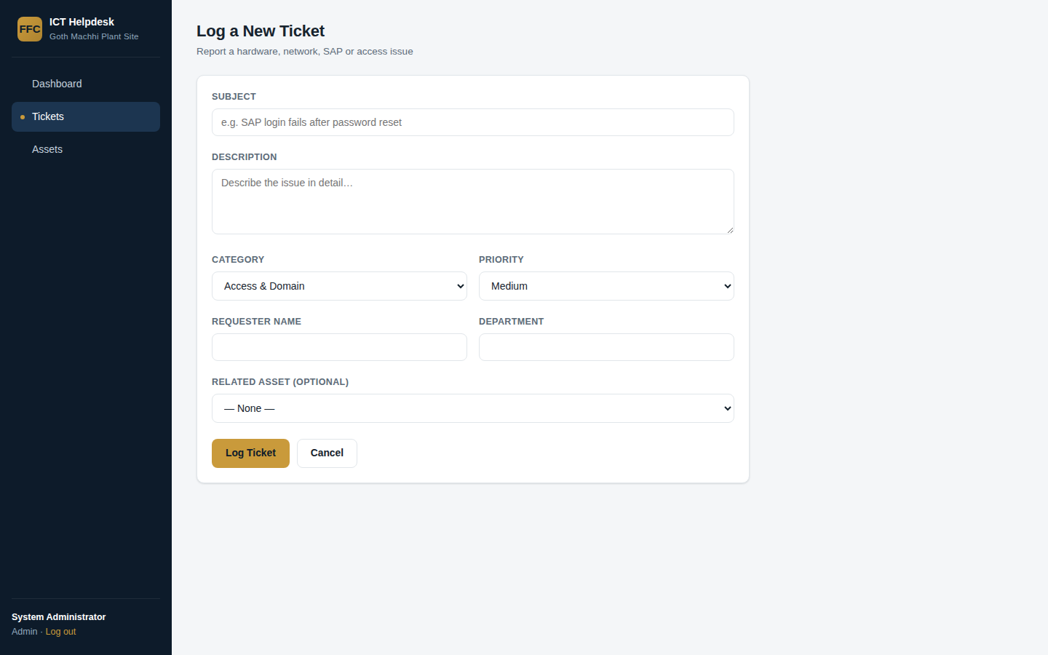
Figure 8 — Logging a new support ticket.

8. Installation & Setup
The project requires only Python 3.9+ and pip — no separate database server or internet connection is needed to run it.
cd FFC_ICT_Helpdesk_System
pip install -r requirements.txt
python app.py
The first run creates and seeds ffc_helpdesk.db automatically. Open http://127.0.0.1:5000 in a browser and log in with any of the demo accounts listed in the README (e.g. admin / admin123).

9. Security & Production Considerations
This build is a complete, working reference implementation suitable for an academic/internship submission and for small-scale real use. Before any wider deployment at FFC, the following should be addressed as part of the organisation's normal IT governance process:
- Replace the local user table with integration into FFC's existing Active Directory / domain, so accounts and passwords are managed centrally rather than duplicated.
- Serve the application over HTTPS and behind a production WSGI server (e.g. gunicorn behind nginx) rather than Flask's built-in development server.
- Add server-side validation and rate-limiting on the login and form-submission routes.
- Introduce role-based access control on write actions (currently any logged-in user can update any ticket; in production this should be limited to IS staff/admin roles).
- Move the secret key and any credentials out of source code and into environment-specific configuration.

10. Future Enhancements
- Email/SMS notifications when a ticket is assigned, updated or resolved.
- An SLA engine that automatically escalates tickets nearing a breach based on priority.
- A QR/barcode label per asset for quick lookup during physical audits.
- CSV/Excel export of tickets and assets for offline reporting.
- A REST API layer so the ticketing data could be surfaced inside SAP or a BI dashboard, echoing the BI/BO and centrally-developed-application landscape already in use at FFC-GM.
- A native mobile companion app for field technicians to update tickets from the plant floor.

11. Conclusion
This project delivers a working, purpose-built ICT Helpdesk & Asset Management System for FFC Goth Machhi — not just a design document. It directly reflects what was observed during the Information Systems internship: a busy helpdesk supporting close to 2,000 users, a wide and ageing asset base spread across plant and township offices, and a real need for a lightweight, centralised way to track both. Built entirely on open-source tools with no ongoing licensing cost and no dependency on internet connectivity, it is intended as a genuinely usable starting point that FFC's own IS team could extend, harden and integrate with its existing systems.

