System Documentation
for
Campus Food Ordering and Management System
Version 3.0

Name | Student No. | Assigned Actor/Process
Hassan Abdelhaleem Hassan Basheir | 251UC2506T | Student
Rashad Ali Qaid Sofan | 251UC2505G | Vendor
Ahmad Aljammal | 251UC2500R | Admin
Mohammed A. M. Alakklouk | 251UC250CR | Staff

Tutorial Section: TT5L | Group No.: 1 | Date: 16/06/2026

Contents
1 Project Management
2 System Overview
3 Requirements
4 Design
5 Implementation Details
6 Testing
7 Sample Screens
8 Reflection and Learning Outcomes
9 User Guide
10 Conclusion
11 References

Revisions
Version | Primary Author(s) | Description | Date Completed
SRS v1.0 | All team members | Part I requirements specification: actors, use cases, business rules, ERD, non-functional requirements. | 15/04/2026
SDS v2.0 | All team members | Part II design specification: activity, sequence, state, architecture, interface, component, and deployment design. | 02/06/2026
System Documentation v3.0 | All team members | Part III implementation documentation, prototype details, screenshots, testing, user guide, and reflections. | 16/06/2026

1 Project Management

1.1 Team Members
Team Member | Student No. | Actor | Assigned Processes
Hassan Abdelhaleem Hassan Basheir | 251UC2506T | Student | Student ordering, cart, payment, tracking, review
Rashad Ali Qaid Sofan | 251UC2505G | Vendor | Menu and inventory, vendor queue, status updates, analytics
Ahmad Aljammal | 251UC2500R | Admin | User/vendor/staff account management, configuration, reports
Mohammed A. M. Alakklouk | 251UC250CR | Staff | Queue calling, pickup/delivery confirmation

1.2 Problem Statement
Campus food outlets experience long queues and overcrowding during peak meal periods. Manual order handling, limited real-time inventory visibility, and lack of centralized pre-ordering reduce student break time and make vendor operations inefficient. The system solves this by digitizing menu browsing, ordering, scheduling, mock payment, queue tracking, vendor order management, staff pickup confirmation, and admin reporting in one role-based platform.

1.3 Project Plan / Gantt Chart
Activity | Jun 2-4 | Jun 5-8 | Jun 9-11 | Jun 12-14 | Jun 15-16
Analyze Part I and Part II | XXXX
Backend API, database, seed data |  | XXXX
Frontend role dashboards |  | XX | XXXX
Real-time queue, charts, validation |  |  | XX | XX
Screenshots and diagrams |  |  |  | XXXX
Part III documentation and QA |  |  |  | XX | XXXX

2 System Overview

2.1 Major Processes and Actors
Actor | Major Processes
Student | Self-register or login with email/password, browse menu, add to cart, schedule order, make mock payment, track order/queue, submit review.
Vendor | Login with an admin-created or seeded account, manage menu and inventory, accept/reject orders, update order status, view sales analytics.
Admin | Create vendor/staff accounts, activate or suspend accounts, configure settings, view and export reports.
Staff | Login with an admin-created or seeded account, call ready queue number, monitor queue display, confirm pickup/delivery, mark order completed.

2.2 Tasks by Team Member
Team Member | Tasks Completed
Hassan | Student workflow: menu browsing, cart, schedule, checkout/payment, tracking, review validation.
Rashad | Vendor workflow: menu/inventory CRUD, queue management, status updates, vendor analytics.
Ahmad | Admin workflow: users/vendors/staff table, account creation, status control, system settings, reports, CSV export, quality checks.
Mohammed | Staff workflow: queue panel, queue calling, pickup/delivery confirmation, completion updates.

2.3 Modules Developed
Module | Description
Authentication and RBAC | Email/password login, database role resolution, student self-registration, admin-created vendor/staff accounts, JWT protected dashboards.
Menu and Inventory | SQLite-backed vendor menu items, stock, availability, and time slot data.
Order and Payment | Order creation, line items, configurable mock payment success/failure, payment receipts.
Queue Management | Database queue tickets, public queue display, estimated waits, staff call and completion flow, live Socket.IO events.
Analytics and Reports | Vendor revenue/top items/ratings and admin system-wide reports with CSV export.
Frontend UI | Responsive React dashboards, charts, status chips, order stepper, toast messages, empty states.

2.4 Assumptions Used in Part III
- The production payment gateway described in Part I/II is represented by a configurable mock payment gateway for the local prototype.
- SQLite is used for the local demo database; the SDS cloud deployment can replace it with a managed relational database later.
- Campus authentication and external notification services are represented by local JWT authentication and Socket.IO events.
- Only pickup fulfillment is fully demonstrated; the data model keeps a fulfillment type field for future delivery support.
- The admin account is seeded for the demo; vendors and staff do not self-register and are created by the campus administrator.

2.5 Use Case Diagram
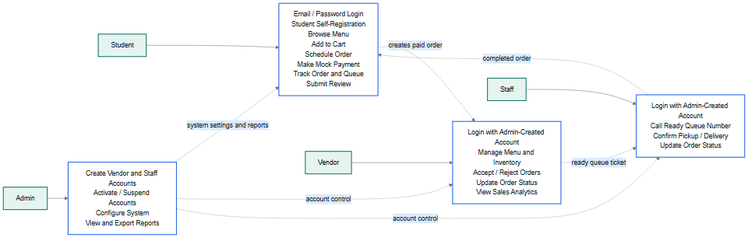
Figure 1. Use case diagram based on Part I actors and Part II interface scope.

3 Requirements

3.1 Class Diagram / ERD
The ERD follows Part I business rules and Part II data design. User is the base authentication entity, while role-specific entities extend it through one-to-one profile tables.
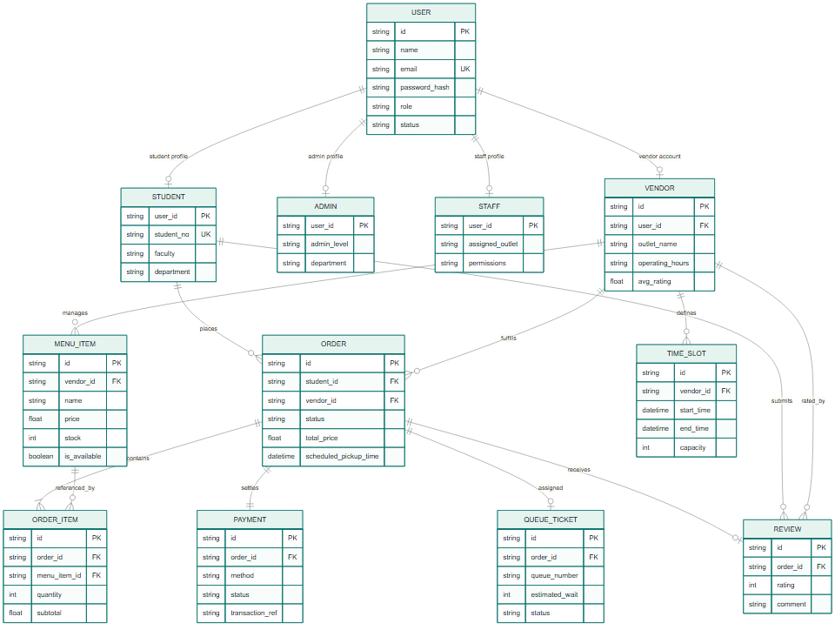
Figure 2. ERD/class model for the implemented SQLite database.

3.2 State Diagram
The implemented order lifecycle follows the SDS state model: payment creates a confirmed or cancelled order; vendors move orders through preparation; staff call and complete queue tickets; reviews are only allowed after completion.
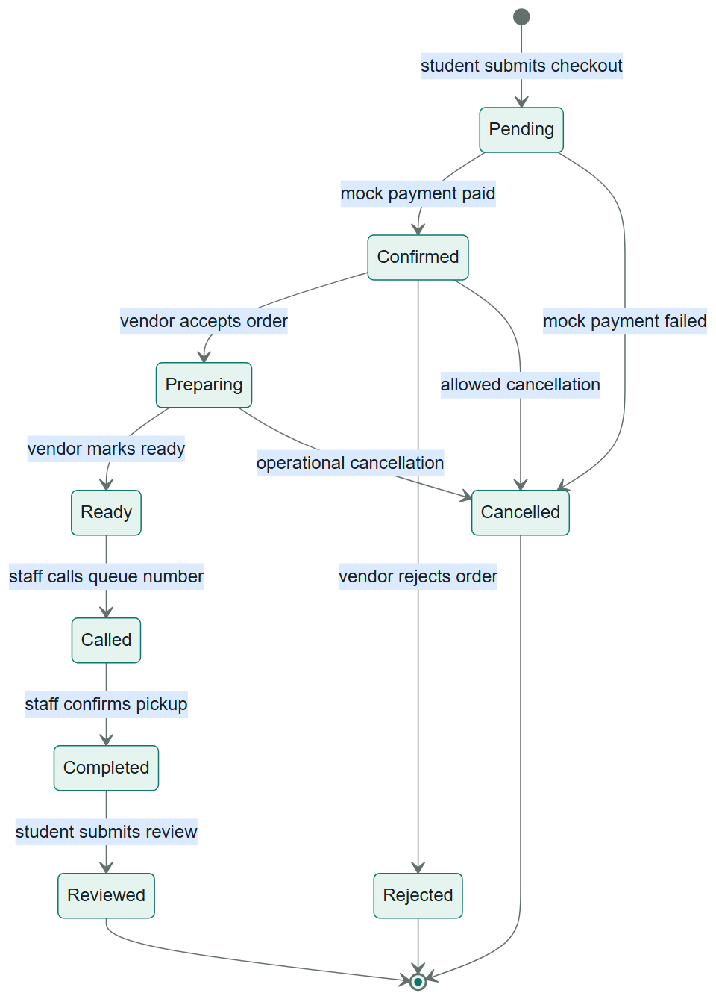
Figure 3. Order lifecycle state diagram.

4 Design

4.1 Data Dictionary
Entity | Main Fields | Purpose
User | id, name, email, password_hash, phone, role, status | Base authentication and authorization record.
Student | user_id, student_no, faculty, department, dietary_preferences | Student profile for orders and reviews.
Vendor | id, user_id, outlet_name, operating_hours, avg_rating, verification_status, location | Food outlet profile and owner of menu/order data.
Admin | user_id, admin_level, department, access_permissions | Administrative profile for system-wide operations.
Staff | user_id, assigned_outlet, permissions | Operational queue and pickup confirmation profile.
MenuItem | id, vendor_id, name, description, price, category, prep_time, stock, is_available, image_url | Vendor-managed sellable menu item.
Order | id, student_id, vendor_id, status, fulfillment_type, total_price, scheduled_pickup_time | Main transaction and status lifecycle record.
OrderItem | id, order_id, menu_item_id, quantity, unit_price, subtotal, customizations | Line items in an order.
Payment | id, order_id, method, status, amount, transaction_ref, failure_reason | Mock payment receipt and result.
QueueTicket | id, order_id, queue_number, estimated_wait, status, called_at, served_at | Queue display and staff operation record.
Review | id, order_id, student_id, vendor_id, rating, comment, created_at | Post-completion student feedback.
TimeSlot | id, vendor_id, start_time, end_time, capacity, booked_count | Scheduled pickup capacity.
SystemSetting | key, value, type, description, updated_at | Configurable runtime settings such as payment success rate and queue prefix.

4.2 Software Architecture
The prototype implements the SDS three-tier client-server architecture: React presentation tier, Express application tier, and SQLite data tier. Socket.IO provides real-time queue/order updates.
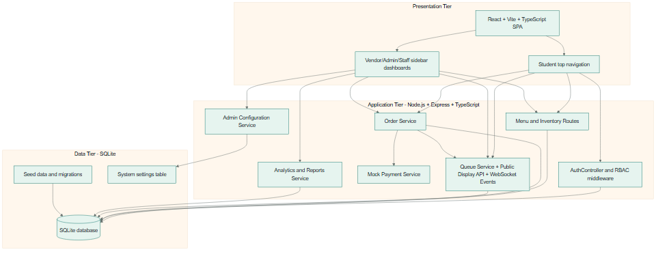
Figure 4. Software architecture diagram.

4.3 Subsystems and Team Member Assignment
Subsystem | Team Member | Implemented Scope
Student and Ordering | Hassan | Menu, cart, schedule, mock payment, tracking, review.
Vendor Management | Rashad | Menu/inventory, queue actions, status updates, sales analytics.
Admin Management | Ahmad | User/vendor control, settings, reports, export.
Staff and Queue | Mohammed | Queue display, call next, confirm pickup/delivery.

4.4 Main Screens
Screen | Actor | Purpose
Login/Register | All | Email/password login, database role routing, student/customer self-registration, and live public queue display.
Student Menu | Student | Browse API-driven menu items with vendor/category filters.
Cart/Checkout | Student | Quantity control, schedule selection, payment method, order placement.
Order Tracking | Student | Status stepper, queue number, payment receipt, review form.
Vendor Dashboard | Vendor | Metrics, active queue, menu/inventory form and table, sales chart.
Admin Dashboard | Admin | System metrics, reports, create vendor/staff accounts, account status management, settings, export.
Staff Queue Panel | Staff | Large queue display, call ready tickets, complete called pickups.

4.5 Student Subsystem Screens
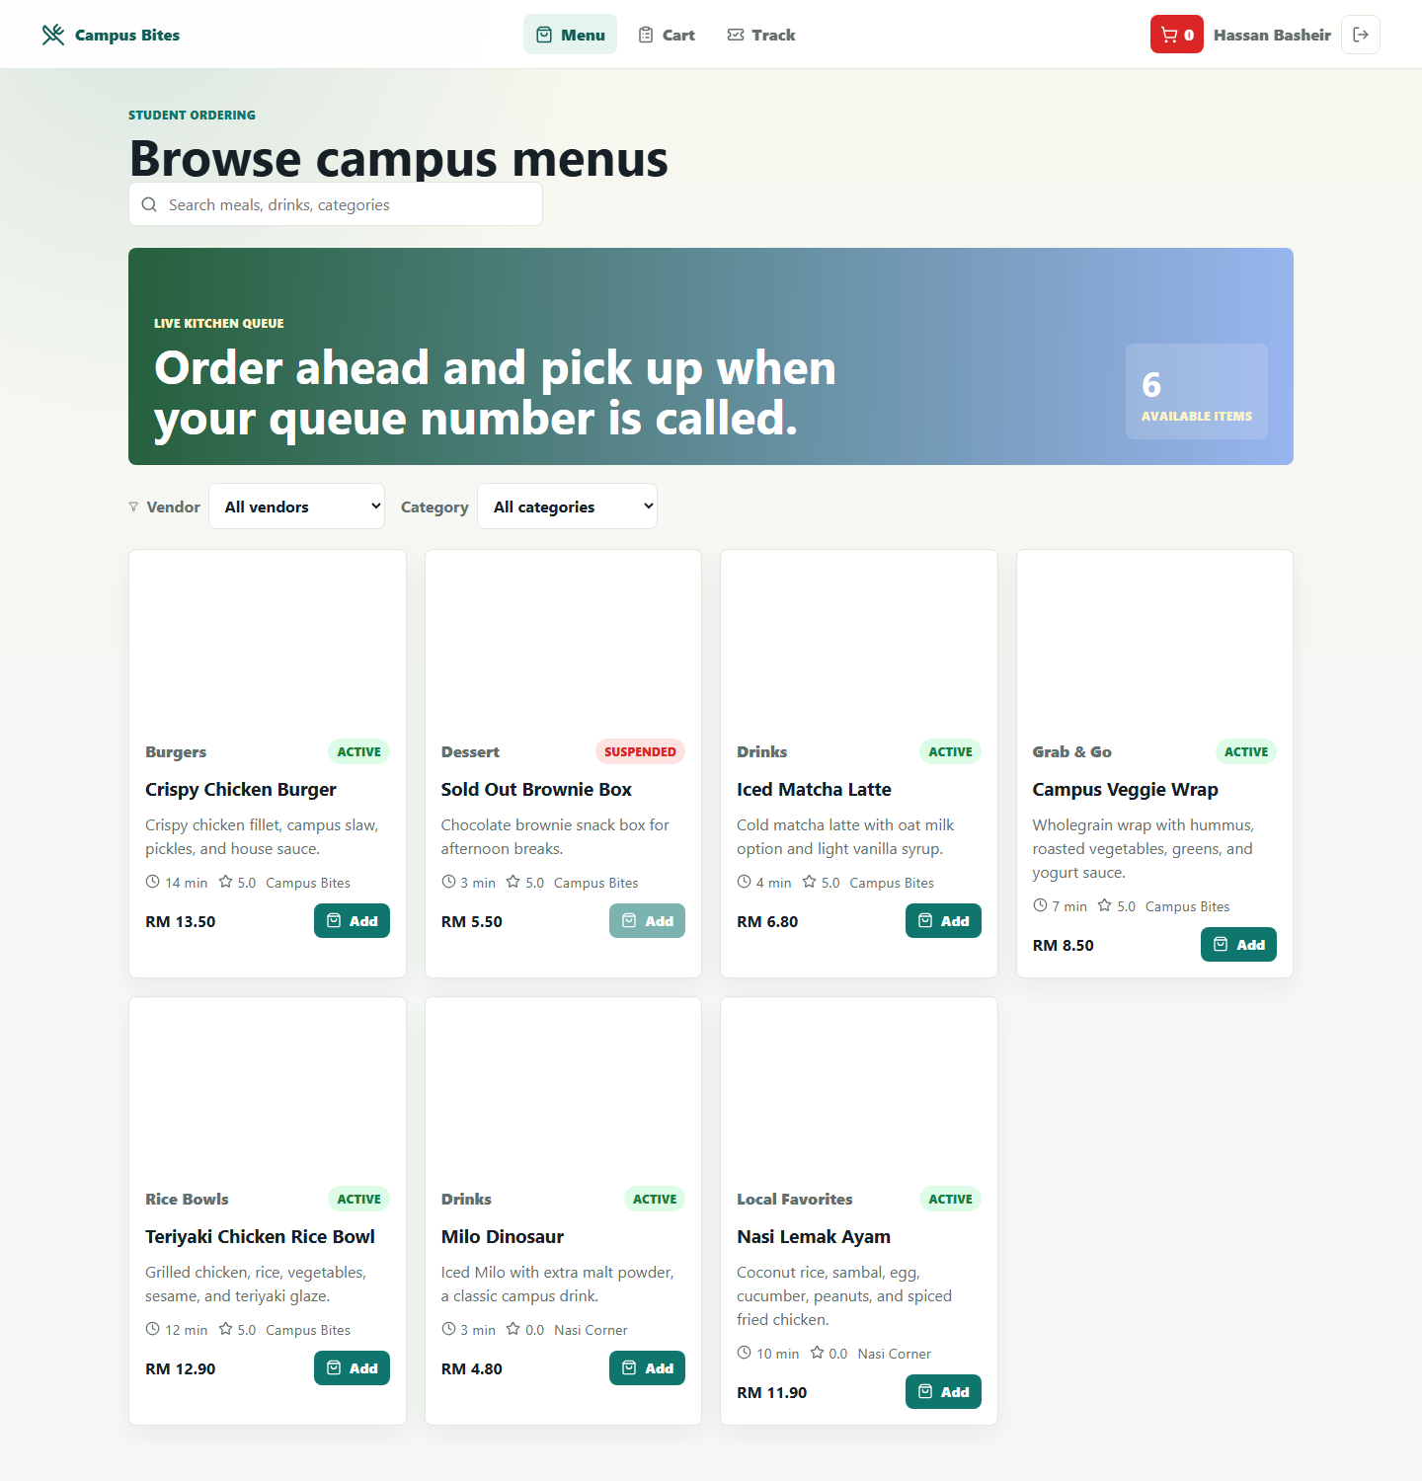
Figure 5. Student menu screen.
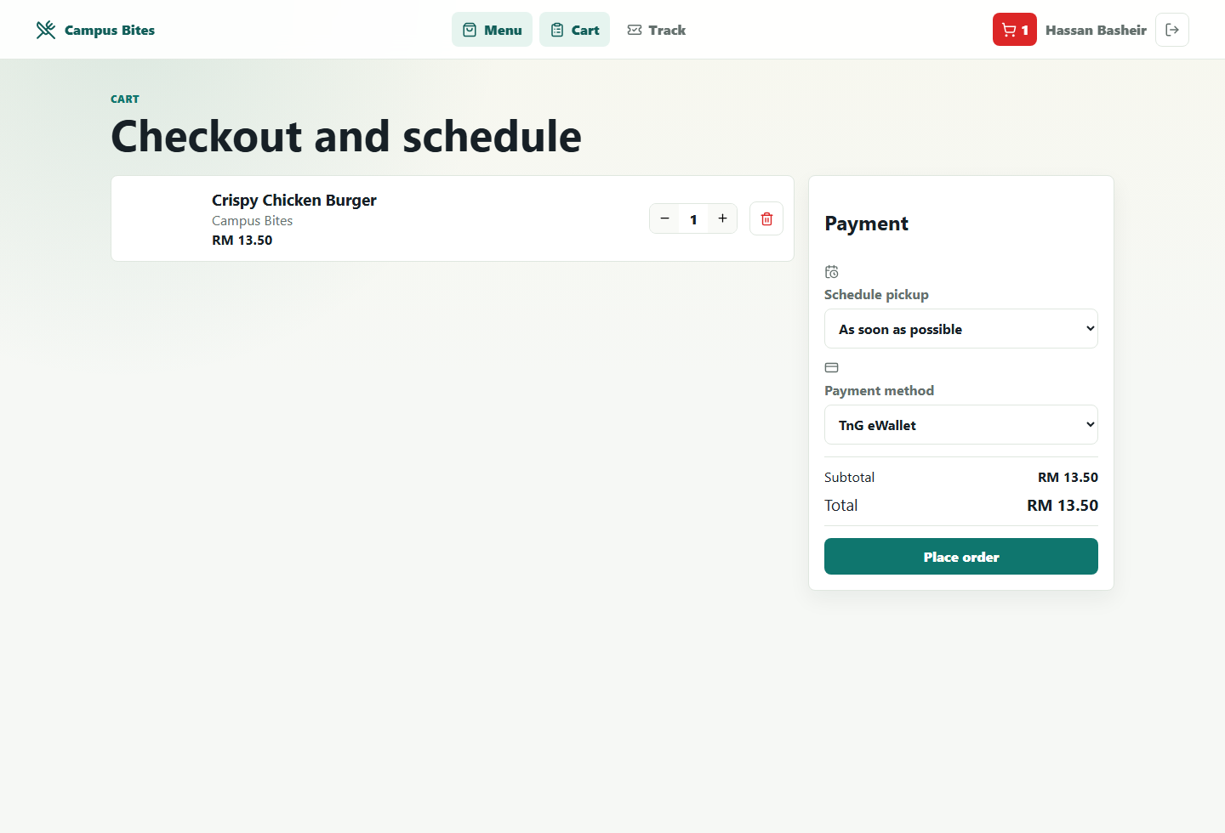
Figure 6. Student cart and checkout screen.
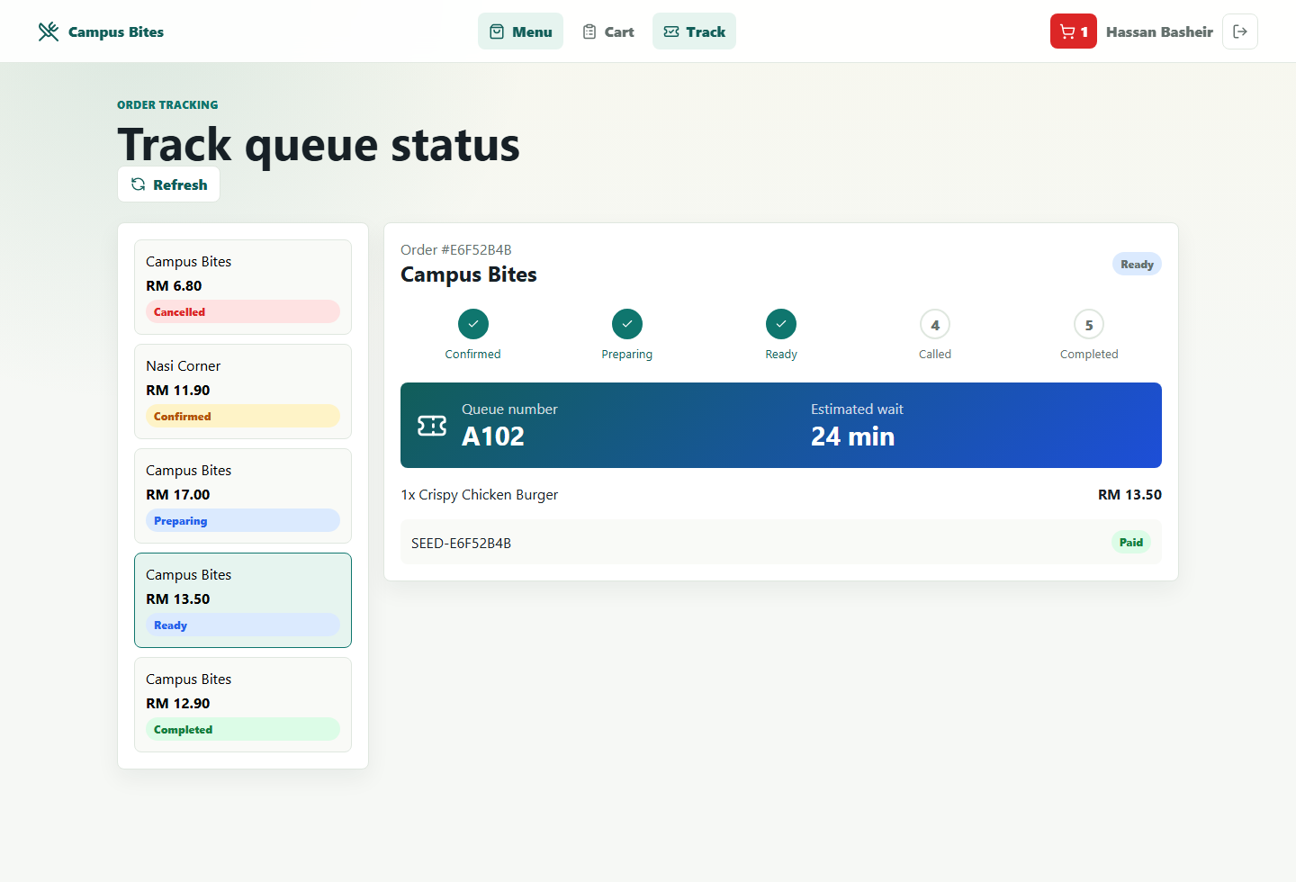
Figure 7. Student order tracking screen.

4.6 Vendor/Admin/Staff Subsystem Screens
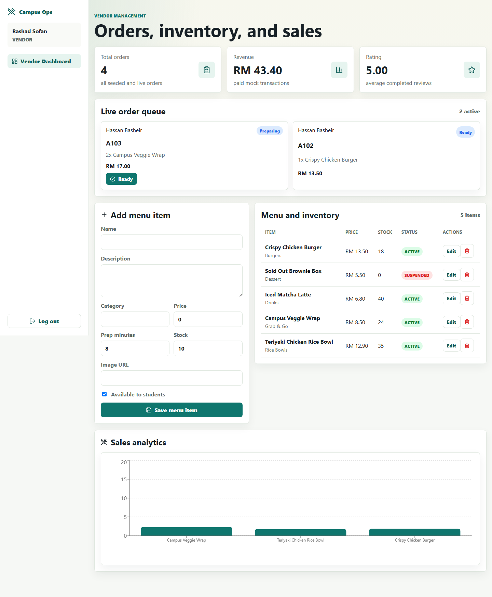
Figure 8. Vendor dashboard and inventory screen.
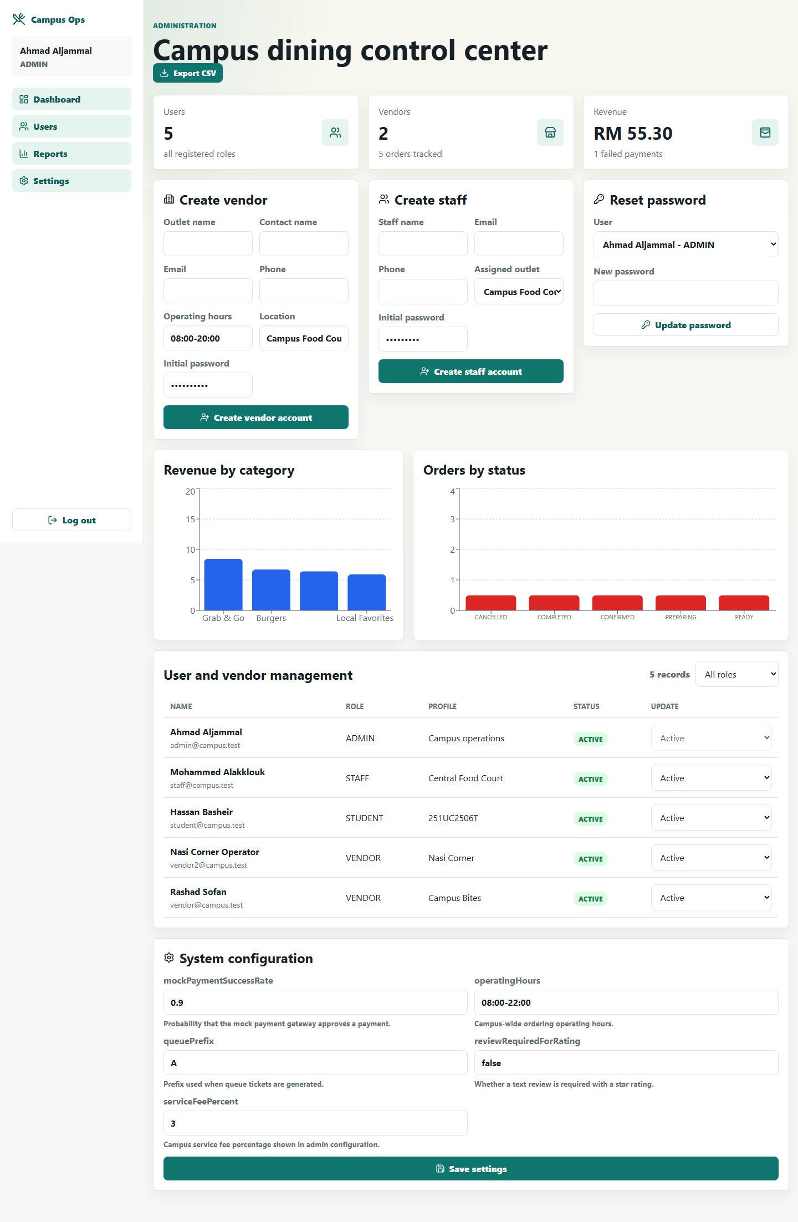
Figure 9. Admin dashboard and reports screen.
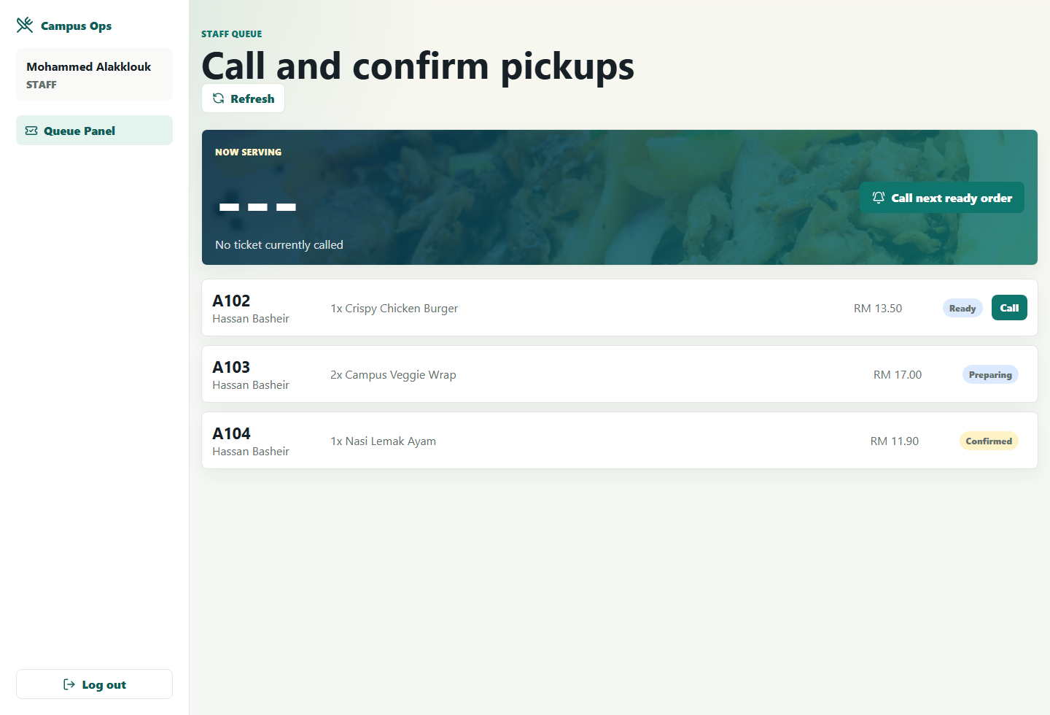
Figure 10. Staff queue panel screen.

4.7 Main Components
Component | Subsystem | Responsibility
AuthService | User Management | Email/password login, student self-registration, admin-created vendor/staff accounts, bcrypt password verification, JWT issuance.
OrderService | Ordering | Order creation, payment result handling, transitions, review rule enforcement.
MenuRepository | Vendor Management | Menu CRUD, availability, stock and time-slot operations.
QueueService/OrderRepository | Queue | Queue ticket creation, public queue display, call, served/cancelled state updates.
PublicQueueCard | Frontend | Displays the latest ready/called queue ticket from the public queue API and refreshes through Socket.IO/polling.
AnalyticsService | Reporting | Vendor and admin aggregate metrics and CSV export.
React Contexts | Frontend | Authenticated user session and cart state management.

4.8 Component Algorithm / Pseudocode / Workflow
Core order placement pseudocode:
1. Validate logged-in student and non-empty cart. 2. Load menu items from database. 3. Reject unavailable or insufficient-stock items. 4. Calculate total. 5. Run mock payment using SystemSetting.mockPaymentSuccessRate. 6. Create Order, OrderItem, and Payment records. 7. On success, decrement stock and create QueueTicket; on failure, save a failed payment and cancelled order without a queue ticket. 8. Emit Socket.IO events so student tracking, vendor queue, staff panel, and the public queue display refresh.
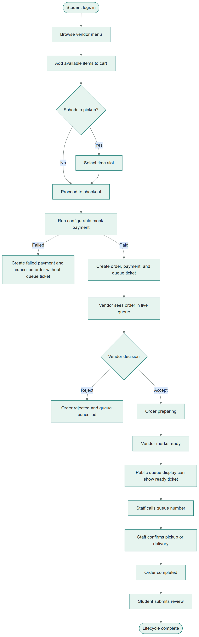
Figure 11. Main order workflow/activity diagram.

4.9 Deployment Diagram
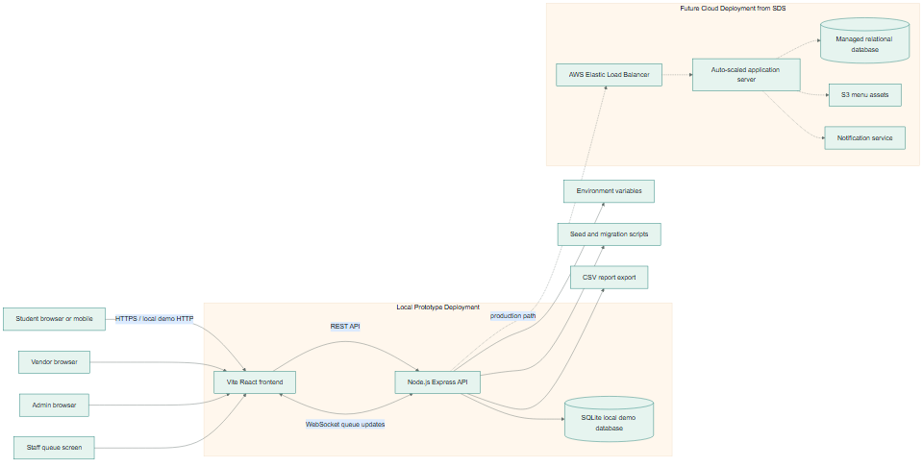
Figure 12. Local prototype and future cloud deployment diagram.

5 Implementation Details

5.1 Development Environment
Area | Tool / Library | Reason Used
Frontend | React, Vite, TypeScript | Maintained SPA stack with fast local development and type safety.
Backend | Node.js, Express, TypeScript | REST API, middleware, validation, and service layering.
Database | Node built-in SQLite module | Real local SQLite persistence without native npm SQLite packages.
Real-time | Socket.IO | Order and queue status update broadcasts.
Charts | Recharts | Vendor/admin analytics charts in React.
Validation/Security | Zod, bcryptjs, jsonwebtoken, helmet, cors | Input validation, password hashing, JWT RBAC, HTTP hardening.
Visual QA | Playwright | Local browser screenshots for sample screens.
Documentation | python-docx, ReportLab, Mermaid | DOCX/PDF generation and diagram rendering.

5.2 Setup Instructions
- Install Node.js 24 or later.
- From the project root, run: npm install
- Initialize demo data: npm run seed
- Start both servers: npm run dev
- Open the frontend at http://localhost:5173
- Login with email/password only; the system reads the role from the database and redirects to the matching dashboard.
- Build and test: npm run build and npm run test

5.3 Software Integration Strategy
Integration is API-driven. Frontend pages never contain hard-coded menu items, orders, analytics, users, or queue tickets. They call backend services through a typed API client. Login uses email/password only, and the backend determines the role from the users table. Role-based routes are protected by JWT and backend RBAC middleware. Socket.IO events and configured polling refresh student tracking, vendor queue, staff panels, and the public queue display when an order changes.

5.4 Database Implementation
The schema is created automatically by backend/src/database/schema.ts when the backend starts. The seed script populates the single demo admin, demo student, demo vendor and staff accounts, menu items, orders, payments, reviews, time slots, settings, and queue tickets. Student/customer self-registration creates only student-role accounts. Vendor and staff accounts are created by admin APIs and can be activated or suspended. Configurable runtime values are stored in system_settings.
Role | Email | Password | Purpose
Student | student@campus.test | Student123! | Browse menu, checkout, track order, review
Vendor | vendor@campus.test | Vendor123! | Manage queue, menu, inventory, analytics
Admin | admin@campus.test | Admin123! | Manage users, settings, reports
Staff | staff@campus.test | Staff123! | Call queue numbers, confirm pickup

5.5 Important Files and Folders
File / Folder | Description
backend/src/config | Environment configuration and runtime constants.
backend/src/constants | Central role, order status, payment status, queue status, and transition enums.
backend/src/database | SQLite schema, connection, and seed script.
backend/src/repositories | Database access layer for users, menu, orders, settings.
backend/src/services | Business rules for auth, orders, analytics, and real-time updates.
backend/src/routes | REST API route definitions by domain and actor.
frontend/src/config | App name, API URLs, nav labels, feature flags.
frontend/src/context | Auth and cart state providers.
frontend/src/pages | Role-based student, vendor, admin, and staff screens.
docs/diagrams | Mermaid sources and rendered PNG diagrams.
docs/screenshots | Playwright screenshots of the running application.
scripts | Screenshot, Mermaid, and documentation generation scripts.

6 Testing

6.1 Testing Strategy
- Backend scenario test verifies health, email/password login for each role, restricted public registration, student checkout, vendor status updates, staff queue calling, review rules, admin account creation/suspension/password reset, role API blocking, and payment failure handling.
- Frontend TypeScript build verifies route/component/service integration.
- Full build verifies backend and frontend compile without errors.
- Playwright screenshot script verifies major pages render in a browser with real API data.
- Manual acceptance testing checks realistic role workflows, order transitions, public queue display updates, account management rules, and review rules.

6.2 Test Data
Role | Email | Password | Seeded Data
Student | student@campus.test | Student123! | Browse menu, checkout, track order, review
Vendor | vendor@campus.test | Vendor123! | Manage queue, menu, inventory, analytics
Admin | admin@campus.test | Admin123! | Manage users, settings, reports
Staff | staff@campus.test | Staff123! | Call queue numbers, confirm pickup

6.3 Acceptance Testing by Team Member / Module
Team Member | Module | Acceptance Test | Result
Hassan | Student | Login, browse menu, add item, view cart, choose schedule/payment, track active order, submit review only for completed order. | Passed
Rashad | Vendor | Login, view active queue, accept confirmed order, mark preparing order ready, update menu item, view analytics. | Passed
Ahmad | Admin | Login, create vendor account, create staff account, activate/suspend vendor and staff, protect seeded admin account, update configuration values, export CSV report. | Passed
Mohammed | Staff | Login, view ready queue ticket, call queue number, confirm called pickup and mark completed. | Passed
All | Integration | Order status updates are visible in student/vendor/staff dashboards and public queue display through API refresh and Socket.IO events. | Passed
All | Build and Audit | npm run build, npm run test, npm audit --audit-level=high. | Passed

7 Sample Screens
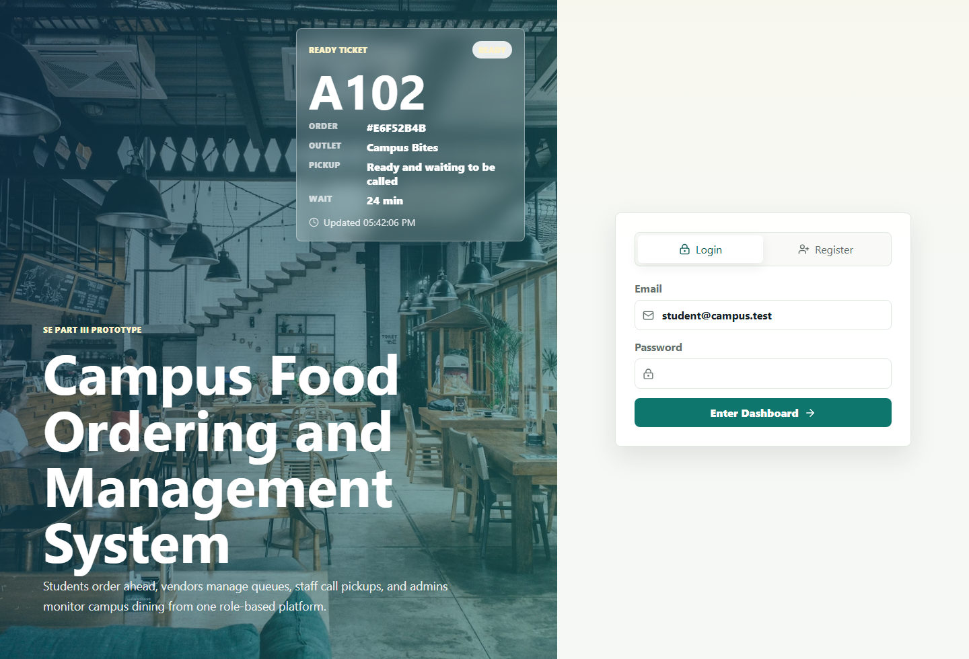
Figure 13. Email/password login, student registration, and public queue display screen.

Figure 14. Student menu browsing screen.

Figure 15. Cart, schedule, and payment screen.

Figure 16. Order tracking and queue status screen.
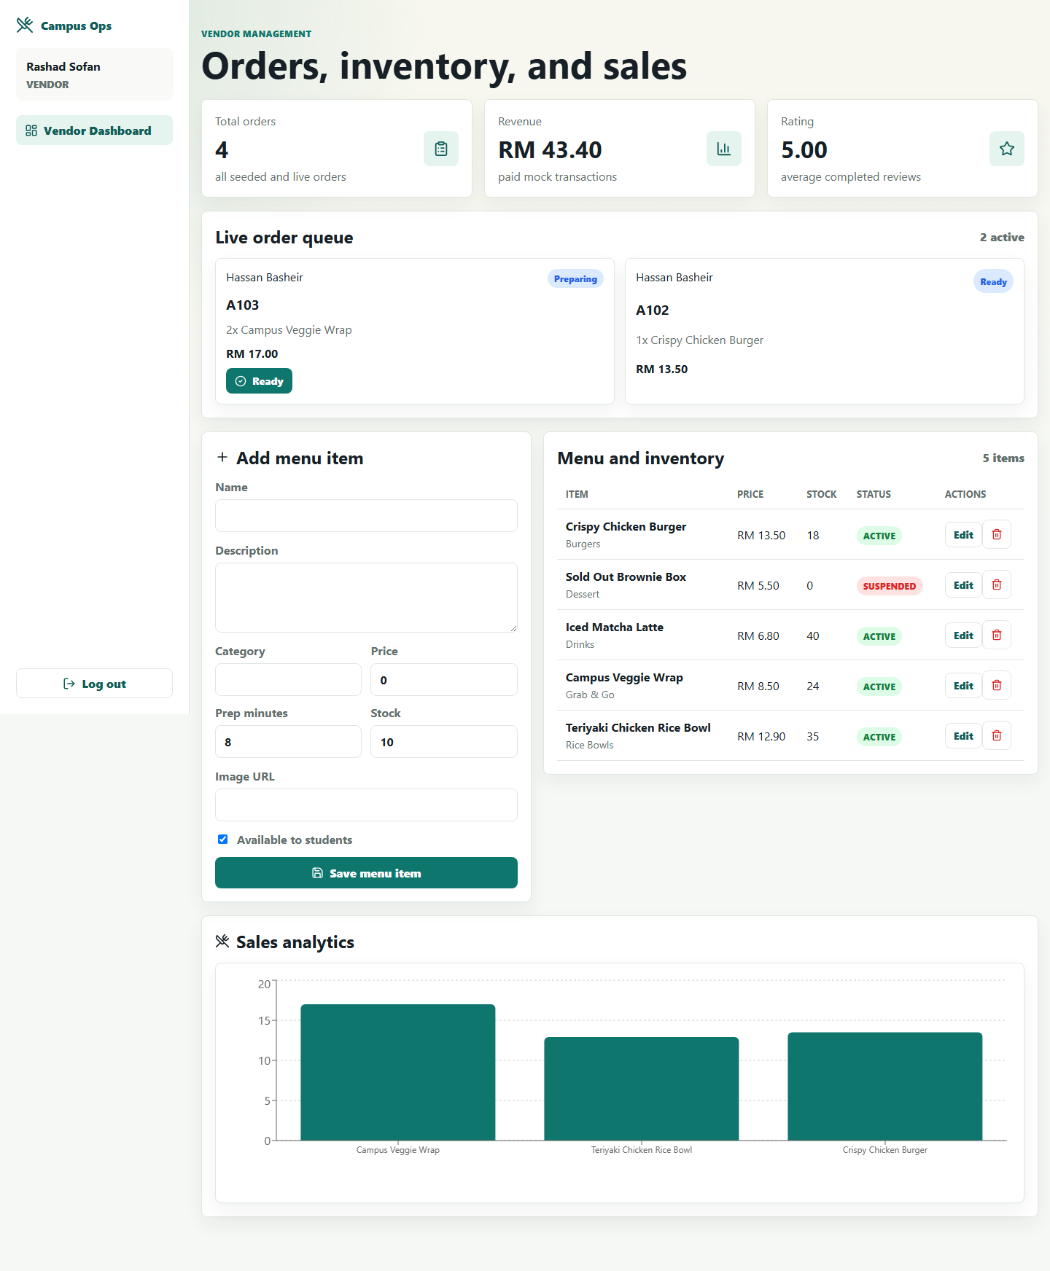
Figure 17. Vendor queue management screen.

Figure 18. Admin dashboard and analytics screen.

Figure 19. Staff queue panel screen.

8 Reflection and Learning Outcomes

Hassan
Working on the Student subsystem showed how important a clear order flow is. A student should not need to understand backend states to place an order, so the UI uses menu filters, a simple cart, a payment result, and a stepper for tracking. I learned to connect user-facing convenience with database rules such as stock checking and review eligibility.

Rashad
The Vendor subsystem required balancing speed and control. Vendors need quick accept, reject, ready, and inventory actions, but those actions must respect the order state machine. I learned how analytics, queue management, and inventory belong together because each order affects sales, stock, and queue visibility.

Ahmad
The Admin subsystem made the value of centralized configuration clear. Settings such as mock payment success rate and queue prefix should not be hidden in components. I learned how reports, user control, and configuration support software quality assurance and operational visibility.

Mohammed
The Staff subsystem focused on the last step of the service experience. Calling the correct queue number and confirming pickup must be simple, visible, and reliable. I learned that even a small staff panel needs strong status rules so completed orders are recorded accurately.

9 User Guide

9.1 Login
- Open http://localhost:5173.
- Type the account email and password only; do not choose a role.
- Click Enter Dashboard.
- The backend validates the password, reads the role from the users table, and redirects to the Student, Vendor, Admin, or Staff dashboard.
- Use Register only for student/customer self-registration. Vendor and staff accounts are created by the admin dashboard.

9.2 Student Ordering
- Browse the Menu page and filter by vendor or category.
- Click Add on an available item.
- Open Cart.
- Adjust quantity if needed.
- Choose a pickup slot or leave as soon as possible.
- Select a payment method and place the order.
- Open Track to view status, queue number, payment receipt, and review eligibility.

9.3 Vendor Queue and Inventory
- Login as vendor.
- Review active orders in Live order queue.
- Accept confirmed orders to move them to Preparing.
- Mark preparing orders as Ready.
- Use the menu form and inventory table to add, edit, or remove menu items.
- Review sales analytics for revenue, order volume, top items, and ratings.

9.4 Admin Reports and Settings
- Login as admin.
- Review users, vendors, revenue, and order status charts.
- Use Create vendor to add an outlet name, email, phone, operating hours, and initial password.
- Use Create staff to add a staff name, email, phone, assigned outlet, and initial password.
- Activate or suspend vendor/staff accounts from the user management table; the seeded admin account is protected.
- Update settings such as mockPaymentSuccessRate and queuePrefix.
- Click Export CSV to download a report.

9.5 Staff Queue Handling
- Login as staff.
- Review Ready and Called tickets in the queue panel.
- Click Call next ready order or Call beside a ready ticket.
- Confirm pickup only after the queue number has been called.
- The order moves to Completed and the queue ticket is marked served.
- The public queue display and student tracking refresh from backend queue/order data.

10 Conclusion

10.1 Completion Summary
Part III completed a working local prototype aligned with the Part I SRS and Part II SDS. The system includes email/password login with database role routing, student/customer self-registration, admin-created vendor/staff accounts, student ordering, mock payment, real queue tracking, vendor management, admin reporting, staff queue handling, seed data, diagrams, screenshots, and setup documentation.

10.2 Software Quality Assurance
- Central enums prevent duplicated status strings.
- Environment variables control API URLs, ports, app name, payment rate, queue prefix, and queue refresh interval.
- Seed data stores demo business records outside UI components.
- Repositories and services separate database access from business rules.
- RBAC middleware protects actor-specific API routes and account status is checked on every request.
- Build, scenario test, audit, and screenshot scripts support repeatable verification.

10.3 Collaboration
The final prototype follows the team actor assignments from Part I and subsystem assignments from Part II. Each role dashboard maps directly to the assigned responsibilities and acceptance tests.

10.4 Problems Encountered
- External services from the SRS, such as payment gateways and campus authentication, were not suitable for a local university prototype, so mock/local equivalents were documented.
- Real-time browser screenshots required local Playwright because the in-app browser surface was unavailable.
- LibreOffice was not available on PATH, so DOCX visual render QA could not be completed through the document renderer; a ReportLab PDF was generated separately.

10.5 Future Recommendations
- Replace mock payment with a sandbox payment gateway.
- Connect campus SSO and official notification services.
- Deploy with HTTPS, managed database backups, and production logging.
- Add automated end-to-end tests for every role workflow.
- Add delivery fulfillment and QR-code pickup verification.

11 References
- IEEE Std 830-1998: IEEE Recommended Practice for Software Requirements Specifications.
- Sommerville, I. (2016). Software Engineering (10th ed.). Pearson.
- Larman, C. (2004). Applying UML and Patterns (3rd ed.). Prentice Hall.
- OWASP Foundation (2024). Password Storage Cheat Sheet. https://cheatsheetseries.owasp.org
- World Wide Web Consortium (2018). Web Content Accessibility Guidelines (WCAG) 2.1.
- Payment Card Industry Security Standards Council (2022). PCI DSS v4.0.
- Amazon Web Services (2024). AWS Architecture Best Practices. https://aws.amazon.com/architecture
- React, Vite, TypeScript, Node.js, Express, SQLite, Socket.IO, Recharts, Mermaid, Playwright, python-docx, and ReportLab official documentation.
- Part I SRS: Proj_PI_TT5L_G1_Hassan, Rashad, Ahmad, Mohammed.pdf.
- Part II SDS: Proj_PII_TT5L_G1_Hassan, Rashad, Ahmad, Mohammed.pdf.

