REPUBLIC OF CAMEROON  Peace – Work – Fatherland  Ministry of Basic Education (MINEDUB)  Regional Delegation of Basic Education – Centre  Divisional Delegation of Basic Education – Mfoundi |   BRIGHT CONTINENT  BILINGUAL SCHOOL  Dragage – Yaoundé • +237 678 34 12 13 | RÉPUBLIQUE DU CAMEROUN  Paix – Travail – Patrie  Ministère de l’Éducation de Base (MINEDUB)  Délégation Régionale de l’Éducation de Base – Centre  Délégation Départementale de l’Éducation de Base – Mfoundi

OCTOBER ASSESSMENT – CLASS ____
CM I / CM II • English Language • Academic year 2026-2027

Name: | Date:
Competence 1A: English Language – Total: 30 marks

SECTION A: GRAMMAR (10 marks)
1. We cannot read or write sentences without using punctuation marks. Below are punctuation marks. Match them to their names.
? |  | Exclamation mark
ABC |  | Full stop
! |  | Question mark
, |  | Capital letters
. |  | Comma
2. Underline the punctuation marks in the sentences below.
1) What is your name?
2) I have a book.
3) Please give me water, juice, and rice.
4) Wow! You are wonderful.
5) Why are you sleeping?
SOUND AND WORD BUILDING (5 marks)
Instruction: Write the names of these objects having the /ir/ sound.
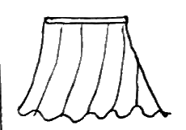  _______________ | 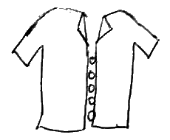  _______________ | 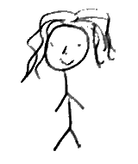  _______________ | 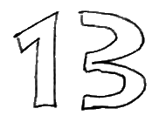  _______________
VOCABULARY (5 marks)
Instruction: Underline the correct answer in the brackets.
1. A place where people save money and get paid is a __________.
(bank, market)
2. Farming is an activity of people living in a __________.
(village, town)
3. We go to the __________ when we want to move from one town to the other.
(taxi, bus station)
4. __________ is a place where people sleep when travelling.
(hotel, hospital)
5. We buy food at the __________.
(restroom, market)
READING COMPREHENSION – CM2
Instruction: Read this passage attentively and then answer the questions that follow.
PASSAGE
The cat and the rat were once very good friends. They ate and played together. Beside their house was a big river. On the other side of the river, there was plenty of food. They ate a piece of yam, made a canoe to cross the river and get the food. As they were crossing the river, the rat ate part of the canoe and water came in. From that day they became enemies.
Questions
1. Name the animals that are mentioned in the passage.
......................................................................................
2. State any two things the animals did together.
......................................................................................
3. What was beside their house?
......................................................................................
4. Why do you think the rat ate the canoe?
......................................................................................
5. What was found on the other side of the river?
......................................................................................
6. What happens today when a cat sees a rat?
......................................................................................
7. What did they use in making the canoe?
......................................................................................
8. Name one creature that lives in water.
......................................................................................
PRODUCTIVE WRITING (5 marks)
Self introduction. Below are sentences. Complete them with information about yourself.
1) My name is ______________________________
2) I am in class ______________
3) The name of my school is ______________________________
4) I am ______________ years old.
5) I live with my ______________ in ______________________.

