REPUBLIC OF CAMEROON  Peace – Work – Fatherland  Ministry of Basic Education (MINEDUB)  Regional Delegation of Basic Education – Centre  Divisional Delegation of Basic Education – Mfoundi |   BRIGHT CONTINENT  BILINGUAL SCHOOL  Dragage – Yaoundé • +237 678 34 12 13 | RÉPUBLIQUE DU CAMEROUN  Paix – Travail – Patrie  Ministère de l’Éducation de Base (MINEDUB)  Délégation Régionale de l’Éducation de Base – Centre  Délégation Départementale de l’Éducation de Base – Mfoundi

NURSERY 1 — WEEKLY ASSESSMENT
Reading • Writing • Mathematics

SCHOOL: Bright Continent Bilingual School
NAME:

READING

1. Match the sounds to the image.
i | ● |  | ● | 
o | ● |  | ● | 
u | ● |  | ● | 
2. Circle sound o.
a | i | o | e | o | b | o
3. Use lines to match the sounds which are the same.
a | ● |  | ● | o
i | ● |  | ● | e
e | ● |  | ● | a
o | ● |  | ● | i

WRITING

1. Trace the following curves.


2. Name and write the following curves.
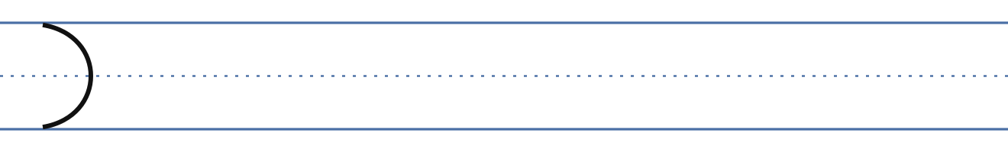
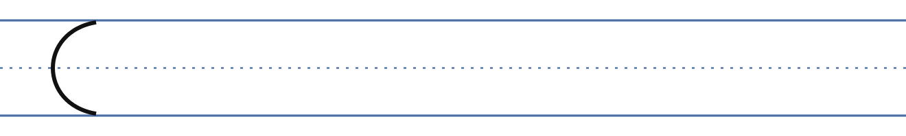

MATHEMATICS

1. Count numbers from 1 – 5.
1 | 2 | 3 | 4 | 5
2. Trace and write number 1.
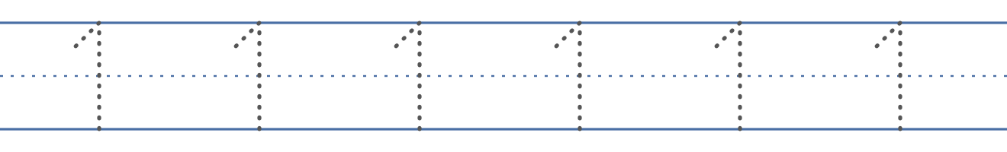
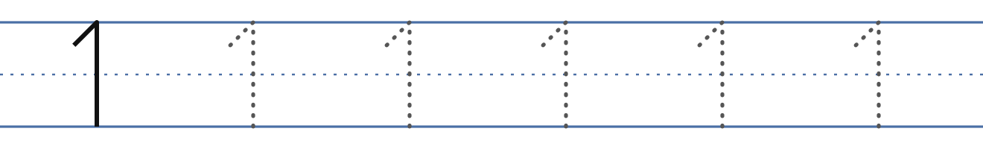
3. Trace number 2.
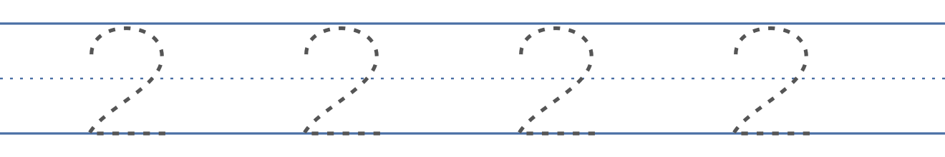
4. Match the same numbers.
1 | ● |  | ● | 2
2 | ● |  | ● | 1

