REPUBLIC OF CAMEROON  Peace – Work – Fatherland  Ministry of Basic Education (MINEDUB)  Regional Delegation of Basic Education – Centre  Divisional Delegation of Basic Education – Mfoundi |   BRIGHT CONTINENT  BILINGUAL SCHOOL  Dragage – Yaoundé • +237 678 34 12 13 | RÉPUBLIQUE DU CAMEROUN  Paix – Travail – Patrie  Ministère de l’Éducation de Base (MINEDUB)  Délégation Régionale de l’Éducation de Base – Centre  Délégation Départementale de l’Éducation de Base – Mfoundi

NURSERY 2 — WEEKLY ASSESSMENT
Mathematics • Reading • Writing

SCHOOL: Bright Continent Bilingual School
NAME:

MATHEMATICS

1. Count and write the number of things found in each set.
  Number: .......... |  |   Number: ..........
  Number: .......... |  | 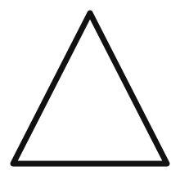  Number: ..........
2. Count and write the missing number.
1 |  | 3 |  |  | 6 |  | 8 |  | 10
 | 2 |  | 4 |  |  | 7 |  | 9

3. Write 0 – 1 in figures and in words.
0 – Zero | 1 – One

READING

1. Build and read 2 letter words.
b + a =  c + a =  d + a =  f + a =  h + a =  j + a =  l + a =  m + a = | n + a =  p + a =  r + a =  s + a =  t + a =  v + a =  y + a =

2. Read and write the 5 vowel sounds.
a | e | i | o | u
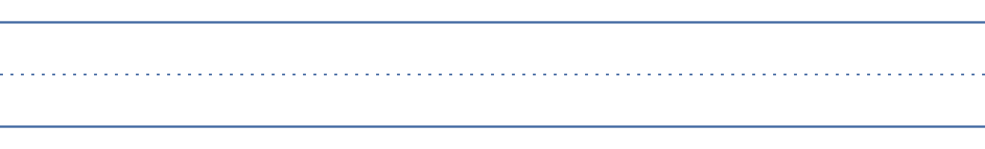

3. Write the initial sound of each image below.
  _____nsect |   _____nk |   _____nvelope
_____pple |   _____gloo |   _____gg

WRITING

Look at the letters and write them on the lines.
b | d | f | h | k | l | t

