REPUBLIC OF CAMEROON  Peace – Work – Fatherland  Ministry of Basic Education (MINEDUB)  Regional Delegation of Basic Education – Centre  Divisional Delegation of Basic Education – Mfoundi |   BRIGHT CONTINENT  BILINGUAL SCHOOL  Dragage – Yaoundé • +237 678 34 12 13 | RÉPUBLIQUE DU CAMEROUN  Paix – Travail – Patrie  Ministère de l’Éducation de Base (MINEDUB)  Délégation Régionale de l’Éducation de Base – Centre  Délégation Départementale de l’Éducation de Base – Mfoundi

OCTOBER ASSESSMENT – CLASS ____
English Language • Academic year 2026-2027

Name: | Date:
Competence 1B: Communication in English – Total: ____ marks

SECTION A: GRAMMAR
A noun is a name of a person, place, thing or animal. Some nouns can be counted and some cannot be counted. Help your sister who lives in the village to differentiate countable and uncountable nouns.
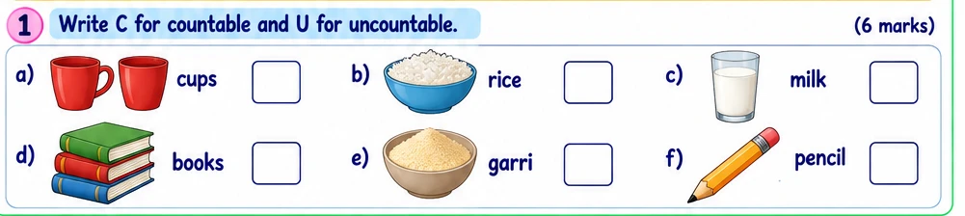
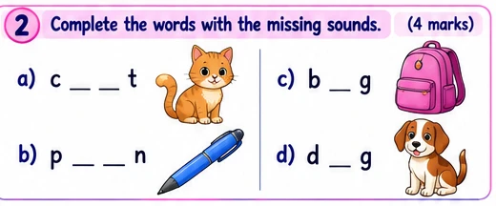 | 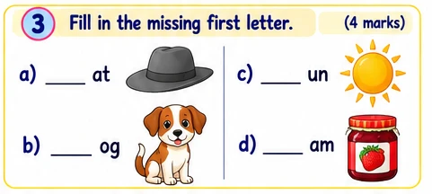
4. Match each activity to the correct word.
Ruler of a village |  | Farming
Growing crops |  | Trading
Selling goods |  | A chief
5. Complete the sentences using the words in the box.
Farmer — Teacher — Bus
a) The person who rears animals and plants crops is the ______________________.
b) The person who teaches pupils is the ______________________.
c) The ______________ is used to move from the village to the town.
LISTENING COMPREHENSION (5 marks)
Instruction: Listen to your teacher read the passage and underline the correct answer in the brackets.
6. What is the name of the place described in the passage?
(Town / village)
7. How do the people in the village live?
(in peace / in war)
8. What is the main occupation of the people in the village?
(schooling / farming)
9. Name two vegetables produced by the people in the village.
(Carrot and green vegetables / okra and cabbage)
10. Name two animals reared by the people in the village.
(Pigs and fowls / goats and cows)
SECTION B: ORAL (10 marks)
Instruction: Answer the following questions orally.
1. Say one proper name, for example, Mary.
2. Say one common noun.
3. Who leads a village?
4. Name one activity done in a village.
5. What does a farmer do?
Teacher’s mark: ______ / 10
SECTION C: PRACTICAL EVALUATION (3 marks)
Picture identification and word building
Look at the pictures in questions 2 and 3. Name each object and complete its two-letter beginning or ending sound where required.
Teacher’s mark: ______ / 3

REPUBLIC OF CAMEROON  Peace – Work – Fatherland  Ministry of Basic Education (MINEDUB)  Regional Delegation of Basic Education – Centre  Divisional Delegation of Basic Education – Mfoundi | BRIGHT CONTINENT  BILINGUAL SCHOOL  Dragage – Yaoundé • +237 678 34 12 13 | RÉPUBLIQUE DU CAMEROUN  Paix – Travail – Patrie  Ministère de l’Éducation de Base (MINEDUB)  Délégation Régionale de l’Éducation de Base – Centre  Délégation Départementale de l’Éducation de Base – Mfoundi

OCTOBER ASSESSMENT – CLASS ____
English Language • FOR THE TEACHER ONLY

Name: | Date:
LISTENING COMPREHENSION – PASSAGE TO BE READ ALOUD
Read the passage twice, slowly and clearly. Pupils then answer questions 6 to 10.
Life in a Village
This is a village. People in this village are good and loving as they live together in peace. Their main occupation is farming. They produce carrots and green vegetables. They also rear pigs and fowls.

