**Contributions**

Factors relevant to each type of AI project and their respective weights. We can use these matrices to evaluate team members' contributions based on their skills and experience in each factor.

**1.**

|  |  |  |
| --- | --- | --- |
| **AI Chatbot** | | |
| **Factors** | **Description** | **weights** |
| Natural Language Processing Expertise | |  |  | | --- | --- | | Implementation of complex NLP models for understanding user intents. | 0.1 | | Proficiency in sentiment analysis and entity recognition. | 0.1 | | Ability to fine-tune pre-trained language models for chatbot use. | 0.05 | | Designing intuitive conversation flows. | 0.1 | | Managing context and user sessions effectively. | 0.05 | | Incorporating fallback mechanisms for handling errors. | 0.05 | | Experience integrating with Facebook Messenger, Slack, etc. | 0.1 | | Ensuring secure communication between chatbot and platform. | 0.05 | | Handling platform-specific features and limitations. | 0.05 | | Creating engaging and user-friendly interactions. | 0.05 | | Conducting usability testing and gathering user feedback. | 0.05 | | Continuously improving the chatbot based on user behavior. | 0.05 | | |
| Dialogue Flow Design |
| Integration with Messaging Platforms |
| User Experience Design |

**2.**

|  |  |  |
| --- | --- | --- |
| **Model Fine-tuning** | | |
| **Factors** | **Description** | **weights** |
| Model Optimization Techniques | |  |  | | --- | --- | | Hyperparameter tuning for optimal performance. | 0.1 | | Techniques for reducing overfitting. | 0.1 | | Implementing model assembling methods. | 0.05 | | Generating synthetic data to enhance training. | 0.1 | | Using data augmentation techniques to balance datasets. | 0.05 | | Evaluating the impact of augmented data on model performance. | 0.05 | | Understanding industry-specific data characteristics. | 0.1 | | Applying domain knowledge to improve model relevance | 0.05 | | Customizing models to fit specific use cases. | 0.05 | | Comparing model performance against standard benchmarks. | 0.05 | | Using metrics like precision, recall, and F1 score. | 0.05 | | Continuous monitoring and reporting of performance metrics. | 0.05 | | |
| Data Augmentation Skills |
| Domain-specific Knowledge |
| Performance Benchmarking |

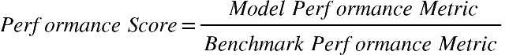

**3.**

|  |  |  |
| --- | --- | --- |
| **Prediction and Forecasting Systems** | | |
| **Factors** | **Description** | **weights** |
| Time-series Analysis | |  |  | | --- | --- | | Identifying temporal patterns and trends. | 0.1 | | Using techniques like ARIMA, SARIMA, etc. | 0.1 | | Handling seasonality and cyclical behavior in data. | 0.05 | | Applying regression models for prediction. | 0.1 | | Using probabilistic models to estimate future values. | 0.05 | | Validating models with historical data. | 0.05 | | Incorporating industry-specific factors into forecasts. | 0.1 | | Adjusting models for unique market dynamics. | 0.05 | | Understanding external influences on predictions. | 0.05 | | Creating visual representations of forecast data | 0.1 | | Using interactive tools to explore forecast scenarios. | 0.05 | | Communicating insights effectively through visuals. | 0.05 | | |
| Statistical Modeling |
| Domain-specific Forecasting |
| Visualization of Results |

**4.**

|  |  |  |
| --- | --- | --- |
| **Web Scraping** | | |
| **Factors** | **Description** | **weights** |
| Handling Dynamic Content | |  |  | | --- | --- | | Scraping websites with dynamic content and JavaScript. | 0.15 | | Using tools like Selenium or Puppeteer. | 0.1 | | Overcoming obstacles like AJAX-loaded content. | 0.05 | | Parsing HTML/XML content accurately. | 0.1 | | Cleaning and structuring data for analysis. | 0.05 | | Handling various data formats (JSON, CSV, etc.). | 0.05 | | Implementing proxies to avoid IP bans. | 0.1 | | Using anti-scraping evasion techniques. | 0.05 | | Rotating user agents and managing request headers. | 0.05 | | Efficiently handling large volumes of data. | 0.1 | | Parallelizing scraping tasks for better performance. | 0.05 | | Ensuring reliability and fault tolerance. | 0.05 | | |
| Data Parsing and Cleaning |
| Proxy and Anti-scraping Techniques |
| Scaling for Large Volumes |

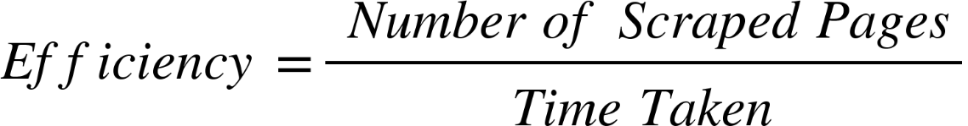

**5.**

|  |  |  |
| --- | --- | --- |
| **AI Persona Development Systems** | | |
| **Factors** | **Description** | **weights** |
| Psychological Profiling Skills | |  |  | | --- | --- | | Creating personas based on psychological theories. | 0.15 | | Analyzing user behavior for accurate profiling. | 0.1 | | Applying profiling techniques in various contexts. | 0.05 | | Simulating realistic behaviors and responses. | 0.1 | | Using simulation tools and techniques. | 0.1 | | Validating simulated behaviors against real data. | 0.05 | | Conducting qualitative research to inform persona development | 0.1 | | Applying ethnographic methods to gather insights. | 0.025 | | Integrating research findings into persona profiles. | 0.025 | | Designing interactive scenarios for persona testing. | 0.05 | | Creating scenarios that mimic real-world interactions. | 0.025 | | Evaluating persona performance in scenarios. | 0.025 | | |
| Behavioral Simulation |
| Ethnographic Research |
| Interactive Scenario Design |

**6.**

|  |  |  |
| --- | --- | --- |
| **AI Object Recognition and Tracking System** | | |
| **Factors** | **Description** | **weights** |
| Object Detection Accuracy | |  |  | | --- | --- | | Achieving high accuracy in detecting objects. |  | | Using advanced object detection algorithms. |  | | Continuously improving detection accuracy. |  | | Integrating data from multiple sensors for robust recognition. |  | | Handling sensor data synchronization. |  | | Ensuring accuracy and reliability of sensor fusion. |  | | Processing and analyzing data in real-time. |  | | Implementing efficient real-time algorithms. |  | | Ensuring minimal latency in processing. |  | | Adapting recognition algorithms to varying conditions. |  | | Testing algorithms in diverse environments. |  | | Ensuring robustness to environmental changes. |  | | |
| Sensor Fusion Integration |
| Real-time Processing |
| Environmental Adaptability |

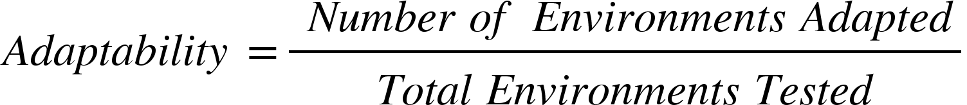

**7.**

|  |  |  |
| --- | --- | --- |
| **AI Data Analytics and Visualization Services** | | |
| **Factors** | **Description** | **weights** |
| Complex Data Analysis | |  |  | | --- | --- | | Analyzing complex datasets using advanced statistical methods. |  | | Using machine learning techniques for data analysis. |  | | Interpreting and drawing insights from data. |  | | Creating interactive visualizations to explore data. |  | | Using tools like Tableau, Power BI, etc. |  | | Ensuring visualizations are intuitive and user-friendly. |  | | Understanding industry-specific data patterns and trends. |  | | Applying domain knowledge to data analysis. |  | | Customizing analysis based on domain requirements. |  | | Ensuring data quality through validation and cleansing. |  | | Implementing data governance practices. |  | | Monitoring data for accuracy and consistency. |  | | |
| Interactive Data Visualization |
| Domain-specific Knowledge |
| Data Quality Assurance |