Assignment 5.1

**Linear Feedback Shift Register**

Introduction: -

**What is LFSR?**

- The **LFSR** is a shift register that has some of its outputs together in exclusive-OR or exclusive-NOR configurations to form a feedback path.

- The initial content of the shift register is referred to as seed. (Note: any value can be a seed except all 0’s to avoid lookup state).

- Lookup state is the state in which shift register values are zeros all the time while shifting and xoring).

- Feedbacks can be comprising of XOR gates or XNOR gates

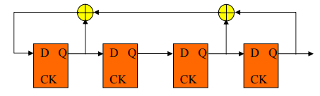

# LFSR Applications

1. Pattern Generators
2. Encryption
3. Compression
4. CRC
5. Pseudo-Random Bit Sequences (PRBS)

LFSR Specification and Operation:

1. Initialize the shift registers using Asynchronous Reset with seed
2. Allow the LFSR to operate for 8 cycles (LFSR Mode) then stop and shift out the content of the 4 registers through OUT signal (R3 > R2 > R1 > R0 > OUT) (Shift Mode).
3. Counter is responsible for counting to 8 then flag a signal to stop the LFSR.
4. Valid signal is high when the output is valid, otherwise low.
5. All outputs are registered.

**Block Diagram**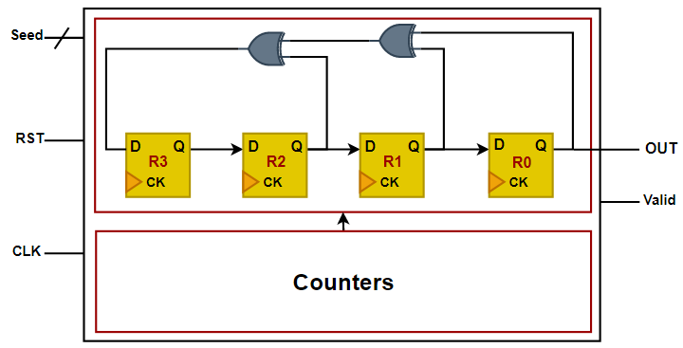

Requirements: -

1- Design a LFSR with the above specifications using Verilog language.

2- Write a testbench to validate your design using

* LFSR seed: 4’b1001
* Clock frequency: 10 MHz