**hassan Mohamed hassan MTH&CS**

**John bols gad elrab MTH&CS**

**kareem emad fawzy MTH&CS**

**Nourhan Ahmed kamal**  **MTH&CS**

spring 2025

University system

System analysis and design application

**Project Objectives**

1. Purpose
2. Targeted Audience and stakeholders
3. The methodology used
4. Functional & Non-functional requirements
5. Project Diagrams
6. **Purpose of the project**

We have chosen to make the project related to the university system since we’re all passionate about learning,

One of the reasons that make us qualified to determine our project’s pillars carefully is that we’re university students so we have faced many challenges that brought ideas for us to make things easier.

The purpose of our project is to make a different system for the university that will function better, including necessary features that might have been missed in our system such as auditing courses easily, making the library connected to the system with a points system that will encourage the students to read more books etc....

1. **Audience and Stakeholders**

The audience we’re targeting is the university students and the academic advisors of each department.

The stakeholders we’re targeting can be the administration of our college if we’re only get to extend step by step, the university administration if we get the approval from the university or the ministry of high education.

1. **The methodology used**

Since we can’t determine our project scale because we don’t know if the approval for applying the system to the whole university or not, we have chosen Agile methodology.

Why did we choose Agile methodology?

Well, Agile methodology allows incremental progress so if we make our project’s scale small, we can increase our progress at any time.

Next step we will discuss how exactly we will gather our requirements and determine the functional & non-functional requirements.

1. **Requirements Determining**

In our requirements gathering procedure, we will avoid gathering by interviews since students can be concerned if such an interview would hurt them if they answer honestly.

Hence, We will depend on anonymous surveys from the students and take the opinion of the presidential board itself.

Our vision after this process in the requirements section is as follows:

|  |
| --- |
| **Functional Requirements**   1. Library auditing    1. Every student can borrow books.    2. Every student can return books after deadline with extra fees.    3. After returning the book on deadline, system will give points.    4. After a student reads a books he will be granted points.    5. The library will present the top 5 readers based on points. 2. Courses auditing    1. students can audit courses if they passed the prerequisites.    2. The system will display top 5 on every department.    3. Withdrawing courses after the third week is not allowed.    4. Every instructor can add the grades online. |
| **Non-Functional Requirements**   1. Database should be big to acquire all the data related to every department 2. The website should be accessible at any time. 3. Server Capacity should exceed all the students, instructors and the presidential board. |

UML

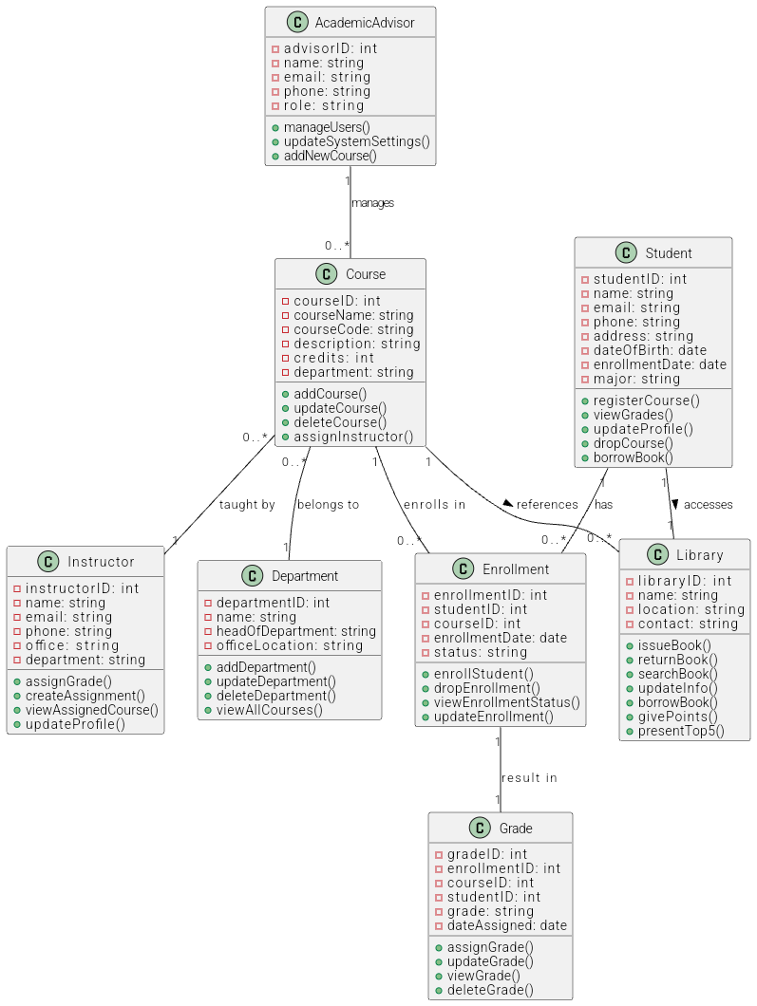

USE CASE DIAGRAM

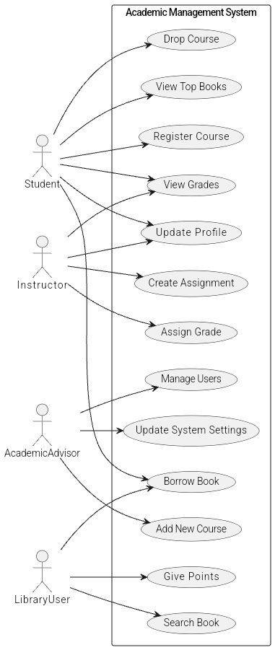

ACTIVITY DIAGRAMS

