9- rectangles

There are N rectangles numbered from 0 to N-1. The K-th rectangle has size A[K] × B[K].

We want to arrange as many rectangles as possible into a strip. The rectangles can be arranged into a strip if they all share a side of the same length (which becomes the height of the strip). Note that rectangles can be rotated.

**Examples:**

1. Given A = [2, 3, 2, 3, 5] and B = [3, 4, 2, 4, 2], the function **should return 3.**

We can choose the 0th, 1st and 3rd rectangles to obtain a strip of height 3. Here we have rotated 1st and 3rd rectangles:

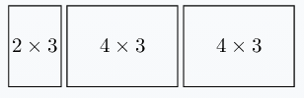

By choosing the 0th, 1st and 3rd rectangles, we get the area of strip which is 2x3 + 4x3 + 4x3 = 6 + 12+ 12 = 30

But Choosing the 0th, 2nd and 4th rectangles we can obtain the following strip of height 2 (note that the 0th rectangle was rotated) which their area is 3x2 + 2x2 + 5x2 = 6+ 4+ 10 =20

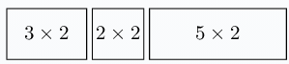

In this case, we can return 3 and choose the 0th, 1st and 3rd rectangles which have the maximum area.

2. Given A = [2, 3, 1, 3] and B = [2, 3, 1, 3], the function should return 2. We can choose the 1st and 3rd rectangles:

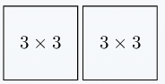

3. Given A = [2, 10, 4, 1, 4] and B = [4, 1, 2, 2, 5], the function should return 3. We can choose the 0th, 2nd and 4th rectangles to obtain a strip of height 4:

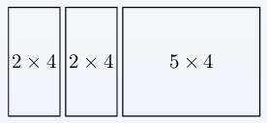

Write an **efficient** algorithm to get the maximum number of rectangles that can be arranged into a strip **and make the strip area is maximal.**