**EGY LMS**

**A learning management system (LMS) is a software application for the administration, documentation, tracking, reporting, automation, and delivery of educational courses, training programs, or learning and development programs . this is Desktop Java App with GUI and SQL Server Database , me and my team used Clean Code Principles to Build up this App from Scratch.**

**After Designing and coding we get done of the App , and it mainly contains of :**

1. **Admin Page, and it can perform this operations a) Login and logout (when login student, instructor, and admin see view different for each other). b) The Admin can (Add, Update, delete) student or instructor and users.**
2. **Courses Page with ability to a) CRUD operation --> (Add, delete, update) parent courses. b) Show all Instructor. c) Show all students. d) Create page to save courses with its details (instructor, room, branch, price, parent course, price, students, and grades of course, start date, days of course, end date). e) Report to display courses that near to start. f) Report to display courses that near to end.**
3. **Student Page could a) See his grades of specific course. b) Make survey about specific course. c) See all courses and update his information.**

**In general :**

**A learning management system (LMS) is a software application for the administration, documentation, tracking, reporting, automation, and delivery of educational courses, training programs, or learning and development programs.[1] The learning management system concept emerged directly from e-Learning. Learning management systems make up the largest segment of the learning system market. The first introduction of the LMS was in the late 1990s.[2] Learning management systems have faced a massive growth in usage due to the emphasis on remote learning during the COVID-19 pandemic.[3]**

**Learning management systems were designed to identify training and learning gaps, using analytical data and reporting. LMSs are focused on online learning delivery but support a range of uses, acting as a platform for online content, including courses, both asynchronous based and synchronous based. In the higher education space, an LMS may offer classroom management for instructor-led training or a flipped classroom.[4] Modern LMSs include intelligent algorithms to make automated recommendations for courses based on a user's skill profile as well as extract metadata from learning materials to make such recommendations even more accurate.**

**EGY_LMS_DatabaseShcema**

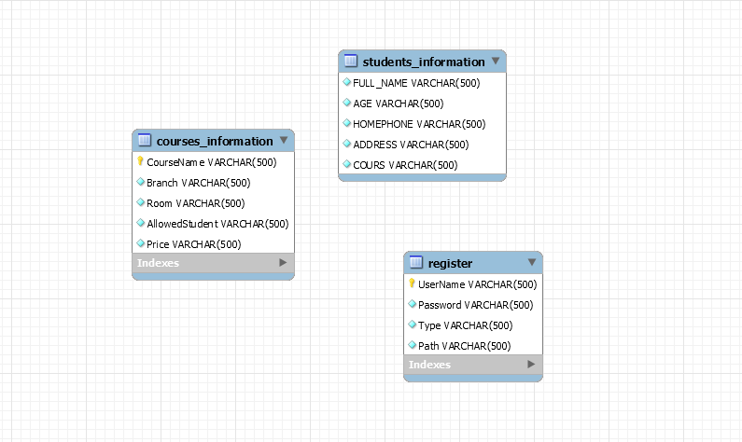

**EGY_LMS Class Diagram**

