FleetCentric.ai: Resource-Constrained Route Optimization for University Shuttle Transport
Final Year Project Proposal
Session Fall 2026

BS in Software Engineering



Department of Software Engineering
Fast School of Computing
Fast National University, Karachi Campus
1st September 2026

Project Registration
Project ID (for office use)
Type of project |  |  | [X] Traditional [ ] Industrial [ ] Continuing
Nature of project |  |  | [ ] Development [X] Research & Development [ ] Research
Sustainable Development Goals(SDGs) |  |  | [ ] Good Health and Well-Being [ ] Quality Education  [X] Industry, Innovation, and Infrastructure [ ] Gender Equality  [ ] Decent Work and Economic Growth [X] Climate Action
Area of specialization |  |  | [X] Artificial Intelligence (AI) [ ] Data Science and Analytics  [ ] Internet of Things (IoT) [ ] Blockchain  [ ] Mobile App Development [X] Web Development [ ] Cybersecurity  [ ] Game Development [ ] Natural Language Processing (NLP)  [ ] Other
Project Group Members
Sr.# | Reg. # | Student Name |  | CGPA | Email ID | Phone # | Signature
(i) | K23-0551 | Shayan Ahmed |  |  | k230551@nu.edu.pk
(ii) | K23-3000 | Mohid Raheel Khan |  |  | k233000@nu.edu.pk
(iii) | K23-0769 | Sheikh Hassan Nafees |  |  | k230769@nu.edu.pk
Declaration: FYP group members have cleared all prerequisite courses For FYP-I as per their degree requirements.

1. Project Abstract
University shuttle transport at FAST NUCES Karachi is planned by hand. An administrator picks a set of stops for each route, drags them into an order that looks reasonable on a map, and the system draws a road-following path through that order. Nothing in the current pipeline decides whether the order is good, whether students have been assigned to the nearest sensible stop, or whether the fleet is balanced. The result is routes that are feasible but not efficient, and a planning workload that grows every semester.
This project treats that gap as an instance of the School Bus Routing Problem (SBRP) and builds an optimization layer on top of the existing production system. The research component asks a question the SBRP literature has largely left alone: how well can these algorithms be made to work under a hard memory and compute budget? Published SBRP and Vehicle Routing Problem (VRP) solvers are benchmarked on workstations with gigabytes of RAM and minutes of CPU time. A student-run university system is deployed on low-cost shared hosting - typically 512 MB of RAM, a cold-starting single worker process, and a request timeout measured in seconds. The pairwise travel-time matrix alone grows as O(n^2), and the solver must share its budget with a Django application already serving requests.
The proposed work therefore develops and evaluates a memory-bounded, anytime optimization pipeline: sparse k-nearest candidate neighbour lists instead of a dense distance matrix, incremental and cached OSRM travel-time queries, and a local-search metaheuristic that can be interrupted at any point and still return a valid improved solution. The dataset is the project's own operational data - real stop coordinates, route memberships, bus capacities and semester registrations from FAST NUCES Karachi - supplemented by standard CVRP benchmark instances for comparability.
The expected contribution is twofold: a deployed, administrator-reviewable route optimization module inside a working transport management system, and an empirical characterisation of the solution-quality / peak-memory / latency trade-off for SBRP on commodity hosting, benchmarked against Google OR-Tools as a reference solver.

2. Introduction
Institutional transport is a routing problem that most universities solve socially rather than computationally. Routes are inherited from previous years, adjusted when students complain, and rarely re-derived from the actual distribution of student addresses. As enrolment and the served area grow, the gap between the routes in use and the routes that are possible widens quietly.
The research domain is combinatorial optimization applied to transport, specifically the School Bus Routing Problem - the family of problems concerned with assigning students to pickup stops, grouping stops into routes subject to vehicle capacity and ride-time limits, sequencing the stops on each route, and scheduling the resulting trips [1], [2]. SBRP is a constrained generalisation of the Capacitated Vehicle Routing Problem (CVRP), which is itself NP-hard [3], so exact methods are impractical beyond small instances and the field relies on constructive heuristics and metaheuristics [4], [6].
The domain matters because the objective is not only cost. Shorter total distance reduces fuel consumption and emissions; balanced routes reduce the maximum time an individual student spends on a bus; better stop assignment reduces the distance students walk at dawn, which is a safety concern in Karachi as much as a convenience one. These objectives conflict, which is what makes the problem interesting rather than merely tedious.
The current situation in this project is concrete. FleetCentric.ai (developed by this group as FAST Transport) is a deployed Django REST Framework and React system handling semester registration, seat allocation, fee verification, complaints, live GPS tracking and administrative reporting. Its routing layer calls an OSRM-compatible engine [10] to draw road geometry through a stop sequence that a human has already chosen. Route order, student-to-stop assignment and fleet balancing are entirely manual.
A computational approach is relevant precisely because the missing piece is a decision problem, not an interface problem. The stops, the road network, the capacities and the student registrations are all already in the database. What is absent is the algorithmic layer that turns that data into a defensible plan - and, given where the system runs, an algorithmic layer that fits in the memory available.

3. Problem Statement
Two gaps are addressed, one methodological and one in performance.
The first is an application and methodology gap in the deployed system. FleetCentric.ai performs waypoint routing only: given an ordered list of stops it returns a road-following path through them in that order. It does not optimize total route distance or duration, does not assign students to stops, does not distribute stops across the available fleet, and does not enforce capacity, ride-time or campus-arrival constraints. Route quality is therefore bounded by an administrator's intuition, and no metric exists against which a proposed change can be judged.
The second is a performance gap in the literature as it applies to this deployment class. State-of-the-art large-scale VRP heuristics achieve their results by exploiting the memory hierarchy of a well-provisioned machine - dense or partially cached distance matrices, large neighbourhood structures, and long uninterrupted runs [7], [8]. Reported evaluations optimize primarily for solution quality at a given time budget; peak memory is rarely treated as a first-class constraint. Yet the institutional systems that would most benefit from route optimization - university, school and NGO fleets - are commonly deployed on free or low-cost tiers where a single process must hold the web application and the solver within a few hundred megabytes and respond within a request timeout.
The problem this project addresses is therefore: how should an SBRP solver be designed and parameterised so that it produces high-quality, constraint-feasible routes for a real university fleet while operating within a strict peak-memory ceiling and an interruptible time budget, and what is the measurable cost in solution quality of enforcing that ceiling?

4. Related Work

4.1 Background of the Research Domain
The Vehicle Routing Problem was introduced as the truck dispatching problem and first attacked with the savings heuristic of Clarke and Wright [4], which remains a standard construction method. Solomon's benchmark instances and insertion heuristics established the treatment of time windows [5], and Toth and Vigo's reference volume consolidates exact, heuristic and metaheuristic approaches to the problem family [3].
The School Bus Routing Problem was formalised as a distinct variant because of its characteristic sub-problems: bus stop selection, student-to-stop assignment, route generation, school bell-time adjustment and route scheduling. Park and Kim's review classifies the literature along these axes and notes that most published work solves the sub-problems in sequence rather than jointly [1]. Ellegood et al. update that picture, documenting a shift toward multi-objective formulations that trade total cost against student-level service measures such as maximum ride time and walking distance, and toward mixed-load models [2].

4.2 Existing Methods and Approaches
Stop sequencing on a single route reduces to a Travelling Salesman Problem, for which the Lin-Kernighan family of local searches and its LKH implementation remain the practical reference [9]. For multi-vehicle instances, hybrid genetic algorithms with adaptive diversity management such as the Unified Hybrid Genetic Search of Vidal et al. handle a broad class of VRP variants within a single framework [6]. Constraint-programming and metaheuristic toolkits, principally Google OR-Tools, have made capacity- and time-window-constrained routing accessible to practitioners without specialist implementations [12].
Work on scale is directly relevant here. Arnold, Gendreau and Sorensen show that very large routing instances become tractable when the neighbourhood is pruned using geometric and knowledge-based criteria rather than explored exhaustively [7]. Accorsi and Vigo's FILO heuristic achieves near state-of-the-art quality on instances with tens of thousands of customers by combining granular neighbourhoods with localised optimization and an acceptance criterion tuned for scale [8]. Both rely on sparse candidate structures rather than dense matrices - the same structural idea this project applies for a different reason.
On the road-network side, it is now standard practice to delegate shortest-path computation to a dedicated engine. Contraction hierarchies made continent-scale queries feasible in microseconds [11], and OSRM packages that approach over OpenStreetMap data with a table service that returns pairwise travel-time and distance matrices [10]. The accepted architecture is therefore a routing engine underneath an optimizer, rather than Euclidean distance inside one.

4.3 Limitations of Existing Research
Three limitations motivate this work. First, the SBRP literature is dominated by offline planning studies evaluated on synthetic or anonymised instances; comparatively little reports on optimizers embedded in a live transport management system where administrators must review, override and publish results. Second, scalability research targets instance size on capable hardware [7], [8]; the complementary question - fixed, small instances under a hard memory ceiling on shared hosting - is largely unaddressed, even though it describes the deployment reality of most institutional fleets. Third, evaluation conventions report solution quality against time, and rarely report peak resident memory, making it difficult for a practitioner to predict whether a published method will run at all in a constrained environment.

5. Motivation
The motivation is that the group already operates the system in which this problem lives. FleetCentric.ai is deployed and serving a real workflow, which means the optimizer has a genuine consumer, real data to work on, and an obvious success criterion: an administrator either accepts the proposed routes or does not.
The project aims to:
- Replace manual route sequencing with an algorithmic proposal an administrator can review, edit and publish.
- Reduce total fleet distance and duration per semester, and with them fuel cost and emissions.
- Reduce student walking distance to assigned stops and cap maximum on-bus ride time.
- Make route quality measurable, so that a proposed change can be justified with numbers rather than argued.
- Establish whether credible SBRP optimization is achievable within the resource envelope available to a self-funded institutional deployment.
- Produce an empirical result of use beyond this campus: a quality/memory/latency characterisation other institutions can reuse when sizing their own deployment.

5.1 Aims and Objectives
The goal is to design, implement and empirically evaluate a memory-bounded route optimization module for university shuttle transport, integrated into a production system and validated on real operational data. The objectives are:
- Formalise the FAST NUCES shuttle operation as an SBRP instance, fixing the objective function, the constraint set (bus capacity, campus arrival deadline, maximum student ride time, maximum walking distance) and the weighting of conflicting terms.
- Build a travel-time and distance matrix service over OSRM using the table endpoint, with sparse k-nearest candidate lists, persistent caching and incremental refresh, and characterise its memory footprint as a function of stop count.
- Implement a baseline pipeline - Clarke-Wright savings construction followed by 2-opt and Or-opt local search - as the memory-frugal reference method.
- Implement an improved metaheuristic (guided local search or simulated annealing over granular neighbourhoods) with an explicit memory ceiling and anytime interruption, and an OR-Tools solver configuration as the quality reference.
- Design and run a controlled evaluation measuring solution quality, peak resident memory and wall-clock latency across configurations and instance sizes, on both campus data and standard CVRP benchmark instances.
- Integrate the optimizer into the admin route builder as a proposal-and-review workflow, so that generated routes are never published without human approval.
- Report the resulting quality/memory/latency trade-off, including the point at which the memory ceiling begins to cost measurable solution quality.

5.2 Scope of the Project
In scope:
- Static, pre-semester route planning: stop selection from the existing stop set, student-to-stop assignment, stop-to-bus grouping and stop sequencing.
- Capacity, campus-arrival-deadline, maximum-ride-time and maximum-walking-distance constraints.
- Separate morning and evening plans, using direction-specific travel-time matrices.
- Road-network travel times and distances obtained from an OSRM-compatible engine, with caching and a documented fallback.
- An administrator proposal-review-publish workflow with per-route metrics and constraint-violation reporting.
- Benchmarking against OR-Tools and against the current manually produced routes, measuring quality, peak memory and latency.
Out of scope:
- Real-time dynamic re-routing in response to live traffic, road closures or breakdowns; the system remains a planning tool with live tracking, not a live dispatcher.
- Modifying the road network or creating new physical stops without administrative approval.
- Driver rostering, payroll, and vehicle maintenance scheduling beyond the existing modules.
- Native mobile applications and hardware GPS device manufacture.
- Deployment at other institutions, although the evaluation is designed to transfer.

6. Proposed Methodology
The work proceeds as a research pipeline layered on an engineering pipeline. The research stages are: data collection, data preprocessing, problem formulation, algorithm development, controlled experimentation, evaluation and interpretation.

6.1 Data Collection
The primary dataset is operational and already partly held by the system: active stops with WGS-84 coordinates and addresses, current RouteStop sequences and ETAs, bus records with seat capacity, driver assignments, and semester-wise student transport registrations. Student residential locations are collected at registration as a chosen stop plus an optional approximate home location, and are anonymised to coordinate pairs before use. Pairwise road travel times and distances are obtained from the OSRM table service. Standard CVRP benchmark sets are used as a secondary dataset so that solver behaviour can be compared against published results.

6.2 Data Preprocessing
Coordinates are validated and snapped to the road network; duplicate and inactive stops are removed; demand per stop is aggregated from registrations; travel-time matrices are built per direction (morning and evening) and stored in a compact fixed-width numeric form rather than as Python objects, since representation choice dominates the memory profile at this scale.

6.3 Problem Formulation
The instance is modelled as a capacitated, deadline-constrained SBRP with a single depot at the Karachi campus. The objective is a weighted sum of total travel distance, total travel duration, aggregate student walking distance and a maximum-ride-time penalty, with capacity and deadline violations penalised. The weights encode institutional priority and are treated as an experimental variable rather than a fixed constant.

6.4 Algorithm Development
Three configurations are implemented and compared: (a) a baseline of Clarke-Wright savings construction with 2-opt and Or-opt improvement; (b) a granular metaheuristic over k-nearest candidate neighbourhoods with an enforced memory ceiling and anytime interruption; and (c) an OR-Tools reference configuration. Memory discipline is applied throughout: sparse candidate lists in place of dense matrices, streaming matrix construction, bounded solution archives, and explicit measurement of peak resident set size rather than estimation.

6.5 Training, Validation and Testing
Where learned components are used - for example a lightweight predictor for stop-level demand or travel-time adjustment by time of day - historical semester data is split chronologically into training, validation and test periods so that evaluation never uses future information. Metaheuristic parameters are tuned on a validation subset of instances and frozen before final measurement.

6.6 Evaluation
Each configuration is evaluated on three axes: solution quality (objective value and gap to the best known solution), peak memory (maximum resident set size during a solve) and latency (wall-clock time to first feasible solution and to final solution). Instances are scaled from the current campus size upward to establish where each configuration fails. The current manually planned routes serve as the operational baseline. Results are reported as a quality/memory Pareto frontier.

6.7 Interpretation
The intended finding is a defensible statement of the form: within a peak-memory budget of X MB and a latency budget of Y seconds, configuration Z delivers routes within W percent of the OR-Tools reference on instances of this size - together with the point at which tightening the budget begins to cost real solution quality.

6.8 Functional and Non-Functional Requirements
The system shall provide the following functional requirements:
- Generate an optimized route plan for a selected semester from current stops, buses and registrations.
- Assign each registered student to a pickup stop subject to a maximum walking distance.
- Group stops into routes subject to bus capacity and campus arrival deadline, and sequence the stops on each route.
- Present each proposed route on the map with distance, duration, students served, capacity utilisation and any constraint violations.
- Allow an administrator to edit, accept or reject a proposal before publishing, and never overwrite a published route automatically.
- Retain the existing registration, seat allocation, fee, complaint, tracking and reporting modules unchanged.
- Export the optimized plan and its metrics as CSV and PDF.
The system shall satisfy the following non-functional requirements:
- Peak additional memory during optimization shall remain within the deployment ceiling (target: 256 MB above baseline application usage).
- The optimizer shall be interruptible and return the best solution found so far within a configurable time budget.
- A routing-engine failure shall degrade visibly and shall never silently store straight-line geometry as a route.
- All optimization endpoints shall enforce the existing JWT authentication and administrator role checks.
- Optimization runs shall be reproducible from a stored random seed and input snapshot.
- The interface shall remain usable on mobile viewports, consistent with the existing application.

7. System Architecture
The system follows a three-tier architecture with the optimization engine as a separable service in the application tier, so that it can be moved to a worker process or a separate host without changing the interface contract. The major layers and components are:
- Presentation Layer - React 19 and Vite single-page application; MapLibre GL renders route geometry, stop markers and proposal overlays; the admin route builder gains a proposal-review view.
- Application Layer - Django 6 and Django REST Framework: existing transport business logic, plus the optimization service comprising the matrix service (OSRM table client with cache), the solver module (construction, local search, metaheuristic, OR-Tools adapter) and the proposal manager that stores generated plans awaiting approval.
- Data Layer - PostgreSQL for routes, stops, buses, registrations and stored proposals; a cache layer for travel-time matrices and route geometry keyed on ordered stop coordinates.
- External Services - OSRM-compatible routing engine for road geometry and travel-time matrices; OpenFreeMap tiles; Brevo SMTP; Stripe sandbox for fee simulation.
The overall optimization workflow is:
Student registrations and stop set -> Stop assignment -> Candidate stops per route -> Travel-time matrix (OSRM table, cached) -> Route grouping and sequencing optimizer -> Ordered stop sequences with metrics -> OSRM route API for final road geometry -> Administrator review in the route builder -> Published RouteStop records and Route geometry.
This ordering is deliberate. Road-level shortest paths are delegated to the routing engine; the optimizer works above it on a matrix, and calls the engine again only once the sequence is fixed. Fig. 1 shows the resulting component and data flow.
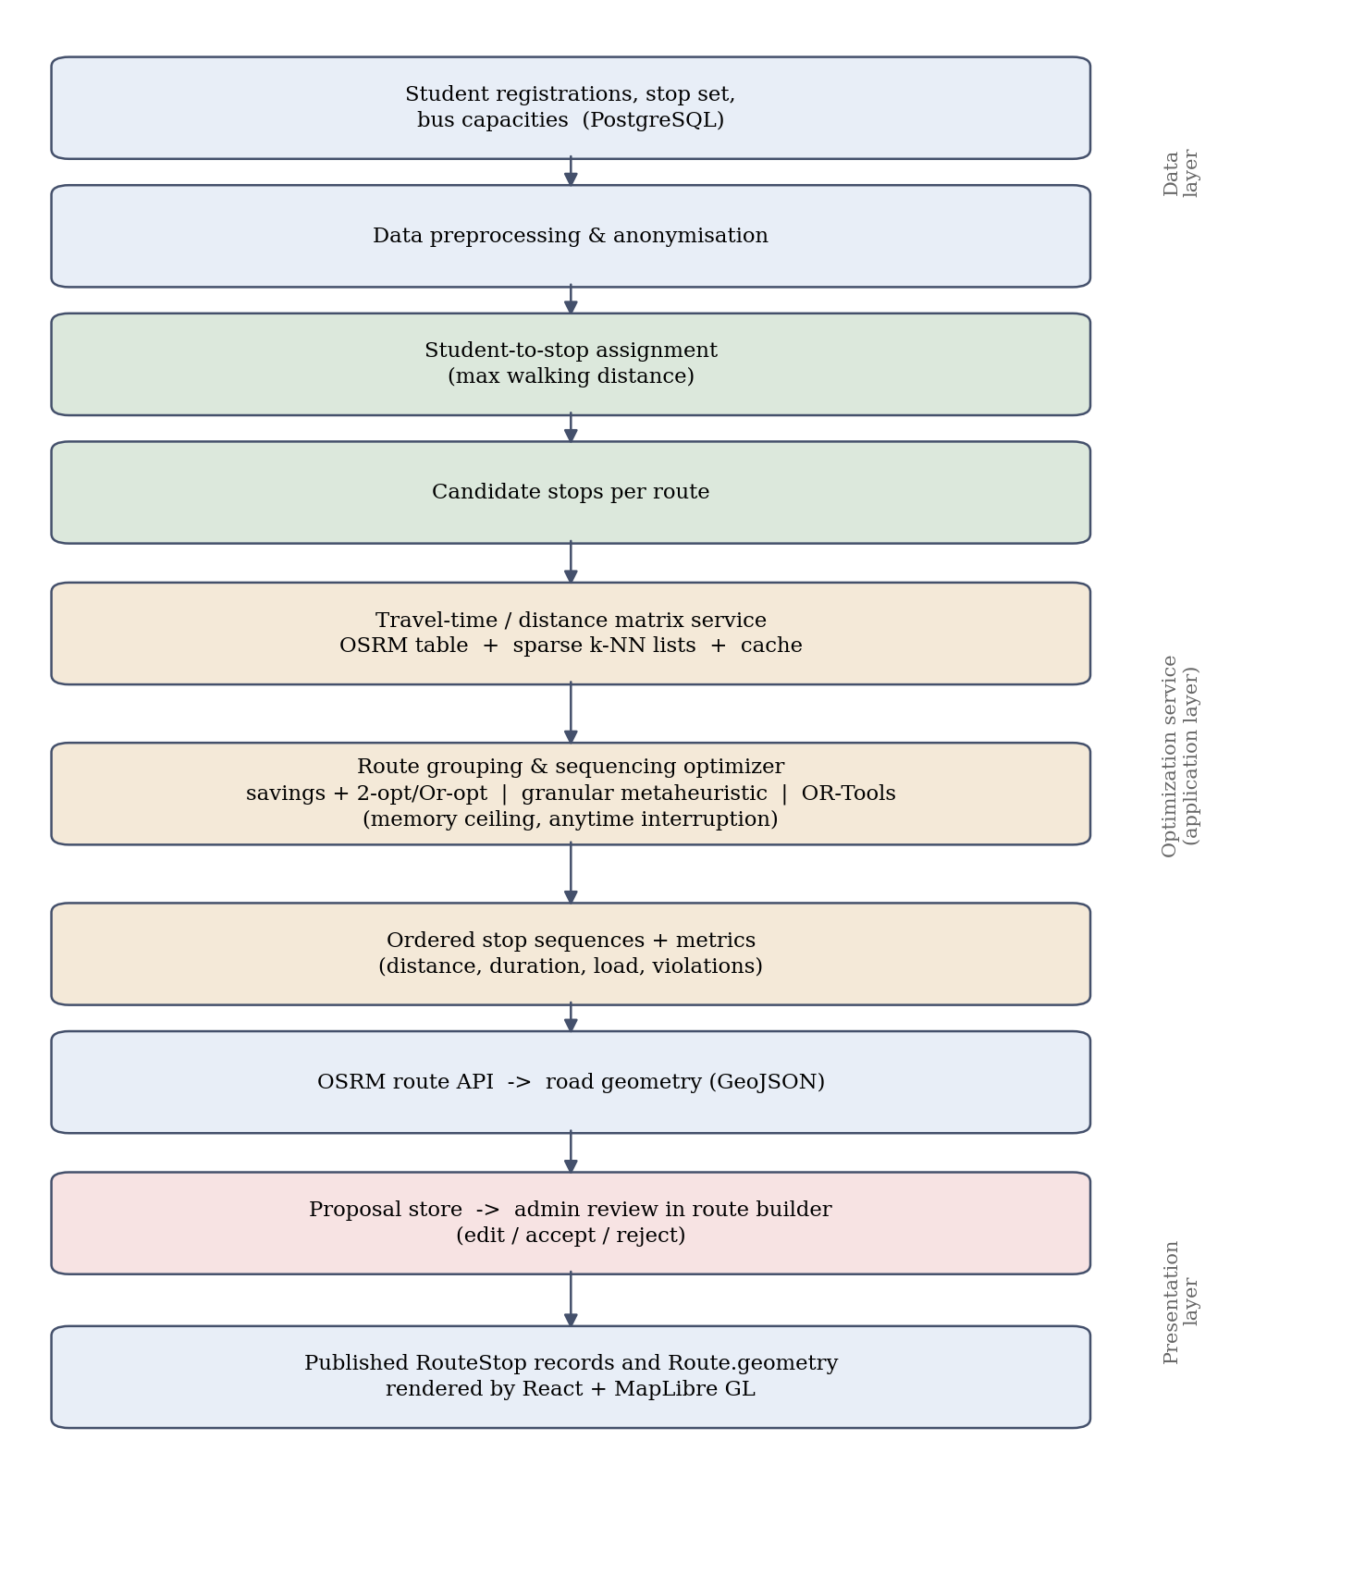
Figure 1. Optimization pipeline and system architecture.

8. Individual Tasks
The work is divided so that each member owns a coherent vertical slice with a research or engineering deliverable of its own, while the evaluation is shared. Table 1 lists the tasks and tentative dates across FYP-I (Fall 2026) and FYP-II (Spring 2027).
Table 1. Individual tasks and tentative schedule.
Team Member | Activity | Tentative Date
Shayan Ahmed  (k230551)  Team Leader | Literature review: SBRP, CVRP and metaheuristic families | Sep - Oct 2026
 | Problem formulation, objective function and constraint set | Oct 2026
 | OR-Tools reference solver configuration and tuning | Nov - Dec 2026
 | Experimental design and benchmarking harness | Jan - Feb 2027
 | Comparative evaluation and results analysis | Mar - Apr 2027
 | Research paper draft and final report | Apr - May 2027
Mohid Raheel Khan  (k233000) | OSRM table integration; travel-time matrix service | Sep - Oct 2026
 | Sparse k-nearest candidate lists and caching layer | Oct - Nov 2026
 | Clarke-Wright baseline with 2-opt and Or-opt local search | Nov - Dec 2026
 | Memory-bounded granular metaheuristic with anytime interruption | Jan - Feb 2027
 | Memory and latency instrumentation and profiling | Feb - Mar 2027
 | Backend API integration and optimization test suite | Mar - Apr 2027
Sheikh Hassan Nafees  (k230769) | Data audit, anonymisation and preprocessing pipeline | Sep - Oct 2026
 | Student-to-stop assignment module | Oct - Dec 2026
 | Proposal storage and review workflow (backend) | Jan 2027
 | Admin proposal-review interface and map overlays | Feb - Mar 2027
 | Metrics dashboard, CSV and PDF export of plans | Mar - Apr 2027
 | SRS, design document, user manual and documentation | Apr - May 2027

9. Gantt Chart
Fig. 2 shows the schedule corresponding to Table 1. Literature review, problem formulation and data preparation run in parallel early; solver implementation is sequential because each configuration depends on the shared matrix service; integration and evaluation overlap deliberately, so that findings from the evaluation can still influence the interface before final documentation.
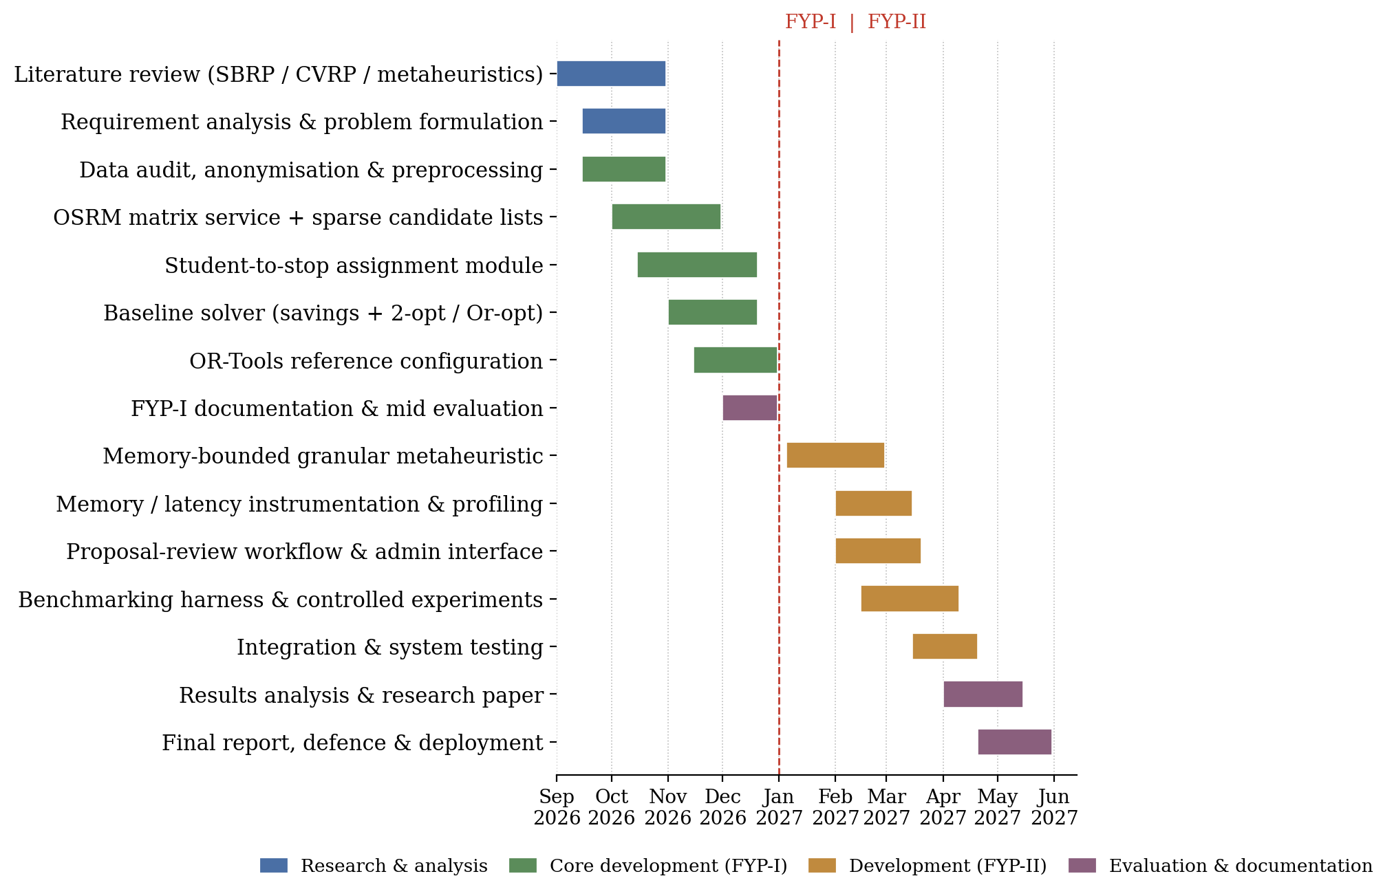
Figure 2. Project schedule for FYP-I (Fall 2026) and FYP-II (Spring 2027).

10. Tools and Technologies
- Backend: Python 3.12, Django 6, Django REST Framework, SimpleJWT.
- Frontend: React 19, Vite, React Router, Axios, MapLibre GL.
- Database: PostgreSQL 15 (Neon serverless in deployment).
- Optimization: Google OR-Tools as the reference solver; NumPy for compact matrix representation; custom Python implementations of Clarke-Wright, 2-opt, Or-opt and the granular metaheuristic.
- Routing and geodata: OSRM-compatible routing engine (route and table services), OpenStreetMap data, OpenFreeMap tiles, GeoJSON.
- Measurement: tracemalloc and resource / psutil for peak resident memory, pytest-benchmark for timing, Matplotlib and pandas for analysis and figures.
- Infrastructure and tooling: Docker and docker-compose, Git and GitHub, Vercel (frontend), Render (backend), Postman, Visual Studio Code.
- Documentation: LaTeX or Microsoft Word with IEEE referencing, draw.io for architecture diagrams.

11. Expected Deliverables
- A route optimization module integrated into FleetCentric.ai, with the proposal-review-publish administrator workflow.
- A travel-time matrix service with sparse candidate lists, caching and documented memory behaviour.
- Three implemented and comparable solver configurations: savings-plus-local-search baseline, memory-bounded granular metaheuristic, and OR-Tools reference.
- An experimental harness and reproducible dataset snapshot for quality, peak-memory and latency measurement.
- A quality/memory/latency evaluation report including the Pareto frontier and a comparison against the current manually planned routes.
- A research paper suitable for submission to a national or international conference on intelligent transportation or applied optimization.
- Complete project documentation: SRS, design document, test report and user manual.

12. References
[1] J. Park and B.-I. Kim, “The school bus routing problem: A review,” European Journal of Operational Research, vol. 202, no. 2, pp. 311-319, 2010.
[2] W. R. Ellegood, S. Solomon, J. North, and J. F. Campbell, “School bus routing problem: Contemporary trends and research directions,” Omega, vol. 95, art. 102056, 2020.
[3] P. Toth and D. Vigo, Eds., Vehicle Routing: Problems, Methods, and Applications, 2nd ed. Philadelphia, PA, USA: SIAM, 2014.
[4] G. Clarke and J. W. Wright, “Scheduling of vehicles from a central depot to a number of delivery points,” Operations Research, vol. 12, no. 4, pp. 568-581, 1964.
[5] M. M. Solomon, “Algorithms for the vehicle routing and scheduling problems with time window constraints,” Operations Research, vol. 35, no. 2, pp. 254-265, 1987.
[6] T. Vidal, T. G. Crainic, M. Gendreau, and C. Prins, “A hybrid genetic algorithm with adaptive diversity management for a large class of vehicle routing problems with time-windows,” Computers & Operations Research, vol. 40, no. 1, pp. 475-489, 2013.
[7] F. Arnold, M. Gendreau, and K. Sörensen, “Efficiently solving very large-scale routing problems,” Computers & Operations Research, vol. 107, pp. 32-42, 2019.
[8] L. Accorsi and D. Vigo, “A fast and scalable heuristic for the solution of large-scale capacitated vehicle routing problems,” Transportation Science, vol. 55, no. 4, pp. 832-856, 2021.
[9] K. Helsgaun, “An effective implementation of the Lin-Kernighan traveling salesman heuristic,” European Journal of Operational Research, vol. 126, no. 1, pp. 106-130, 2000.
[10] D. Luxen and C. Vetter, “Real-time routing with OpenStreetMap data,” in Proc. 19th ACM SIGSPATIAL Int. Conf. Advances in Geographic Information Systems, Chicago, IL, USA, 2011, pp. 513-516.
[11] R. Geisberger, P. Sanders, D. Schultes, and D. Delling, “Contraction hierarchies: Faster and simpler hierarchical routing in road networks,” in Proc. 7th Int. Workshop on Experimental Algorithms (WEA), Provincetown, MA, USA, 2008, pp. 319-333.
[12] L. Perron and V. Furnon, “OR-Tools.” Google. [Online]. Available: https://developers.google.com/optimization/

