FleetCentric.ai: A University Shuttle Transport Management System with Route Optimization
Final Year Project Proposal
Session Fall 2026

BS in Software Engineering



Department of Software Engineering
Fast School of Computing
Fast National University, Karachi Campus
1st September 2026

Project Registration
Project ID (for office use)
Type of project |  |  | [X] Traditional [ ] Industrial [ ] Continuing
Nature of project |  |  | [ ] Development [X] Research & Development [ ] Research
Sustainable Development Goals(SDGs) |  |  | [ ] Good Health and Well-Being [ ] Quality Education  [X] Industry, Innovation, and Infrastructure [ ] Gender Equality  [ ] Decent Work and Economic Growth [X] Climate Action
Area of specialization |  |  | [X] Artificial Intelligence (AI) [ ] Data Science and Analytics  [ ] Internet of Things (IoT) [ ] Blockchain  [ ] Mobile App Development [X] Web Development [ ] Cybersecurity  [ ] Game Development [ ] Natural Language Processing (NLP)  [ ] Other
Project Group Members
Sr.# | Reg. # | Student Name |  | CGPA | Email ID | Phone # | Signature
(i) | K23-0551 | Shayan Ahmed |  |  | k230551@nu.edu.pk
(ii) | K23-3000 | Mohid Raheel Khan |  |  | k233000@nu.edu.pk
(iii) | K23-0769 | Sheikh Hassan Nafees |  |  | k230769@nu.edu.pk
Declaration: FYP group members have cleared all prerequisite courses For FYP-I as per their degree requirements.

1. Project Abstract
Shuttle transport at FAST NUCES Karachi is still administered by hand. Registrations are collected on forms and spreadsheets, seats are allocated manually against bus capacity, fee receipts are checked one at a time, complaints are relayed informally, and route sheets are printed and pinned up. Each step works on its own, but none of them is connected to the others: a student who has paid cannot see that their registration is confirmed, a student waiting at a stop has no way of knowing where the bus is, and an administrator who wants to know how full a route is has to count.
This project proposes FleetCentric.ai, a web-based transport management system that moves the entire semester cycle online. Built as a three-tier application with a React single-page frontend, a Django REST Framework API and a relational database, it will provide token-based authentication with email OTP verification and role-based student, driver and administrator portals. Students will register for transport each semester, choose the stop nearest to them and be assigned a route and a seat, join a waitlist when a route is full, submit and confirm their transport fee online, request stop or route changes that are validated against live seat availability, report complaints and incidents and follow their resolution, and track their assigned bus in real time on an interactive map showing the actual road path, stop markers and expected arrival times. Administrators will manage buses, drivers, routes and stops with separate morning and evening timings, assign vehicles and drivers per semester with capacity in view, verify fee payments to release registrations, resolve complaints and change requests, receive alerts when a bus leaves its route, and export route sheets, fee reports and assignment lists as CSV and PDF. The system is intended for real use on the Karachi campus and is the main body of the work.
Alongside the system, we plan a smaller research component addressing the one planning decision an interface cannot make on its own: which stops belong on which bus, and in what order. We intend to model this as the School Bus Routing Problem [1], [2], a constrained generalisation of the NP-hard Capacitated Vehicle Routing Problem [3], and to study how well such optimization can perform within the resource limits of the low-cost hosting a self-funded project can afford, where memory is measured in hundreds of megabytes and the table of pairwise travel times grows with the square of the number of stops. The plan is to implement a memory-bounded optimizer that can be interrupted at any point and still return a usable route, compare it against Google OR-Tools [11] on the project's own data, and present its output to administrators as a proposal they review rather than a change applied on their behalf.
The expected outcome is a deployed transport management platform the campus can use, and a modest but honest empirical account of what route optimization costs in solution quality when it has to run inside a small memory budget.

2. Introduction
Most universities solve their transport problem socially rather than computationally. Routes are inherited from previous years, adjusted when enough students complain, and rarely rebuilt from the actual distribution of where students live. The administration around them grows the same way: a transport office that began with a register and a handful of buses ends up handling several hundred registrations a semester with the same tools it started with.
FAST NUCES Karachi is a clear instance of this. Transport registration is collected on forms and spreadsheets, seat allocation is done by hand against bus capacity, fee receipts are verified individually, complaints reach the transport office through whoever is available, and route information is distributed on paper. This is not a failure of effort on anyone's part; it is simply what happens when an operation of this size runs without a system behind it. The cost shows up as duplicated record-keeping for staff and as a lack of visibility for students, who cannot check their own status or find out where their bus is without asking someone.
The problem lends itself well to a software solution because the information involved is already structured. Students, stops, routes, buses, seat capacities, payments and semesters are entities with clear relationships, and the operations performed on them are routine and repetitive. Bringing them into a single application removes the duplicated records, makes each student's status visible to them directly, and gives administrators a live view of the fleet instead of one reconstructed from paper. Live bus location, which a manual process cannot offer at all, becomes a matter of relaying a coordinate and drawing it on a map, with road-level paths delegated to an established routing engine [9].
This project therefore proposes FleetCentric.ai, a transport management system covering the full semester cycle: registration and route assignment, seat allocation and waitlisting, online fee submission and verification, route change requests, complaint and incident handling, live bus tracking, fleet and route administration, notifications and reporting. Its design follows a conventional three-tier separation, with role-based access distinguishing what students, drivers and administrators may see and do. Developing, testing and deploying this system is the principal objective of the work.
One part of transport planning, however, resists being solved by a better interface. Choosing which stops belong on which bus and in what order they should be visited is a decision problem, not a data-entry task. A conventional system can draw the road path through a sequence an administrator has already chosen, but it cannot say whether that sequence is efficient, whether students have been assigned to the nearest sensible stop, or whether the load is spread evenly across the fleet. This is a recognised combinatorial optimization problem, the School Bus Routing Problem [1], [2], and it is NP-hard [3], which is why the field relies on heuristics and metaheuristics rather than exact methods [4], [5]. Investigating it under the memory and time limits of our own deployment forms the research component of the project, roughly a fifth of the total effort, and is deliberately scoped so that the system remains useful whether or not the optimizer outperforms the reference solver.

3. Problem Statement
The primary problem is operational. University shuttle transport at FAST NUCES Karachi has no digital system of record. Registration, seat allocation, fee verification, route changes and complaints are handled through separate manual processes that do not share data, which produces four recurring difficulties: administrative effort that grows with every intake; inconsistent records, since the same information is entered more than once in more than one place; no visibility for students, who cannot confirm their own registration status or locate their bus; and no reliable basis for reporting, because occupancy, revenue and complaint history must be reconstructed by hand whenever someone asks. What is required is a single application that holds this data once, enforces the rules around it, and exposes to each role exactly what that role needs.
A secondary problem sits inside route planning itself. Even once the operation is digitized, a system that performs waypoint routing only will reproduce whatever stop order an administrator supplies: it optimizes nothing, does not assign students to the nearest suitable stop, and does not balance stops across the available fleet. Route quality remains bounded by intuition, and no metric exists against which a proposed change can be defended. Addressing this computationally is complicated by where such a system realistically runs. Published routing solvers are evaluated on well-provisioned machines with generous memory and uninterrupted running time [6], [7], whereas a self-funded institutional deployment runs on a shared hosting tier of a few hundred megabytes with a request timeout measured in seconds, and the pairwise travel-time matrix alone grows as O(n^2). The question the research component asks is therefore narrow and practical: how should a School Bus Routing Problem solver be configured to produce feasible, good-quality routes within that ceiling, and what does enforcing the ceiling cost in solution quality?

4. Related Work

4.1 Existing Transport Management Systems
Digital transport management is well established commercially. Fleet platforms such as Samsara and Zonar and school transport products such as Tyler Technologies' routing suite provide vehicle tracking, route administration and parent-facing notifications, and ride-hailing systems have made live vehicle tracking a familiar interaction for ordinary users. Within universities, transport is more often handled by modules bolted onto an ERP than by a purpose-built product, and in Pakistan it is commonly managed through spreadsheets and printed notices, as is presently the case on our own campus.
The gap for this project is not novelty of feature but fit. Commercial fleet products are licensed per vehicle and priced for operators, they assume a dispatcher rather than a semester registration cycle, and they have no notion of the things that actually govern a university shuttle: enrolment-linked eligibility, a per-semester transport fee and its verification, seat entitlement tied to a route, and route change requests arising from a student moving house. A system built around the university's own workflow and data can support those directly, and can be deployed at no recurring cost.

4.2 Background of the Research Domain
The Vehicle Routing Problem was introduced as the truck dispatching problem and first attacked with the savings heuristic of Clarke and Wright [4], which remains a standard construction method; Toth and Vigo's reference volume consolidates the exact, heuristic and metaheuristic approaches that followed [3]. The School Bus Routing Problem was later formalised as a distinct variant because of its characteristic sub-problems: stop selection, student-to-stop assignment, route generation, bell-time adjustment and scheduling. Park and Kim's review classifies the literature along these axes and notes that most published work solves the sub-problems in sequence rather than jointly [1], while Ellegood et al. document a shift toward multi-objective formulations that trade total cost against student-level measures such as maximum ride time and walking distance [2].

4.3 Existing Methods and Limitations
Sequencing the stops of a single route reduces to a Travelling Salesman Problem, for which the Lin-Kernighan family of local searches remains the practical reference [8]. For multi-vehicle instances, hybrid genetic methods such as the unified hybrid genetic search of Vidal et al. handle a broad class of variants in one framework [5], and toolkits such as Google OR-Tools have made capacity-constrained routing accessible without specialist implementations [11]. Work on scale is directly relevant here: Arnold, Gendreau and Sörensen show that very large instances become tractable when neighbourhoods are pruned by geometric criteria rather than explored exhaustively [6], and Accorsi and Vigo reach near state-of-the-art quality on very large instances using granular neighbourhoods and localised optimization [7]. On the road-network side it is standard to delegate shortest paths to a dedicated engine, an approach made practical by contraction hierarchies [10] and packaged over OpenStreetMap data by OSRM [9].
Two limitations motivate our smaller research contribution. First, scalability research targets instance size on capable hardware [6], [7]; the complementary case of small, fixed instances under a hard memory ceiling on shared hosting is largely unaddressed, even though it describes the deployment reality of most institutional fleets. Second, evaluations conventionally report solution quality against a time budget and rarely report peak memory, which makes it difficult for a practitioner to predict whether a published method will run at all in a constrained environment.

5. Motivation
The motivation is immediate and local. Transport affects a large share of the student body every working day, and the process around it is the kind of administrative burden that software removes well. Registration and fee verification are rule-based tasks that do not need human judgement. Complaints and route change requests need to be tracked, not remembered. Live bus location is information students already want and cannot currently get. Building this system gives the campus something it can use from the first semester it is deployed, and gives us the experience of taking a full-stack application through design, testing, deployment and real users rather than stopping at a prototype.
The research component is motivated by what remains once the system exists. Having the stops, capacities, registrations and the road network in one database makes route optimization possible for the first time on this campus, and better routes have consequences beyond tidiness: shorter total distance reduces fuel cost and emissions, balanced routes reduce the time an individual student spends on a bus, and better stop assignment reduces the distance students walk early in the morning, which in Karachi is a safety matter as much as a convenience. Whether that is achievable inside the memory we can afford is an open question worth answering.

5.1 Aims and Objectives
The goal is to design, build, test and deploy a transport management system for university shuttle operations, and to extend it with a resource-aware route optimization module evaluated against an established solver. The objectives are:
1. Elicit and document requirements for the student, driver and administrator roles, and produce a software requirements specification and system design.
2. Implement authentication and authorisation: institutional email signup with OTP verification, token-based sessions, password reset and role-based access control.
3. Implement the semester registration workflow, including stop selection, route assignment, seat allocation against bus capacity and waitlist handling.
4. Implement online transport fee submission and administrative verification, with registration confirmed only once payment is verified.
5. Implement fleet and route administration: buses, drivers, stops, routes, per-route stop sequences with morning and evening timings, and per-semester bus and driver assignment.
6. Implement live bus tracking on an interactive map with road-following route geometry, stop markers, estimated arrival times and an alert when a bus leaves its route.
7. Implement complaint and incident reporting, route change requests validated against seat availability, and email notifications for status changes.
8. Implement an administrative dashboard with occupancy, fee and complaint reporting, and CSV and PDF export of route sheets and assignment lists.
9. Deploy the system on cloud hosting with a responsive interface, and validate it through unit, integration and user acceptance testing.
10. Formulate the shuttle operation as a School Bus Routing Problem instance, fixing the objective function and the constraint set, and implement a memory-bounded, interruptible optimizer.
11. Evaluate that optimizer against Google OR-Tools and against the current manual routes on solution quality, peak memory and latency, and report the trade-off.

5.2 Scope of the Project
In scope:
• A web application with student, driver and administrator roles, usable on desktop and mobile browsers.
• The full semester cycle: registration, stop and route assignment, seat allocation and waitlisting, fee submission and verification, route change requests, complaints and incidents, notifications and reporting.
• Live bus location relayed from a driver-side device or tracker, displayed on a map with road-following route geometry and off-route alerting.
• Static, pre-semester route planning: student-to-stop assignment, grouping stops into routes under bus capacity and campus arrival deadlines, and stop sequencing.
• An administrator proposal-review-publish workflow for optimized plans, with per-route metrics and constraint-violation reporting.
• Benchmarking the optimizer against OR-Tools and the current manual routes on quality, peak memory and latency.
Out of scope:
• Real-time dynamic re-routing in response to live traffic, road closures or breakdowns; the system remains a planning tool with live tracking, not a live dispatcher.
• Native mobile applications and the manufacture of GPS hardware.
• Driver payroll, rostering and vehicle maintenance scheduling.
• Creating new physical stops or modifying the road network without administrative approval.
• Deployment at other institutions, although both the system and the evaluation are designed to transfer.

6. Proposed Methodology
The work is organised as an incremental, iterative development process with the research study layered on top of the finished data model. Development proceeds in short cycles, each producing a working vertical slice: requirements for a module, database and API design, implementation of endpoints and interface, testing, and review with the supervisor before moving on. Modules are ordered by dependency, so that authentication and the core fleet data model come first and the features that build on them follow.

6.1 Development Phases
• Requirements and design (Sep - Oct 2026): stakeholder discussion with the transport office, use case and role definition, entity-relationship and API design, interface wireframes, SRS.
• Core platform (Oct - Nov 2026): authentication with institutional email and OTP, role-based access control, and CRUD for buses, drivers, stops and routes with stop sequences and timings.
• Registration and fees (Nov 2026 - Jan 2027): semester registration, stop selection, route assignment, seat allocation and waitlisting, fee submission, verification and registration release.
• Tracking and student services (Jan - Feb 2027): live bus location and map display with road-following geometry, off-route alerts, route change requests, complaints and incidents, notifications.
• Reporting and hardening (Feb - Mar 2027): administrative dashboard, occupancy and fee reports, CSV and PDF export, security review, performance tuning, deployment.
• Optimization module and study (Feb - Apr 2027): matrix service, solver implementations, benchmarking, and the administrator proposal-review interface.
• Validation and documentation (Apr - May 2027): integration and user acceptance testing, design document, test report, user manual and final report.

6.2 System Modules
The application is divided into modules that correspond to the workflow rather than to the technology: accounts and authentication; fleet and route administration; semester registration and seat allocation; fees and verification; tracking; complaints, incidents and route change requests; notifications; reporting and exports; and the route optimization module described below. Each exposes a documented REST interface, and each interface element in the frontend maps onto one of them, which keeps testing and division of work straightforward.

6.3 Research Component: Route Optimization
The optimization study reuses the data the system already holds and therefore begins only once the fleet and registration modules are in place. It proceeds in five steps.
Data preparation. Active stops with their coordinates, current route memberships and timings, bus capacities and semester registrations are exported as an instance snapshot. Student locations are reduced to anonymised coordinate pairs. Pairwise road travel times and distances are obtained from an OSRM-compatible engine [9] and stored in a compact fixed-width numeric form, since representation choice dominates the memory profile at this scale.
Problem formulation. The instance is modelled as a capacitated, deadline-constrained School Bus Routing Problem with a single depot at the Karachi campus [1], [2]. The objective is a weighted sum of total travel distance and duration, aggregate student walking distance and a maximum-ride-time penalty, with capacity and arrival-deadline violations penalised. The weights encode institutional priority and are treated as an experimental variable.
Implementation. Three configurations are compared: a baseline of Clarke-Wright savings construction [4] followed by 2-opt and Or-opt local search [8]; a granular metaheuristic over sparse k-nearest candidate neighbourhoods with an enforced memory ceiling and anytime interruption, following the pruning idea used for large-scale instances [6], [7]; and an OR-Tools configuration as the quality reference [11].
Evaluation. Each configuration is measured on solution quality, peak resident memory and wall-clock latency, on campus data and on standard CVRP benchmark instances for comparability, with the current manually planned routes as the operational baseline. Results are reported as a quality against memory frontier, and instance size is scaled upward to find where each configuration fails.
Integration. Generated plans are stored as proposals and shown in the administrator route builder with per-route metrics and any constraint violations, so that an administrator edits, accepts or rejects them and published routes are never overwritten automatically.

6.4 Functional Requirements
1. Students shall sign up with an institutional email address, verify it by OTP, and sign in with a token-based session; password reset shall be self-service.
2. Students shall register for transport in an open semester, select a preferred stop, and receive a route and seat assignment, or a waitlist position when the route is full.
3. The system shall generate a fee challan for a registration, accept online payment confirmation, and confirm the registration only after administrative verification.
4. Students shall request a stop or route change, which the system shall validate against live seat availability before an administrator approves or denies it.
5. Students shall submit complaints and incident reports and track their status; the system shall notify them by email when the status changes.
6. Students shall view their assigned route on a map with its stops, timings and current bus location where available.
7. Drivers shall sign in and their assigned bus shall report its location to the system periodically.
8. Administrators shall manage buses, drivers, stops and routes, define per-route stop sequences with morning and evening timings, and assign buses and drivers per semester within capacity.
9. Administrators shall verify fee payments, resolve complaints and incidents, and approve or deny route change requests.
10. The system shall raise an alert when a bus deviates from its assigned route beyond a configured tolerance.
11. Administrators shall view occupancy, fee and complaint summaries and export route sheets, fee reports and assignment lists as CSV and PDF.
12. The system shall generate an optimized route plan for a selected semester from current stops, buses and registrations, present it with per-route metrics and violations, and require administrator approval before publishing.

6.5 Non-Functional Requirements
1. All endpoints shall enforce authentication and role-based authorisation; no student shall be able to read or modify another student's records.
2. Interface pages shall load within three seconds on a typical mobile connection, and list endpoints shall be paginated.
3. The interface shall be responsive and usable on mobile viewports.
4. Passwords shall be stored hashed, and payment and personal data shall be transmitted over HTTPS only.
5. Peak additional memory during optimization shall remain within the deployment ceiling, with a target of 256 MB above baseline application usage.
6. The optimizer shall be interruptible and shall return the best solution found so far within a configurable time budget.
7. A routing-engine failure shall degrade visibly and shall never store straight-line geometry as a route.
8. Optimization runs shall be reproducible from a stored random seed and input snapshot.

7. System Architecture
The system follows a three-tier architecture, with the optimization engine kept as a separable service inside the application tier so that it can later be moved to a worker process or a separate host without changing the interface contract.
• Presentation layer: a React single-page application built with Vite; MapLibre GL renders route geometry, stop markers, live bus position and proposal overlays; separate portals for students, drivers and administrators.
• Application layer: Django and Django REST Framework, exposing the accounts, fleet, registration, fees, tracking, complaints, notifications and reporting modules, plus the optimization service, which comprises the travel-time matrix client with its cache, the solver module and the proposal manager.
• Data layer: a managed PostgreSQL database holding users, buses, drivers, stops, routes, registrations, seat allocations, payments, complaints, location history and stored route proposals, with a cache for travel-time matrices and route geometry.
• External services: an OSRM-compatible routing engine for road geometry and travel-time matrices [9], map tiles, an SMTP provider for OTP and notification email, and a payment gateway in sandbox mode for fee simulation.
The optimization workflow sits above the routing engine rather than inside it: registrations and the stop set feed stop assignment, which yields candidate stops per route; a cached travel-time matrix is built over those stops; the optimizer groups and sequences them; and only once the sequence is fixed is the routing engine called again for final road geometry, which an administrator then reviews and publishes. Fig. 1 shows the resulting components and data flow.
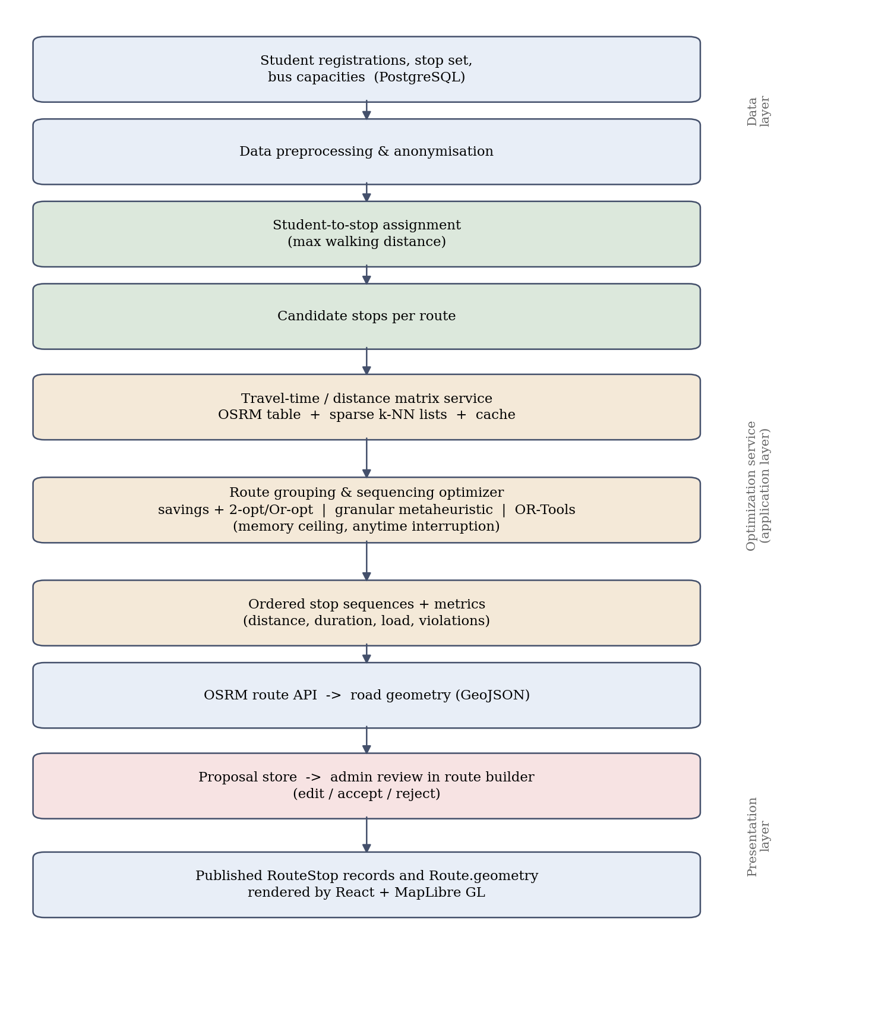
Figure 1. System architecture and optimization pipeline.

8. Individual Tasks
The work is divided so that each member owns a coherent vertical slice of the system, with the optimization study shared between the member who builds the solver and the member who designs the experiments. Table 1 lists the tasks and tentative dates across FYP-I (Fall 2026) and FYP-II (Spring 2027).
Team Member | Activity | Tentative Date
Shayan Ahmed  (k230551)  Team Leader | Requirements elicitation, use cases and SRS | Sep - Oct 2026
Shayan Ahmed  (k230551)  Team Leader | Authentication, OTP verification and role-based access control | Oct - Nov 2026
Shayan Ahmed  (k230551)  Team Leader | Fee challan, payment integration and verification workflow | Nov 2026 - Jan 2027
Shayan Ahmed  (k230551)  Team Leader | Admin dashboard, reporting and CSV/PDF exports | Feb - Mar 2027
Shayan Ahmed  (k230551)  Team Leader | Problem formulation and OR-Tools reference configuration | Feb - Mar 2027
Shayan Ahmed  (k230551)  Team Leader | Experimental design, evaluation and final report | Apr - May 2027
Mohid Raheel Khan  (k233000) | Database schema, API design and project setup | Sep - Oct 2026
Mohid Raheel Khan  (k233000) | Fleet and route administration: buses, drivers, stops, route stops | Oct - Nov 2026
Mohid Raheel Khan  (k233000) | Semester registration, seat allocation and waitlist module | Nov 2026 - Jan 2027
Mohid Raheel Khan  (k233000) | Travel-time matrix service with sparse candidate lists and caching | Jan - Feb 2027
Mohid Raheel Khan  (k233000) | Memory-bounded optimizer with anytime interruption and profiling | Feb - Apr 2027
Mohid Raheel Khan  (k233000) | Backend test suite and API documentation | Apr - May 2027
Sheikh Hassan Nafees  (k230769) | Interface wireframes, frontend architecture and design system | Sep - Oct 2026
Sheikh Hassan Nafees  (k230769) | Student portal: registration, profile, route and fee pages | Nov 2026 - Jan 2027
Sheikh Hassan Nafees  (k230769) | Live bus tracking map, stop markers and off-route alerts | Jan - Feb 2027
Sheikh Hassan Nafees  (k230769) | Complaints, incidents, route change requests and notifications | Feb - Mar 2027
Sheikh Hassan Nafees  (k230769) | Admin proposal-review interface and map overlays | Mar - Apr 2027
Sheikh Hassan Nafees  (k230769) | User acceptance testing, user manual and documentation | Apr - May 2027
Table 1. Individual tasks and tentative schedule.

9. Gantt Chart
Fig. 2 shows the schedule corresponding to Table 1. Requirements, design and the core platform run early and largely in parallel; registration, fees, tracking and student services follow in dependency order; the optimization module and its evaluation are scheduled in the second semester, once the data model they depend on is stable; and testing and documentation overlap the final modules deliberately, so that findings can still influence the interface before the report is written.
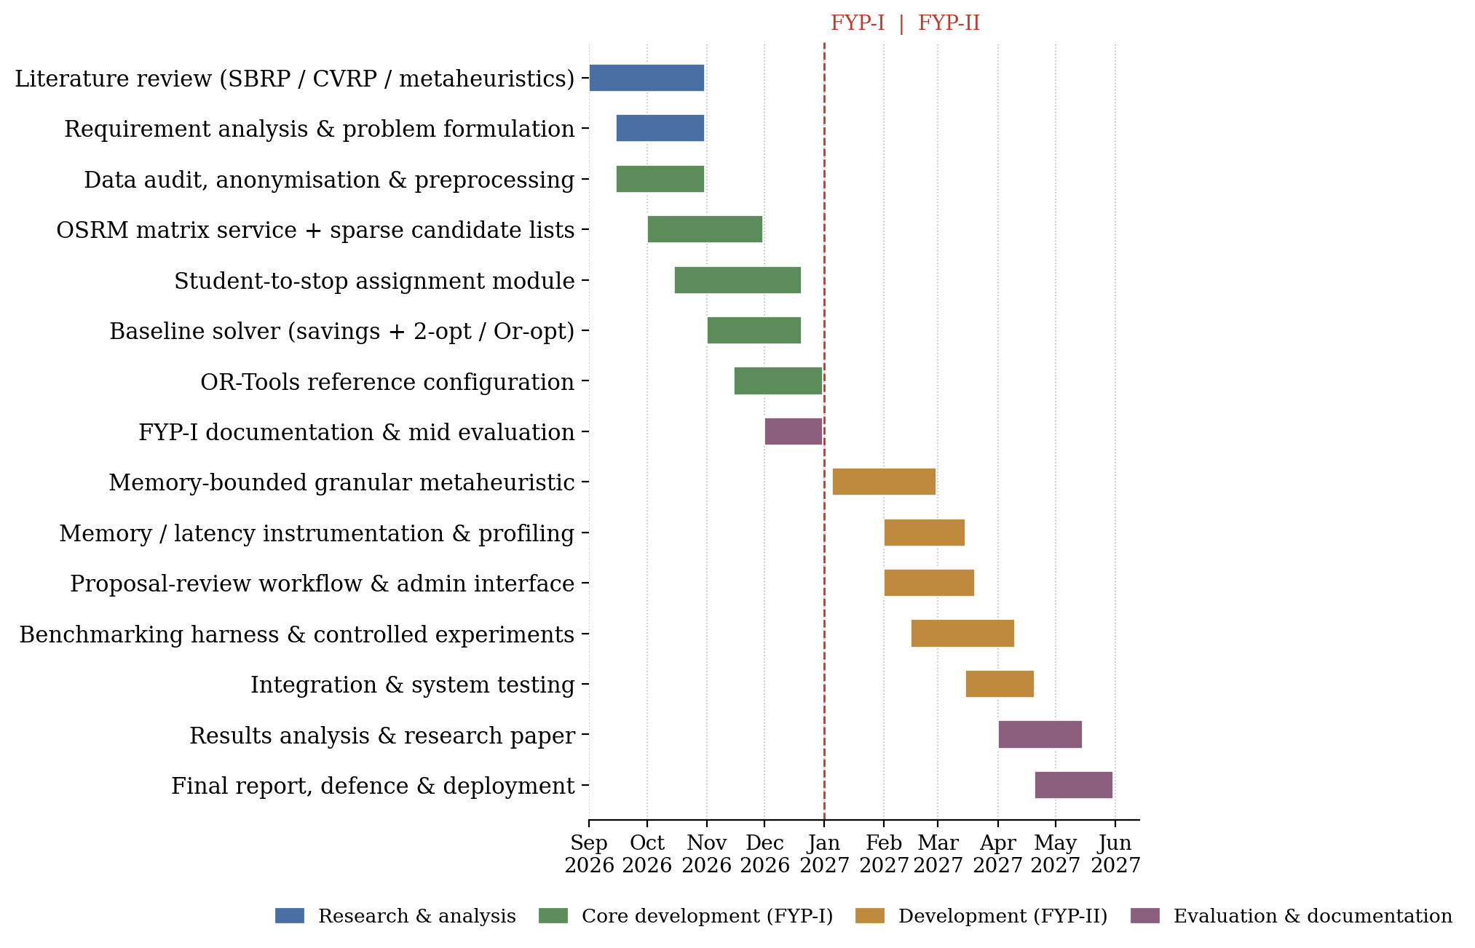
Figure 2. Project schedule for FYP-I (Fall 2026) and FYP-II (Spring 2027).

10. Tools and Technologies
• Backend: Python 3.12, Django, Django REST Framework, SimpleJWT.
• Frontend: React, Vite, React Router, Axios, MapLibre GL.
• Database: PostgreSQL, hosted on Supabase in deployment.
• Maps and geodata: OSRM-compatible routing engine (route and table services), OpenStreetMap data, OpenFreeMap tiles, GeoJSON.
• Email and payments: Brevo for transactional email (OTP and notifications); Stripe sandbox for fee payment simulation.
• Optimization: Google OR-Tools as the reference solver; NumPy for compact matrix representation; custom implementations of Clarke-Wright, 2-opt, Or-opt and the granular metaheuristic.
• Measurement: tracemalloc and psutil for peak resident memory, pytest and pytest-benchmark for testing and timing, pandas and Matplotlib for analysis and figures.
• Infrastructure and tooling: Docker and docker-compose, Git and GitHub, Vercel for the frontend, Render for the backend, Postman, Visual Studio Code.
• Documentation: Microsoft Word or LaTeX with IEEE referencing, draw.io for diagrams.

11. Expected Deliverables
• A deployed transport management system with student, driver and administrator portals covering registration, seat allocation, fees, tracking, complaints, route changes, notifications and reporting.
• A documented REST API and relational database schema for the university transport domain.
• A route optimization module integrated into the administrator route builder as a proposal-review-publish workflow.
• A travel-time matrix service with sparse candidate lists, caching and documented memory behaviour.
• Three comparable solver configurations: savings with local search, memory-bounded granular metaheuristic, and OR-Tools reference.
• An experimental harness and reproducible dataset snapshot for quality, peak-memory and latency measurement, with the resulting evaluation report.
• Complete project documentation: SRS, design document, test report and user manual.
• A conference-length paper on route optimization under constrained memory, subject to results.

12. References
[1] J. Park and B.-I. Kim, "The school bus routing problem: A review," European Journal of Operational Research, vol. 202, no. 2, pp. 311-319, 2010.
[2] W. R. Ellegood, S. Solomon, J. North, and J. F. Campbell, "School bus routing problem: Contemporary trends and research directions," Omega, vol. 95, art. 102056, 2020.
[3] P. Toth and D. Vigo, Eds., Vehicle Routing: Problems, Methods, and Applications, 2nd ed. Philadelphia, PA, USA: SIAM, 2014.
[4] G. Clarke and J. W. Wright, "Scheduling of vehicles from a central depot to a number of delivery points," Operations Research, vol. 12, no. 4, pp. 568-581, 1964.
[5] T. Vidal, T. G. Crainic, M. Gendreau, and C. Prins, "A hybrid genetic algorithm with adaptive diversity management for a large class of vehicle routing problems with time-windows," Computers & Operations Research, vol. 40, no. 1, pp. 475-489, 2013.
[6] F. Arnold, M. Gendreau, and K. Sorensen, "Efficiently solving very large-scale routing problems," Computers & Operations Research, vol. 107, pp. 32-42, 2019.
[7] L. Accorsi and D. Vigo, "A fast and scalable heuristic for the solution of large-scale capacitated vehicle routing problems," Transportation Science, vol. 55, no. 4, pp. 832-856, 2021.
[8] K. Helsgaun, "An effective implementation of the Lin-Kernighan traveling salesman heuristic," European Journal of Operational Research, vol. 126, no. 1, pp. 106-130, 2000.
[9] D. Luxen and C. Vetter, "Real-time routing with OpenStreetMap data," in Proc. 19th ACM SIGSPATIAL Int. Conf. Advances in Geographic Information Systems, Chicago, IL, USA, 2011, pp. 513-516.
[10] R. Geisberger, P. Sanders, D. Schultes, and D. Delling, "Contraction hierarchies: Faster and simpler hierarchical routing in road networks," in Proc. 7th Int. Workshop on Experimental Algorithms (WEA), Provincetown, MA, USA, 2008, pp. 319-333.
[11] L. Perron and V. Furnon, "OR-Tools." Google. [Online]. Available: https://developers.google.com/optimization/

