Project Report

23k-3000

23k-0625

23k-0769

1. These are #include statements for standard C libraries:

**Stdio.h** for input and output operations, **stdlib.h** for memory allocation and random number generation, **time.h** for seeding the random number generator, and **string.h** for string manipulation functions.

1. Defined a Structure Cell with two integer members **type** and **to**. This structure will be used to represent each cell on the game board. There are 3 “**types”** of cells, 0 for normal 1 for ladder and 2 for snakes. The “**to”** declares the position if it is snake or ladder.
2. Defined a Structure **small** with a character array **name** and an integer **num**. This Structure is used for keeping track of player names and their move counts.
3. Declared a function **check** that takes a file pointer as an argument, reads player names and move counts from the file, checks if the current player's move count is better than the existing leader, and updates the leaderboard accordingly.
4. Declared a function **initialize** that takes a double pointer to Cell as an argument and initializes each cell on the game board.
5. Declared a function **addSnakeOrLadder** that takes a double pointer to Cell and integers representing the **start, end, and type of a snake or ladder**. It modifies the game board accordingly.
6. Declared a function **play** that takes a double pointer to Cell and implements the game logic, allowing the player to roll the dice and move through the game board based on the dice outcome.
7. Declared a function **displayBoard** that takes an integer position and displays the current state of the game board with the player's position marked. Used a 2D-array to build the board in the snake pattern using the even and odd rows manipulation.

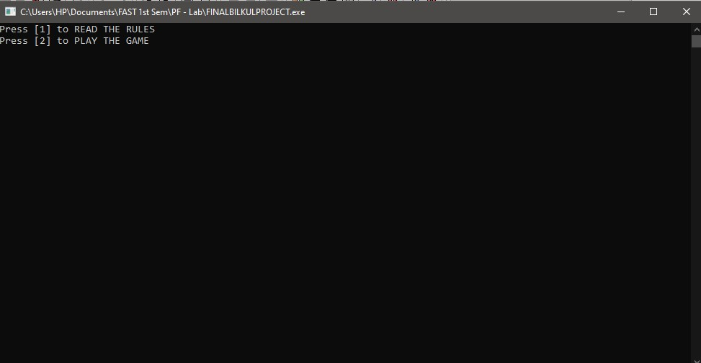

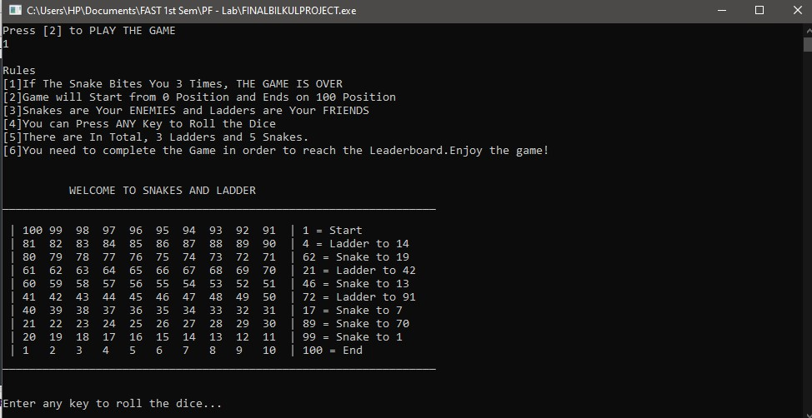

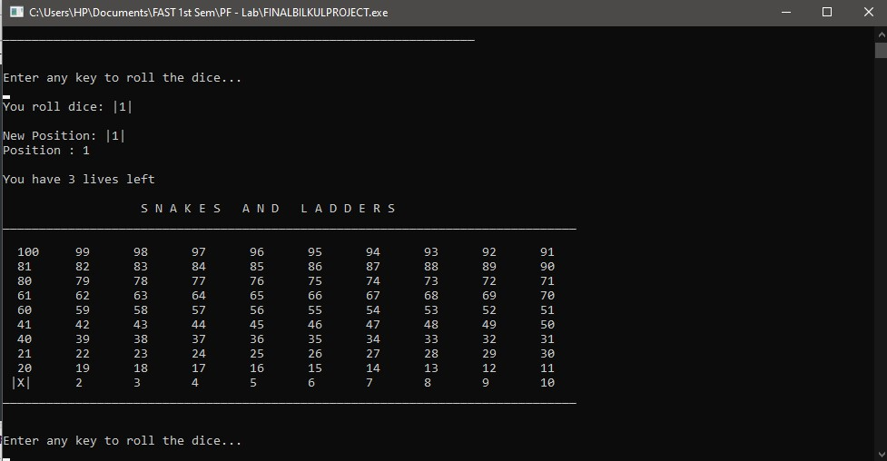

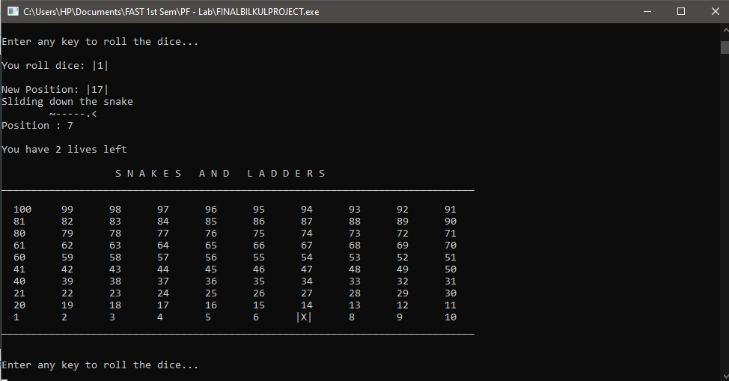

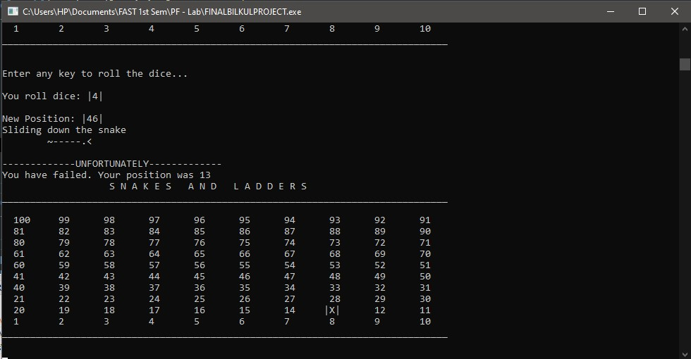

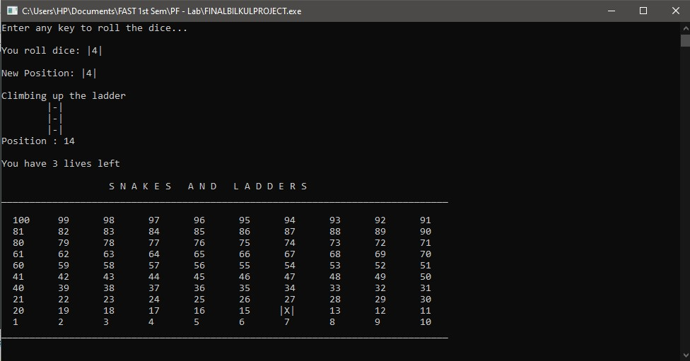

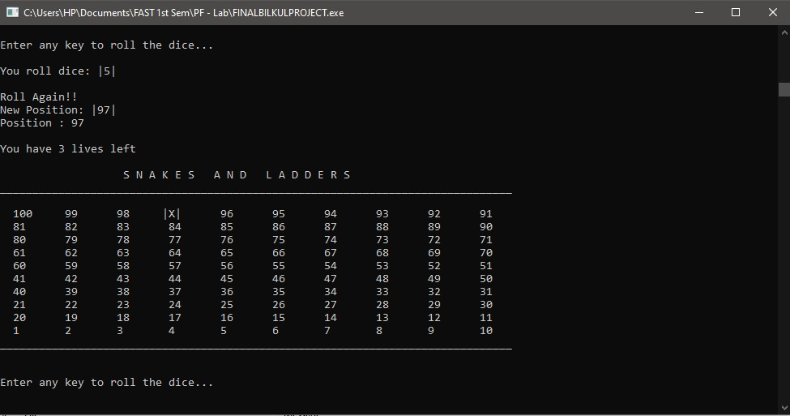

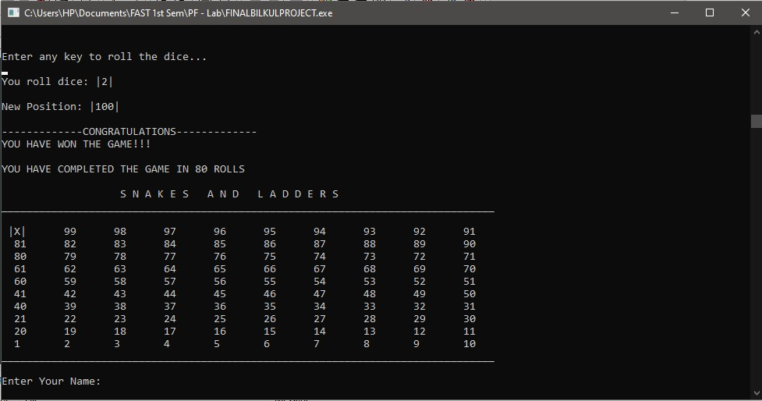

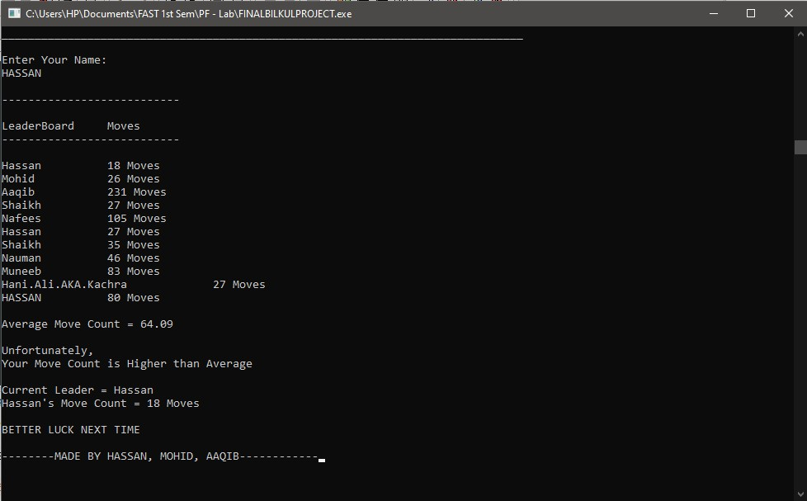

**CODE:**

