## Vue vs react vs angular

* AngularJS was developed in 2010 by Google in 2016 Angular got updated to Angular 2
* React came to existence in 2013 developed by Facebook
* Vue was created in 2014 by ex-Google employee Evan
* Vue is combination of React and Angular
* Angular is a framework (its full MVC) it gives you state management, routing, http request etc.
* React is a JS library (its only view of MVC)
* Vue is a framework give you state management routing like angular but we get to choose other things like react

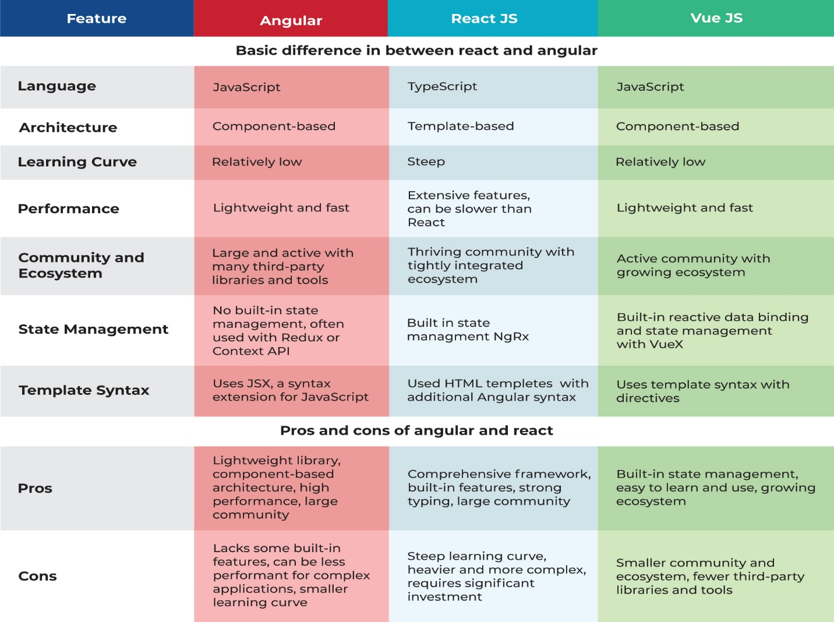

Vue is SPA

We send first initial request to server

Server return the response along with VueJS bundle

After that VueJS makes additional request from client side





Vue install

npm init vue@latest  
  
<script setup> is a compile-time syntactic sugar for using Composition API inside Single-File Components (SFCs).

What is a component composition API?

Composition API is a set of APIs that allows us to author Vue components using imported functions instead of declaring options. It is an umbrella term that covers the following APIs: Reactivity API, e.g. ref() and reactive() , that allows us to directly create reactive state, computed state, and watchers.

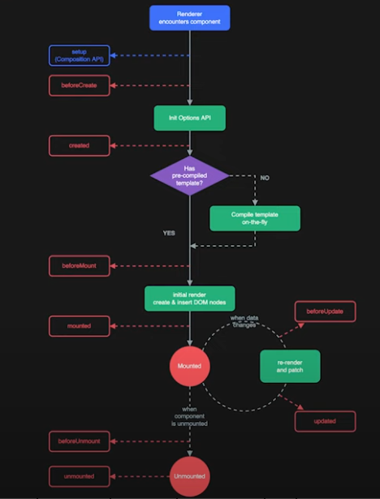

Vue v-model is a directive that creates a two-way data binding between a value in our template and a value in our data properties. A common use case for using v-model is when designing forms and inputs.

Ref in is used used to make our data reactive

Suppose const todos = ref(‘thinking’); if this data is binded to input without ref data will not change if empty will change but in this case will not changes with ref data will changes  
The v-on directive allows us to perform actions based on specified events.  
v-on:click="lightOn = !lightOn"

Short form

@click

v-if dont insert element to dom  
v-show insert elemnt to dom just changes css display to none  this is preffered  
:class="{ 'input-err': todoState.invalid }" this called binding add class when conditions meet  
slot pass template data to your component to make them dynamic.

<TodoItem v-for="todo in todoList" :todo="todo" />

:todo is a props