|  |
| --- |
| Close-up image showing the leaf-sides of two oversized books side-by-side on a bookshelf, with additional books in soft focus background |
| COMPUTER NREWORK  **PROJECT: RESTAURANT_NETWORK_DESIGN** |
| |  |  |  | | --- | --- | --- | |  |  |  | |

**Project members:**

**HASSAN JAVAID F2023332015**



**Project**: **Restaurant Network Design**

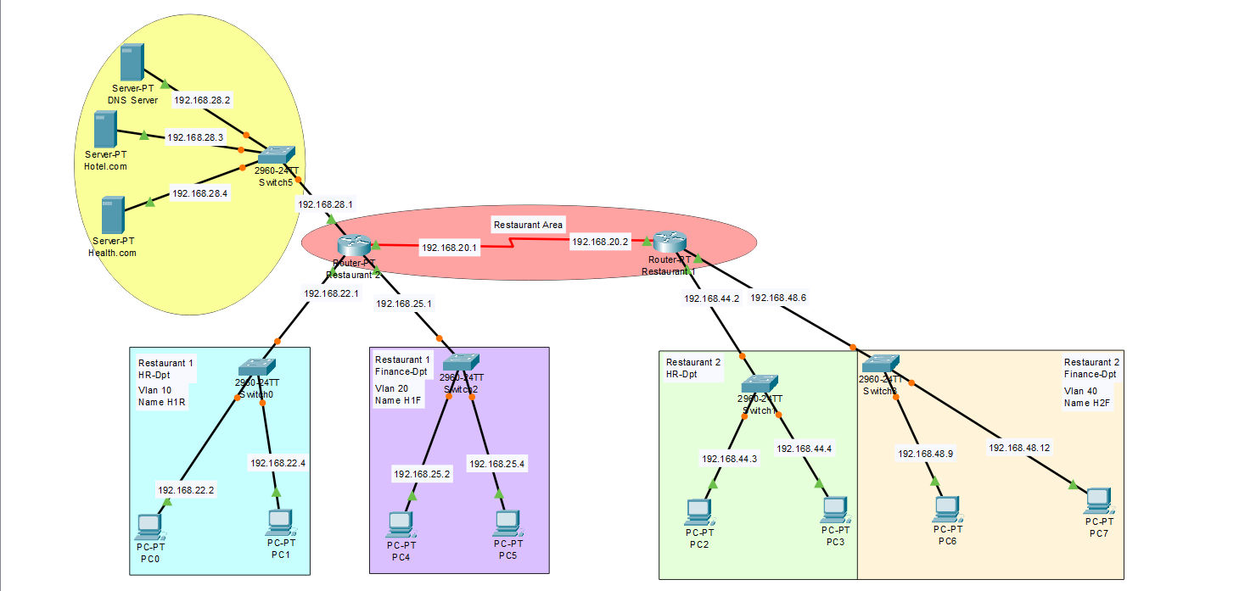

# 1.Introduction

This project presents a network design for a restaurant, focusing on ensuring reliable, secure, and scalable communication among various devices and departments within the establishment. The design includes routing, switching, IP addressing, VLANs, and wireless connectivity to support operations such as ordering, billing, administration, and guest Wi-Fi.

# 2. Objectives

- To design a functional network layout for a restaurant.  
- To ensure efficient data communication among kitchen, counter, and admin departments.  
- To implement wireless access for customers and wired connections for staff.  
- To segment traffic using VLANs for improved performance and security.

# 3. Network Design Overview

The network design includes routers, switches, access points, and end devices such as POS systems, admin PCs, and customer Wi-Fi. VLANs are used to separate guest and internal traffic. IP addressing is planned to avoid conflicts and support future scalability.

# 4. Topology Description

The topology consists of:  
- Core router for inter-VLAN routing.  
- Layer 2 switches for connecting different departments.  
- Wireless Access Point for customer internet access.  
- End devices including admin PCs, POS systems, kitchen displays, and printers.  
- VLANs such as Admin, POS, Kitchen, and Guest Wi-Fi.

# 5. IP Addressing Scheme

An IP addressing scheme is used with subnetting for each VLAN:  
- Admin VLAN: 192.168.10.0/24  
- POS VLAN: 192.168.20.0/24  
- Kitchen VLAN: 192.168.30.0/24  
- Guest Wi-Fi VLAN: 192.168.40.0/24

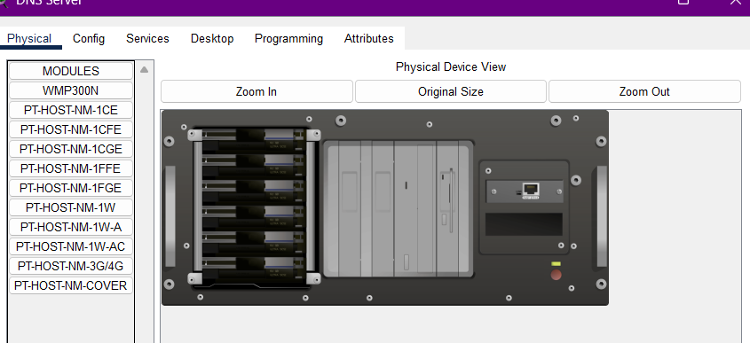

# 6. Security Measures

- VLANs to separate traffic.  
- Access control on routers and switches.  
- Guest Wi-Fi isolated from internal network.  
- Strong password policies and encryption for wireless access.

# 7. Conclusion

This restaurant network design provides a secure, organized, and scalable network infrastructure. By separating traffic and ensuring proper IP allocation, the design enhances both performance and security. It also provides flexibility for future expansion or changes.

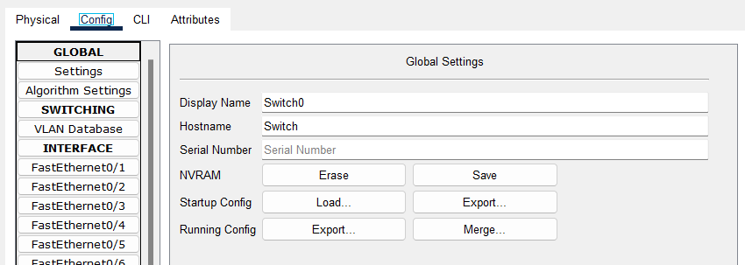

**FINAL PROJECT DESIGN**



**THANK YOU**