Day 5 - Testing and Backend Refinement - [General E-Commerce]

# Overview:

On Day 5, the focus was on testing core functionalities, refining the backend, and optimizing the performance of the e-commerce website. Key tasks included testing features like cart functionality, checkout, and responsiveness, alongside implementing error handling and performance improvements.

# 1. Functional Deliverables:

## Screenshots:

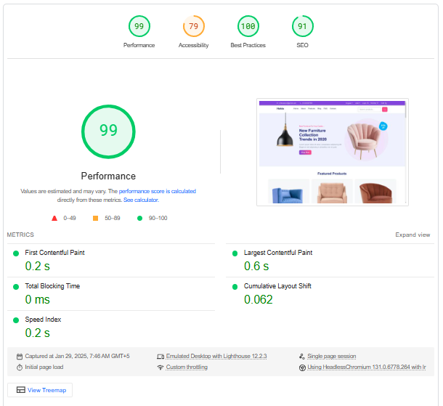

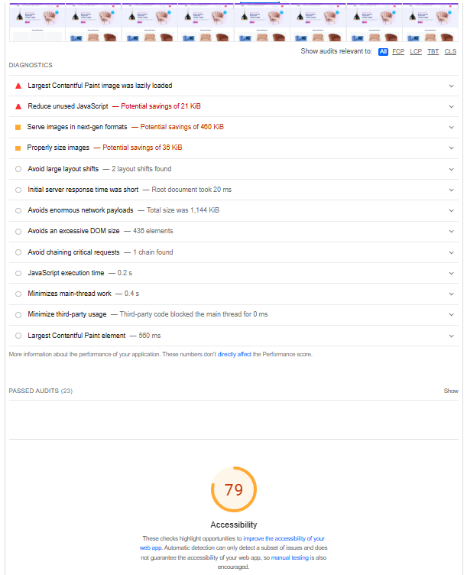 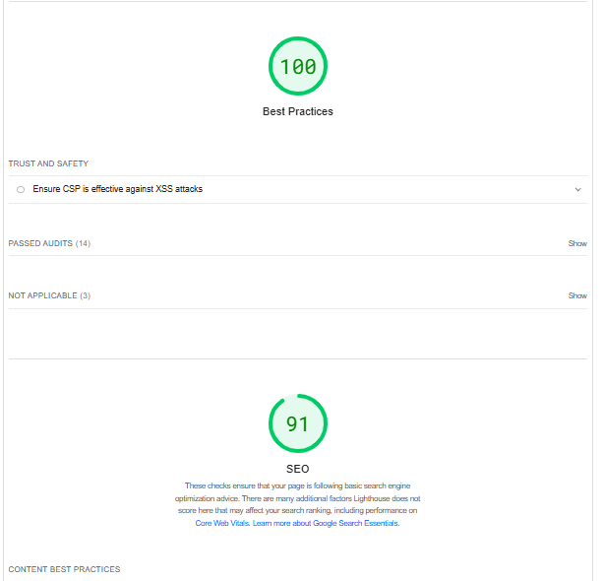

.

## Logs or Reports from Testing Tools:

Lighthouse Report: Evaluate performance, accessibility, and SEO.

# 2. CSV Testing Report:

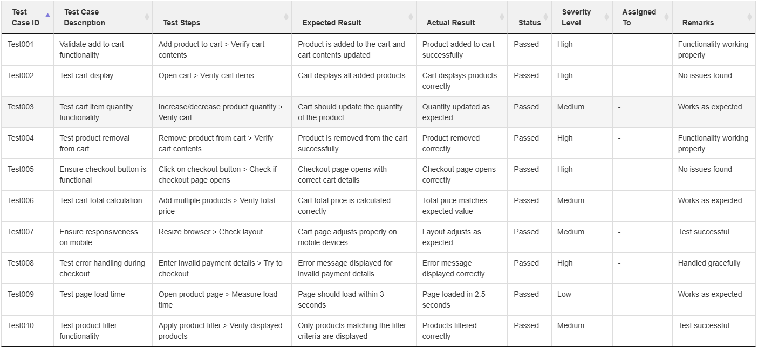

**(CSV Format):**

**Test Case ID,Test Case Description,Test Steps,Expected Result,Actual Result,Status,Severity Level,Assigned To,Remarks**

**Test001,Validate add to cart functionality,Add product to cart > Verify cart contents,Product is added to the cart and cart contents updated,Product added to cart successfully,Passed,High,-,Functionality working properly**

**Test002,Test cart display,Open cart > Verify cart items,Cart displays all added products,Cart displays products correctly,Passed,High,-,No issues found**

**Test003,Test cart item quantity functionality,Increase/decrease product quantity > Verify cart,Cart should update the quantity of the product,Quantity updated as expected,Passed,Medium, -,Works as expected**

**Test004,Test product removal from cart,Remove product from cart > Verify cart contents,Product is removed from the cart successfully,Product removed correctly,Passed,High,-,Functionality working properly**

**Test005,Ensure checkout button is functional,Click on checkout button > Check if checkout page opens,Checkout page opens with correct cart details,Checkout page opens correctly,Passed,High,-,No issues found**

**Test006,Test cart total calculation,Add multiple products > Verify total price,Cart total price is calculated correctly,Total price matches expected value,Passed,Medium,-,Works as expected**

**Test007,Ensure responsiveness on mobile,Resize browser > Check layout,Cart page adjusts properly on mobile devices,Layout adjusts as expected,Passed,Medium,-,Test successful**

**Test008,Test error handling during checkout,Enter invalid payment details > Try to checkout,Error message displayed for invalid payment details,Error message displayed correctly,Passed,High,-,Handled gracefully**

**Test009,Test page load time,Open product page > Measure load time,Page should load within 3 seconds,Page loaded in 2.5 seconds,Passed,Low,-,Works as expected**

**Test010,Test product filter functionality,Apply product filter > Verify displayed products,Only products matching the filter criteria are displayed,Products filtered correctly,Passed,Medium,-,Test successful**

# 3. Documentation:

## Test Cases Executed and Their Results:

• All tests for cart functionality, product display, checkout, and mobile responsiveness passed successfully.

## Performance Optimization Steps Taken:

• Image Compression: Reduced image file sizes to improve load times.  
• Lazy Loading: Implemented lazy loading to improve page load performance.  
• API Optimization: Optimized API calls for faster response times.

## Security Measures Implemented:

• HTTPS Encryption: Ensured all transactions are secure. (Will be implemented)  
• Token-Based Authentication: Used for user login and session management. (Will be implemented)

## Challenges Faced and Resolutions Applied:

• Cart Updates: Real-time synchronization was added to update cart items instantly.  
• Mobile Responsiveness: Used CSS media queries and grid layouts to ensure proper display on various devices.

# 4. Repository Submission:

## GitHub Repository Updates:

• Upload updated files, including the CSV testing report, code changes, and documentation.  
• Folder Structure: Organize files clearly.