Day 01 Network Fundamentals & Wireshark Packet Analysis
Objective
The objective of this lab was to understand fundamental networking concepts including:
- OSI Model vs TCP/IP Model
- Unicast, Broadcast, and Multicast Communication
- TCP Communication
- ARP Resolution Process
- Packet Analysis using Wireshark
This lab provides foundational knowledge required for Cybersecurity, SOC Analysis, Network Monitoring, Incident Response, and Threat Hunting.

Tools Used
Tool | Purpose
Wireshark | Network packet capture and analysis
Web Browser | Generate TCP traffic
Command Prompt | Generate ARP requests
Windows OS | Host system

Lab Environment
Component | Details
Operating System | Windows
Network Adapter | Wi-Fi
Packet Analyzer | Wireshark
Traffic Types Captured | ARP, TCP

Task 1: ARP Broadcast Analysis
Objective
Capture and analyze ARP traffic to understand how devices discover MAC addresses on a local network.
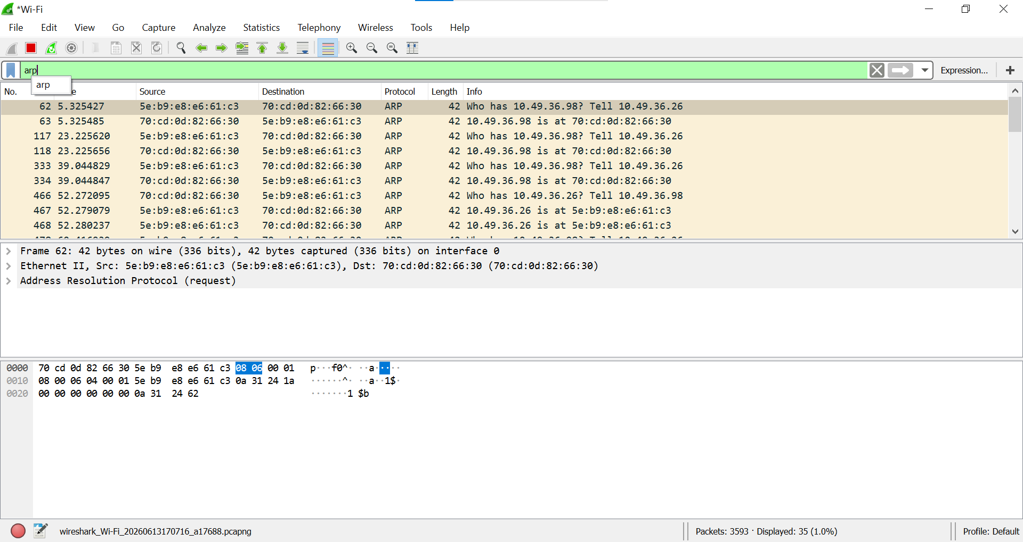

Wireshark Filter
arp

Captured Traffic
Observed ARP requests and replies:
Who has 10.49.36.98? Tell 10.49.36.26
10.49.36.98 is at 70:cd:0d:82:66:30

Analysis
ARP (Address Resolution Protocol) is responsible for mapping an IP address to a MAC address within a local network.
The captured request packet was broadcast to all devices on the local network because the sender did not know the destination MAC address.
The device owning the requested IP address responded with its MAC address.

Communication Type
ARP Request
Broadcast
ARP Reply
Unicast

OSI Layer Mapping
Protocol | OSI Layer
ARP | Layer 2 (Data Link Layer)

Security Relevance
ARP traffic is frequently analyzed by SOC Analysts during:
- Network troubleshooting
- ARP Spoofing investigations
- Man-in-the-Middle attack detection
- Internal network monitoring

Observation
The ARP protocol successfully resolved the MAC address associated with the target IP address. The packet exchange demonstrated the broadcast nature of ARP requests and the unicast nature of ARP replies.

Task 2: TCP Traffic Analysis
Objective
Capture and analyze TCP traffic generated during communication with remote servers.
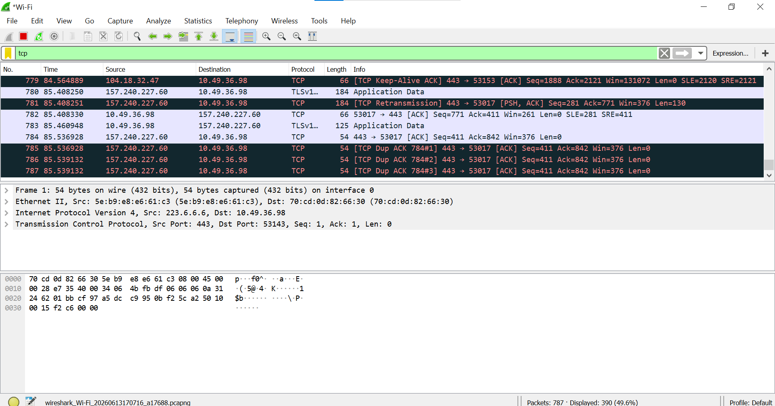

Wireshark Filter
tcp

Captured Traffic
Observed TCP packets including:
- TCP ACK
- TCP Keep-Alive ACK
- TCP Retransmission
- TCP Duplicate ACK
Traffic was observed between:
- Local Host: 10.49.36.98
Remote Hosts: Public Internet Servers
- Port: 443 (HTTPS)
Analysis
TCP (Transmission Control Protocol) is a connection-oriented protocol that provides reliable communication between devices.
The captured packets demonstrate:
ACK Packets
Used to acknowledge successful receipt of data.
Keep Alive Packets
Maintain active TCP sessions.
Retransmission Packets
Sent when previously transmitted packets are not acknowledged.
Duplicate ACK Packets
Indicate missing segments and trigger retransmission mechanisms.

Communication Type
Unicast
- TCP communication occurs directly between two endpoints.

OSI Layer Mapping
Protocol | OSI Layer
IP | Layer 3 (Network Layer)
TCP | Layer 4 (Transport Layer)
HTTPS/TLS | Layer 7 (Application Layer)

Security Relevance
TCP analysis is a critical skill for:
- SOC Analysts
- Incident Responders
- Threat Hunters
- Network Security Engineers

Common investigations include:
- Packet loss
- Network latency
- Suspicious communications
- Malware Command-and-Control traffic
- Data exfiltration detection

Observation
TCP traffic captured during HTTPS communication demonstrated reliable transport mechanisms through acknowledgements, retransmissions, and keep-alive packets. The traffic confirmed unicast communication between the client and remote servers.

OSI Layer Summary
Protocol | Layer | Purpose
Ethernet | Layer 2 | Frame delivery
ARP | Layer 2 | IP-to-MAC resolution
IP | Layer 3 | Routing
TCP | Layer 4 | Reliable transport
TLS/HTTPS | Layer 7 | Secure application communication
Key Learning Outcomes
After completing this lab, I was able to:
- Capture and analyze network packets using Wireshark
- Differentiate between Broadcast and Unicast traffic
- Identify ARP requests and replies
- Analyze TCP communication patterns
- Map network protocols to their respective OSI layers
- Understand packet behavior relevant to SOC and cybersecurity operations

Conclusion
This lab provided practical exposure to network packet analysis using Wireshark. ARP traffic demonstrated Layer 2 address resolution mechanisms, while TCP traffic illustrated reliable transport-layer communication. These foundational concepts are essential for cybersecurity professionals working in Security Operations Centers (SOC), Incident Response, and Network Security Monitoring.

