Project Flow / Report
User Management System — PHP & MySQL CRUD Application

1. Project Overview
This project is a web-based User Management System developed using PHP and MySQL. It implements complete CRUD (Create, Read, Update, Delete) functionality with server-side input validation, duplicate-email checking, live search, and pagination. The application follows a single-file architecture (index.php) where PHP logic for handling requests runs first, followed by HTML markup that renders the interface based on the resulting data.

2. Project Flow Diagram
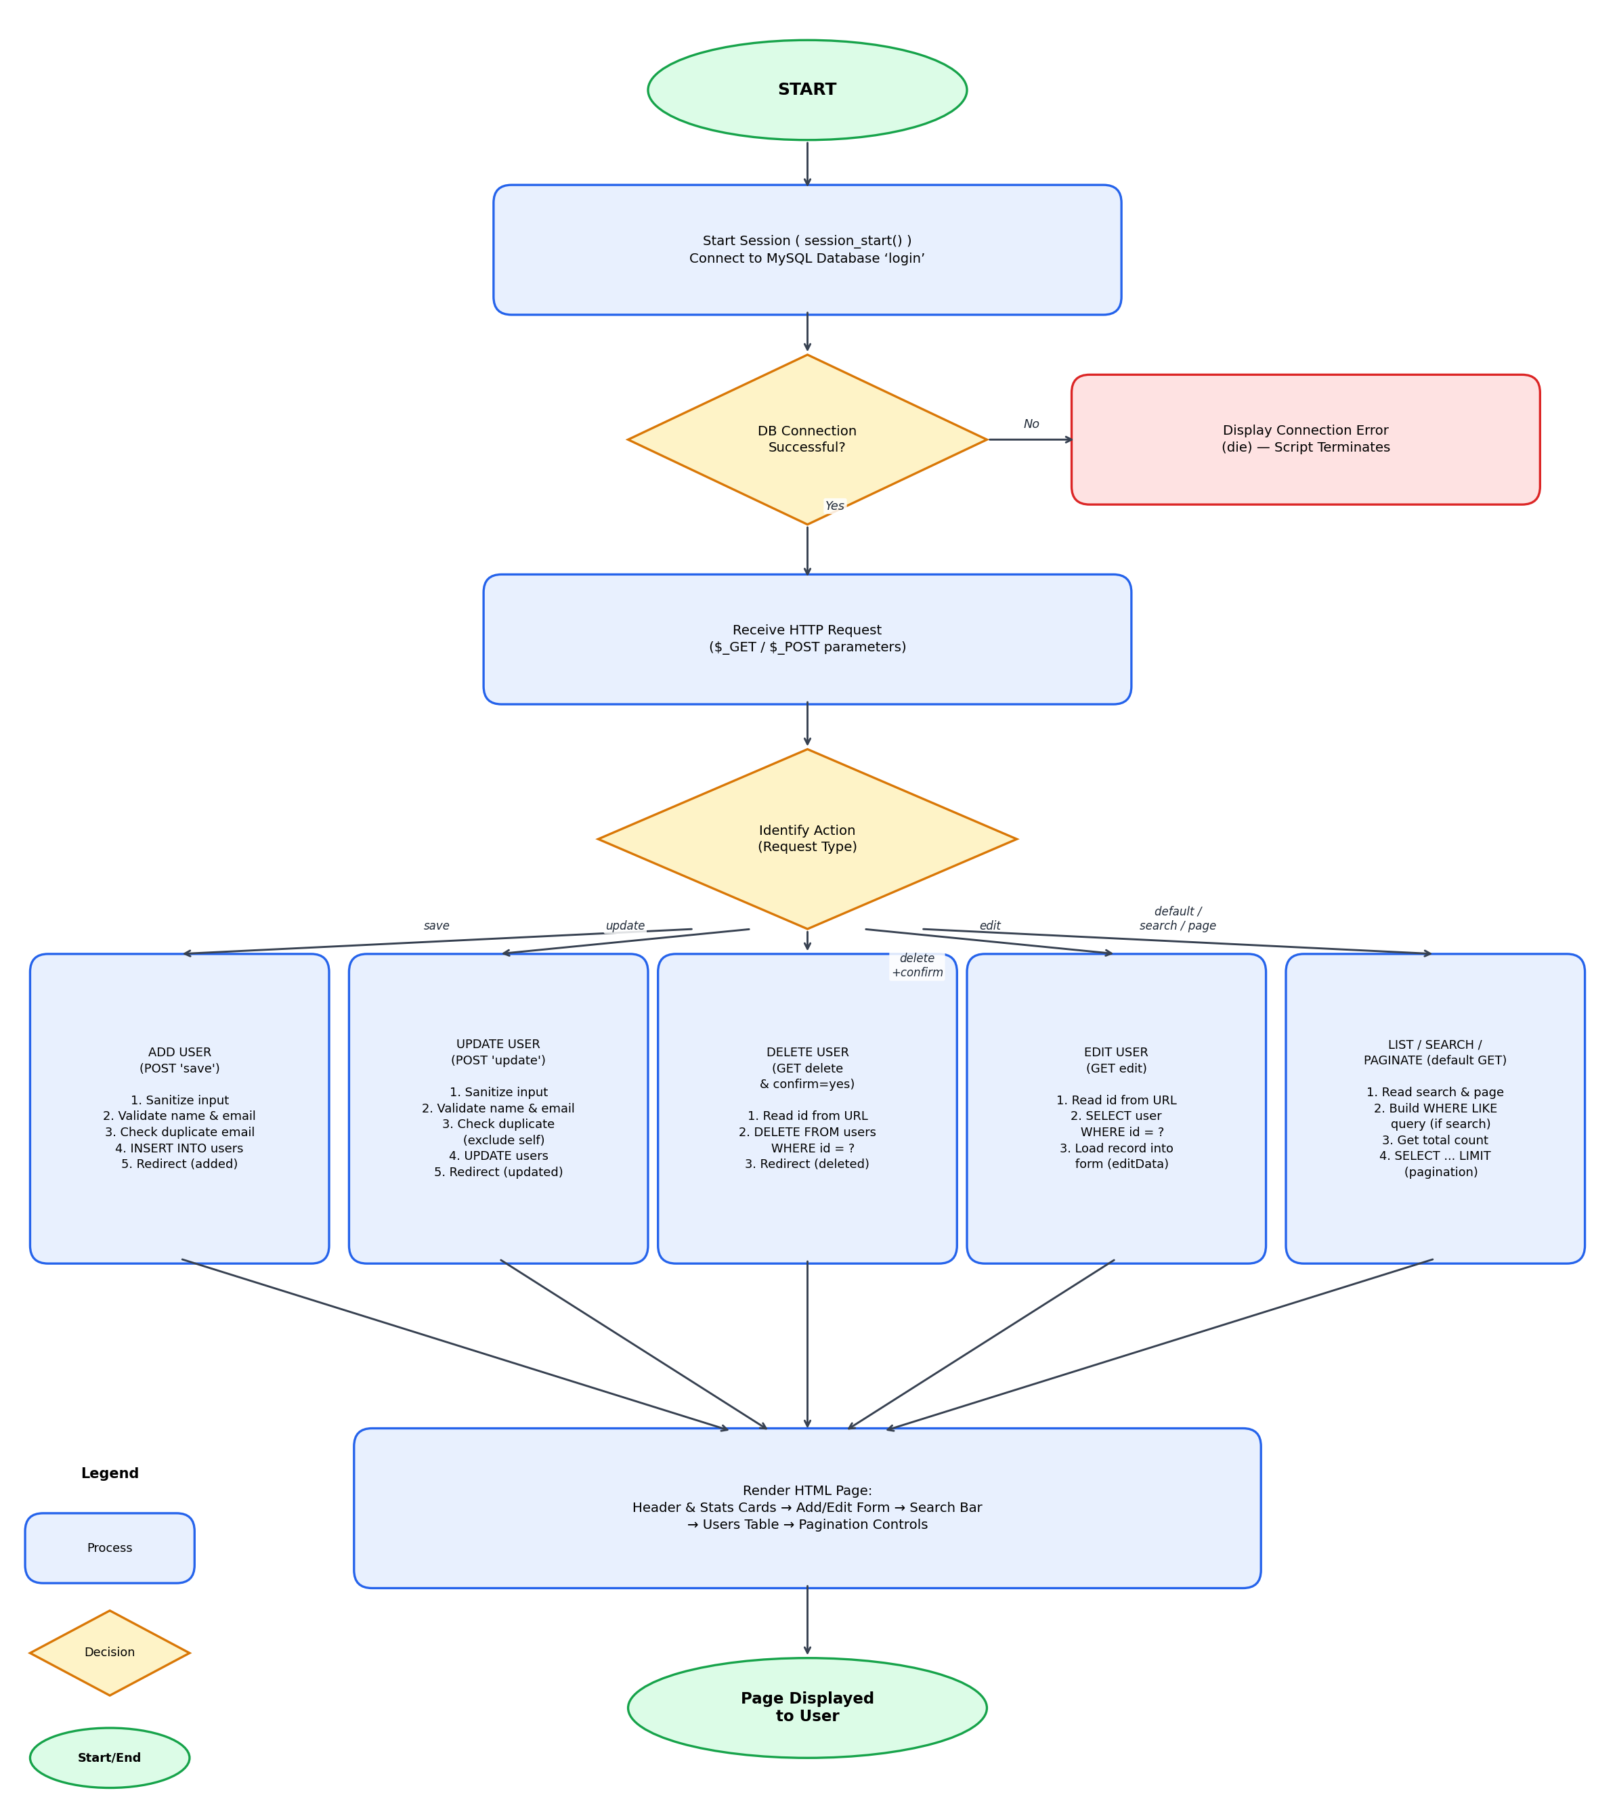
Figure 1: End-to-end request flow of the CRUD application

3. Flow Explanation

3.1 Initialization & Database Connection
When index.php is loaded, the script first calls session_start() and opens a connection to the MySQL database (login) using mysqli_connect(). If the connection fails, an error message is displayed and the script terminates immediately using die(), preventing any further database operations on a broken connection.

3.2 Request Routing
Once connected, the script inspects the incoming request to determine which action the user intends to perform. This is done by checking specific keys in the $_POST and $_GET superglobals: 'save' and 'update' indicate form submissions for adding or editing a user, while 'delete', 'edit', 'search' and 'page' are read from the URL query string for the remaining operations. Based on which keys are present, control branches into one of five possible flows.

3.3 Add User Flow (POST 'save')
The submitted name and email are sanitized using htmlspecialchars() and trimmed of whitespace. The data is then validated: both fields must be non-empty, the name must contain only letters and spaces, and the email must be a valid format. The system then checks whether the email already exists in the users table. If all checks pass, a prepared INSERT statement adds the new user, and the page redirects to index.php with a success flag. If any check fails, an appropriate error message is shown and no database change occurs.

3.4 Update User Flow (POST 'update')
This flow mirrors the Add User flow but operates on an existing record identified by its id. After sanitization and the same validation rules, the duplicate-email check excludes the current record itself (so a user can keep their own email). On success, a prepared UPDATE statement modifies the name and email for that id, and the page redirects with an 'updated' success flag.

3.5 Delete User Flow (GET delete & confirm=yes)
When the user clicks Delete, a JavaScript confirm() dialog first asks for confirmation. If confirmed, the browser requests the page with delete and confirm=yes set in the URL. The script reads the id, casts it to an integer for safety, and runs a prepared DELETE statement to remove that record before redirecting back to index.php with a 'deleted' success flag.

3.6 Edit User Flow (GET edit)
Clicking Edit sends a request with the user's id in the URL. The script runs a prepared SELECT statement to fetch that user's record and stores it in $editData. The form section of the page then detects $editData and pre-fills the Name and Email fields with the existing values, switching the form's heading and submit button to 'Update User' mode.

3.7 List, Search & Pagination Flow (default GET)
For a normal page load, the script reads optional search and page parameters from the URL. If a search term is present, a WHERE name LIKE ? OR email LIKE ? condition is added to both the count query and the data query. The total record count determines the number of pages (5 records per page), and the offset for the current page is calculated. A prepared SELECT ... LIMIT query then retrieves only the records for that page, ordered by id in descending order.

3.8 Page Rendering
After the relevant PHP logic has run, the HTML section renders the final page. This includes any success or error alert message, statistic cards showing the total number of users and pages, the Add/Edit form (pre-filled if editing), the search bar, the users table populated by looping over the result set, and pagination controls generated from the calculated total pages. Each row in the table includes Edit and Delete action links that feed back into the routing logic described above.

4. Conclusion
The application demonstrates a complete, secure request-response cycle for a CRUD system: every database operation uses prepared statements to prevent SQL injection, all output is sanitized to prevent XSS, and PHP's redirect-after-POST pattern (header + exit) avoids duplicate form submissions on page refresh. This single, well-structured flow allows the Add, Update, Delete, Edit, and Search/Pagination features to share the same connection, validation helpers, and rendering logic.

