## The Model Used:

Scrum Development model is being used in this project. With small incremental steps.

## Interface:

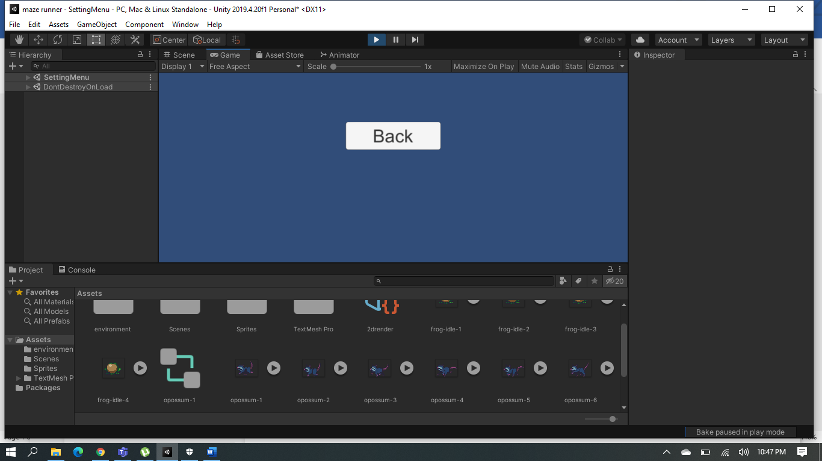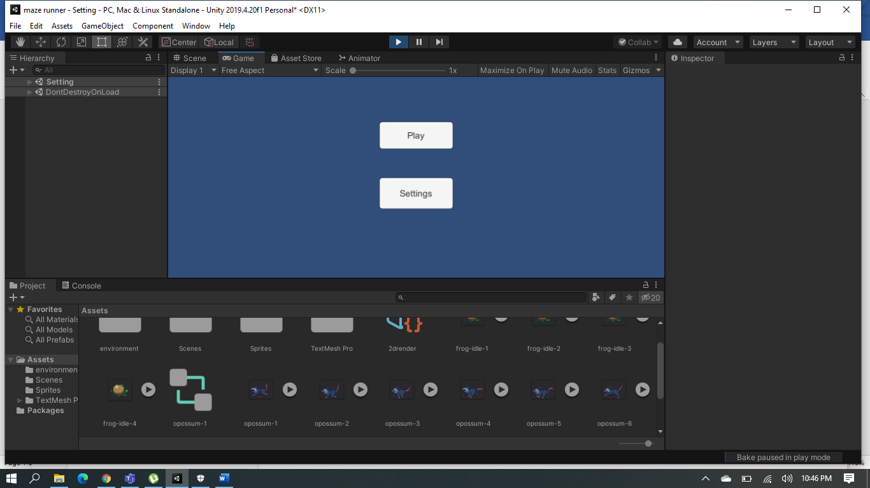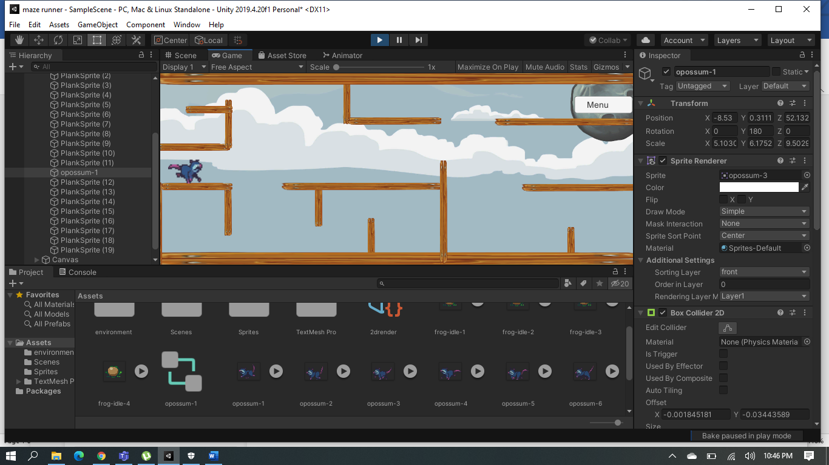

## Buttons:

1. Menu.
2. Back (Resume).
3. Settings.
4. Back to main Menu.

## Future Work:

1. Add volume setting buttons to lower/increase game volume.
2. Add SFX volume setting button to enable/disable the game music.