Cloud Computing Internship Report
Performed by : Hassan Mujtaba
Project Title: AWS EC2 Web Server Deployment and Management
Platform: Amazon Web Services (AWS)
Service Used: Elastic Compute Cloud (EC2)

1. Objective
The objective of this project was to create and manage an AWS EC2 Linux instance, connect to the server using SSH, deploy a simple web page using Apache Web Server, configure security settings, and verify public accessibility through the instance public IP address.

2. Tools and Technologies
- Amazon Web Services (AWS)
- EC2 (Elastic Compute Cloud)
- Ubuntu Linux
- Apache2 Web Server
- SSH
- Web Browser

3. Project Activities
- Created an AWS EC2 Ubuntu instance.
- Configured security group rules for SSH (Port 22) and HTTP (Port 80).
- Connected to the Linux server through SSH.
- Installed and verified Apache2 web server.
- Created a custom HTML page displaying "Welcome to DecodeLabs".
- Verified Apache service status and port accessibility.
- Accessed the web page using the EC2 public IP address.
- Managed and monitored the EC2 instance from the AWS Console.

4. Project Screenshots
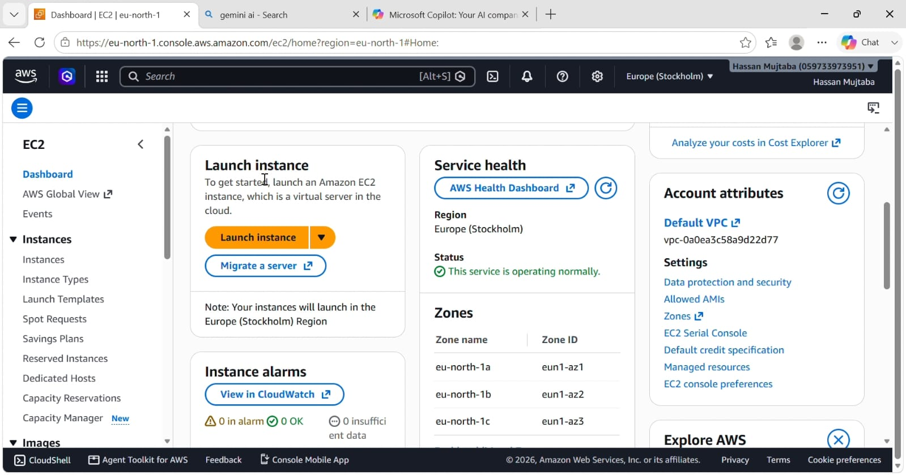
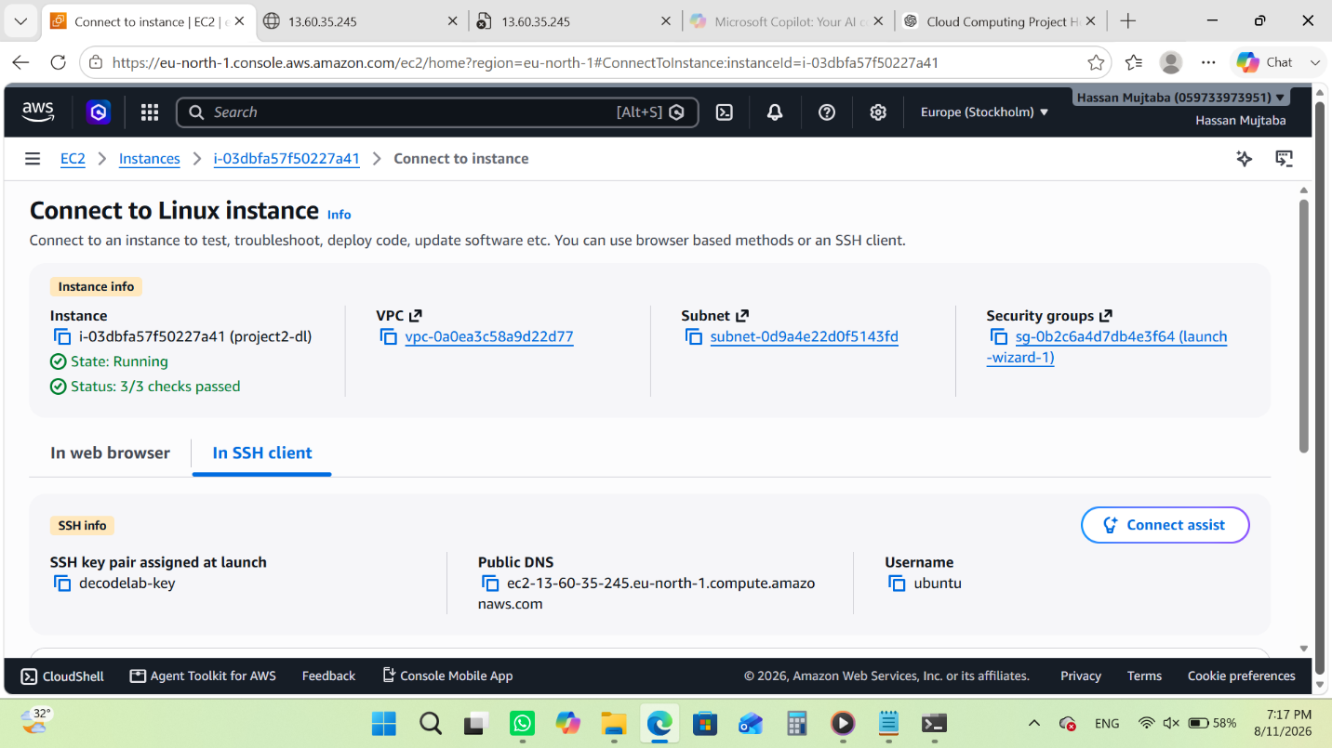
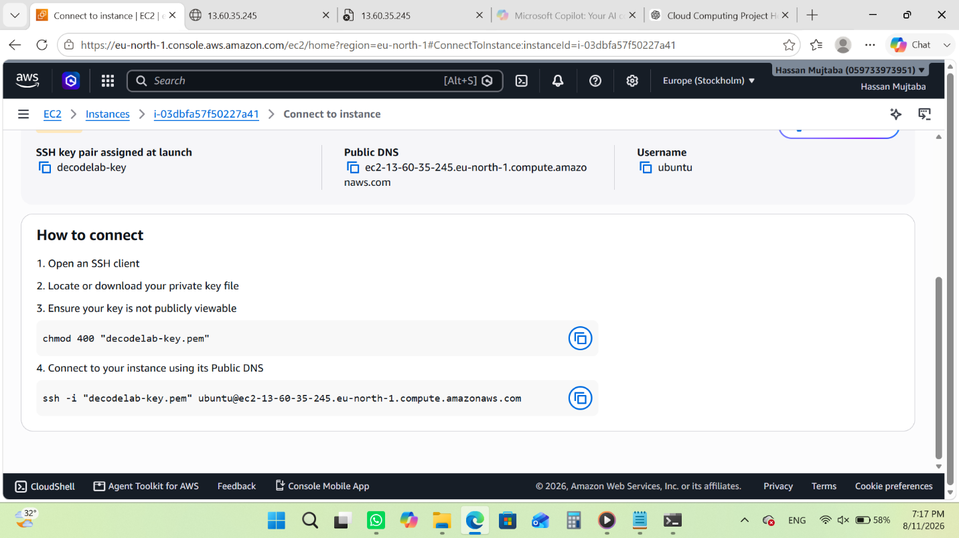
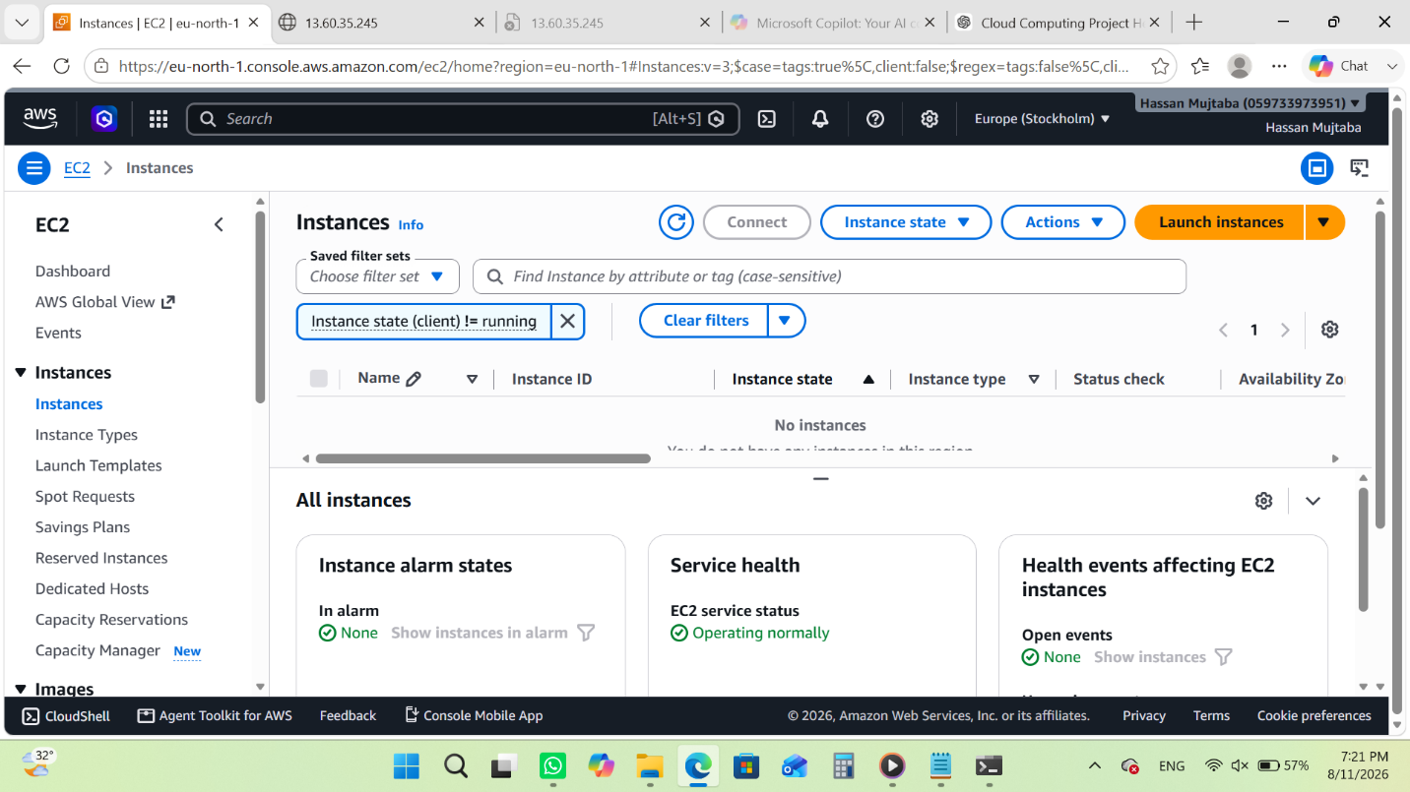
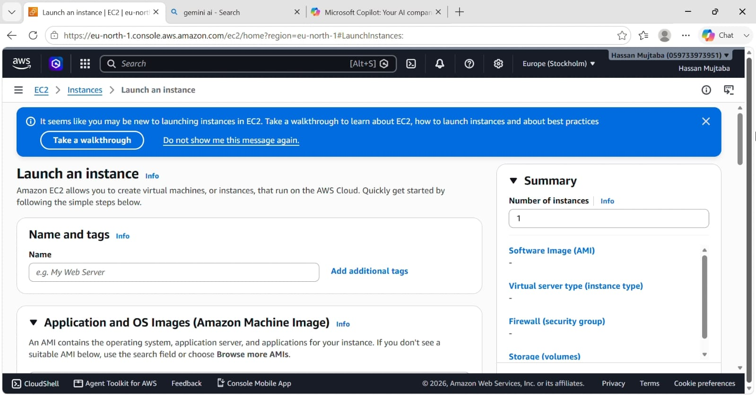
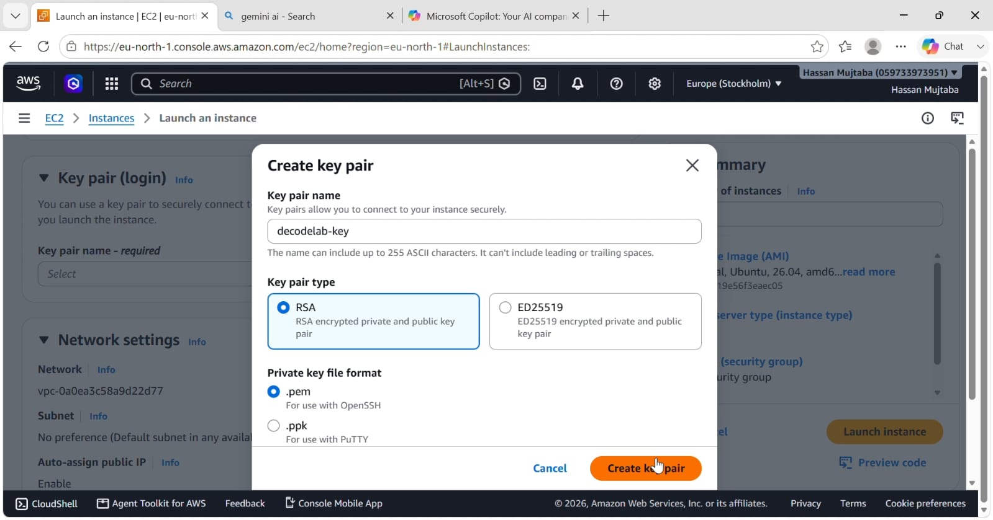
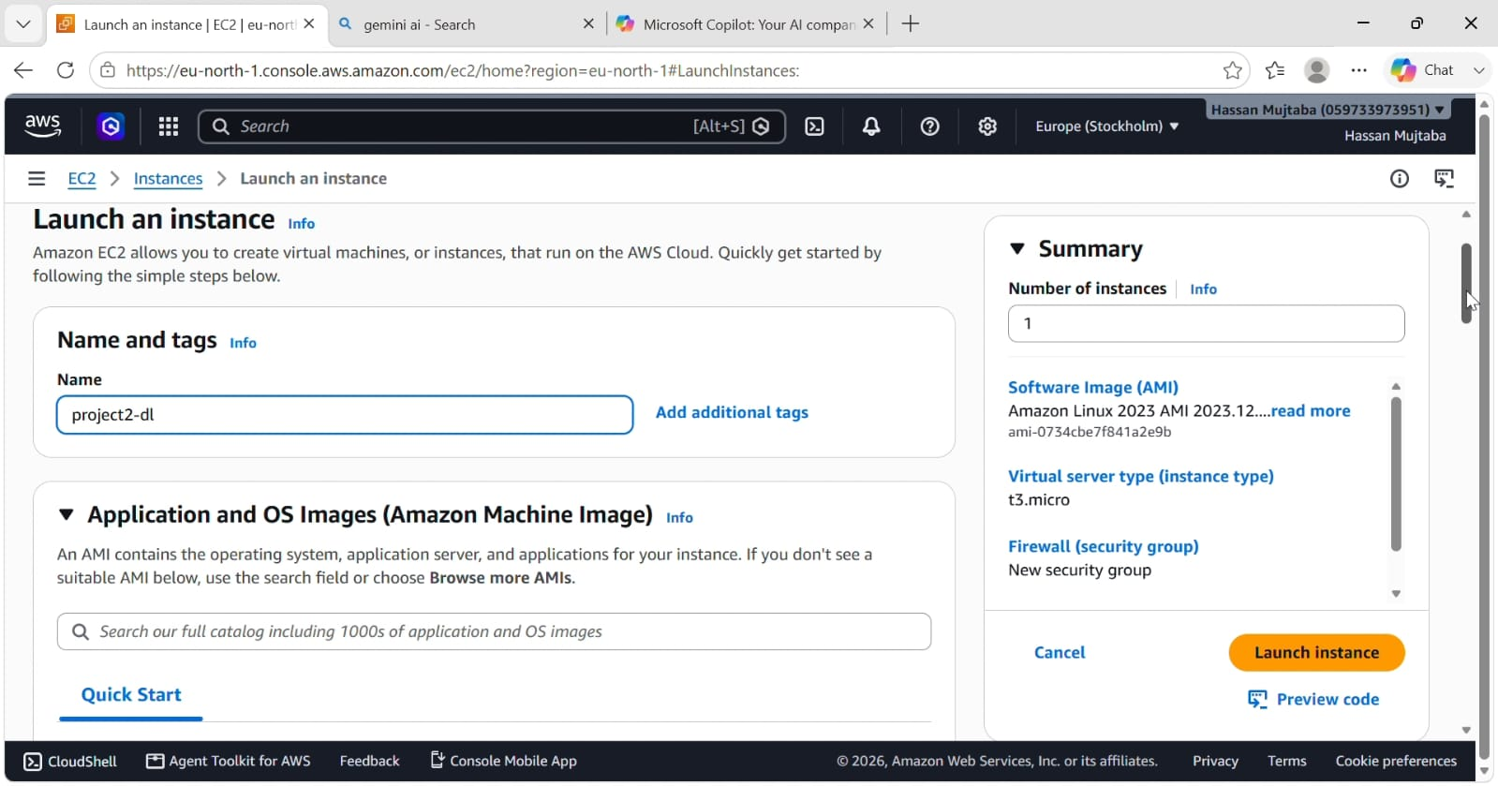
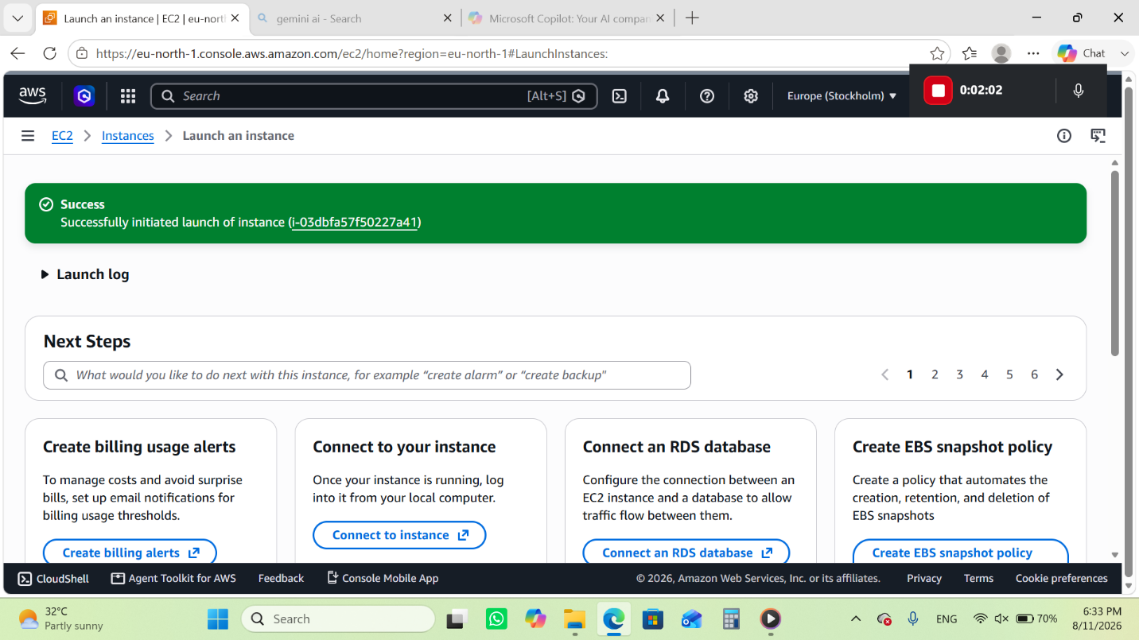
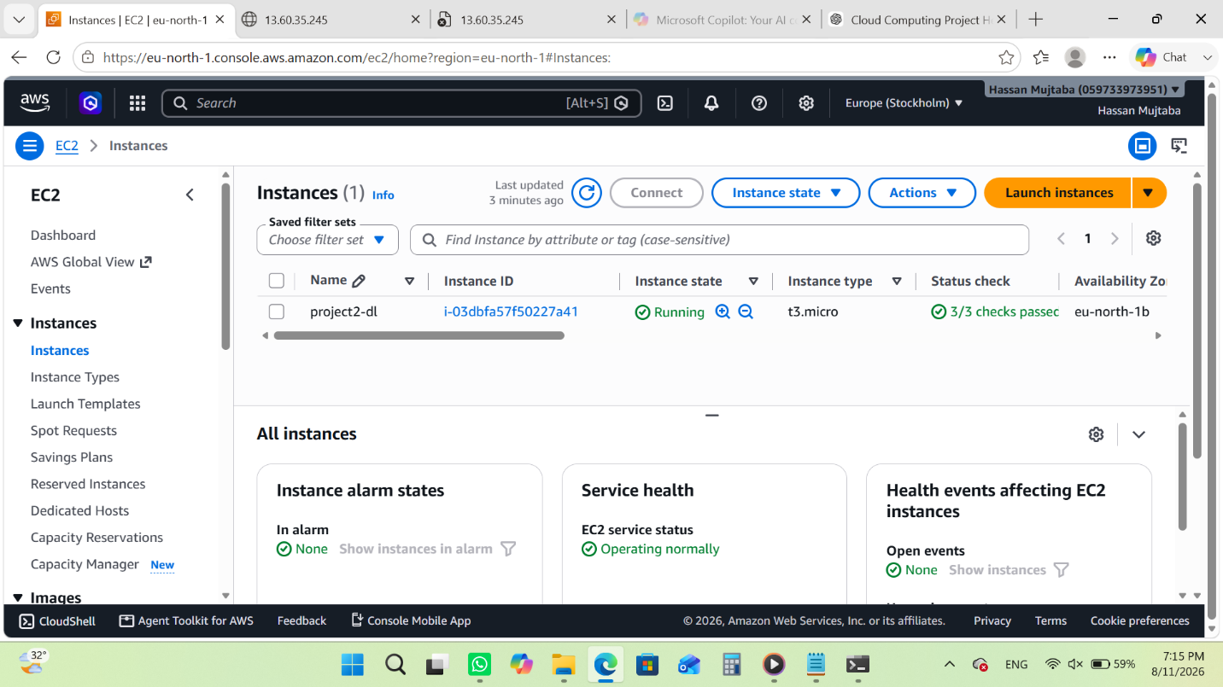
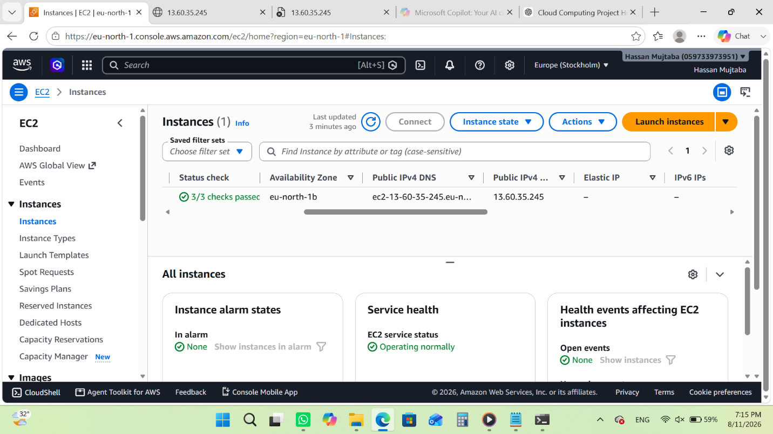
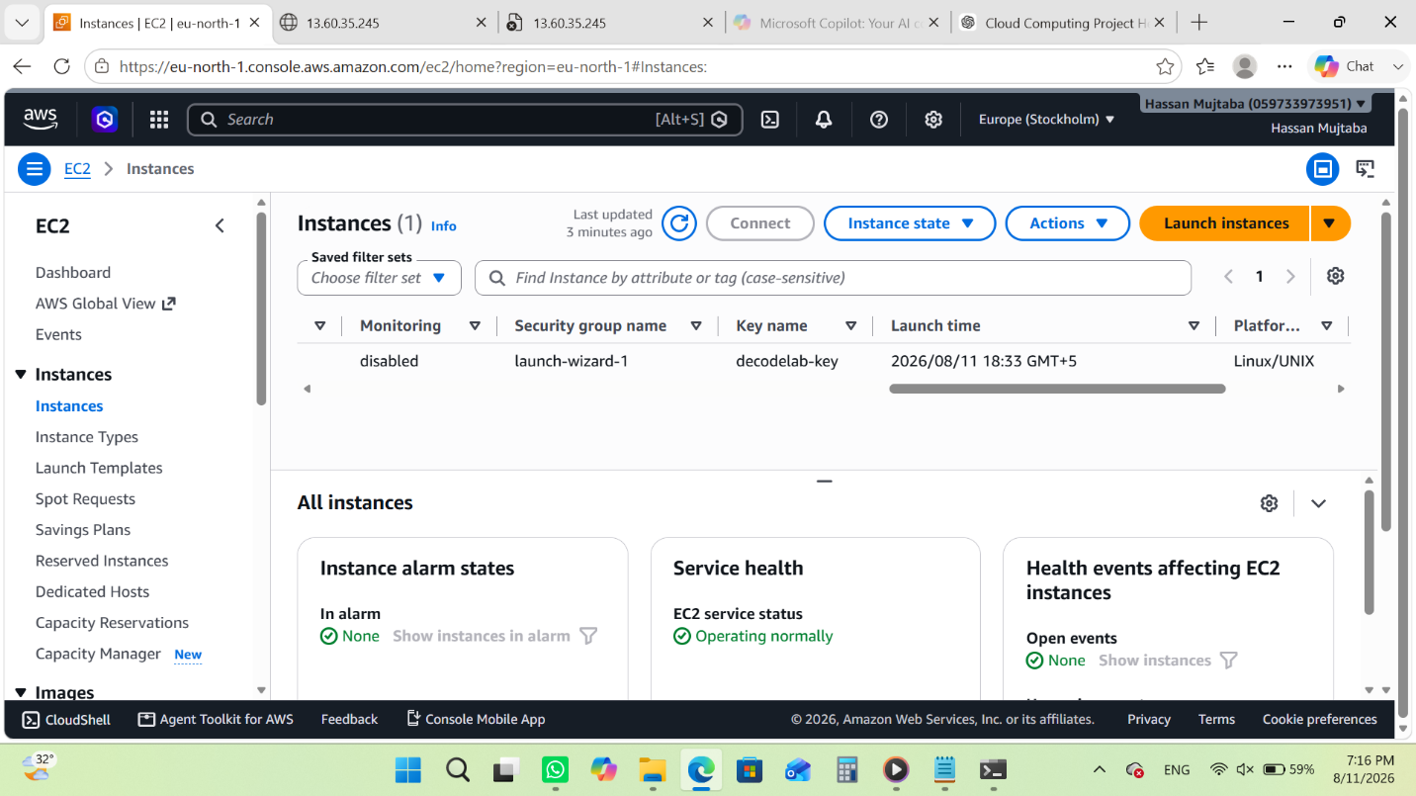
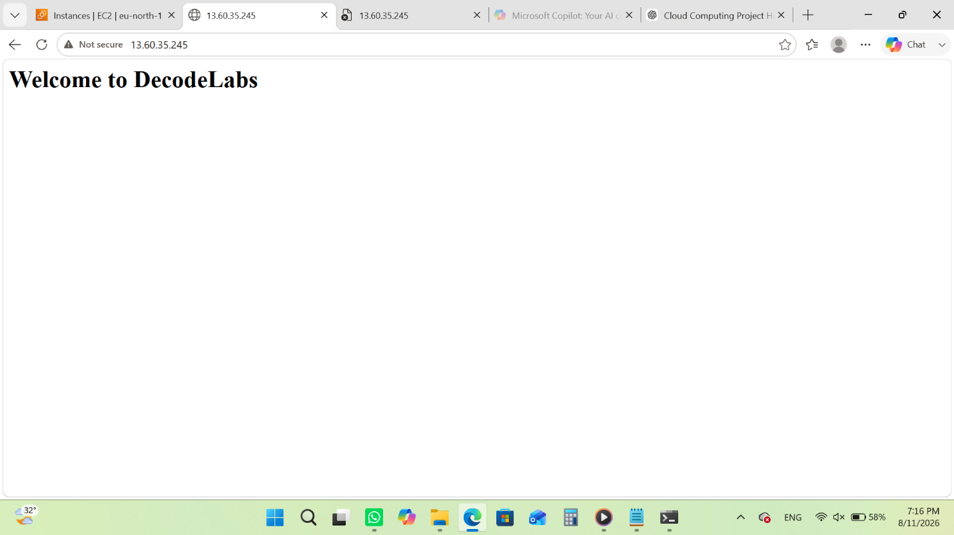

5. Results
The EC2 instance was successfully deployed and configured. Apache web server responded correctly, and the custom web page became accessible through the public IP address.

