video: 1-5

Course Structure and Projects

a. Quick over view how to course organized

Go to:F:\Work\Udemy\Js\complete-javascript-course-master\01-Fundamentals-Part-1\final\Pdf\pathways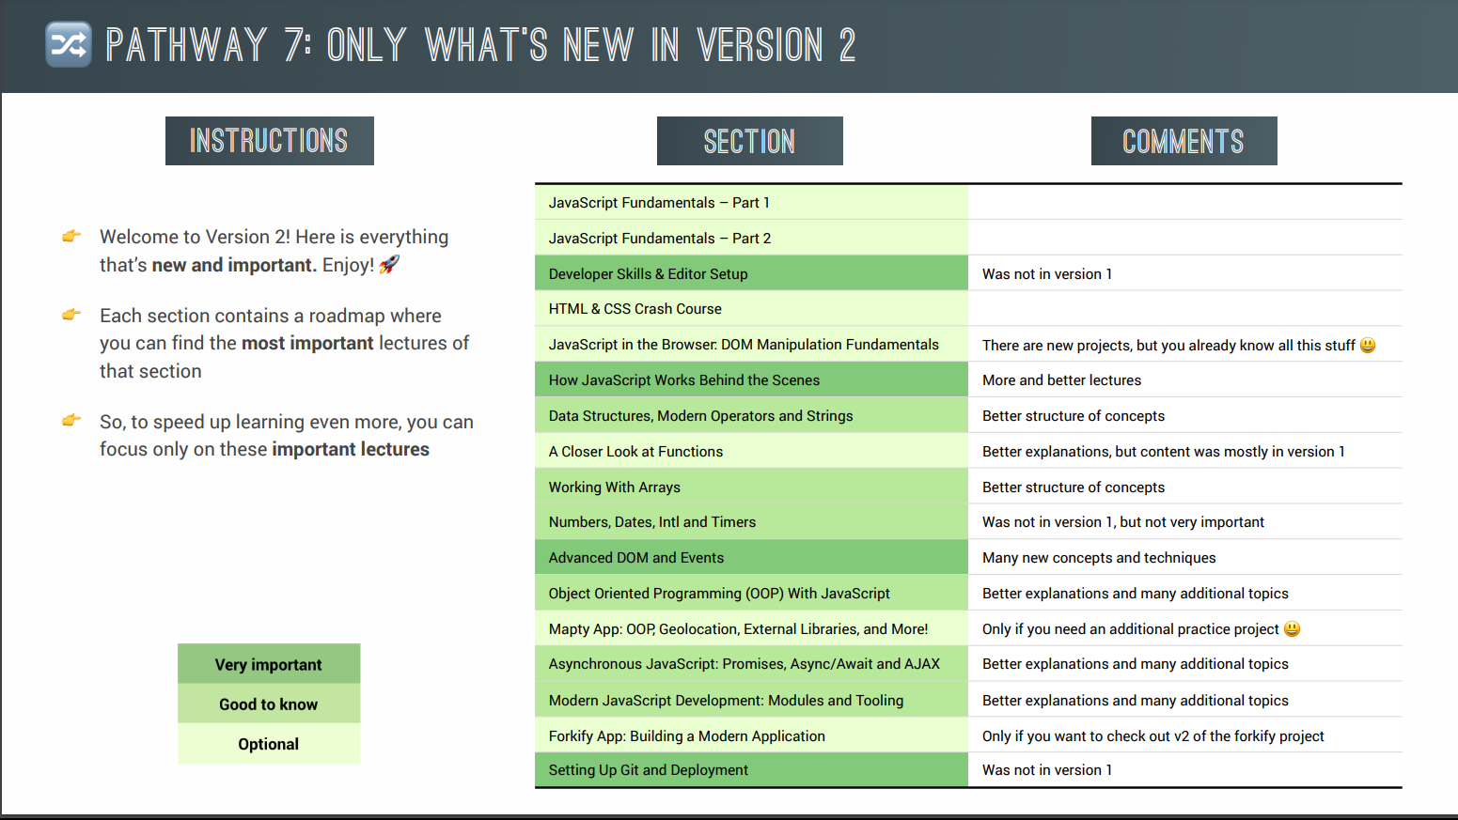

Note: Color-coded according to their relevance for students who watched the course previously.

2. Read Before You Start!

1️⃣ Download starter code

2️⃣ Download course material

3️⃣ Community & resources

👉 During the course, we use many online tools and resources, which are all on my resources page.

And now, have a ton of fun with the course! 😁

3. Watch Before You Start!

a. Asked question in QNA section in udemy

b. Try all the coadding challenges

c. Rewatch the lecture

d. Try to understand them batter and move on.

e. Totally non-coadding... try to understand a single word\*\*\\*\*\*

f. if you want to course material to stick, them take notes. note on code syntax, note on theory concepts and really notes on everything.\\*\\*\\*\\*

g. you will not understand everything at the beginning

h. we just want to make things work. we will understand the why later in the course.

I. moving another section, make sure that you understand exactly what was covered.

j. Review the code that we wrote, review your notes and review the Projects that we built.

k. if you ever have an error in your code, or a question always trying to solve it yourself, because this is absolutely essential for your progress.

l. QNA section: someone probably already had same problem before and if that doesn't help either then just asked a new question.

4. Migration Guide to v2 + Old Course

🚨🚨🚨 If you bought this course AFTER 2020, then please just skip this lecture

5. Setting Up Our Code Editor

vs code setting.

================================================================

1. In Section two [Fundamentals – part 1] and three [Fundamentals – part 2] with the very basic of the JavaScript language, to give you a solid foundation for the rest of the course.
2. In section five [Developer skills] you will learn some general skills that you will need as a developer, like problem solving, fixing errors, and setting up a development environment.
3. In section seven [Dom Manipulation] we built our very first project with the user interface.
4. In section eight [How JavaScript works] we will take a detailed look behind the scenes of JavaScript to learn how the language actually works. And this will give you valuable knowledge.
5. In section nine [modern operators (ES6+)] and ten [Function] we will keep working on our JavaScript fundamentals, but now with a focus on more modern ES6 topic. Such as maps and also strings, function, closures and more.
6. Then, throughout section eleven and twelve, will build our next project, which will teach you all you need to know about array methods, numbers, date and timers.
7. After that we jump right into our next project which is gonna be this beautiful website full packed will Visual effects and components.
8. In section 14 we finally reach the pretty advanced, but also important topic of object-oriented programming with constructor function and ES6 classes which will then the next section allow us to build this stunning real-world project.
9. All about asynchronous JavaScript which is used for things like loading data form external web servers with ajax
10. In section seventeen and eighteen we will learn how modern JavaScript applications are actually built cutting edge technologies like Npm, Bable, parcel and es6 modules.

Note: really notes on everything.

Coding is a lot a fun.