Project Overview
Future Mall - Early-stage Computer Engineering Portfolio
Portfolio ID: EYOUTH-30909090117044

What I Built
Future Mall is a personal portfolio project that combines a shopping mall idea with beginner-level Computer Engineering skills. The project includes visitor analysis, garage logic, a cybersecurity plan, and a simple visual identity.

Project Goals
- Practice turning visitor numbers into a simple business observation.
- Show the main states of a smart garage gate clearly.
- Make an easy-to-read brand that can be reused in an opening advertisement.
- Write practical safety steps for a small mall team.

Logo Development
I started with two quick concepts. Concept 1 uses a forward arrow to show future thinking. Concept 2 uses connected squares to show shops and people coming together. I chose Concept 1 because it stays clear at small sizes and works well on a web page or poster.
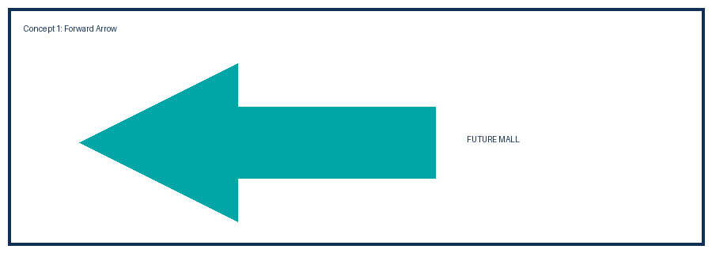
Concept 1 - Forward arrow (chosen).
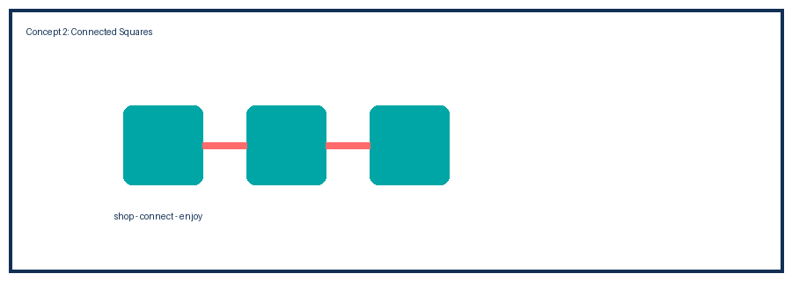
Concept 2 - Connected squares.

Color Choice
The brand uses only three colors: navy (#123055) for trust, teal (#00A6A6) for a fresh modern feel, and coral (#FF6B6B) for energy and a welcoming touch.

Portfolio Notes
This work is a learning project. The documents explain the decisions in a direct way and can be improved later as more features are built.

