Faculty of Engineering
Ain Shams University
CSE241 Object-Oriented Computer Programming
Desktop Hotel Reservation System
Milestone 1 Report
Course | CSE241 Object-Oriented Computer Programming
Project | Desktop Hotel Reservation System
Milestone | Milestone 1 - OOP Foundations
Submitted to | Milestone 1 source code archive and assignment brief
Submitted by | Zeineldin Mohamed  Yousef Cherif Elprince  Hassan Sherif Hassan  Yehya Amr Ahmed | 25P0452  25P0167  25P0391  25P0176
Date: 26-4-2026

Table of Contents
Table of Contents 2
1. Executive Summary 3
2. Problem Description and Objectives 3
3. Milestone 1 Requirement Mapping 3
4. System Analysis and Architecture Overview 4
5. Detailed Design 4
5.1 User and Staff Hierarchy 4
5.2 Room, Room Type, and Amenity Modeling 5
5.3 Reservation and Payment Workflow 5
5.4 Authentication and Data Storage 5
5.5 Validation and Exception Handling 5
5.6 Use of OOP Principles 6
5.7 Design Decisions 6
6. UML Class Diagram 6
7. Detailed Solution and Major Workflows 7
7.1 Guest registration and login 7
7.2 Viewing rooms and searching availability 7
7.3 Making a reservation 8
7.4 Deposit handling 8
7.5 Receptionist check-in and check-out 8
7.6 Administrative resource management 8
8. Class Inventory and Responsibilities 8
9. Testing Strategy and Test Cases 9
10. Sample Console Output 10
11. Limitations and Improvement Opportunities 10
12. Additional Submission Information 11
13. References 11
Appendix A. Full-page UML Diagram 12

1. Executive Summary
This report documents the first milestone of the Desktop Hotel Reservation System. Milestone 1 focuses on the backend only: object-oriented modeling, in-memory data storage, authentication, reservation management, room administration, payment processing, and validation. The submitted codebase is implemented as a console application in Java and is organized around a small, clear domain model that includes users, staff roles, rooms, room types, amenities, reservations, invoices, and supporting service classes.
The project already demonstrates the core OOP ideas requested in the assignment brief: encapsulation through private fields and accessor methods, inheritance in the User -> Staff -> Admin/Receptionist hierarchy, abstraction through abstract utility and base classes, and interface-based payment processing through Payable. The system also includes custom exceptions for authentication and payment-related errors, a pre-populated in-memory database for direct testing, and complete console flows for guest, receptionist, and administrator actions.

2. Problem Description and Objectives
Hotels need a reliable way to register guests, manage room inventory, record reservations, and settle payments without depending on scattered manual records. A backend reservation system solves this by centralizing data, applying business rules consistently, and separating responsibilities between guests and staff.
The objective of this milestone is to design a maintainable Java backend for a Desktop Hotel Reservation System using sound OOP practices. The code must model the main real-world entities, enforce essential validation rules, and provide enough dummy data and workflows to test the system immediately at launch.

3. Milestone 1 Requirement Mapping
Table 1 maps the milestone requirements to the classes and behaviors implemented in the submitted code.
Requirement from brief | Code implementation | Status
Guest model with registration/login and reservation actions | Implemented using Guest, User, Authentication, Main, and ReservationService. Guest stores balance, address, gender, and roomPreferences, and can register, login, browse rooms, make reservations, pay deposit, and cancel reservations through the console flow. | Implemented
Admin and Receptionist with shared staff parent | Implemented through abstract Staff with subclasses Admin and Receptionist. Staff stores role and workingHours; Admin handles room/room-type/amenity management; Receptionist handles check-in and check-out operations. | Implemented
Room types and amenities | Implemented using RoomType and Amenity classes. Each Room stores one RoomType and an ArrayList of Amenity objects. | Implemented
Reservation and invoice model | Implemented using Reservation and Invoice. Reservation stores guest, room, dates, status, deposit flags, and total price. Invoice stores totalAmount, paymentMethod, and paymentDate. | Implemented
Validation and custom exceptions | Password strength, negative invoice totals, negative guest balance, duplicate usernames, invalid credentials, and some booking/payment conditions are validated. Custom exceptions are included in the exceptions package. | Implemented
In-memory database with dummy data | Implemented through Database with static ArrayList collections for guests, staff, rooms, room types, amenities, reservations, and invoices. Static initialization preloads sample users, amenities, room types, and room ranges. | Implemented
Use of interfaces and/or abstract classes | Implemented through Payable, User, Staff, ReservationService, Catalog Service, and SystemTime. | Implemented
UML class diagram and design decisions | Included in this report. | Implemented

4. System Analysis and Architecture Overview
The backend follows a layered object model. The domain entities are User, Guest, Staff, Admin, Receptionist, Room, RoomType, Amenity, Reservation, and Invoice. Supporting services are Authentication, Database, ReservationService, and SystemTime. Main provides a menu-driven console interface for exercising all major features.
From a design perspective, the code separates responsibilities well: User subclasses store state, Database stores system-wide collections, Authentication handles login/registration, ReservationService concentrates booking rules, and Main acts as the presentation layer for milestone testing.

5. Detailed Design

5.1 User and Staff Hierarchy
User is the root abstract class for all authenticated actors. It stores username, password, and dateOfBirth and also exposes a static login method that delegates to Authentication. Guest extends User with guest-specific data such as balance, address, gender, and roomPreferences. Staff extends User with role and workingHours, then branches into Admin and Receptionist.
This hierarchy avoids duplication and gives each role only the operations it actually needs. Admin focuses on CRUD operations for hotel resources, while Receptionist focuses on operational workflows such as viewing reservations, checking in guests, checking out guests, and printing a formatted invoice.

5.2 Room, Room Type, and Amenity Modeling
The room model is centered on three classes. RoomType stores the type name, capacity, and pricePerNight. Amenity stores the amenity name and its price. Room stores its roomNumber, a single RoomType, and a list of Amenity objects. This design is simple and extensible: changing the room type changes capacity and nightly price, while amenities can be attached or removed independently.
The Database class pre-populates amenities and room types, then generates realistic ranges of rooms. The Room constructor automatically adds the basic amenities already stored in Database, and Database.generateRoomRange adds extra amenities depending on the selected room type.

5.3 Reservation and Payment Workflow
Reservation stores the booking identity and state: reservationId, guest, room, check-in date, check-out date, status, gym-pass flag, total price, deposit deadline, depositPaid, and fullPaid. The status lifecycle used in code is PENDING -> CONFIRMED -> ONGOING -> COMPLETED, with CANCELLED available whenever the booking is terminated.
ReservationService implements the reservation rules. It validates date ranges, checks room availability, creates reservations, computes deposit and remaining balances, confirms reservations after deposit payment, checks guests in, checks guests out, and searches available rooms using room type and guest-count filters.
Invoice implements the Payable interface. At checkout, ReservationService creates an Invoice for the remaining amount, validates the amount and payment method, and marks the reservation as fully paid and completed.

5.4 Authentication and Data Storage
Authentication centralizes login and registration. It consults Database.findUser during login and enforces unique usernames and password-strength rules during registration. The password regex requires at least one digit, one lowercase letter, one uppercase letter, and a minimum length of eight characters.
Database acts as the in-memory data store of the application. It uses static ArrayList collections for every major entity category and provides helper methods for creation, lookup, and deletion. Dummy data is inserted in a static block so the application is testable as soon as it starts.

5.5 Validation and Exception Handling
Validation appears both at the entity level and at the service level. Guest.setBalance prevents negative balances. Invoice.setTotalAmount prevents negative invoice totals. Authentication.validatePasswordStrength rejects weak passwords. ReservationService rejects invalid date ranges, unavailable rooms, duplicate deposit payment, and invalid check-in/check-out transitions.
The exceptions package includes InvalidCredentialsException, InvalidPasswordException, UserNotFoundException, UsernameAlreadyTakenException, WeakPasswordException, InvalidPaymentException, and RoomNotAvailableException. In the current code, authentication and invoice errors use custom exceptions directly, while several reservation workflow errors are reported through IllegalArgumentException.

5.6 Use of OOP Principles
Principle | How it appears in the code
Encapsulation | All domain objects store their state in private fields and expose getters/setters or controlled methods. Examples include Guest, Room, RoomType, Amenity, Reservation, and Invoice.
Inheritance | Guest and Staff inherit from User; Admin and Receptionist inherit from Staff; several exception classes inherit from InvalidCredentialsException.
Abstraction | User and Staff are abstract base classes, while ReservationService and SystemTime are abstract utility classes that collect shared static behavior.
Polymorphism | Database.addUser accepts User and then stores either a Guest or a Staff object based on runtime type. Admin.registerStaff also creates different subclasses depending on the chosen Role.
Interface-based design | Invoice implements Payable, separating the payment contract from the concrete invoice implementation.

5.7 Design Decisions
Using a shared abstract User base class keeps login data consistent across guests and staff.
Using an abstract Staff class avoids duplication of role-based functionality and provides a clear hierarchy for Admin and Receptionist.
Separating Authentication from User keeps credential management independent from the entities themselves.
Collecting reservation business rules inside ReservationService reduces logic duplication and keeps the Reservation entity focused on state rather than workflow orchestration.
Catalog Service serves as a centralized helper for managing and querying the hotel catalog (room types, amenities, rooms). Encapsulates business rules (uniqueness, in-use protection) and delegates storage to Database.
Using Database as a static in-memory store simplifies Milestone 1 testing and removes the complexity of database configuration before the GUI milestone.
Using enums for gender, role, payment method, and reservation status makes the valid states explicit and avoids fragile string comparisons in most places.

6. UML Class Diagram
Figure 1 presents the UML class diagram generated from the submitted source code. It includes the actual classes, inheritance structure, interface implementation, major associations, enumerations, and custom exceptions present in the archive.

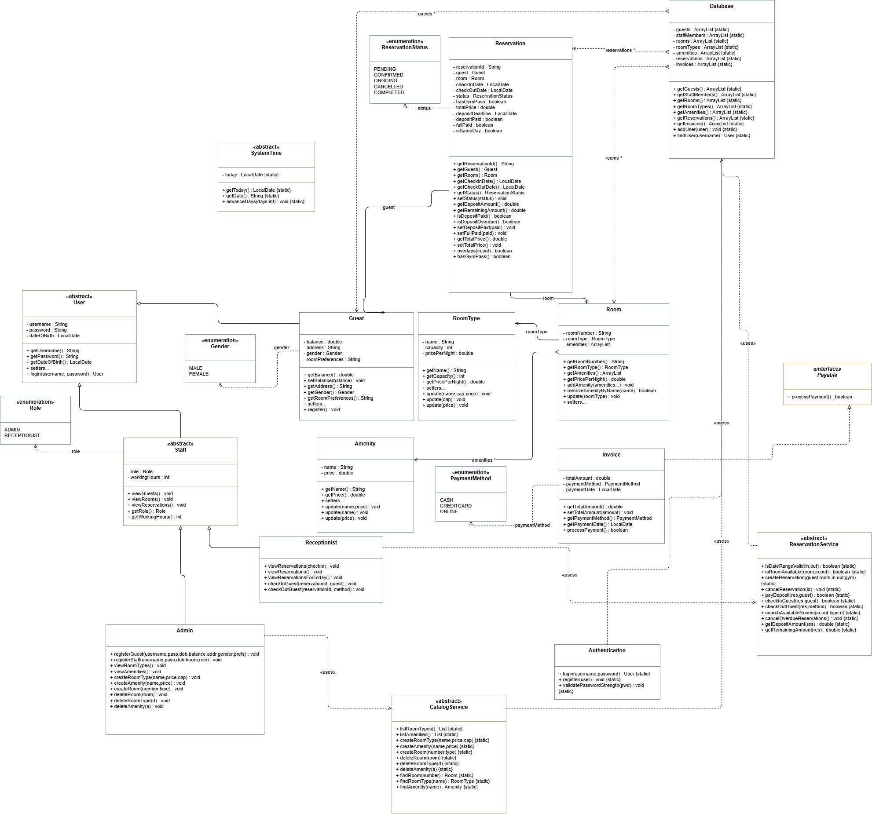
Figure 1. UML class diagram of the Milestone 1 backend.

7. Detailed Solution and Major Workflows

7.1 Guest registration and login
A new guest enters credentials and profile data through the Main registration flow. The password is checked using Authentication.validatePasswordStrength. If the username is unique, Authentication.register stores the new Guest in Database. During login, Main calls Authentication.login and dispatches the user to the guest, admin, or receptionist menu based on runtime type.

7.2 Viewing rooms and searching availability
Available rooms are either shown directly for the current day or searched through ReservationService.searchAvailableRooms using check-in date, check-out date, room type, and number of guests. The availability check ignores reservations that are cancelled and rejects overlapping active bookings.

7.3 Making a reservation
ReservationService.createReservation first validates dates and room availability, then generates a reservation identifier using UUID, creates the Reservation object, computes the total price, and stores it in the shared reservations list. Same-day reservations are confirmed immediately, while future reservations remain pending until the deposit is paid.

7.4 Deposit handling
For future reservations, ReservationService computes a 25 percent deposit. The guest can pay this amount from the guest menu. If the guest balance is sufficient, the balance is reduced, depositPaid becomes true, and the reservation status changes to CONFIRMED.

7.5 Receptionist check-in and check-out
At check-in, the receptionist verifies that the reservation is confirmed, that the current date matches the check-in date, and that the guest still has enough balance for the remaining amount. At check-out, the receptionist chooses a PaymentMethod, ReservationService creates an Invoice, processes the payment, marks the reservation as fully paid, and changes its state to COMPLETED.

7.6 Administrative resource management
The administrator can create and delete room types, amenities, and rooms. CatalogService encapsulates catalog use-cases (listing, creation, deletion, lookups) so UI/controllers and role classes (e.g., Admin) do not manipulate Database collections directly

8. Class Inventory and Responsibilities
Table 2 summarizes the responsibility of each class and enum in the codebase.
File / Type | Main responsibility | Important notes
User (abstract class) | Base authenticated user model | Stores username, password, and dateOfBirth; exposes static login helper.
Guest (class) | Guest profile and balance model | Adds balance, address, gender, roomPreferences, and guest registration.
Staff (abstract class) | Shared staff parent | Stores role and workingHours; can view guests, rooms, and reservations.
Admin (class) | Administrative management | Registers guests/staff and performs CRUD-like operations for hotel resources.
Receptionist (class) | Operational front-desk role | Views reservations and performs check-in/check-out.
RoomType (class) | Room category metadata | Stores type name, nightly price, and capacity.
Amenity (class) | Room feature metadata | Stores amenity name and price.
Room (class) | Concrete room entity | Links a room number to one room type and multiple amenities.
Reservation (class) | Booking state model | Stores guest, room, dates, price, deposit data, and status.
Invoice (class) | Payment record and processing | Implements Payable and records checkout payment details.
Authentication (class) | Credential validation and registration | Handles login, duplicate usernames, and password strength.
ReservationService (abstract class) | Booking business logic | Contains static rules for availability, deposit, check-in, and checkout.
CatalogService (abstract class) | Catalog (items) management logic | CRUD method helpers for Rooms, Amenities, and Room Types with safety checks.
Database (class) | In-memory datastore | Maintains all shared entity lists and seeds sample data.
SystemTime (abstract class) | Adjustable application date | Supports time simulation for testing.
Payable (interface) | Payment contract | Implemented by Invoice.
Gender / Role / PaymentMethod / ReservationStatus (enums) | Controlled value sets | Avoid magic strings for important states.
Custom exceptions package | Error classification | Covers authentication, payment, and room-availability, catalog, and related issues.
Main (class) | Console entry point | Provides interactive milestone testing menus for all roles.

9. Testing Strategy and Test Cases
Testing for Milestone 1 is mainly scenario-based because the code is currently organized as a console application. The following cases cover successful flows, validation failures, and business-rule enforcement.
ID | Scenario | Input / Action | Expected result | Observed code behavior
T1 | Guest registration with strong password | Register new guest with unique username and valid password | Guest is added to Database and can log in later | Supported through Guest.register -> Authentication.register -> Database.addUser
T2 | Registration with duplicate username | Register using an existing username | Registration is rejected | UsernameAlreadyTakenException is thrown
T3 | Registration with weak password | Provide password that fails regex | Registration is rejected | WeakPasswordException is thrown
T4 | Login with wrong username | Attempt login with unknown username | Login fails | UserNotFoundException is thrown
T5 | Login with wrong password | Attempt login with valid username but invalid password | Login fails | InvalidPasswordException is thrown
T6 | Create reservation with past or invalid dates | Check-out not after check-in or check-in before today | Reservation is rejected | ReservationService.isDateRangeValid returns false and createReservation throws IllegalArgumentException
T7 | Create overlapping reservation | Choose room that already has overlapping active reservation | Reservation is rejected | Room availability check rejects the booking
T8 | Pay deposit with insufficient balance | Choose pending reservation with low guest balance | Payment is rejected | IllegalArgumentException is thrown
T9 | Check in before check-in date | Receptionist tries to check in too early | Check-in fails | IllegalArgumentException is thrown
T10 | Successful checkout | Receptionist checks out ongoing reservation with valid payment method and balance | Invoice is created and reservation is completed | Supported through ReservationService.checkOutGuest and Invoice.processPayment
T11 | Delete room with active reservation | Admin deletes room attached to non-cancelled, non-completed reservation | Deletion is blocked | ItemInUseException is thrown
T12 | Delete room type currently in use | Admin deletes a resource still linked to rooms | Deletion is blocked | ItemInUseException is thrown

10. Sample Console Output
The following snippets are representative of the exact menu-based behavior implemented in Main and Receptionist. They illustrate the style of interaction produced by the current Milestone 1 console application.
===========================================
Welcome to the Hotel Reservation System
===========================================
--- Main Menu (Today: 2026-04-24) ---
1. Login
2. Register as Guest
3. Advance Time
0. Exit
--- Guest Menu [Hassan] ---
(Current date: 2026-04-24)
1. View Profile
2. View Available Rooms
3. Make a Reservation
4. View My Reservations
5. Pay Deposit (for PENDING reservations)
6. Cancel a Reservation
0. Logout
Reservation created! ID: RES-XXXXXXXX
Status: PENDING
Total Price: $......
Deposit Due (25%): $......
Deposit Deadline: 2026-04-25
Please pay the deposit to confirm your reservation.
============================================================
HOTEL CHECKOUT INVOICE
============================================================
RESERVATION DETAILS:
Reservation ID : ...
Guest Name : ...
Room Number : ...
Room Type : ...
PAYMENT DETAILS:
Total Stay Cost : $...
Amount Paid at Checkout : $...
Payment Method : CASH / CREDITCARD / ONLINE

11. Limitations and Improvement Opportunities
The system currently uses an in-memory database only; all runtime data is lost when the application closes.
The milestone is console-based. A full JavaFX GUI is reserved for Milestone 2.
Most reservation workflow failures are reported using IllegalArgumentException rather than a dedicated family of booking exceptions.
Room preferences are currently stored as a plain String rather than a richer preference object.
Invoice creation occurs during checkout; the deposit flow updates balances directly without generating a separate invoice record for the deposit.
Validation is good but not exhaustive. For example, empty usernames and empty addresses are not consistently rejected through setter-level checks.
These limitations do not prevent the milestone from demonstrating the required backend structure, but they identify clear opportunities for improvement in Milestone 2 and the final project submission.

12. Additional Submission Information
Item | Required by brief | Value / link to insert
Source code archive | Yes | HotelReservationDesktop-Milestone-1.zip
Project report (.docx) | Yes | This document
GitHub repository | Yes | GitHub repository
UML Diagram pdf | No | Milestone1-UML.pdf (with submission)

13. References
- CSE241 Object-Oriented Computer Programming project brief, Desktop Hotel Reservation System, 2nd Semester 2025/2026.
- Oracle Java Documentation for java.time.LocalDate and related date/time classes.
- Oracle Java Documentation for ArrayList, UUID, and exception handling in Java.
- The submitted Milestone 1 Java source files contained in HotelReservationDesktop-Milestone-1.zip.

Appendix A. Full-page UML Diagram

Appendix Figure A1. Enlarged UML diagram for easier reading.

