SCHOOLbook

Advanced Programming project

Hassan Rasheed Muhammad Ahsan Fahim Sikandar Azam

# Abstract:

The following description document describes the Android application called “SchoolBook” which provides features that are useful for parents, students and teachers alike while looking or searching for new schools.

# Introduction:

Schoolbook is an interactive mobile application. Its purpose is to provide information about schools starting from the location to every minor detail a person needs to know about a school. Schoolbook has all the academic records of schools which is the major concern for parents when looking for a school for their children. Schoolbook includes information including name, logo, address and location, small description, fee, student to teacher ratio, rankings, ratings etc.

Schoolbook is personalized for each of its users. It can tell you the schools near your location and you yourself decide the radius you want the school to be in, the fee limit on the school so the users can see the schools that are within their budget and the ranking of the schools according to the reputation they have. All of this makes choosing a school easier for anyone who uses our application.

# Literature review:

The android app that we have made is education based as it helps students, parents and teachers the targeted audience for the app are the people who have any relation to primary and secondary schools. Apps exist for the colleges and universities that contain information of colleges and universities, rankings, concentrations taught, student to teacher ratio etc. One such app called ‘College Search’ is a similar application which has lesser features and is based in UK, this also targets aspiring College students. No such app currently exists in Pakistan or even in the world to our knowledge that does this for students of primary and secondary schools. We have added new features and filters which other apps of a similar kind that they do not have.

# Problem statement:

No convenient platform/system exists where a person can search details of schools in an area/city.

# Design:

Class diagram:   
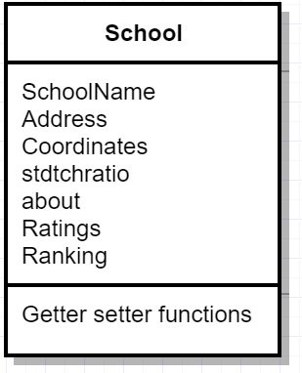

This android application is linked with two major software components, namely the database (created on Android Studio using SQLite) and the Google Play Services API (using the Google Maps Segment). Android API 24 has been used for the development of the project and the application has been tested on two devices one running Android Nougat 7.0 and one running Android Marshmallow 6.0. This system is also backward compatible with devices running an android version as low as Lollipop 5.0. To access the map, Google Play Services are vital. Without the compatibility and availability of these services, the user will not be able to view the map.

Interface is simple and easy to use, buttons have images indicating the tasks that they perform. In only 2-3 touches from the home screen every action can be performed on the application. The application is complete, it does not have a backend server, so it can be used from anywhere, and does not need an active internet connection to work. Once the application is downloaded and installed on the device users can enjoy full functionality.

Implementation:

There is no need for any credentials to use the application, the application only needs to be downloaded and installed on the device and the users can start surveying the schools. The users open the application and they are shown 4 buttons on the main screen from where they can choose the way they want to look for schools, there are 4 options:

* Using their own location (requires GPS) they can search for schools that are near them, multiple radii of area can be selected i.e. 2KM, 5KM, 10KM.
* By fee, they enter a maximum limit for fee of the school and they are shown schools that fall under that limit
* By ranking, users are shown schools arranged according to their ranking on the application, this ranking may change with time, but the changes are made using updates from the store.
* By going all the schools that are available in the application database

All schools have the details page that contains the relevant information about the school, every search method leads to the same details page, the page includes details such as school logo, address, rating, ranking, fee, student to teacher ratio and a section for description of the school.

# Interfaces:

## Home screen:

## 

## School Details:

## Map (nearby Schools):

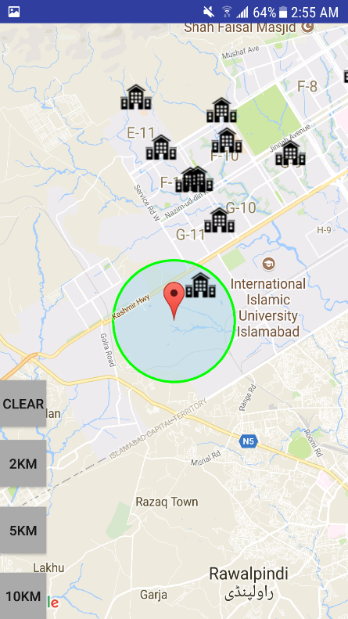  
  
Drawer:  
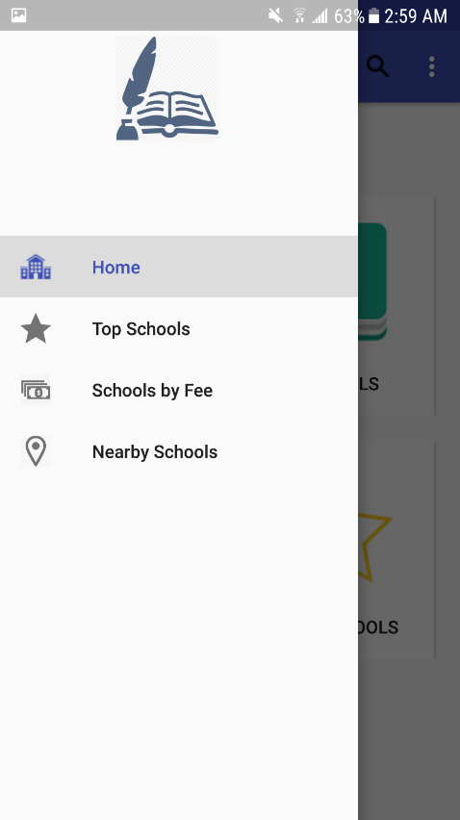

## Filter (By fee):

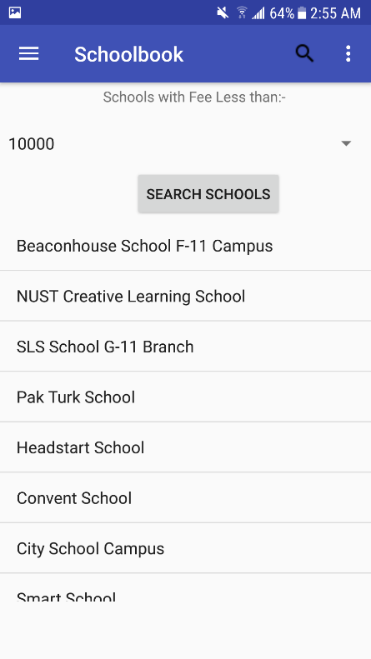

## 

# Efficient design:

The App has been designed efficiently as to use minimum amount of memory. The performance of the application has been improved by using SQLite so the data is retrieved much faster and is also available offline. The following screenshot shows the memory usage of the app:

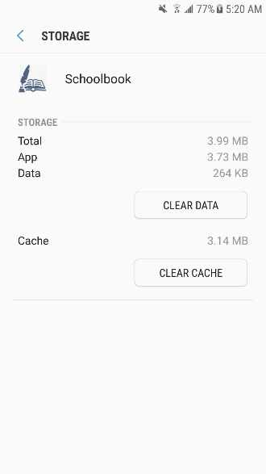

# Conclusions:

The android app ‘Schoolbook’ is a new idea from which many people can benefit. It is free and requires very little hardware specifications and memory. The app not only provides details of each school, it provides different filters through which the user can explore the different options of schools available and a visual map that helps locate schools easily. SchoolBook also ranks the schools according to different parameters and shows the top schools in the area. The improvements that can be brought to the app are:

* Adding more schools (Private and government)
* Adding more cities
* Adding more filters like Sports and extra-curricular activities
* Adding more details like Male-female ratio, teacher salaries etc.