Hassan Rasheed, Muhammad Ahsan Fahim, Sikander Azam

BSCS 5B

Schoolbook user manual

# Introduction:

Schoolbook is an interactive mobile application. Its purpose is to provide information about schools starting from the location to every minor detail a person needs to know about a school. Schoolbook has all the academic records of schools which is the major concern for parents when looking for a school for their children. Schoolbook includes information about extracurricular activities, sports offered, school rules etc.

Schoolbook is personalized for each of its users. It can tell you the schools near your location and you yourself decide the radius you want the school to be in, the fee limit on the school so the users can see the schools that are within their budget. Ranking of the schools according to the reputation they have, all of this makes choosing a school easier for anyone who uses our application.

# Steps to run:

First of all you need to install the application, by downloading the APK on your phone and installing it by going to the directory where the APK was downloaded and running it, the application will be installed.

**Home Screen:**

Once installed, click on the app with the name SchoolBook and the following screen will appear:  
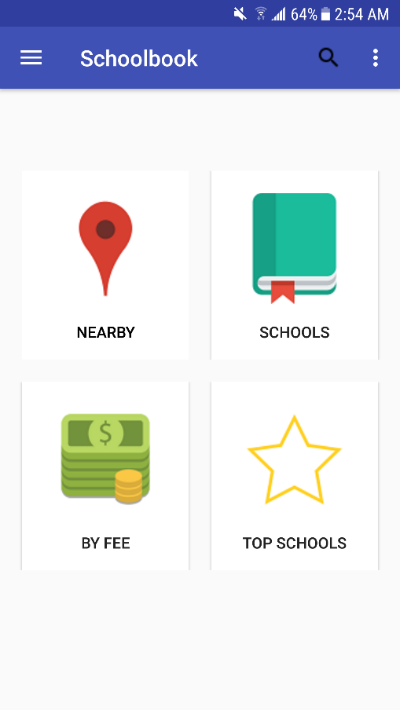

**Nearby:**

These are all buttons which can be clicked to avail a certain feature of the app.  
If the ‘Nearby’ button is clicked the following screen appears:

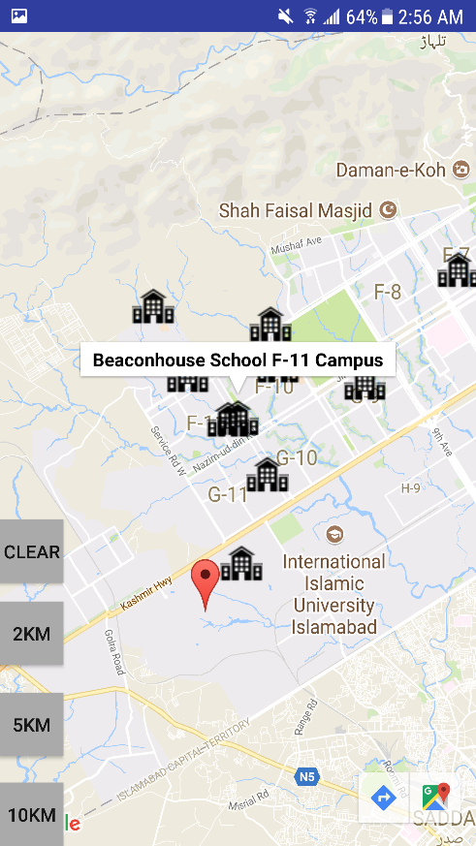

The red marker shows the location of the user and the black building icon shows the schools. User can zoom in and zoom out according to their wish by pinching in and pinching out on the screen.   
The buttons on the left are used for different radii selected by the user:   
 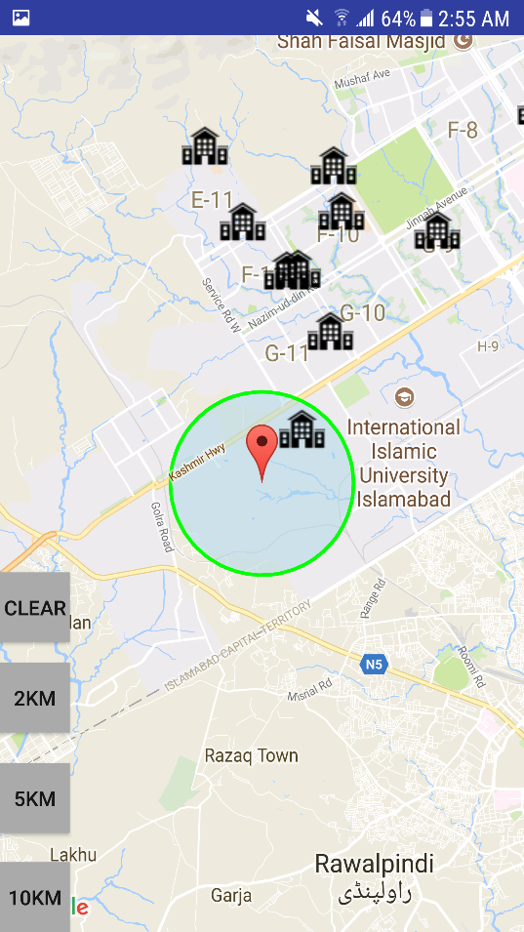 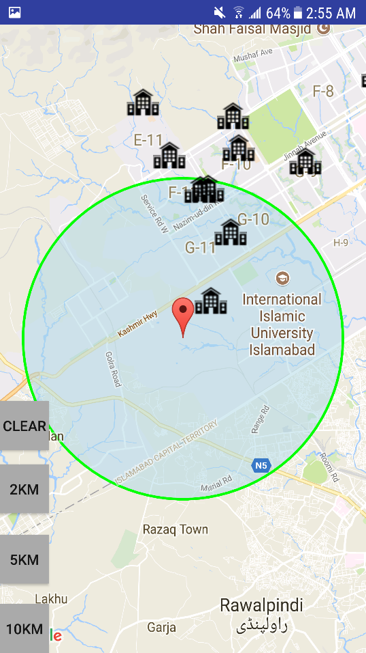

**BY FEE:**

From the home screen if by fee is selected the following screen appears:

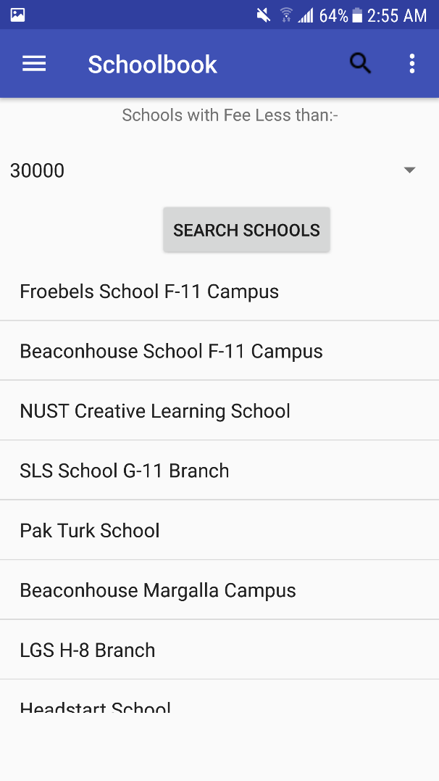 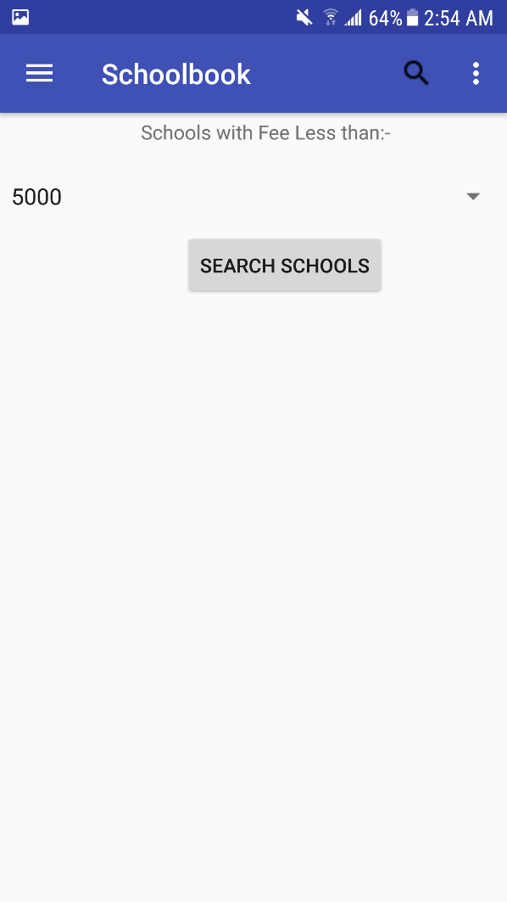

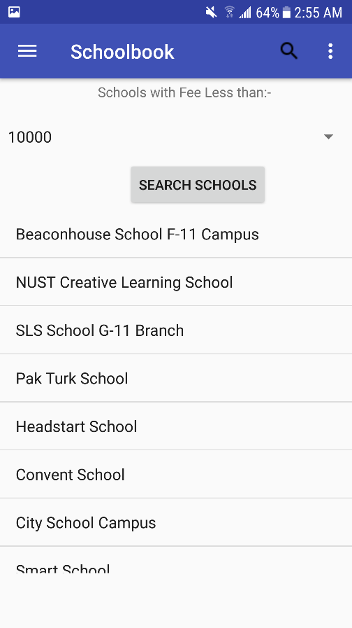  
The screens shown above contain a combo box using which user can select a limit for the fee and then click on search schools. The system will return the list of schools that have a fee less than the limit selected.

**Top Schools:**

From Home screen if top schools are clicked this screen appears:

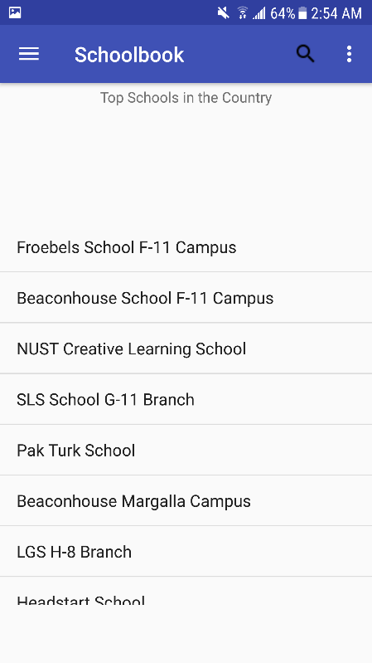   
This lists down all the schools according to their rankings. The school shown at the top will have the highest ranking, the second will be positioned at second item on the list and so on.

**School Details:**

Clicking on any school on the map will open up a screen like the following:

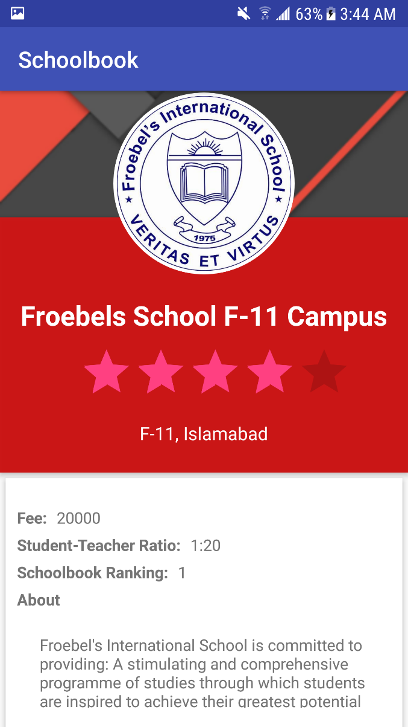 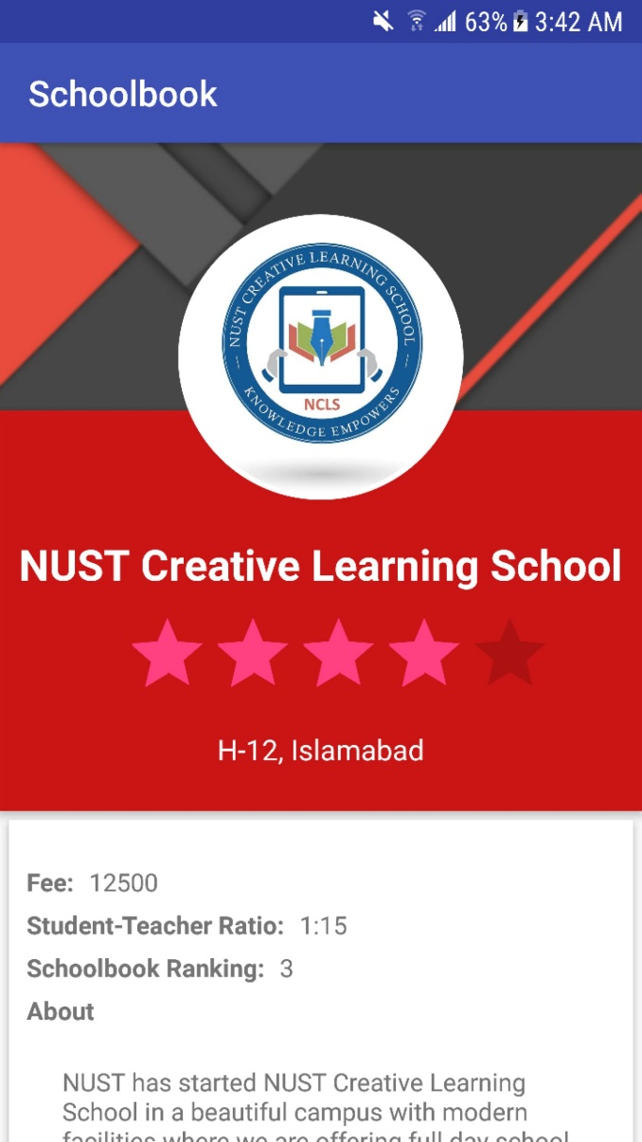

This screen shows the detail of the schools.