**Software Requirements Specification**

**for**

**Schoolbook**

**Version 1.0 approved**

**Prepared by**

**Hassan Rasheed 126900**

**Muhammad Ahsan Fahim 129416**

**Sikander Azam 133767**

**SEECS**

**3 Jan 2018**

**Table of Contents**

**Table of Contents i**

**Revision History ii**

**1. Introduction 3**

1.1 Purpose 3

1.2 Document Conventions 3

1.3 Intended Audience and Reading Suggestions 3

1.4 Product Scope 3

1.5 References 4

**2. Overall Description 4**

2.1 Product Perspective 4

2.2 Product Functions 4

2.3 User Classes and Characteristics 5

2.4 Operating Environment 6

2.5 Design and Implementation Constraints 6

2.6 User Documentation 6

2.7 Assumptions and Dependencies 7

**3. External Interface Requirements 7**

3.1 User Interfaces 7

3.2 Hardware Interfaces 8

3.3 Software Interfaces 9

3.4 Communications Interfaces 9

**4. System Features 9**

4.1 System Feature 9

4.2 System Feature 2 (and so on) 10

**5. Other Nonfunctional Requirements 10**

5.1 Performance Requirements 11

5.2 Software Quality Attributes 11

**6. Other Requirements 12**

**Appendix A: Glossary 12**

**Revision History**

|  |  |  |  |
| --- | --- | --- | --- |
| **Name** | **Date** | **Reason For Changes** | **Version** |
| **AP Project** | **3rd Jan 2018** | **None (First draft)** | **1.0** |

**Introduction**

**Purpose**

Schoolbook is an interactive mobile application. Its purpose is to provide information about schools starting from the location to every minor detail a person needs to know about a school. Schoolbook has all the academic records of schools which is the major concern for parents when looking for a school for their children. Schoolbook includes information about extracurricular activities, sports offered, school rules etc.

Schoolbook is personalized for each of its users. It can tell you the schools near your location and you yourself decide the radius you want the school to be in, the fee limit on the school so the users can see the schools that are within their budget. Ranking of the schools according to the reputation they have, all of this makes choosing a school easier for anyone who uses our application.

**Document Conventions**

Basic document conventions were followed while writing this SRS document such as the font style was Times New Roman and the font size was 12. The document was divided into 6 sections.

**Intended Audience and Reading Suggestions**

The intended audience for this document include: the system developers, project managers,

marketing staff, testers, document writers, the users.

Schoolbook was not restricted to parents choosing a school for their children but for anyone who needs to find out more about schools. Students themselves are very vigilant in this case nowadays.

The system developers, testers and managers must read the document in the given sequence for better comprehension of what the system is about and what features are available in the system. Testers need to know about the system and its features before they can test the system from all perspectives. The users can optionally skip the system architecture and interface section as it is not of their interest.

**Product Scope**

Schoolbook is an interactive mobile application for finding schools, it will contain location, academic information, sports information, extracurricular activities information and many other things needed to know in one application. But the main idea is to get all these useful things in one place, people usually need to go to the schools in person to check everything out, but a person will use schoolbook the for all the information regarding schools. Even if they eventually need to visit the schools in the end, it will at least help them shorten their list of schools to visit.

**References**

The software requirement specifications document has been designed and written according to the IEEE standard for SRS Document (IEEE 830).

**Overall Description**

**Product Perspective**

The application designed and developed from user requirements and specifications. For keeping track of schools, currently the users have to ask different people or visit schools themselves but this mechanism is not as efficient as it is required to be. The activities of this application would have up to date information, an easy to understand interface to access that information. For ease of understanding, it could be said that the system can be used easily by anyone, anywhere. The application does not even need an internet connection at all times to work because the data is stored in the application itself, with time to time updates from the play store (which requires an internet connection) the users will have the information that they require at their disposal. The client side consists of the application interface which is to be used and interacted by the user. The server side includes a database which is connected to the application and which adds, deletes or updates the data accordingly.

**Product Functions**

The android application provides these basic functionalities:

* Current location of user
* Displaying schools on the map
* Showing nearby schools
* Details about the schools
* Find schools using filters (By fee)

The user is shown a home screen when the app is opened and from there, the user has the option to go to nearby schools, which shows the user’s location and all the schools in the city, shown with markers (small school icon). The user can use buttons to specify range of radii which shows schools within a specific distance from user’s location. From the home screen, user can see list of schools, filter (by fee) and favorite schools.

**Class diagram:**

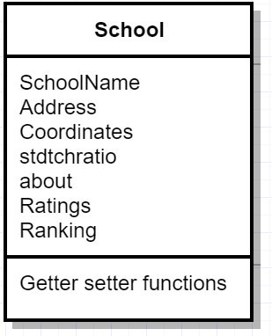

**User Classes and Characteristics**

The various classes that are anticipated to use this product are as follows:

* **Parents:**

The parents will be the major users of this product. Their frequency of use will be more than any other user. The basic functionality they will be using is searching for schools. They will use the app to get information about the schools. They can use the app to locate schools near their own location. For using this product, the parents must have basic knowledge of an android app.

* **Students:**

Students can use this app to find schools if they have moved to a new city or can use it to if they decide to shift schools. All the details of school’s will be added so it will be easy for the user to decide.

* **Teachers:**

Teachers can use this app to find new schools to work in. A teacher looking to land a job in a nearby school can use our app. Similarly, a teacher who wants to find a new school to teach in can use it as well.

**Operating Environment**

The website will be operable on any cell phone which has Android on it (preferably Android Lollipop 5.0). It will also be necessary for the cellphone users to have Internet facility and GPS to use the application.

**Design and Implementation Constraints**

The development of this application requires a set of constraints that must be observed. They are listed as follows:

* The system must be developed in accordance to the policies of the institution for which it is being developed.
* The hardware (in this case cellphone) must have **android**.
* The cellphone must have sufficient memory for the application.
* There must be **internet connection** available for using the system.
* A working GPS system in the phone is required.
* The database must be developed using **SQLite**.
* The system must be compatible enough to allow the use of Google Play Services (Google Maps in particular).

**User Documentation**

The user documentation is as important as the development of the system. In order to aid the users and help them in using the app efficiently, a user manual will be made available to the users. This will contain information of the various functionalities and how a user can implement them. For ease of use, pictures and diagram images will be provided along with step wise details regarding various functionality applications.

A separate option of contacting the Developer’s team will be made available in the application which the users can use in case of any technical problems or queries.

**Assumptions and Dependencies**

For development of the system application, following are the assumptions and the dependencies:

* The user of the system has internet connectivity.
* The user owns an android phone.
* The user of the system has GPS in their phone.
* The user is aware of how to use an android app.
* The database is connected.
* The user can view the map whenever they want to view the schools on the map

**External Interface Requirements**

**User Interfaces**

The user interface should be as simple and self-explanatory as possible. The goal here is to help the user recognize the interface elements rather than recall. The system interface needs to be developed in accordance to the standards declared by the Human Computer Interaction. The sample screens from the prototype are given below:

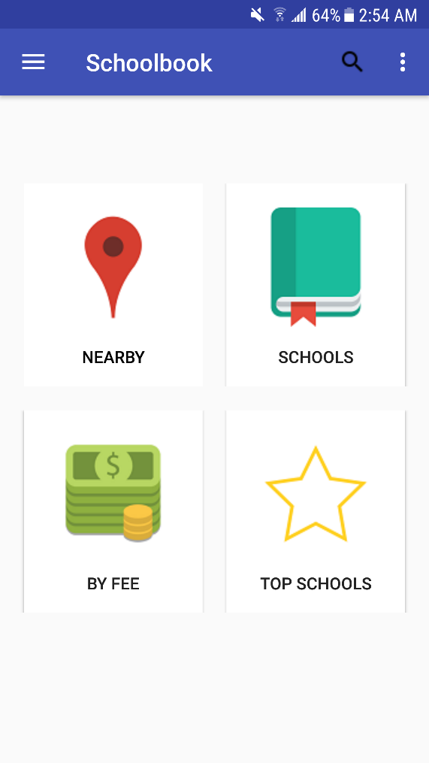 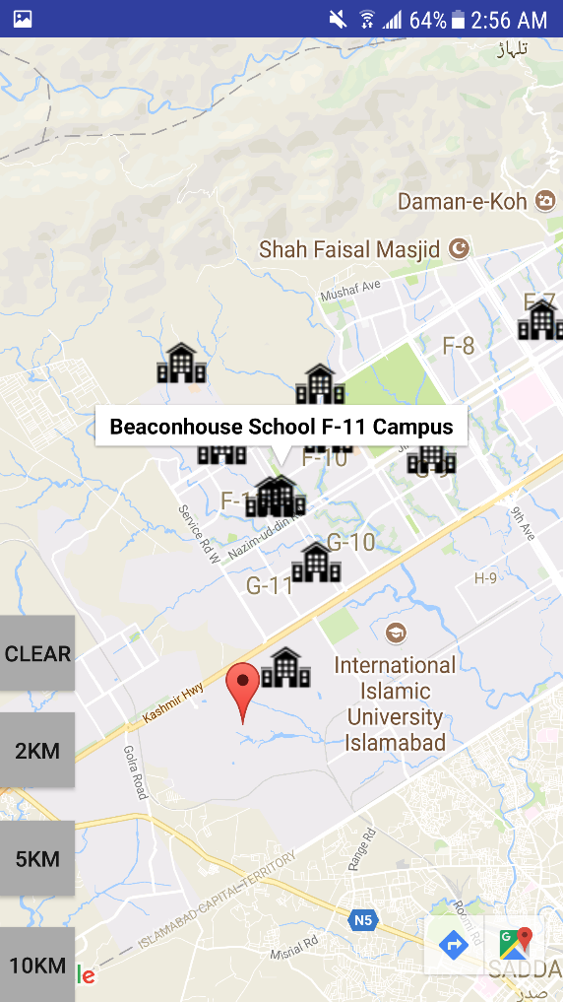

As clearly visible from these screen samples, the option buttons on the screen should be large and clearly visible. The background should be of a lighter color in comparison to the front objects (i.e.the buttons). The buttons should be labelled in case someone is unable to understand what they stand for. Once the user clicks a button, the appropriate form or screen should open.

**Hardware Interfaces**

The hardware interfaces are as follows:

* A cellphone with android facility (max. disk space of 5 MB).
* Communication protocols for internet connectivity (for Google Maps) and database connectivity (for accessing and manipulating data stored on database).

The software is designed as such that in can be used on any of the above devices. It requires internet connectivity and database connectivity in the back end (on the server, the User does not have to do anything)

## 

**Software Interfaces**

This android application is linked with two major software components, namely the database (created on Android Studio using SQLite) and the Google Play Services (using the Google Maps Segment). The system also required an android version of Lollipop 5.0 or above to work properly. In order to access the map, Google Play Services are vital. Without the compatibility and availability of these services, the user will not be able to view the map.

**Communications Interfaces**

In order for the system application to work as required, this communication interface is to be used:

* Internet Connectivity:

Internet connection is a part of communications protocol which enables the user to access

all the APIs that get data online. Since this is an already-built function or module which is being integrated in the system, it is to be made sure that it is properly integrated into the system. For this purpose, different map related APIs have been used to get relevant data from the internet. If the internet connection is not available, the system will be unable to use this module.

**System Features**

The reason for developing this web application is to provide the people everything they need from school location, academic records. Everything in one place. For better facilitation, a Google Map is also to be provided which could be used for visual guidance. For better comprehension, we can divide each of these functionalities into separate system features, giving a detailed explanation of each.

**Functional requirements:**

1. **Ranking:**

This feature allows the user to sort the schools by their Rankings. The user will open up a screen on which with a click of a button a list of schools will be displayed to the user sorted according to the ranking from highest to lowest. The user can scroll through the list and can click on any of the school names to view its full details.

1. **School details:**

This is one of the most important feature of the application. The user can view the details of each school by clicking on the name on the map or in the list. The user will be able to view the details of the school in one place. Details include name of school, address of school, logo, a small description of the school, ranking, ratings, fee, students to teacher ratio and extra-curricular activities.

1. **Fee:**

This feature allows the user to sort the schools by fee. The user is shown a combo box using which the user can select an amount in PKR and according to that, all the schools which have a monthly fee below the selected value are shown in a list. This is a very useful feature which parents can use while finding schools for their children as it easily lists all the schools which come under their selected budget.

1. **Nearby schools:**

This feature allows the user to view a Google map on which the user is able to see his/her own location (marked by a location pointer) and also see all the schools in the city which are shown using markers (school icon). The feature allows the user to select a certain radius using the buttons provided using which a circle is shown on the map showing which schools are in the selected distance range pictorially. User can select different radii, and a circle will show all the schools that are within that specific radius.

**Other Non-functional Requirements**

## **Performance**

## This android application’s major requirement is internet connectivity which it requires to perform the functionalities that it provides. Other than that, the details are stored using SQLite and thus are retrieved quickly. Another performance requirement this app has is that of connecting to a user’s GPS on their phones to be able instantly show a map with the user’s location upon user’s request.

## **Backward compatibility**

The application must be backward compatible so it can be run on previous and older versions of Android as well.

1. **Easy to use interface**

The interface of the application is designed in a way such that it is easy to use. The buttons on the interface along with the picture also have written captions for anyone who is unable to understand the picture. Buttons must be of a size which are easily clickable. The overall design is user friendly and attractive.

## **Software Quality Attributes**

* Availability: This application will currently be available for users of Islamabad.
* Usability: This application shall be designed for all users who use internet on any android devices.
* Maintainability: This application shall be designed to cope with all sorts of breakdowns e.g. inability to connect to the internet, database connections problems, etc.
* Reusability: This application shall be designed to be reusable as it can be reused in any other similar applications.
* Testability: This application shall be designed such that all its components i.e. school information, map etc are testable. All these components shall be made testable individually as well in integrated form.

## **Business Rules**

* This android application is specific to people with android devices (who have internet access).
* User can be a parent, student or a teacher.

The other requirements are as follows:

* The application requires a database(SQLite)
* The system should be developed while keeping in view the legal technological market standards.
* The Google Maps API should be defined properly in the system and should be integrated

into it in such a way that it is treated like a module of the system.

* For future developments and expansions, the system should be designed to be expandable, flexible and portable. First of all, it should add more schools including private and government schools. Schools from all over Pakistan should be added to the system.

**Appendix A: Glossary**

|  |  |
| --- | --- |
| **Technical term/abbreviation** | **Meaning** |
| SRS | Software requirement specification document. |
| Database | A set of tables containing various attributes and  their values in the form of records. |
| Tuple | A particular record in the database. |
| API | Application program interface-a set of routines for building software applications. |
| Prototype | The technique of developing a rough sketch of  the interface to get an idea about how the output will look like. It also helps in making future design decisions. |