Name: Hassan Rasheed

Registration Number: 126900

Class: BSCS5B

Course: Advanced Programming

Lab 6 – Persistent ECafe

**Introduction**The task was to create a persistent design for the e-cafe developed in lab 2 of advanced programming. JDBC is used to connect the Java implementation to the database created using SQL. To create a persistent version of the ordering application created earlier.

**Approach**Instead of using an offline SQL database, an online database is created using XAMPP and accessed through phpmyadmin. The data from the java app is sent to the database using the jdbc driver. Connection, statement, resultset and preparedstatement have been used to make the transactions in the database.

**Design**XAMPP was used to create a database in SQL there were four tables created one to store the ordering customers, one to store food items on the menu, one for storing orders and the last one was created to connect each order with the food items with a many-to-many relationship. The create menu class creates a menu and it is stored inside the items table in the database. The menu is the displayed on the console when the application runs by retrieving it from the database. The order is taken by entering the serial numbers of the menu items which are then saved in the order_food table which stores food items inside each order. Which can be later retrieved for reuse, when the program is run again.

**How to Run**The project can be run easily by importing it to NetBeans/Eclipse or any other Java IDE and building the project. It starts by printing the menu to the screen and asking user for input.

**Analysis**

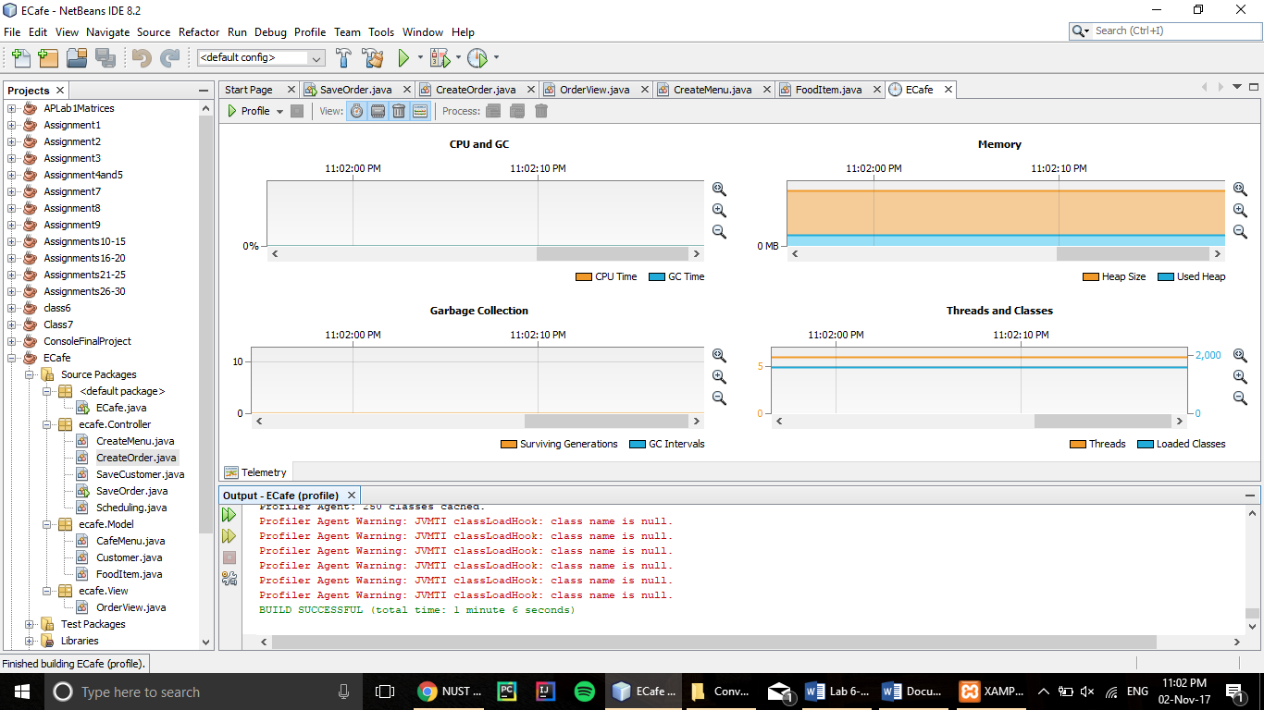

The project uses constant memory from start of printing the order to the screen to Entering whole order, which is also stored to the database later on.

**GitHub Repository**

**https://github.com/hassanrasheedk/persistentecafe/**