**Introduction**

This implementation of the ecafe required us to edit the previously made persistent ecafe to use prepared and callable statements, use maven as a code management tool to handle the dependencies (e.g. JDBC and SQL connector).

**Approach**

A maven project was created using NetBeans IDE. Then the previously made code files were copied to the project. The pom.xml file was edited to include the JDBC driver. New classes retrieveorders and deleteorder were created to complete the requirements of preparedstatements select and update queries.

**Design**

The design is pretty simple. The skeleton of the project is based upon MVC. The base classes that are storing the data are in the Model, View contains the classes that print data out to the screen. And the controller contains the classes that do all the work.

There are prepared statements with insert queries for inserting data (orders or data of customers) into the database, prepared statements with delete queries to delete orders from the database when the orders have been served. And for retrieving orders from the database prepared statements with select queries.

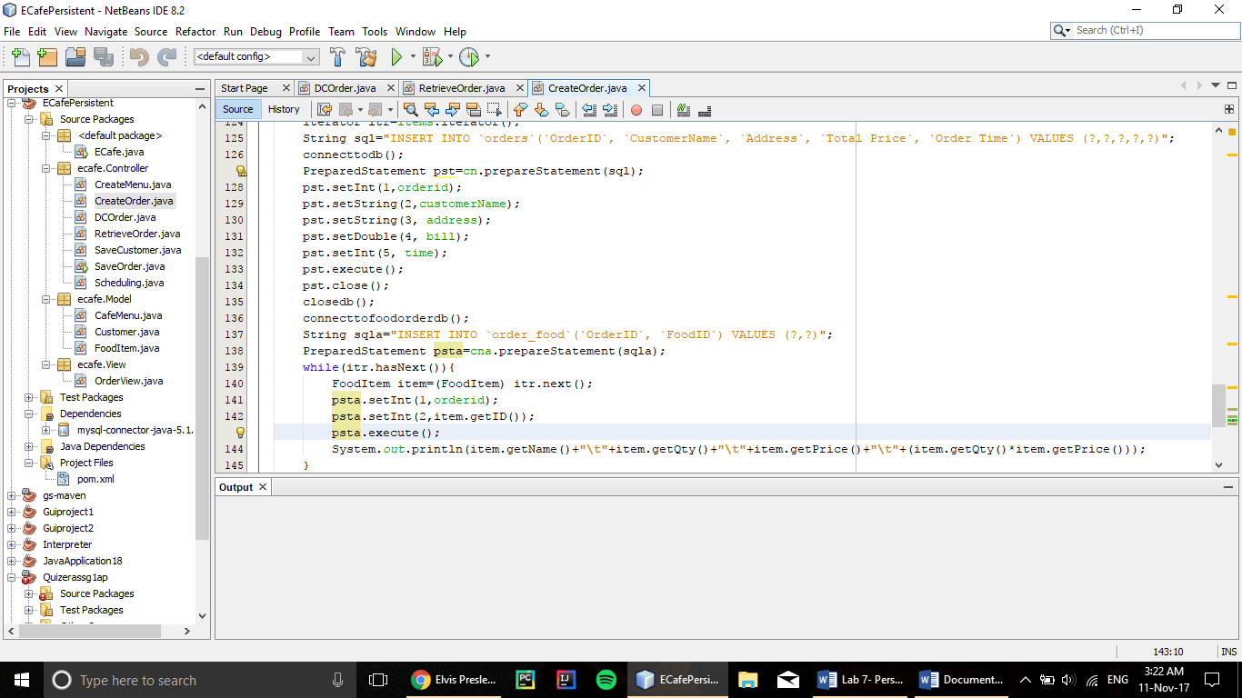

Figure :Two Queries to insert orders into the order table and order_food table

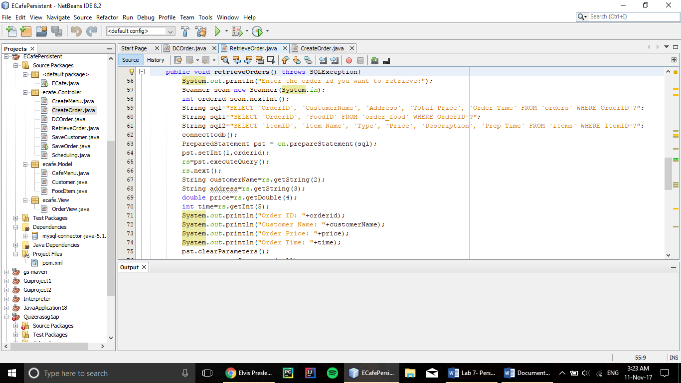

Figure :Queries to retrieve orders from orders table, and retrieve food items from the items table using the values stored in order_food table.

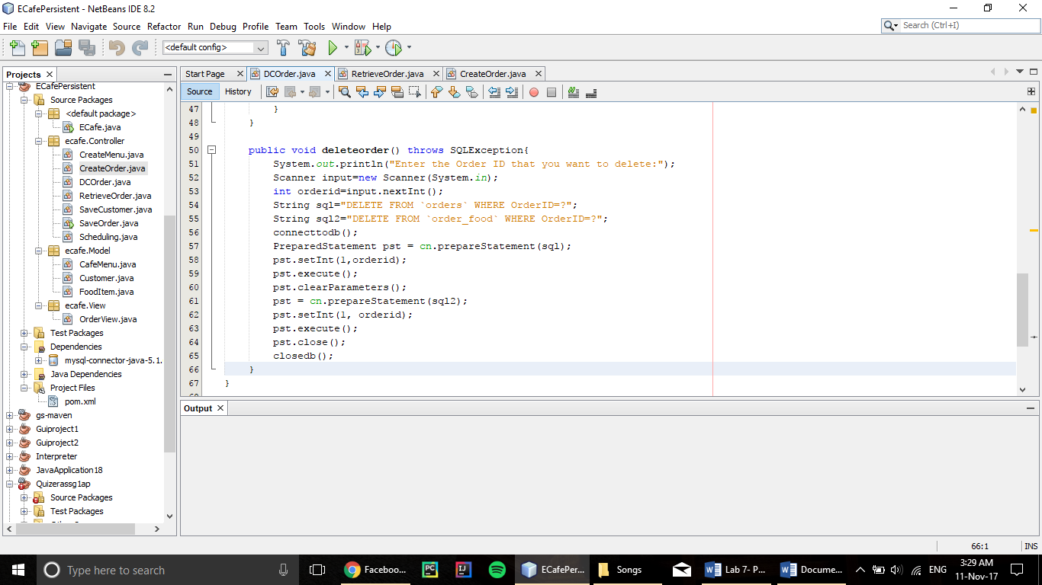

Figure :Delete queries to delete the saved order in the database from order table and the order_food table.

**How to Run**

The program can be run by simply importing the project to any Java IDE. Compiling and Running. Or if maven is installed then going to the base project directory on the terminal where pom.xml file is placed and typing the command mvn compile then running the project from the terminal.

**Analysis**

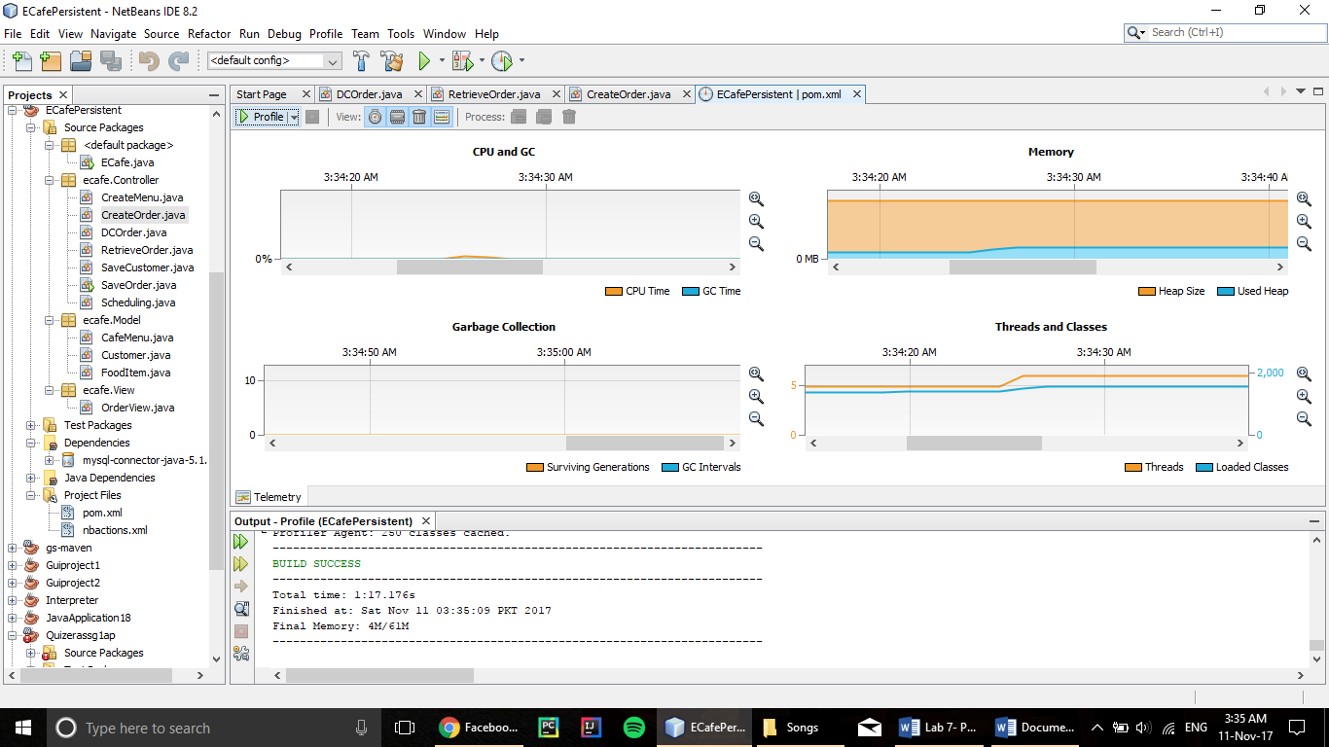

Figure :There's a little spike in CPU and Memory usage when the user first starts to input

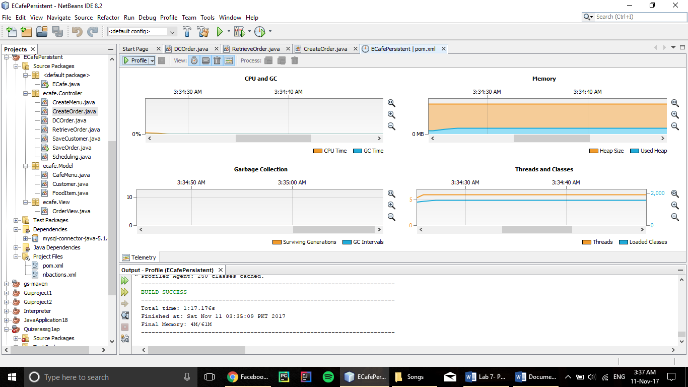

Figure :After the initial spike the usage is constant

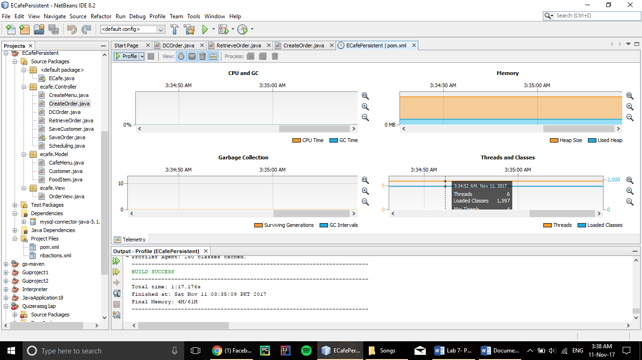

Figure :Continuing the constant usage

**Github Repository:**

https://github.com/hassanrasheedk/persistentecafe2