Project Report On
Alberto Watch Company Website

Table Of Contents
- Acknowledgments
- Information About Developers
- Introduction About Project
- Analysis
- Screen Shots
- Final Statement

Acknowledgments
The combined study on this project is an honor for our group members.
We were eager to make such a dynamic and interesting project, which may provide us with a huge amount of practical knowledge and will help us use our skills efficiently.
Our heartiest appreciation and gratitude towards our teachers, whose help, dedication and encouragement has helped our team members to successfully achieve our goals.
We are grateful to Aptech for providing us the necessary facilities and support which we needed, and also for giving us the opportunity to practically implement what we have learned, which will help us in the future.

Information About Developers
Name | Role
Hassan Ali | Front-End Development & Layout
Mirsub Khan | UI Styling & Documentation
Shayan Shoukat | Content, Testing & Project Report

Introduction About Project
The Alberto Watch Company website is a captivating online platform developed to showcase an exquisite variety of luxury, vintage, smart and classic timepieces.
This project combines HTML5, CSS3, JavaScript and the Bootstrap framework to create an immersive, user-friendly website that caters to both aesthetic appeal and functionality on the front end.
By leveraging modern web technologies, the website provides a visually refined, dark, editorial-style experience while ensuring smooth navigation and easy access to product information, store details and support services.
Whether it's exploring the watch catalogue, learning about the technology behind each collection, browsing the gallery, locating a store, or contacting the company, the Alberto Watch Company website offers a delightful and elegant shopping experience.

Analysis
Purpose
The purpose of the Alberto Watch Company website is to create an immersive online platform that showcases the diverse range of watches and services offered by the company.
This project aims to provide a visually appealing, user-friendly website with an excellent user experience that effectively communicates the brand's identity and values of precision, heritage and craftsmanship to potential customers.
By offering a seamless browsing experience, detailed product information and convenient contact options, the website's purpose is to attract and engage visitors and support the sale of Alberto watches.
Working
Visitors can browse the website's watch catalogue, organised into Vintage, Luxury, Smart and Classic collections, and view each product's name, description and price.
The Technology section explains the movements used across the collections (Automatic, Eco-Drive, Smart and Quartz), while the Gallery section presents a justified image showcase of the products.
The Store Locator section displays the flagship store's address and opening hours, and the Support section outlines services such as watch repair, appraisal and personal concierge.
Finally, the Contact section provides an enquiry form along with the company's email, phone number and address, allowing customers to easily reach out for assistance.

Screen Shots
Home page
This is the home page of the website, featuring the hero banner, navigation menu and an introduction to the Alberto watch collection.
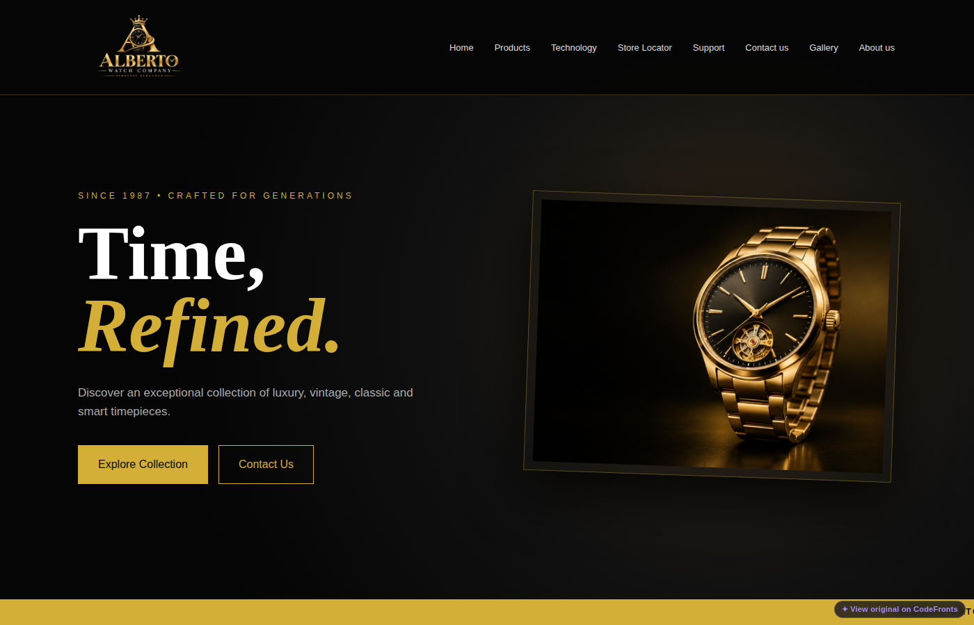
Fig 1: Home page
Product page
From this page, customers can browse and explore the Vintage, Luxury, Smart and Classic watch collections.
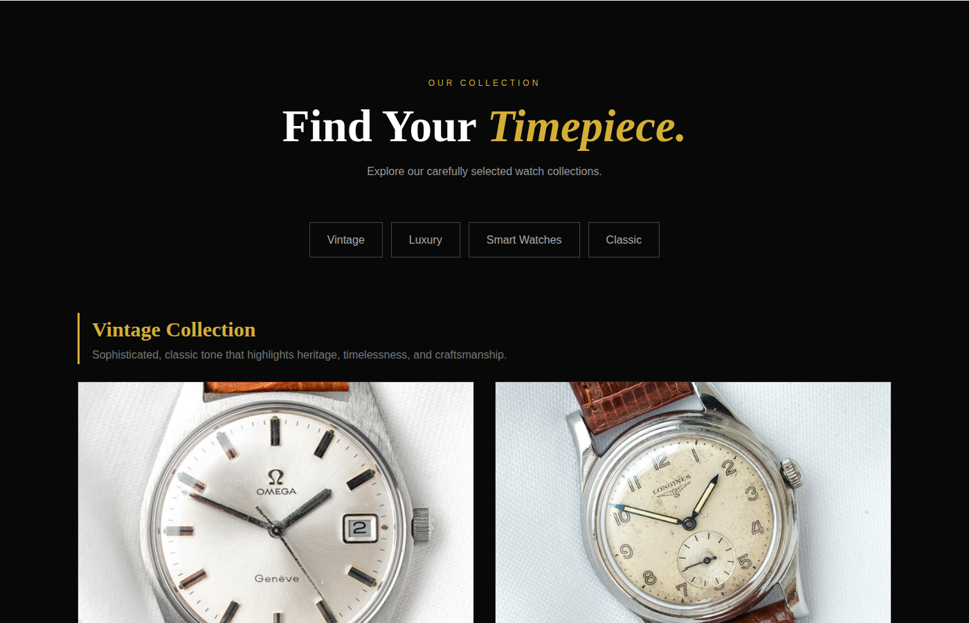
Fig 2: Product page
About us page
From this page, customers can learn about the Alberto standard, the company's history and key statistics.
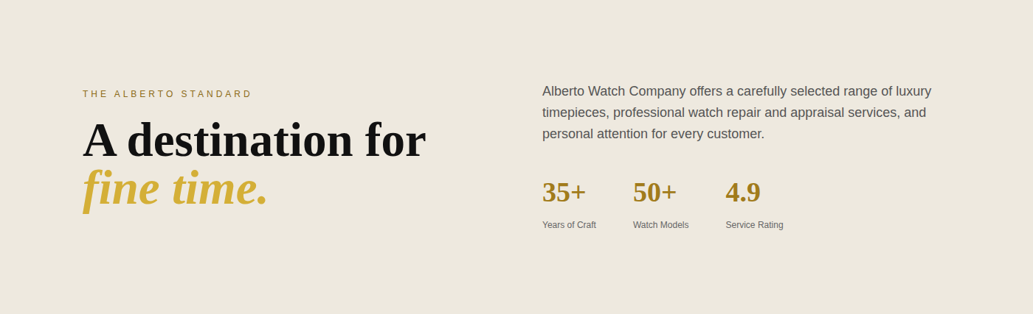
Fig 3: About us page
Contact us page
Customers can contact the company through this page using the enquiry form, or reach out directly by email, phone or store address.
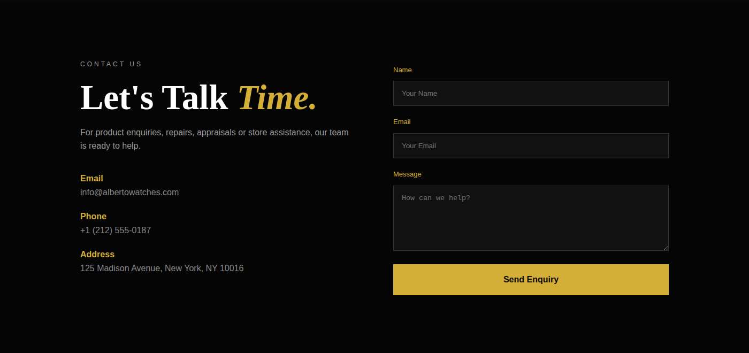
Fig 4: Contact us page

Final Statement
This e-project was created with firm determination. We, the students, did a lot of hard work to complete this Alberto Watch Company website project.
We did our best to make this project perfect, functional, helpful, easy to use and qualified as much as possible within the given time.
We kept future technologies and usage in mind while making this project.
We hope that APTECH will like our project and will appreciate our hard work and firm determination.
THANK YOU!
Documentation Created By
Hassan Ali
Mirsub Khan
Shayan Shoukat

