

**Assignment #1**

**(Object Oriented Programming)**

**Software Engineering Department**

**NED University of Engineering and Technology**

**CLO:1**

**Description: Airplane Seating Assignment**

Write a program that can be used to assign seats for a commercial airplane. The airplane has 12 rows, with 7 seats in each row. Rows 1 and 2 are *first class*, rows 3 to 7 are *business class*, and rows 8 to 12 are *economy class* as shown in *Figure A*. Your programs must follow as per following Menu.

|  |  |
| --- | --- |
| **System Choices (Menu)** | **Air Plane Seating Assignment *(Figure A)*** |
| -----------------------------------------------------  Welcome To Air Plane Reservation System  -----------------------------------------------------  1. Book First Class Seats  2. Book Business Class Seats  3. Book Economy Class Seats  4. View Air Plane Seating Assignment  5. Know Fair  6. System Reset  7. Exit From The Booking System  Enter Your Choice |  |

**Question 1 Answer:**

**Syntex:**

#include<iostream>

#include<conio.h>

#include<stdio.h>

using namespace std;

double firstclass(int b[12][7], int seats, double price)

{

int m = 0;

//price = 10500;

for (int i = 0; i < 2; i++)

{

for (int j=0;j<7;j++)

{

if (b[i][j] == 0 && m <= seats)

{

b[i][j] = 1;

// price = 10500 * m;

m++;

}

if (m == seats)

{

break;

}

}

if (m == seats)

{

break;

}

}

if (m == seats)

{

return price*m;

}

else if (m > 0 && m < seats)

{

cout <<endl<< "There is no seats left so we can book only " << m << "seats so proceed with booking(Y/N)";

char confirmbooking;

cin >> confirmbooking;

if (confirmbooking == 'y' || confirmbooking == 'Y')

return price * m;

else

return -2;

}

else

{

return -1;

}

}

double businessclass(int b[12][7], int seats, double price)

{

int m = 0;

//price = 10500;

for (int i = 2; i < 7; i++)

{

for (int j = 0; j < 7; j++)

{

if (b[i][j] == 0 && m <= seats)

{

b[i][j] = 1;

// price = 10500 * m;

m++;

}

if (m == seats)

{

break;

}

}

if (m == seats)

{

break;

}

}

if (m == seats)

{

return price * m;

}

else if (m > 0 && m < seats)

{

cout << endl << "There is no seats left so we can book only " << m << "seats" << "seats so proceed with booking(Y/N)";

char confirmbooking;

cin >> confirmbooking;

if (confirmbooking == 'y' || confirmbooking == 'Y')

return price * m;

else

return -2;

// return price * m;

}

else

{

return -1;

}

}

double economyclass(int b[12][7], int seats, double price)

{

int m = 0;

//price = 10500;

for (int i = 7; i < 12; i++)

{

for (int j = 0; j < 7; j++)

{

if (b[i][j] == 0 && m <= seats)

{

b[i][j] = 1;

// price = 10500 * m;

m++;

}

if (m == seats)

{

break;

}

}

if (m == seats)

{

break;

}

}

if (m == seats)

{

return price * m;

}

else if (m > 0 && m < seats)

{

cout << endl << "There is no seats left so we can book only " << m << "seats"<< "seats so proceed with booking(Y/N)";

char confirmbooking;

cin >> confirmbooking;

if (confirmbooking == 'y' || confirmbooking == 'Y')

return price * m;

else

return -2;

// return price * m;

}

else

{

return -1;

}

}

void displaysetting(int b[12][7])

{

for (int i = 0; i < 50; i++)

{

cout << "-";

}

cout << endl;

for (int i = 0; i < 12; i++)

{

for (int j = 0; j < 7; j++)

{

cout << b[i][j] << "\t";

}

cout << endl;

}

for (int i = 0; i < 50; i++)

{

cout << "-";

}

cout << endl;

}

void knowfair(double ff, double bf, double ef)

{

cout << "The fair of first class is " << ff << endl;

cout << "The fair of business class is " << bf << endl;

cout << "The fair of economy class is " << ef << endl;

}

void systemreset(int b[12][7])

{

char c;

cout <<endl<< "Do you really want to reset system(Y/N)";

cin >> c;

if (c == 'Y' || c == 'y')

{

for (int i = 0; i < 12; i++)

{

for (int j = 0; j < 7; j++)

{

b[i][j] = 0;

}

}

cout<<endl << "System is reset";

}

}

int main()

{

int booking[12][7];

int fair1 = 105000, fair2 = 68000, fair3 = 35000;

for (int i=0;i<12;i++)

{

for (int j = 0; j < 7; j++)

{

booking[i][j] = 0;

}

}

cout << endl;

for (int i=1; i >0; i++)

{

for (int i = 0; i < 50; i++)

{

cout << "-";

}

cout <<endl<< "Welcome to the AirPlane Reservation System" << endl;

for (int i = 0; i < 50; i++)

{

cout << "-";

}

cout << endl << "1)Book first class seats";

cout << endl << "2)Book Business class seats";

cout << endl << "3)Book economy class seats";

cout << endl << "4)View Airplane Seating system";

cout << endl << "5)know Fair";

cout << endl << "6)System Reset";

int choice, s;

cout << endl << "7)Exit From the Booking System";

cout << endl << "Enter Your choice" << endl;

cin >> choice;

if (choice == 1)

{

cout <<endl<< "Enter how many seats you want to book";

cin >> s;

for (int i = 0; i < 50; i++)

{

//cout << "-";

}

int h = firstclass(booking, s, fair1);

if ( h!= -1)

{

cout << endl << "Congratulation you have got your booking in first class" << endl;

cout << "Total fair of your booking is = " << h << endl;

}

else if (h == -2)

{

cout << endl << "As there is less seats as compare to your wish booking is not done";

}

else

{

cout<<endl << "There is no seats left in first class";

}

}

else if (choice == 2)

{

cout << endl << "Enter how many seats you want to book";

cin >> s;

for (int i = 0; i < 50; i++)

{

//cout << "-";

}

int h = businessclass(booking, s, fair2);

if (h != -1)

{

cout << endl << "Congratulation you have got your booking in business class" << endl;

cout << "Total fair of your booking is = " << h << endl;

}

else if (h == -2)

{

cout << endl << "As there is less seats as compare to your wish booking is not done";

}

else

{

cout << endl << "There is no seats left in first class";

}

}

else if (choice == 3)

{

cout << endl << "Enter how many seats you want to book";

cin >> s;

for (int i = 0; i < 50; i++)

{

//cout << "-";

}

int h = economyclass(booking, s, fair3);

if (h != -1)

{

cout << endl << "Congratulation you have got your booking in economy class" << endl;

cout << "Total fair of your booking is = " << h << endl;

}

else if (h == -2)

{

cout << endl << "As there is less seats as compare to your wish booking is not done";

}

else

{

cout << endl << "There is no seats left in first class";

}

}

else if (choice == 4)

{

displaysetting(booking);

}

else if (choice == 5)

{

knowfair(fair1, fair2, fair3);

}

else if (choice == 6)

{

systemreset(booking);

}

else if (choice == 7)

{

break;

}

else

{

cout <<endl<< "Plz enter correct choice";

}

}

system("pause");

return 0;

//system("pause");

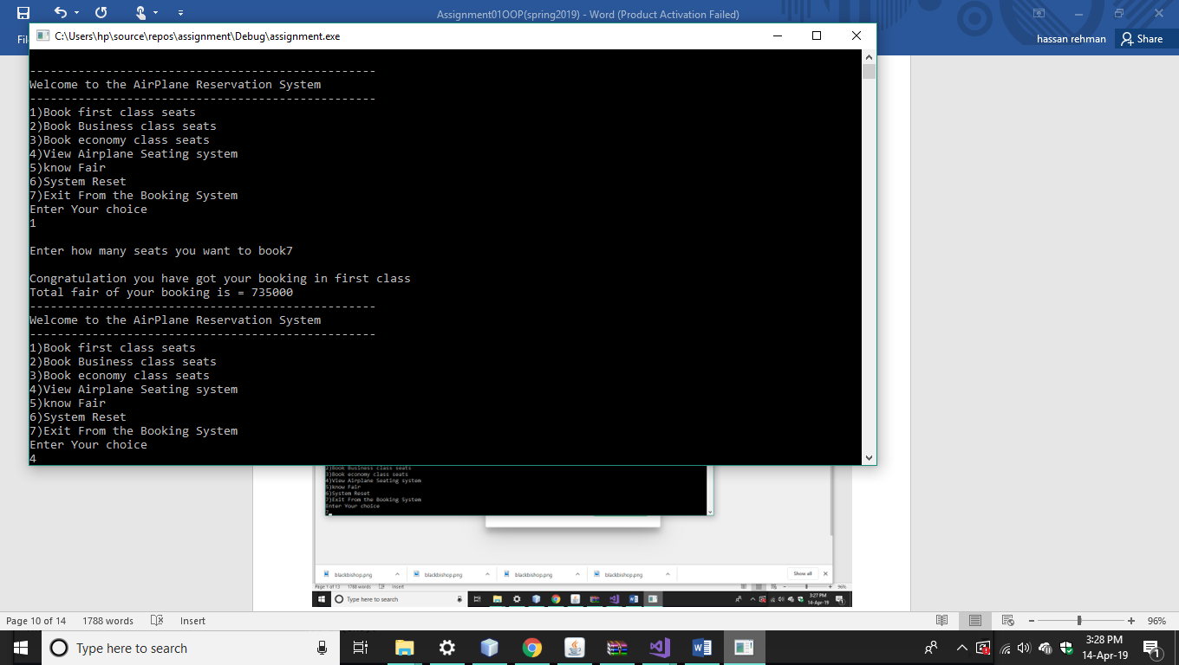

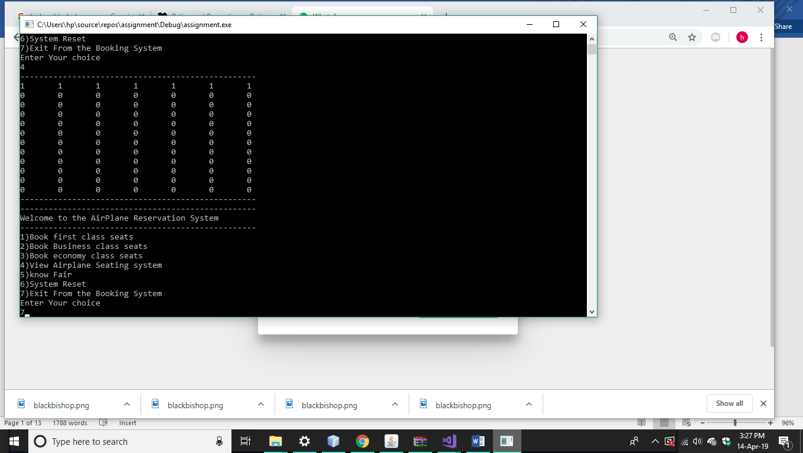

Q.2 Design a class named Fan to represent a fan. The class contains:

• Three constants named **SLOW, MEDIUM and FAST** with value 1, 2, and 3 to denote the fan speed

. • An **int** data field named **speed** that specifies the speed of the fan (default **SLOW**).

• A **boolean** data field named **on** that specifies whether the fan is o (default false)

• A **double** data field named **radius** that specifies the radius of the fan (default 5).

• A string data field named color that specifies the color of the fan (default blue).

• A default constructor that creates a default fan.

• The accessor and mutator methods for all four data fileds.

• The method named **Showdata()** that returns a string description for the fan. If the fan is on, the method returns the fan speed, color and radius in one combined string. If the fan is not on, the method returns fan color and radius along with the string “fan is off” on one combined string.

**Syntex:**

1. #include<iostream>
2. #include<conio.h>
3. #include<string>
4. using namespace std;
5. using std::cout;
6. using std::endl;
7. class fan {
8. private:
   * 1. bool turn = 0;
     2. double radius = 5;
     3. int speed = slow;
     4. string color = "blue";
9. public:
   1. const int slow = 1;
   2. const int medium = 2;
   3. const int fast = 3;
   4. fan()
   5. {
   6. }
   7. int types(int b)
   8. {
      1. if (b == 1)
      2. {
         1. return slow;
      3. }
      4. else if (b == 2)
      5. {
         1. return medium;
      6. }
      7. else if (b == 3)
      8. {
         1. return fast;
      9. }
      10. else
      11. {
          1. return slow;
      12. }
   9. }
   10. void onoff(bool a)
   11. {
       1. if (a == 0||a==1)
       2. {
          1. turn = a;
       3. }
   12. }
   13. void speed1(int b)
   14. {
       1. types(b);
   15. }
   16. void radius1(double r)
   17. {
       1. radius = r;
   18. }
   19. void changecolor(string color1)
   20. {
       1. color = color1;
   21. }
10. string showdata()
    1. {
       1. string h, i, j;
       2. if (turn = 1)
       3. {
          1. //string p = "";
       4. // h = ("The speed of fan is" + speed);
          1. //i = "The radius of fan is" + (int)radius;
          2. //j = "The color of fan is " + color;
          3. return std::string("The speed of fan is"+(int)speed+(string)"\nThe radius of fan is" + (int)radius + (string)"The color of fan is " + color);
       5. // return h + i + j;
       6. }
       7. else {
    2. // h = "fan is off";
       1. // i = "The radius of fan is" + (int)radius;
          1. //j = "The color of fan is " + color;
          2. return std::string("fan is off\nThe radius of fan is"+(int)radius+(string)"The color of fan is " + color);
       2. }
    3. }
11. };
12. int main()
13. {
    1. fan f1;
    2. f1.onoff(1);
    3. cout<<f1.showdata();
    4. system("pause");
    5. return 0;

