Week #3

Objective: For students to get some practice of:
- Using basic C++ types , arrays and multi-dimensional arrays

- Working with C++ Structures
  - How to pass structure to a function
  - How to create nested structures.
- How to Use Pointers , declaration and manipulation in C++

Write a program to compute the length of the line segment connecting two points. For input the two numbers representing each point are entered in the form (x,y). The parentheses and comma are read as character data and then discarded.

The distance between any two points is given by taking out the square root of the formula d= (x₂-x₁)² + (y₂-y₁)² . In C++ the square root is evaluated by the function (operation) sqrt() that is declared in the file math.h.

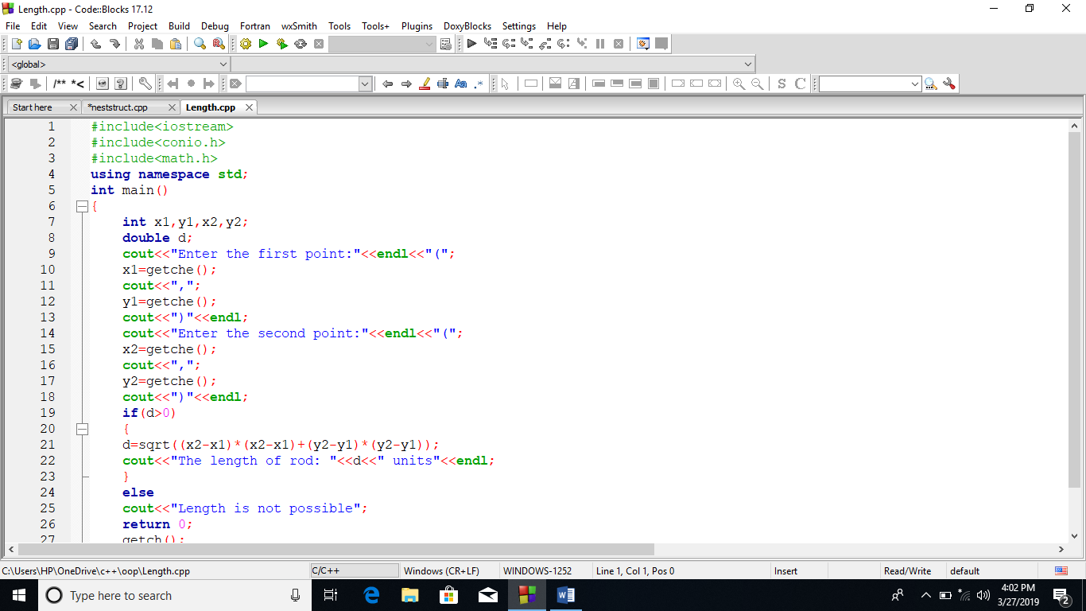

OUTPUT: 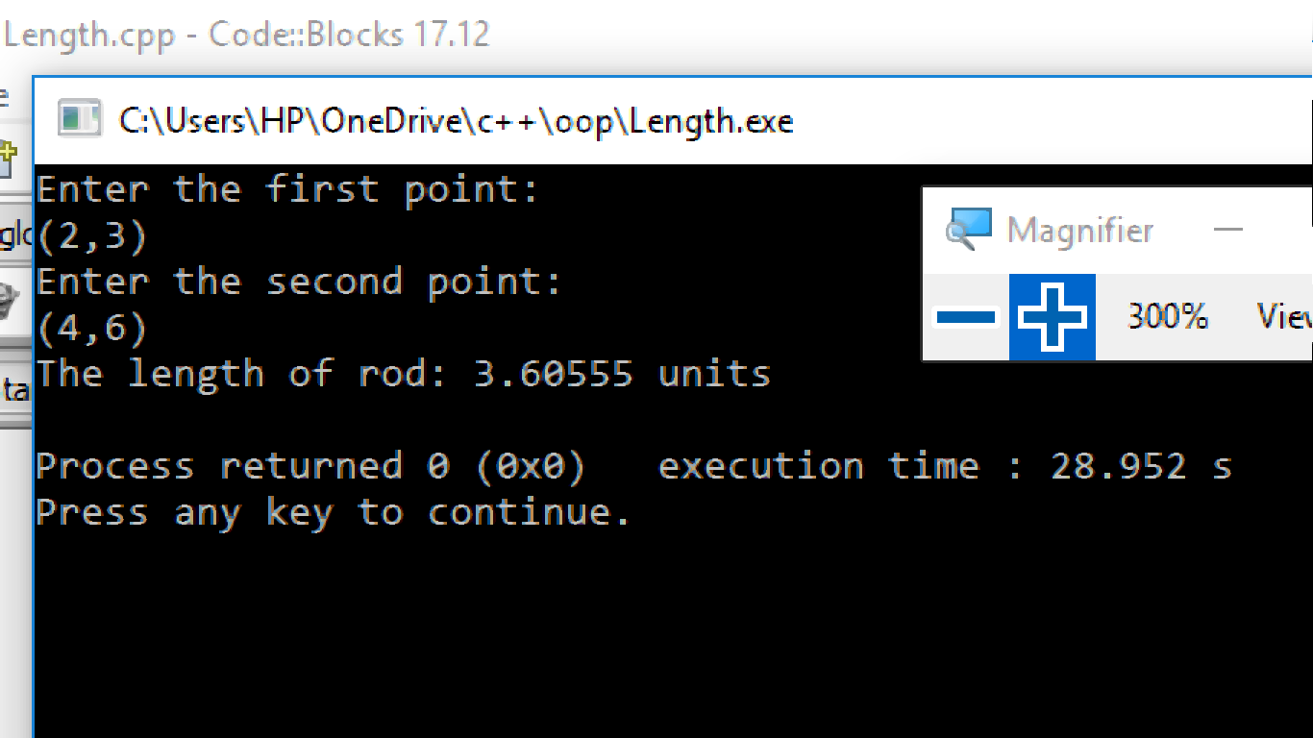

Q #2. Take two matrix M1 and M2 as an input and perform the addition and multiplication of these two matrices.
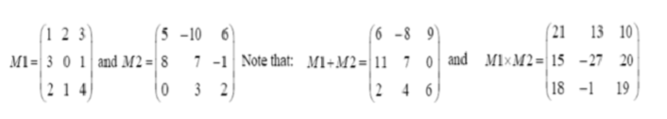
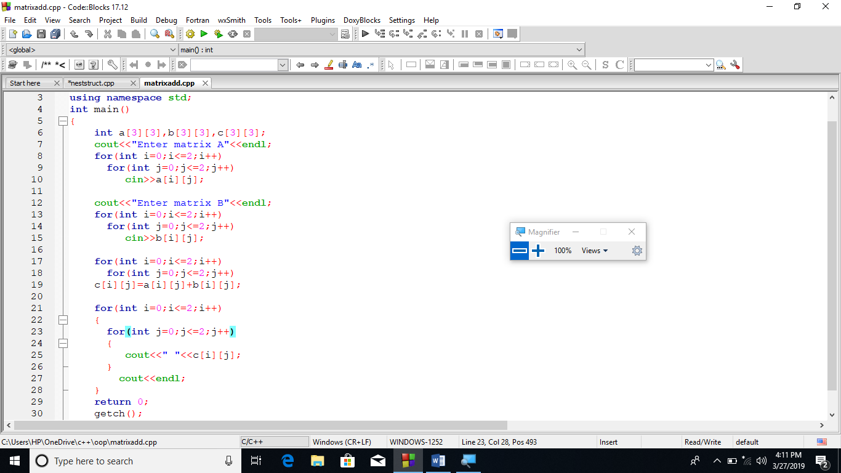

OUTPUT:
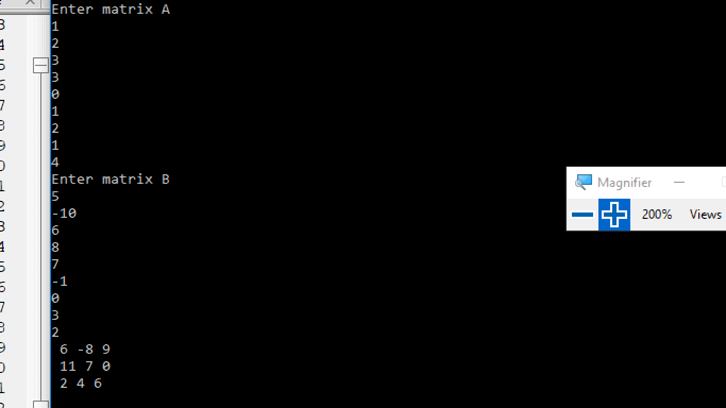

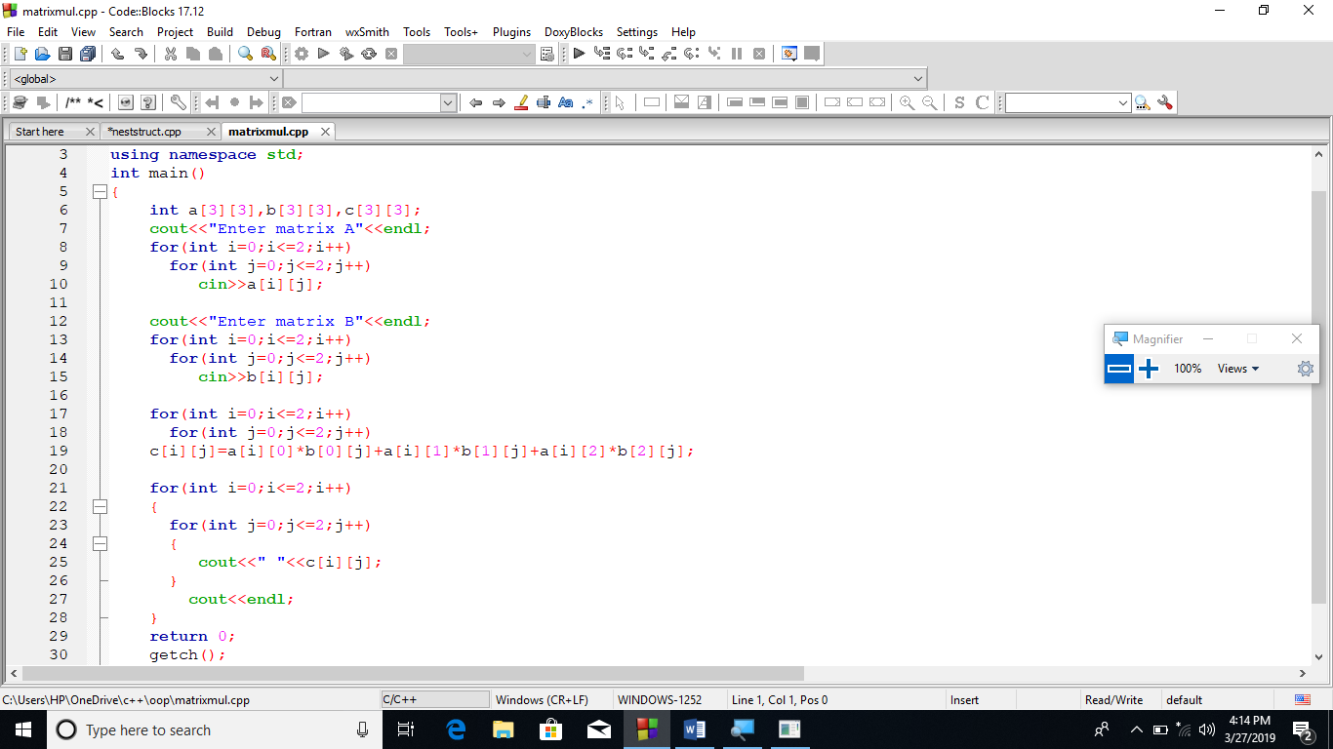

OUTPUT:
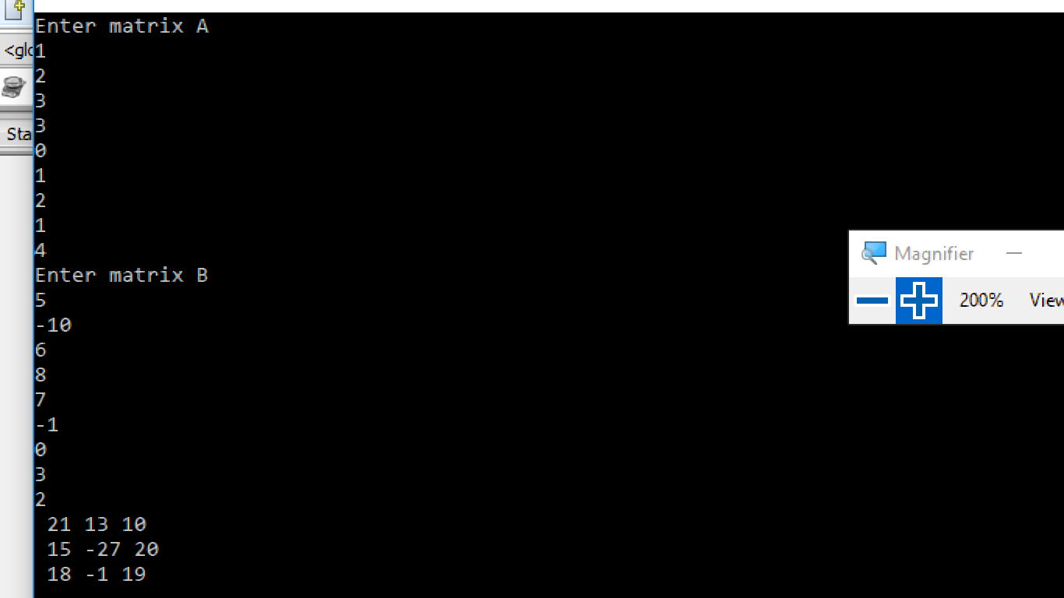
Q.3 Write a program that define structure to maintain student records, structure student should be consisting of the following attributes.
1. Student first name (max 20 characters)
2. Student last name (max 20 characters)
3. Student scores (float/double) e.g 85.4.
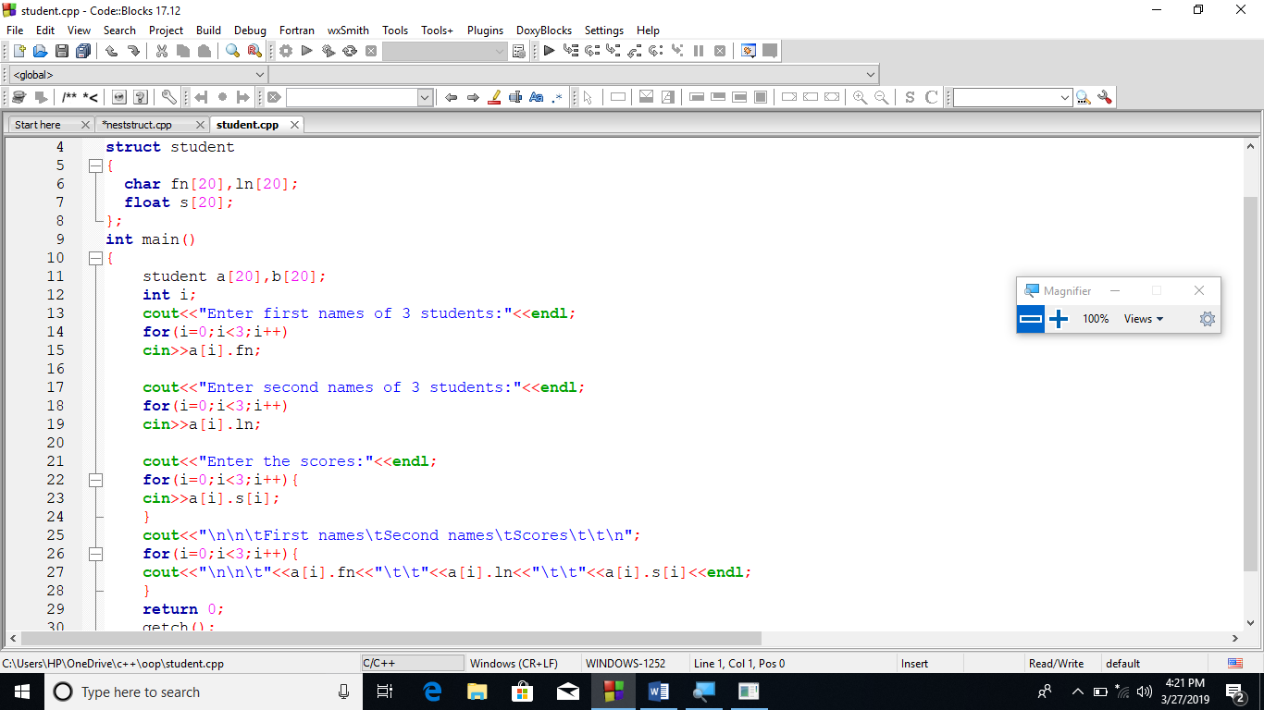

OUTPUT:
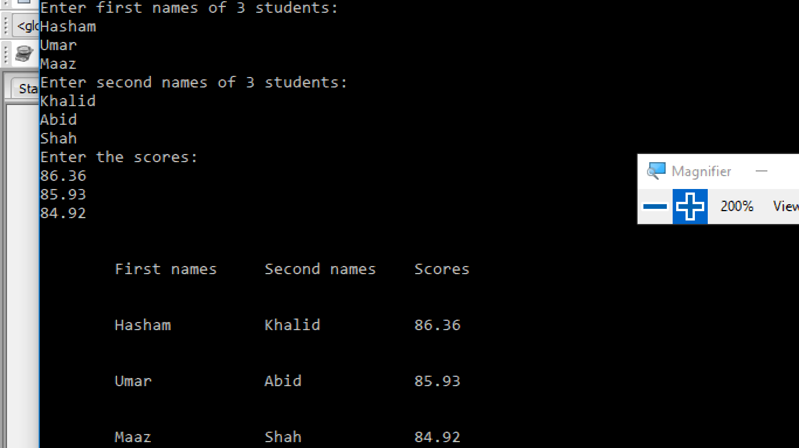

Q.4. Pass the structure define in Q.3 to some function to move to display.
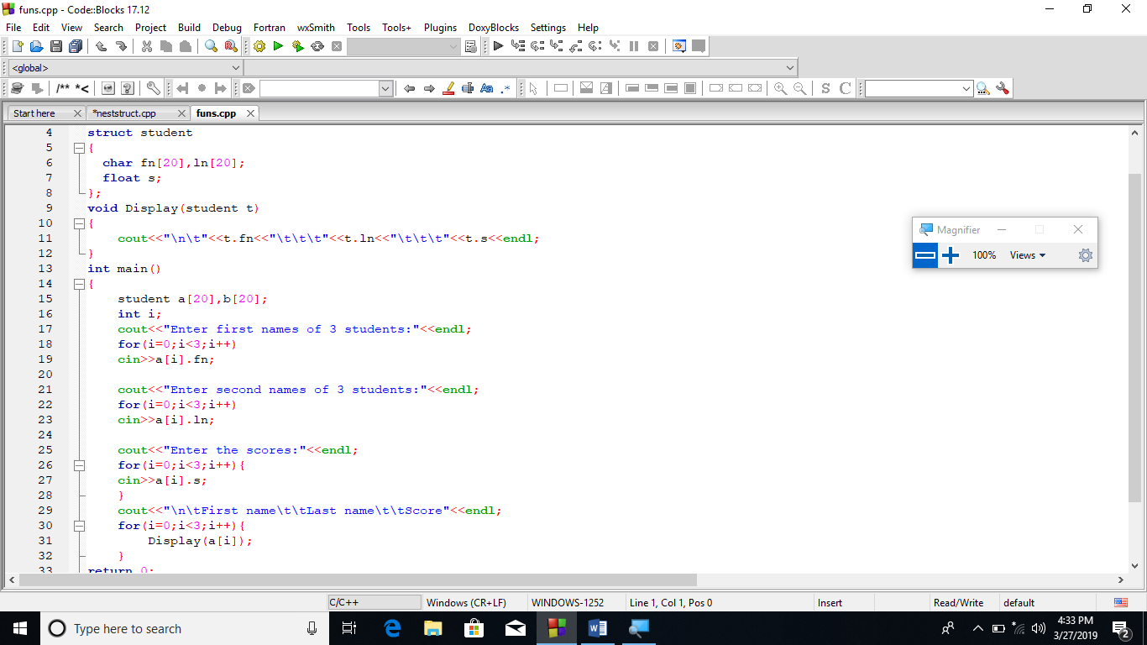

OUTPUT:
Q.5 Create nested structure . Firstly define Address structure and then call address
Structure in Employee Structure and program will give some raise in salary ,if it is less than 50000
Address (house no, city, pin code)
Employee (empid,name,salary,address)
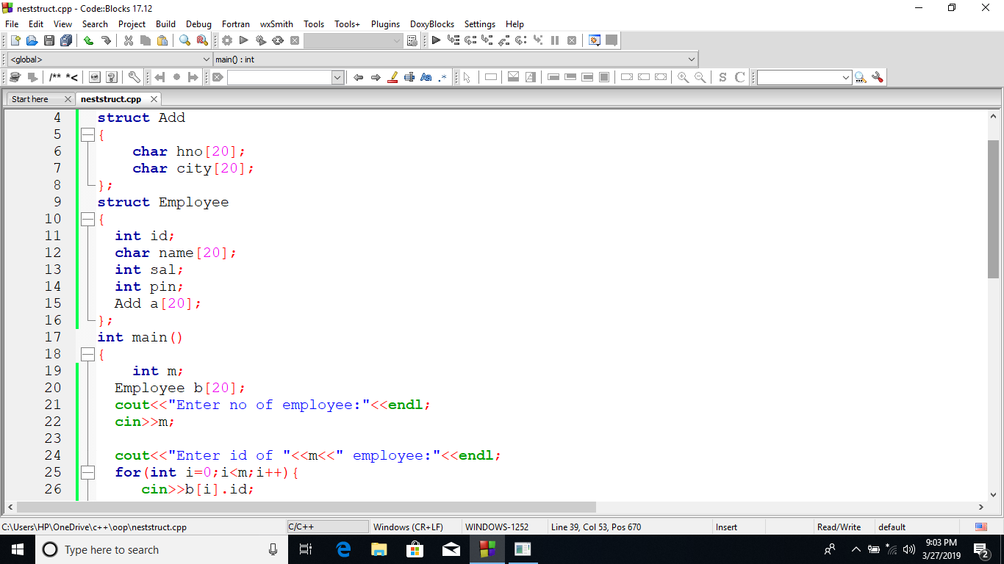
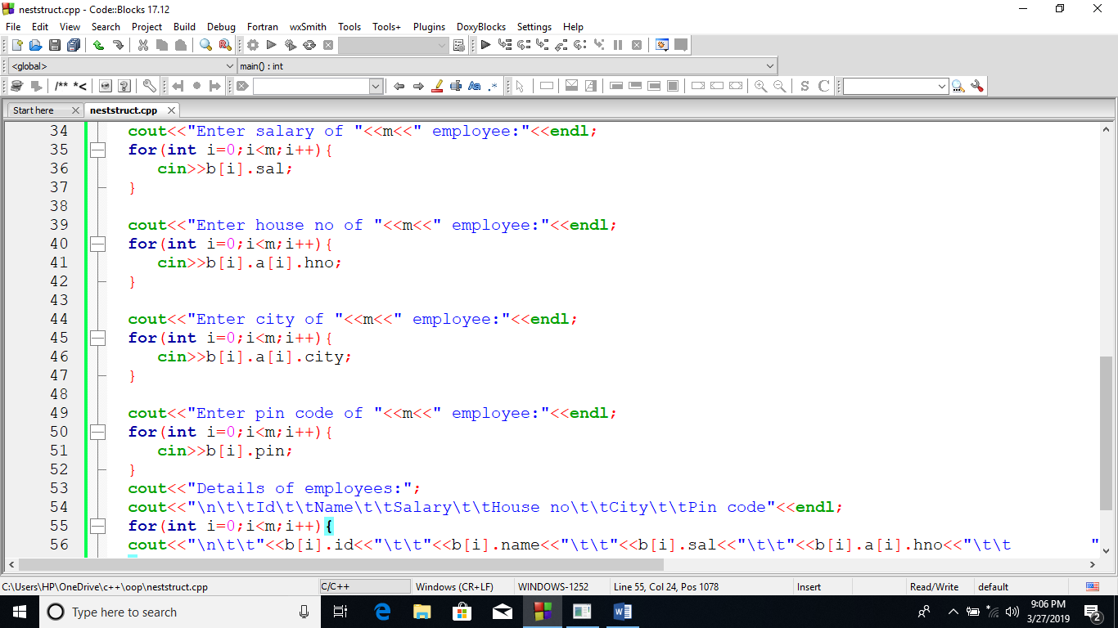

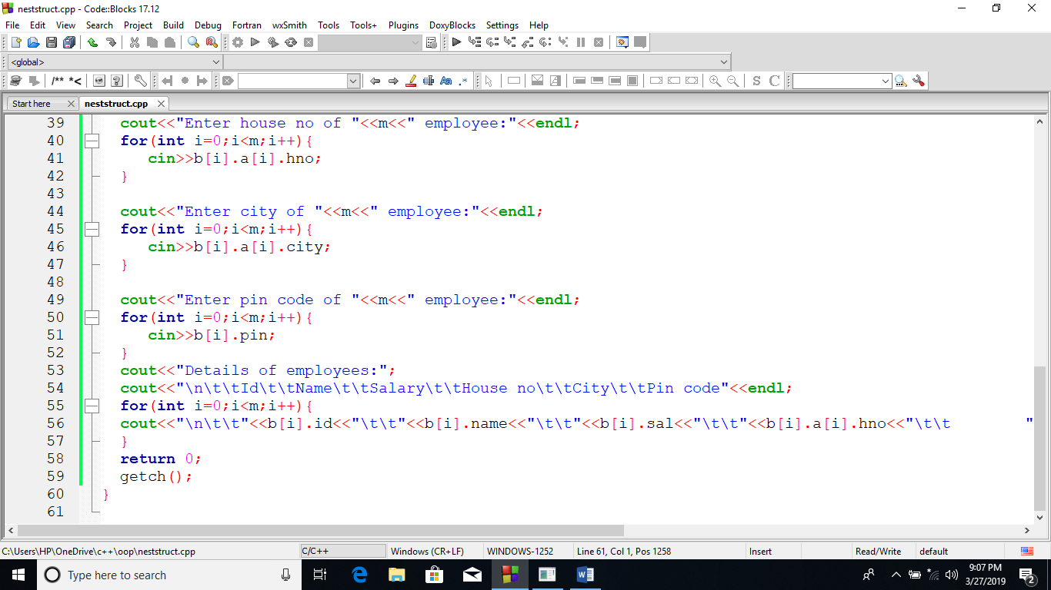

OUTPUT:
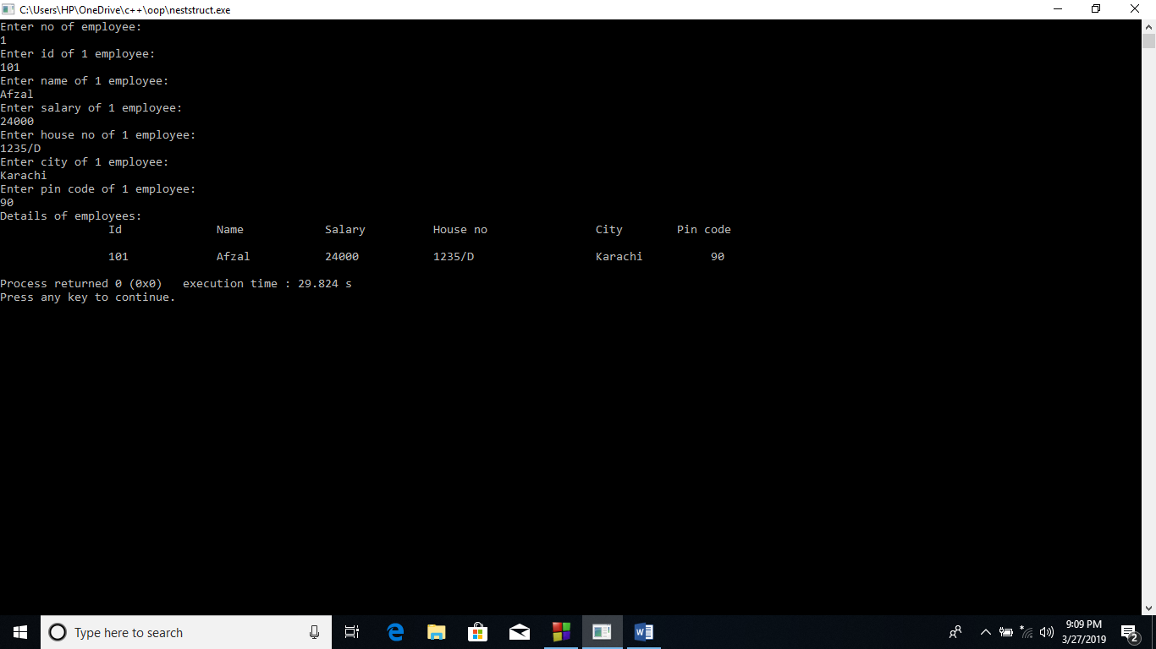
Q.6. Write a C++ Program to create a small Calculator by using Pointers
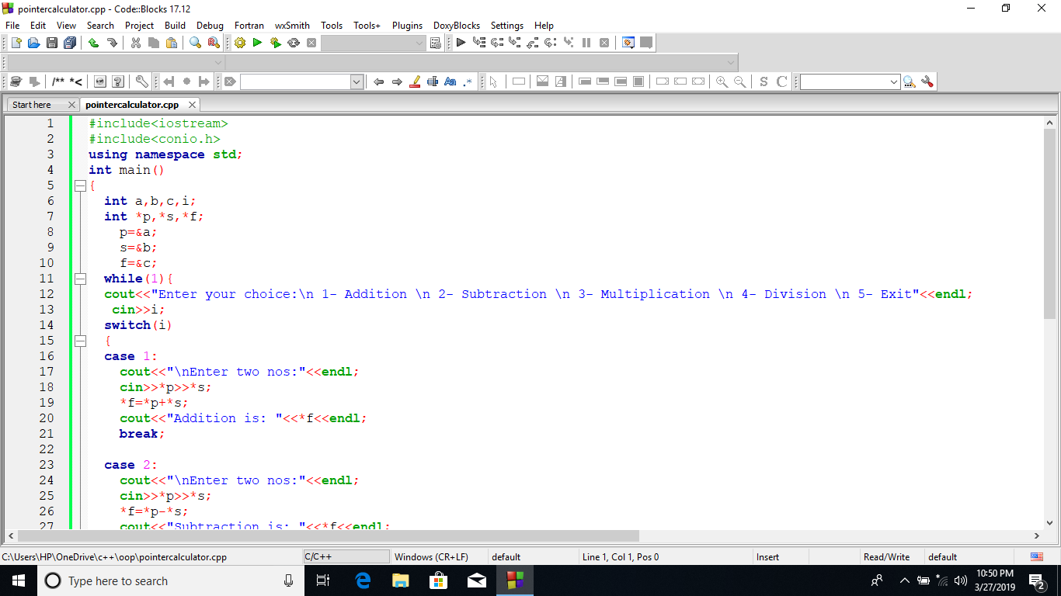
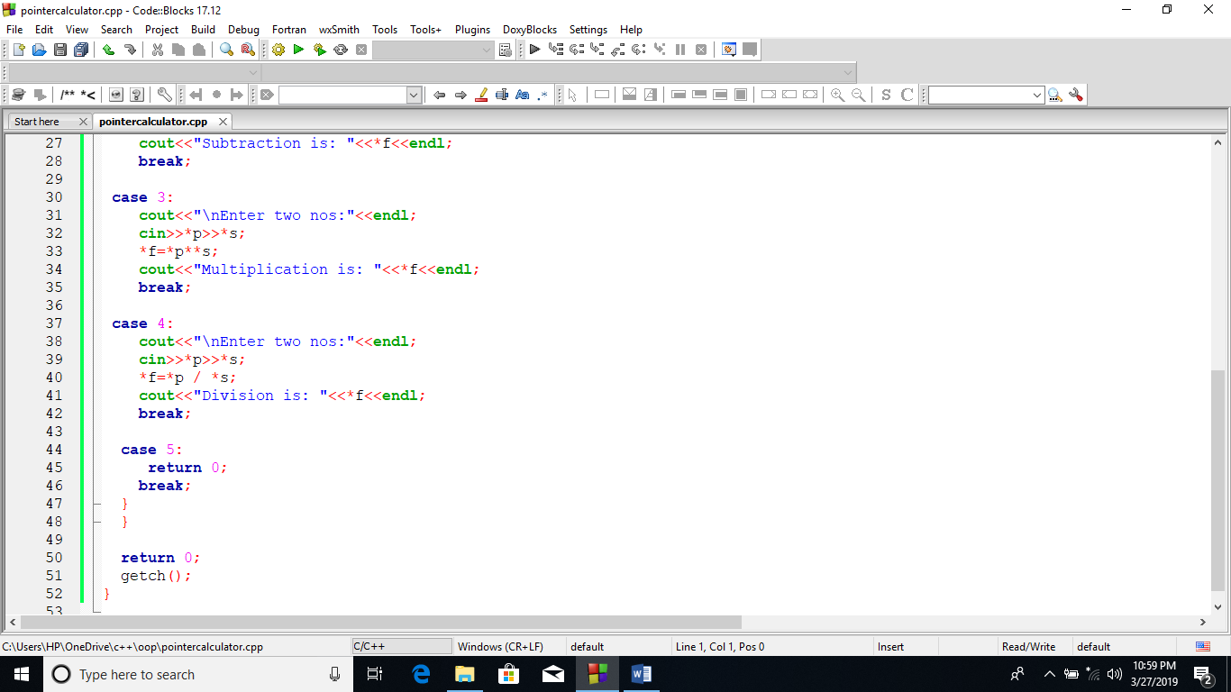
OUTPUT:
