Week #4

Objective: For students to get some practice of:

- To understand the concept of Pointer and use of Pointers.
- Use of Reference and Dereference operator

A pointer is a variable that holds a memory address where a value lives. [ need a super brief description of why pointers are useful here ]

Declare an empty pointer variable
A pointer is a variable that holds a memory address where a value lives.
A pointer is declared using the * operator before an identifier.
As C++ is a statically typed language, the type is required to declare a pointer. This is the type of data that will live at the memory address it points to.
int *numberPointer;
cout << "The numberPointer points to the memory address " << numberPointer << ".\n";
We've initialized a pointer, but it points nowhere, it has no memory address.

Set a pointer's memory address
We can set the memory address the pointer points to using the memory address of the number variable.
The memory address of any variable can be accessed using the & operator.
numberPointer = &number;
std::cout << "The numberPointer points to the memory address `" << numberPointer << "`, which is the memory address of number\n";
// Outputs: The numberPointer points to the memory address 0x1001054a0
// NOTE: if you run this code, you will get a different memory address.

Declare a pointer while assigning its address a value
When declaring a pointer, we can alternatively instantiate a variable at its memory address.
int *numberPointer = new int(3);
Instantiating a variable with the new operator always returns a pointer.

Access and modify the value at a pointer's memory address
The value at the memory address pointed to can be accessed with the dereference operator, *.
*numberPointer = 4;
cout << "The variable's value has been modified using the pointer. The variable's value is now " << number << "\n";
// Outputs: The variable's value has been modified using the pointer. The variable's value is now 4

Sample Program:
#include <iostream>
using namespace std;
int main()
{
int var1 = 3;
int var2 = 24;
int var3 = 17;
cout << &var1 << endl;
cout << &var2 << endl;
cout << &var3 << endl;
}
Output
0x7fff5fbff8ac
0x7fff5fbff8a8
0x7fff5fbff8a4

Task1: write a program in C++ that can calculate the factorial of a number by passing the address of that number to a function,using pointers.

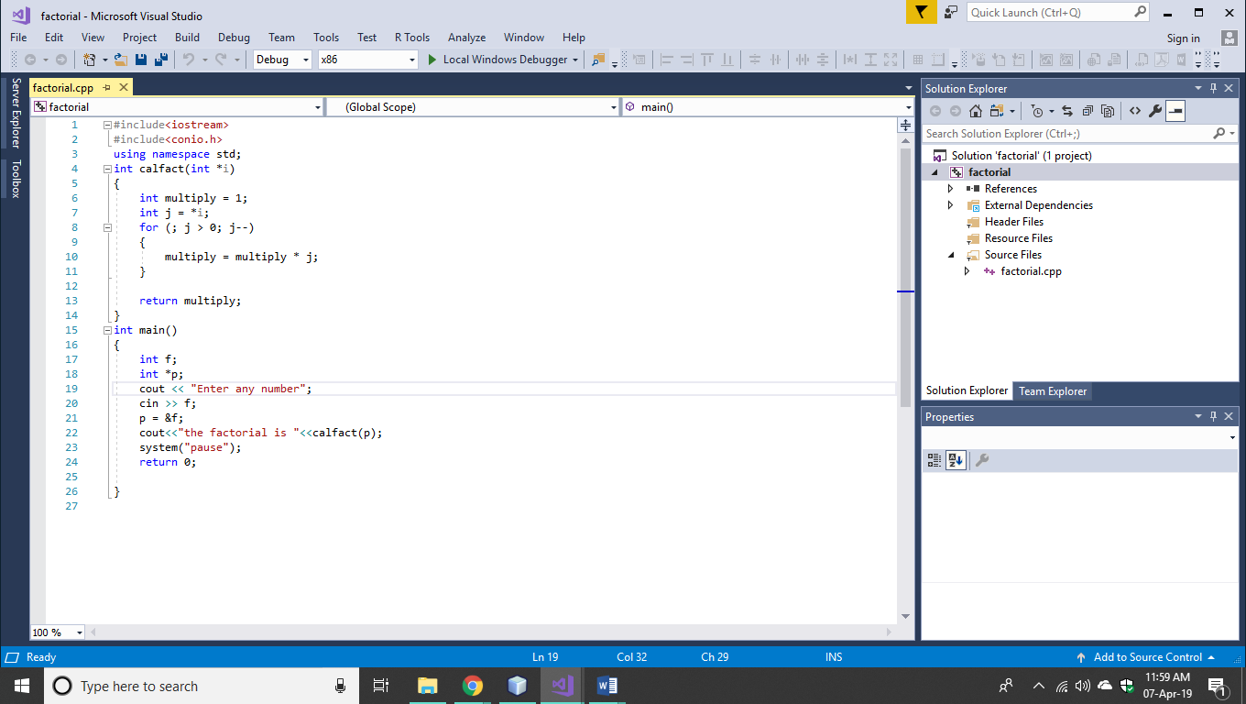
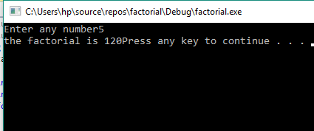

Task2: Write down a C++ program that will declare and initialize two arrays and would generate the sum of these two arrays by using pointers.
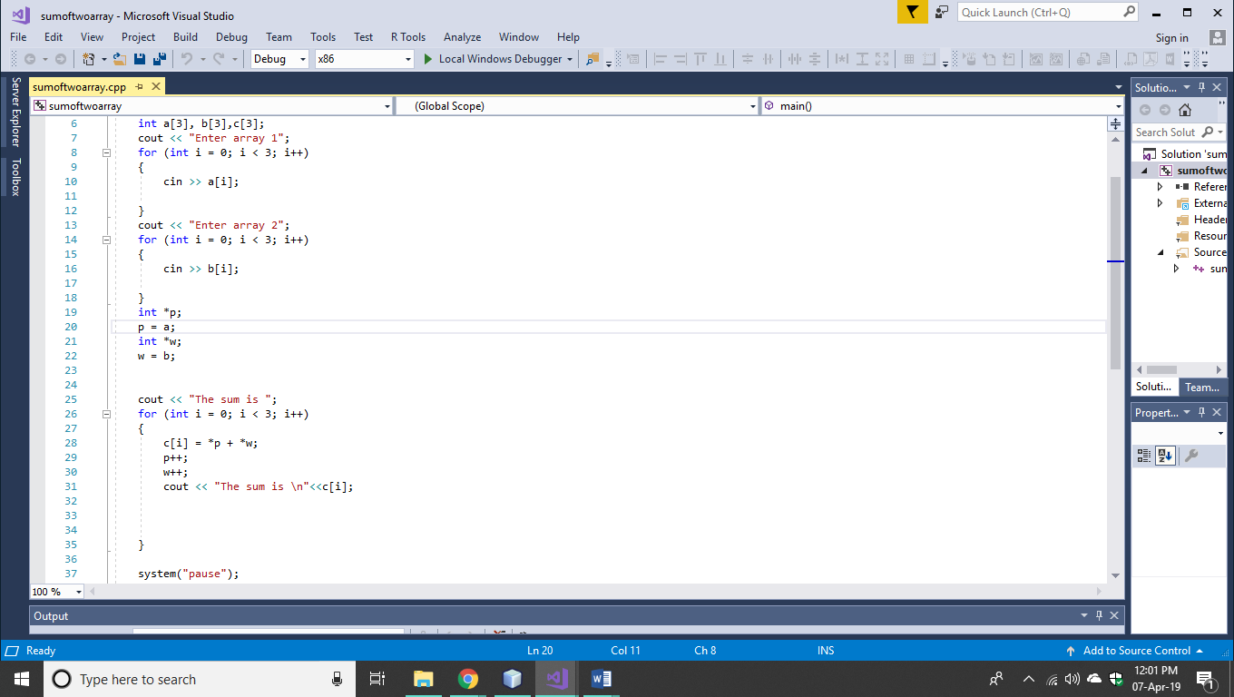
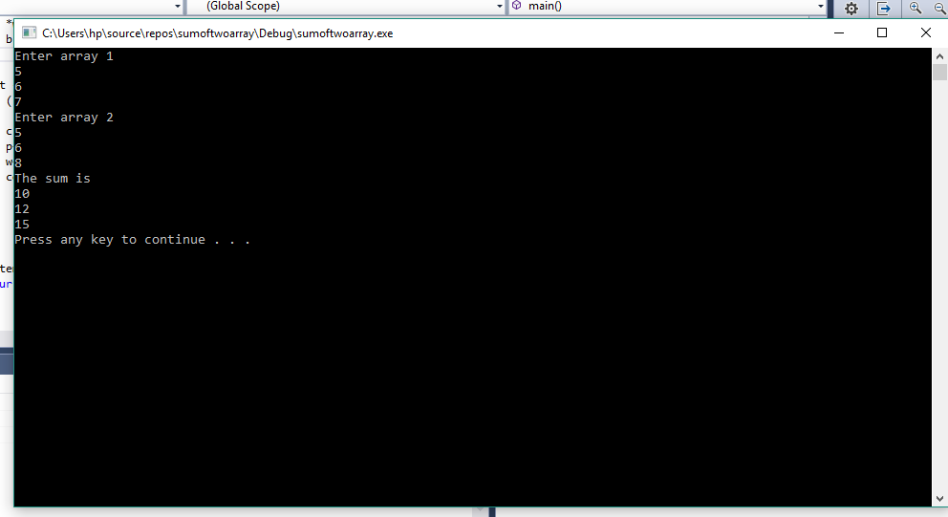

Task3: Write down a C++ program ,that will Calculate the area of a Circle by using Constant Data member PI=3.14, and by using Constant Pointer.

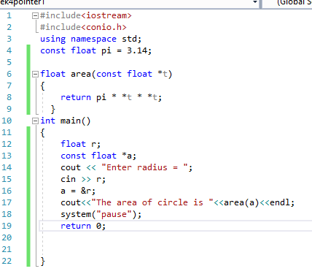

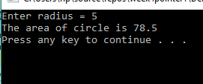

Task4: Write down a C++ program that would generate some table 2*1=2,2*10=20by using pointers.
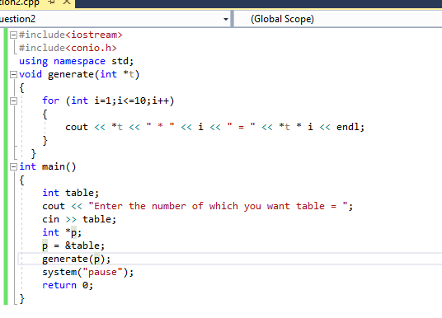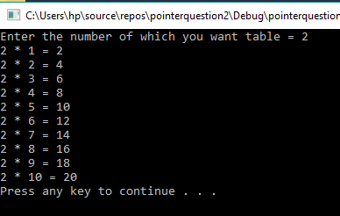

Task5: Write down a C++ program that would design a simple Calculator , by using Pointers.

