**Algorithm:**

ON LINE=1 OFF LINE=0

|  |  |  |  |
| --- | --- | --- | --- |
| L0 | L1 | R1 | R0 |

L=L1 L0 R=R1 R0

|  |  |  |  |
| --- | --- | --- | --- |
| 0 | 0 | 1 | 1 |

L=0 R=3

|  |  |  |  |
| --- | --- | --- | --- |
| 0 | 1 | 1 | 1 |

L=2 R=3

|  |  |  |  |
| --- | --- | --- | --- |
| 0 | 1 | 1 | 0 |

L=2 R=2

|  |  |  |  |
| --- | --- | --- | --- |
| 1 | 1 | 0 | 0 |

L=2 R=0

1. If all sensors read 0 go to step 3

Else,

If L>R: Move Left

If L<R : Move Right

If L=R: Move Forward

Goto step 4

1. Move Clockwise if line was last seen on Right

Move Counter Clockwise if line was last seen on Left

Repeat step 3 till line is found.

1. Go to step 1

**Flow Chart:**

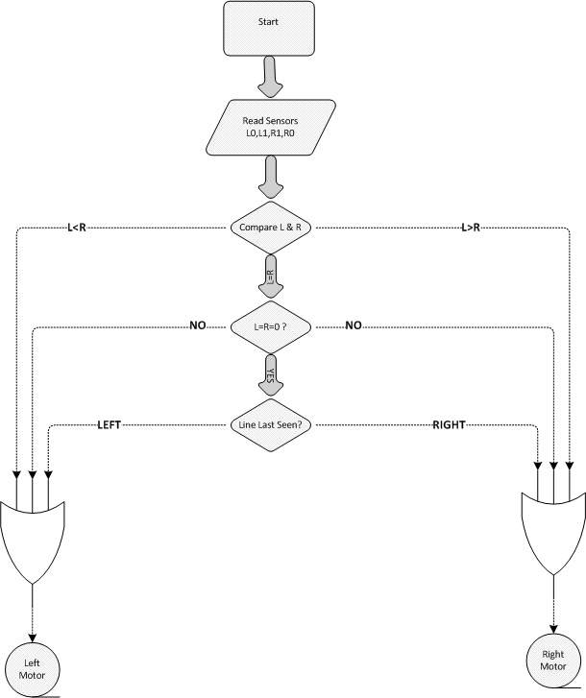

**Line Follower**:

A **line follower** is an autonomous bot that can follow a specific colored line painted on a surface of different contrast, such as white on black or vice versa.

**Application of LFR**:

1. Automated cars running on roads with embedded magnets;
2. guidance system for industrial robots moving on shop floor;
3. Learning purpose: To understand how real life robots work by reading the data from sensors and other feedback circuits;
4. To deliver mail within an office building and deliver medications in a hospital.
5. The technology has been suggested for running buses and other mass transit systems, and may end up as part of autonomous cars navigating the freeway.

Process:

Parts List:

PCB DIAGRAM:

