**Complete Schematic:**

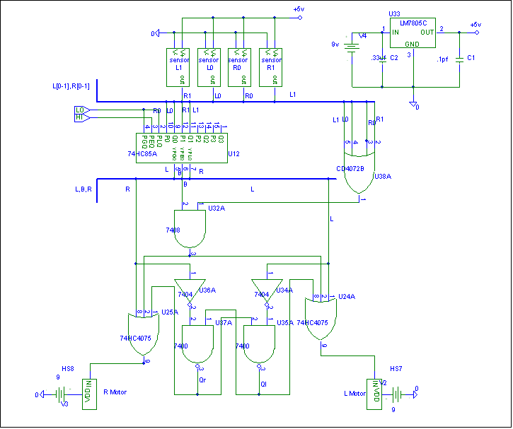

**Sensor Part:**

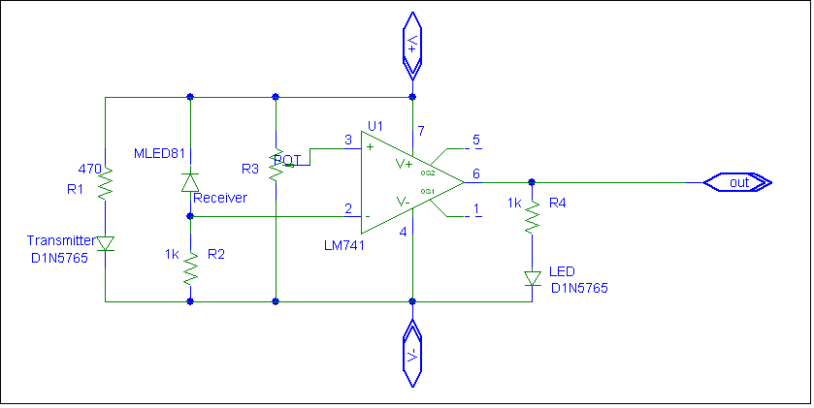

**Motor Part:**

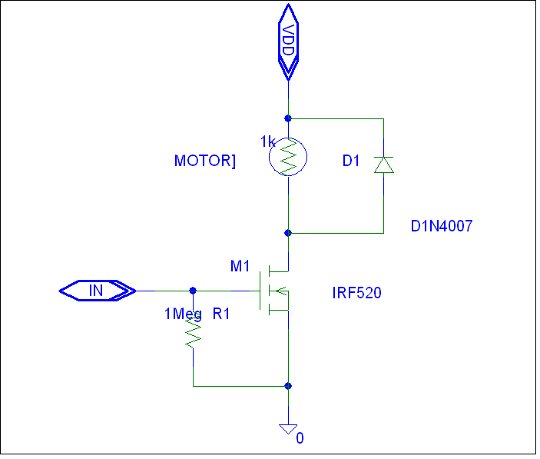

**Output:**

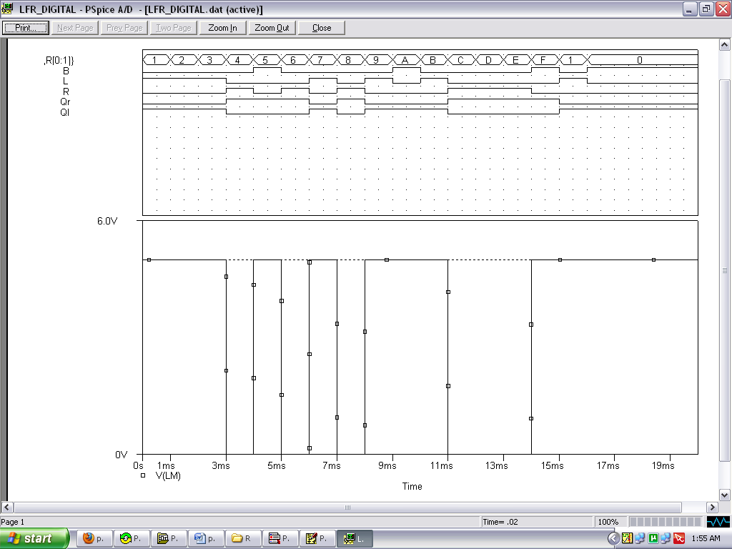

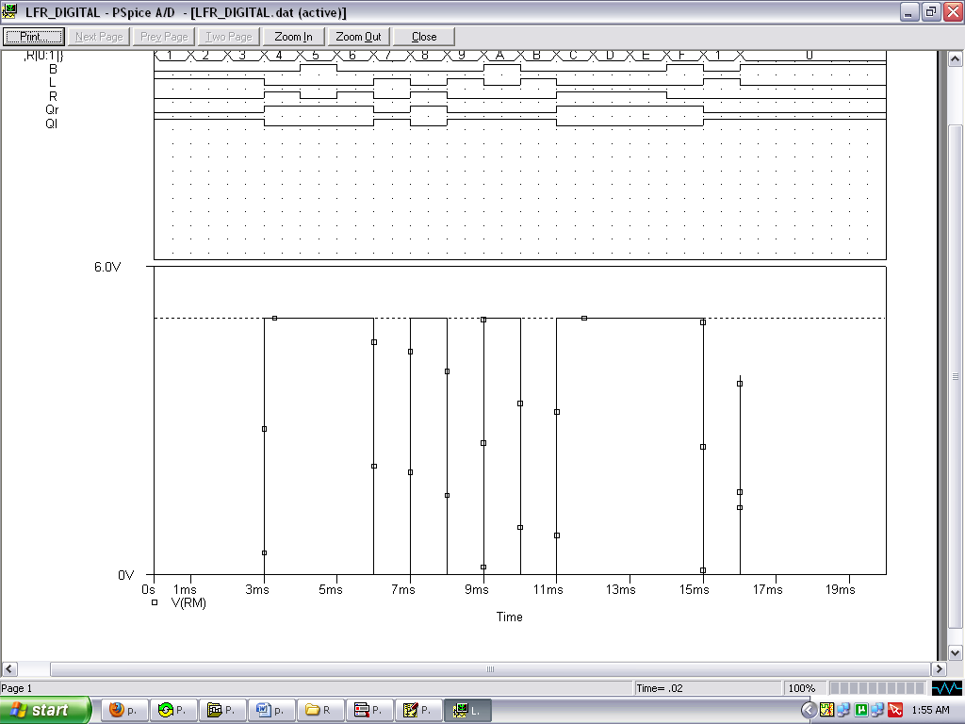

Motor Selection:

You can choose a motor of rpm around 100 and a torque of 1kg-cm

**Wheel:**

**Diameter of a wheel:**For selection of 'wheel diameter' you have to consider following important factors:

* **Speed of bOt**: We always wish that our bOt should move as fast as possible (if we are participating in any rObOtic competition then it is necessary http://botskool.com/sites/all/modules/fckeditor/fckeditor/editor/images/smiley/msn/regular_smile.gif), therefore I will suggest you that it is better to opt for wheels with large diameters, as it will increase the speed of bot. The speed of your bot is equal to speed of wheels (while you are moving straight). The speed of the wheel is, v=ω*r (as shown in the figure). Therefore, as the radius increases, the speed of the wheel increases and ultimately the speed of your bOt.
* **Torque**:The other important factor is that as the diameter of the wheel increases the torque required to rotate the wheel also increases because the torque produced by friction opposes the torque of motor.
  + *Net torque = torque of motor- torque of friction*
  + The friction is the only external force that acts on system & takes the bOt forward linearly tough the torque due to friction opposes the torque produced by motors.
  + ***Torque of friction= f*r*** which increases as the radius of wheels increase.

**Additional Information**

* Always remember not to buy a wheel that has the diameter close to or less than the diameter of the motor and it should provide sufficient ground clearance.
* **Traction of wheels:** It is a very important factor and needs to be considered for winning competitions. If your wheel is smooth it will not have much friction it will skid while accelerating or turning. If you wish to increase the traction (grip) of wheel you can make a rubber grip from an old cycle tube. If you need to travel on smooth surface like wet mud you can go for a chain drive.

**CHASSIS**: As a beginner you can go for simple rectangular or circular shaped base, made of wood unless you want to make an attractive bOt.

**Material**:

* Strength to carry weight
* Should be light
* Can be easily worked (drilled, cut)
* Easily available

Materials which you can use for building bOts:

1. Balsa wood: light weight, good choice for flying bots.
2. Aluminum: light and strong.
3. Acrylic sheet: cheaper than aluminum, easy to work.
4. Electric switch board, sheet metal, or any other easily available material.

Things you can check for the stability of bots:

• The centre of gravity (cog) of robot should lie inside the polygon formed by the wheels. 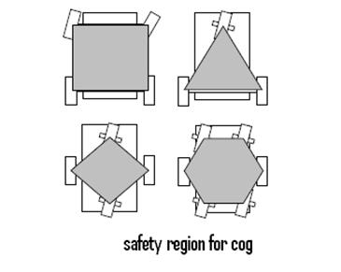

Let’s take an example of a three wheeler to understand this concept. Let the polygon formed by the wheels be an equilateral. (REMEMBER the condition to topple is that the normal about any one point of contact become zero!!) Let initially the cog is located at the centroid, if we start increasing weight equally on the two adjacent corners of the polygon, the normal on the third corner become zero.

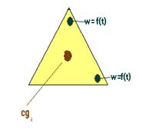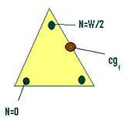

• The cog should be as low as possible for better stability while accelerating/decelerating.

• Moving the cog can allow the bot to move across wider gaps, climb steeper slopes and get over or onto higher steps.

• If you wish, you can do the dynamic and static analysis of stability. [Coming Soon]

(It will help you answer yourself a few question like Angle of slope your bOt can climb? the ratio of length: height, etc)