Lab Manual 2

Home Task

Name: Hassan Aun Ali

CMS: 463654

Section-B

Q1.Program that assigns a grade on entering marks.

#include <iostream>

using namespace std;

int main() {

int num;

cout << "Enter your marks: " << endl;

cin >> num;

if (num >= 90 && num <= 100) {

cout << "Your grade is A." << endl;

}

else if (num >= 75 && num < 90) {

cout << "Your grade is B." << endl;

}

else if (num >= 60 && num < 75) {

cout << "Your grade is C." << endl;

}

else if (num >= 45 && num < 60) {

cout << "Your grade is D." << endl;

}

else if (num >= 0 && num < 45) {

cout << "Your grade is F." << endl;

}

return 0;

}

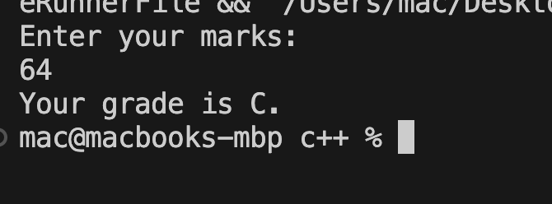

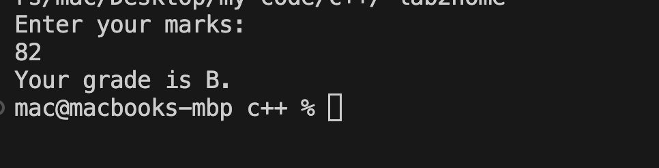

Q2. Program that checks if an entered number is even/odd and divisible by 5 or not.

#include <iostream>

using namespace std;

int main() {

int num;

cout << "Enter a number:" << endl;

cin >> num;

if (num % 5 == 0 && num % 2 == 0) {

cout << "the number is divisible by 5 and even" << endl;

}

else if (num % 5 == 0) {

cout << "the number is divisible by 5 but odd" << endl;

}

else if (num % 2 == 0) {

cout << "the number is even but not divisible by 5" << endl;

}

else {

cout << "the number is odd and not divisible by 5" << endl;

}

return 0;

}

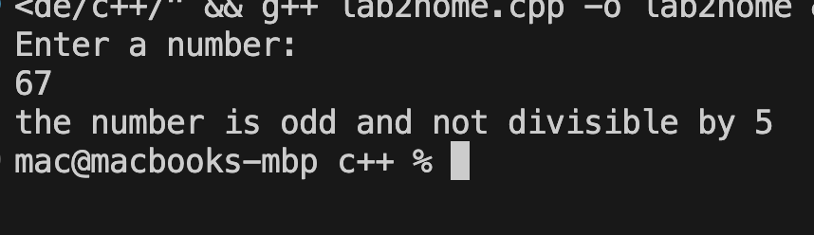

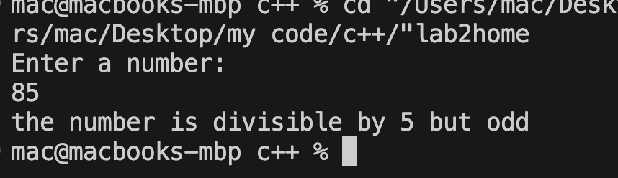

Q3. Program that checks if a year is a leap year or not.

#include <iostream>

using namespace std;

int main() {

int year;

cout << "Enter a year" << endl;

cin >> year;

if (year % 400 == 0 || (year % 4 == 0 && year % 100 != 0)) {

cout << "The Year " << year << " is a leap year" << endl;

}

else {

cout << "The Year " << year << " is not a leap year" << endl;

}

return 0;

}

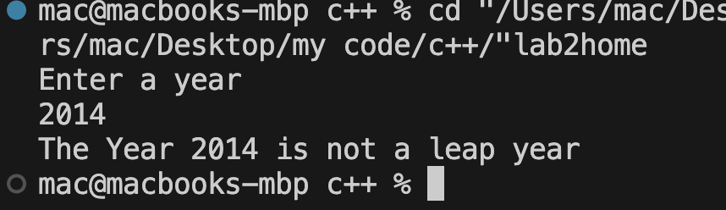

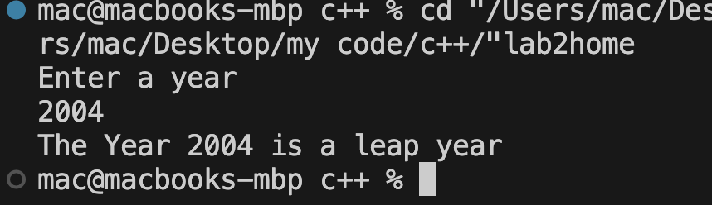

Q4. Program that checks if you are eligible for scholarship based on your GPA and attendance.

#include <iostream>

using namespace std;

int main() {

float gpa, attend;

cout << "Enter your GPA and attendance: " << endl;

cin >> gpa >> attend;

if (gpa >= 3.5 && attend >= 80) {

cout << "You are eligible for scholarship." << endl;

}

else {

cout << "You are not eligible for scholarship." << endl;

}

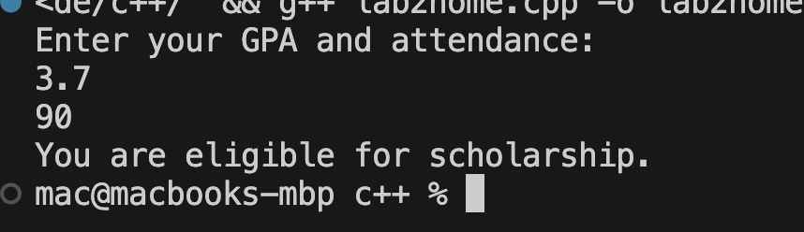

Q5. Program that checks if an alphabet is a vowel or consonant.

#include <iostream>

using namespace std;

int main() {

char alphabet;

cout << "Enter an alphabet: " << endl;

cin >> alphabet;

if (alphabet == 'a' || alphabet == 'e' || alphabet == 'i' || alphabet == 'o' || alphabet == 'u') {

cout << "It is a vowel." << endl;

}

else {

cout << "It is a consonant." << endl;

}

