Lab Manual 4

Home Task

Name: Hassan Aun Ali

CMS: 463654

Section-B

Q1.Program that prints numbers from 1 to 150 except the multiples of 10.

#include <iostream>

using namespace std;

int main(){

// //Task 1: printing numbers from 1 to 150 except the multiples of ten

for (int i = 0 ; i<151 ; i++){

if (i % 10 == 0){

continue;

}

cout<<i<<" ";

}

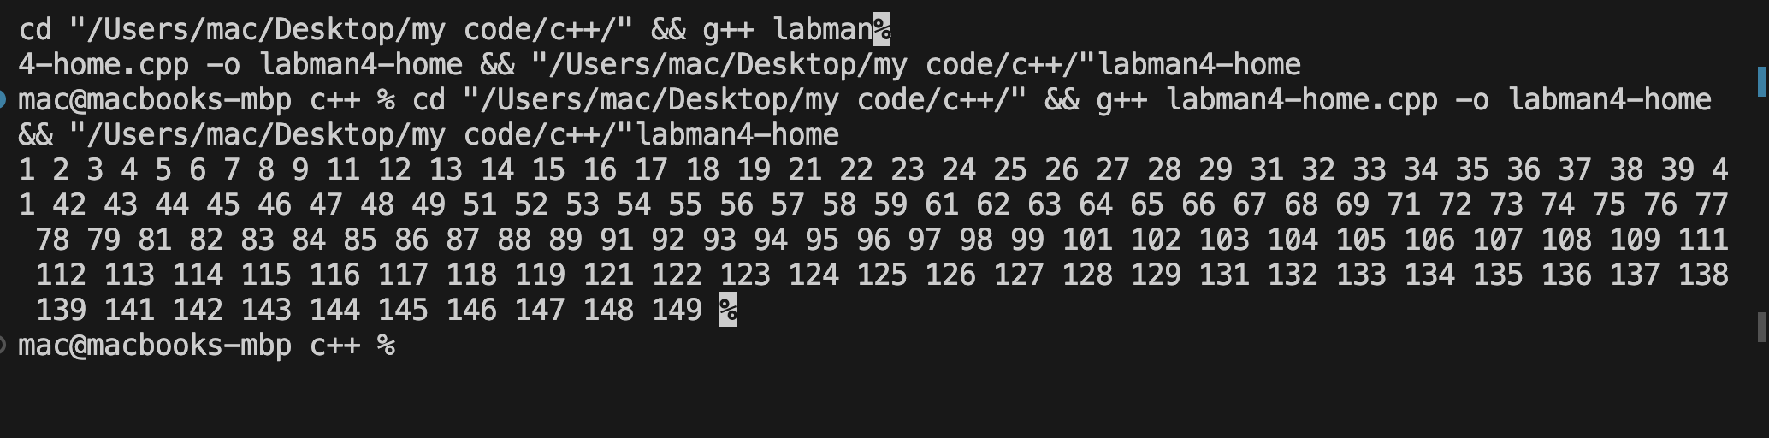

Q2. Program that prints sum of digits of a number.

#include <iostream>

using namespace std;

int main(){

int i;

cout<<"Enter a number: "<<endl;

cin>>i;

int num = i;

int l = 0;

while (num>0){

num = num /10;

l++;

}

int sum=0;

num = i;

for ( int s = 0; s<l; s++){

sum+=(num%10);

num = num/10;

}

cout<<"The sum of the digits is "<<sum<<endl;

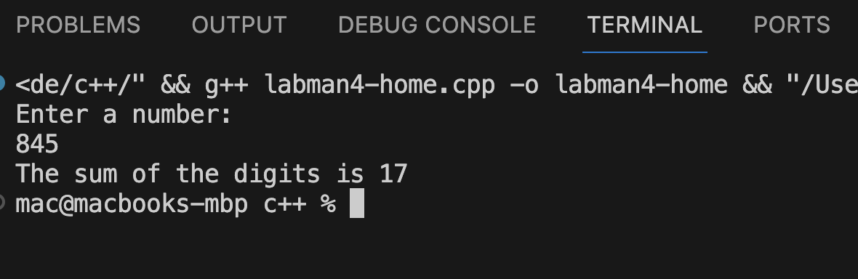

Q3. Program that checks whether a number is prime or not

#include <iostream>

using namespace std;

int main(){

int num;

cout<<"Enter a number: "<<endl;

cin>>num;

bool isPrime = true;

for (int s = 2; s < num; s++){

if (num%s == 0){

isPrime = false;

}

}

if (isPrime){

cout<<"Number is a prime number"<<endl;

}

else{

cout<<"Number is not prime"<<endl;

}

}

