Lab Manual 4

Lab Task

Hassan Aun Ali. 463654. Section-B

Q1. Write a program in C++ to find the sum of first 10 natural numbers.

#include <iostream>

using namespace std;

int main(){

int n;

int sum = 0;

for (n=1; n<11; n++){

sum=sum+n;

}

cout<<"the sum of first 10 natural numbers is "<<sum<<endl;

}

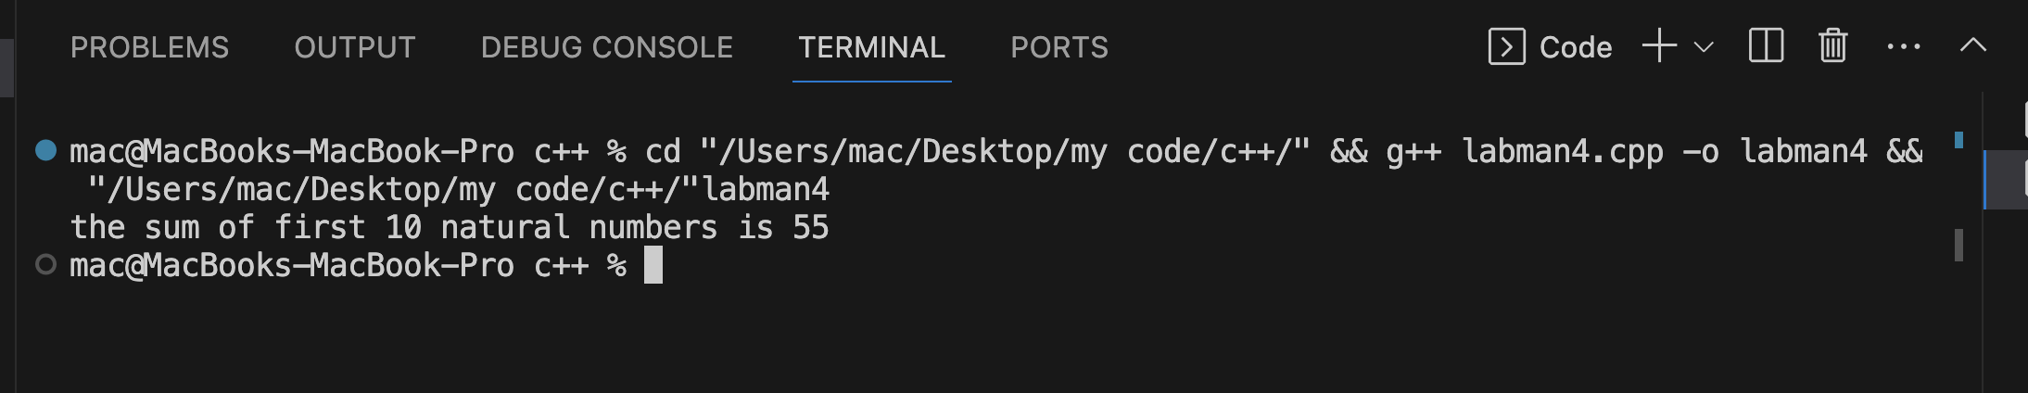

* Write a C++ program to Print a Table of any Number.

#include <iostream>

using namespace std;

int main(){

int table_of_num=8;

int m;

for (m=1; m<11; m++){

cout<<table_of_num<<" "<<"*"<<" "<<m<<" "<<"="<<" "<<table_of_num*m<<endl;

}

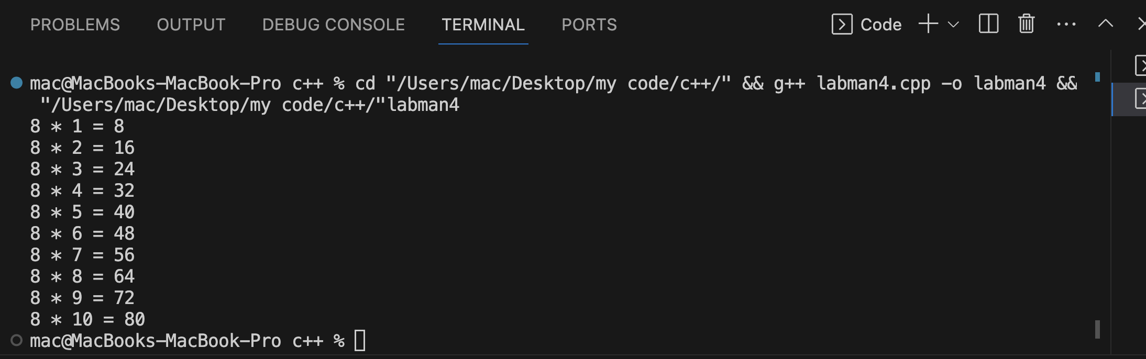

* Write a Program to Generate Factorial. A Certain Number Factorial of any number is the product of an integer and all the integers below it for example factorial of 4 is: 4! = 24.

#include <iostream>

using namespace std;

int main(){

int factorial_of_num;

int k;

cout<<"Factorial of: "<<endl;

cin>>factorial_of_num;

int answer=factorial_of_num;

for (k=(factorial_of_num-1); k>0; k--){

answer*=k;

}

cout<<"the factorial of "<<factorial_of_num<<" is = "<<factorial_of_num<<"! ="<<answer<<endl;

}

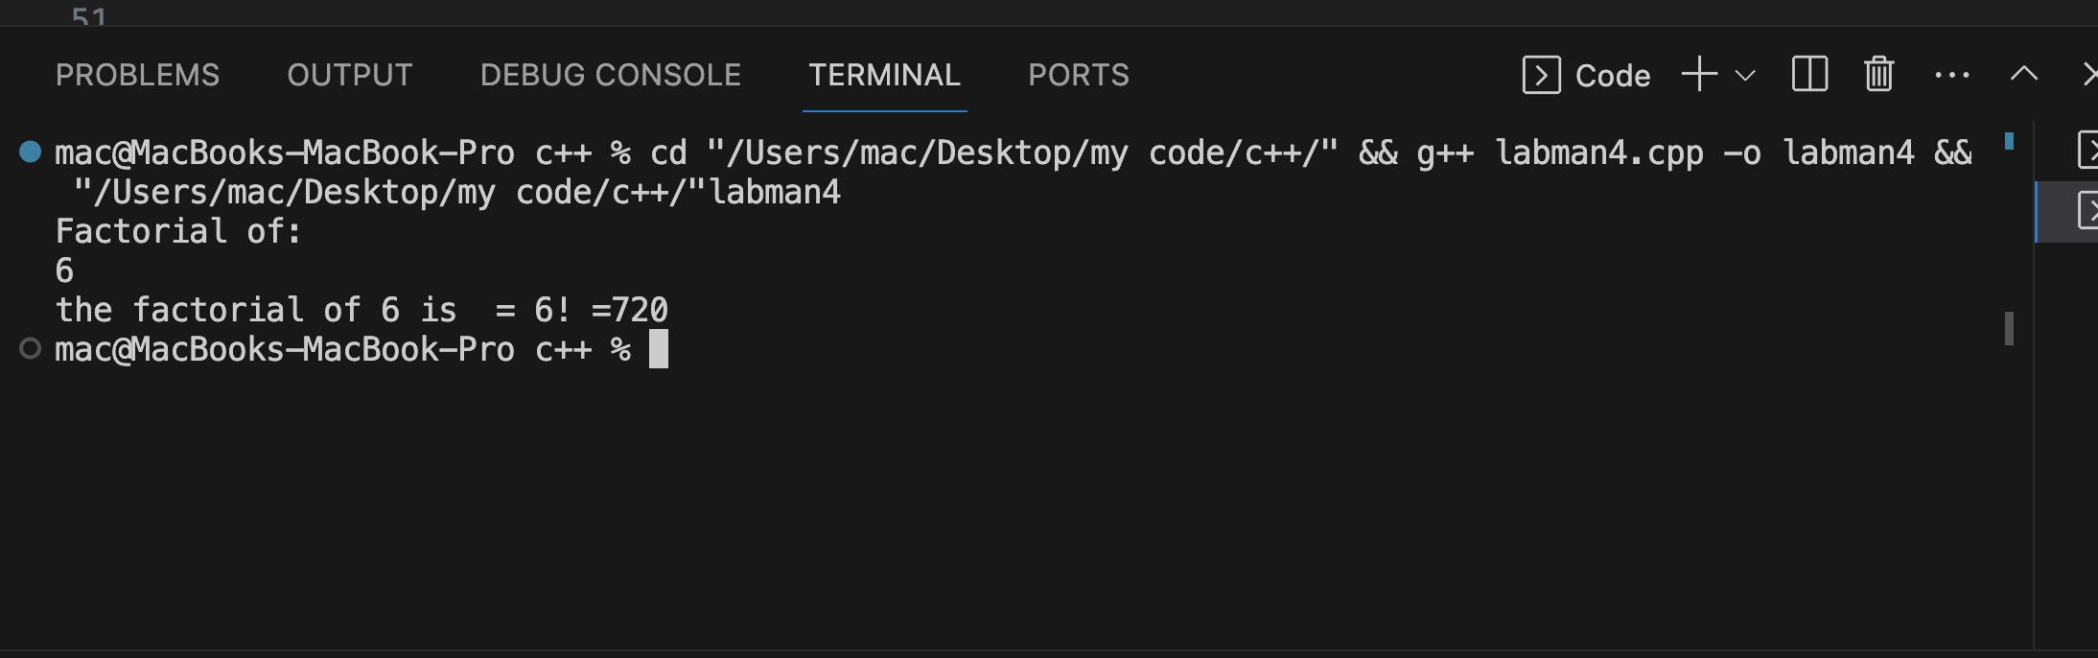

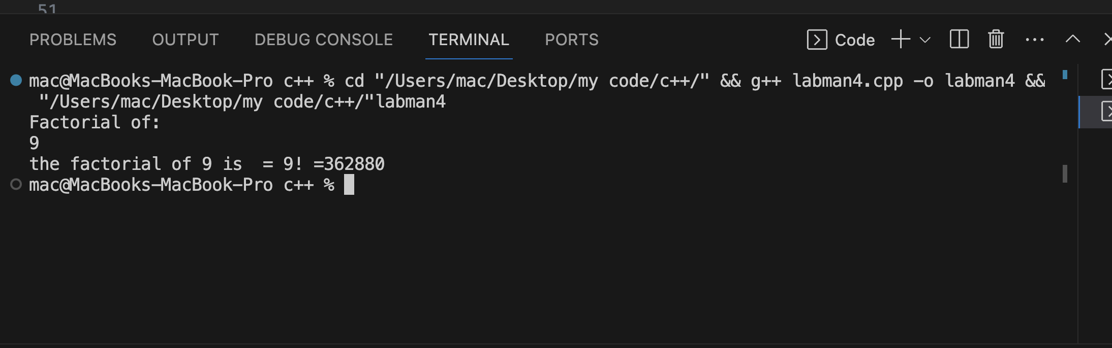

* Write a C++ program to generate a Fibonacci sequence up to a certain number input by the user.

#include <iostream>

using namespace std;

int main(){

int num1;

int num2;

int a;

int next;

int range;

cout<<"Enter first and second: "<<endl;

cin>>num1>>num2;

cout<<"Enter range: "<<endl;

cin>>range;

for (a = 0; a <range; a++){

if (a==0){

cout<<num1<<endl;

continue;

}

else if (a==1){

cout<<num2<<endl;

continue;

}

next = num1 + num2;

num1 = num2;

num2 = next;

cout<<next<<endl;

}

