**Lab Manual 5**

**Lab Task**

Name: Hassan Aun Ali

CMS: 463654

(Section-B)

Q1) Coverting given loop to do while

#include <iostream>

using namespace std;

int main()

{

//Converting a given while loop to a do while loop

int x = 1;

do{

cout<<"enter a number: "<<endl;

cin>>x;

}

while(x > 0);

}

Q2) Use a do while loop to make a simple calculator for two numbers. Insert buttons for it to ask again and for termination.

#include <iostream>

using namespace std;

int main(){

// Calculator which asks for continuation after every user input

double n1, n2, result;

char oper;

char choice;

do{

cout<<"Enter a number: "<<endl;

cin>>n1;

while (true){

cout<<"Enter an operator: "<<endl;

cin>>oper;

if (oper=='x' || oper=='/' || oper=='+' || oper=='-'){

break;

}

else{

cout<<"Operator Invalid"<<endl;

}

}

cout<<"Enter a second number: "<<endl;

cin>>n2;

switch (oper)

{

case '+':

result = n1 + n2;

break;

case '-':

result = n1 - n2;

break;

case 'x':

result = n1 * n2;

break;

case '/':

result = n1 / n2;

break;

default:

cout << "operator invalid" << endl;

break;

}

cout<<n1<<" "<<oper<<" "<<n2<<" = "<<result<<endl;

cout<<"Would you like to continue: "<<endl;

cin>>choice;

}

while(choice=='Y' || choice=='y');

cout<<"end.";

}

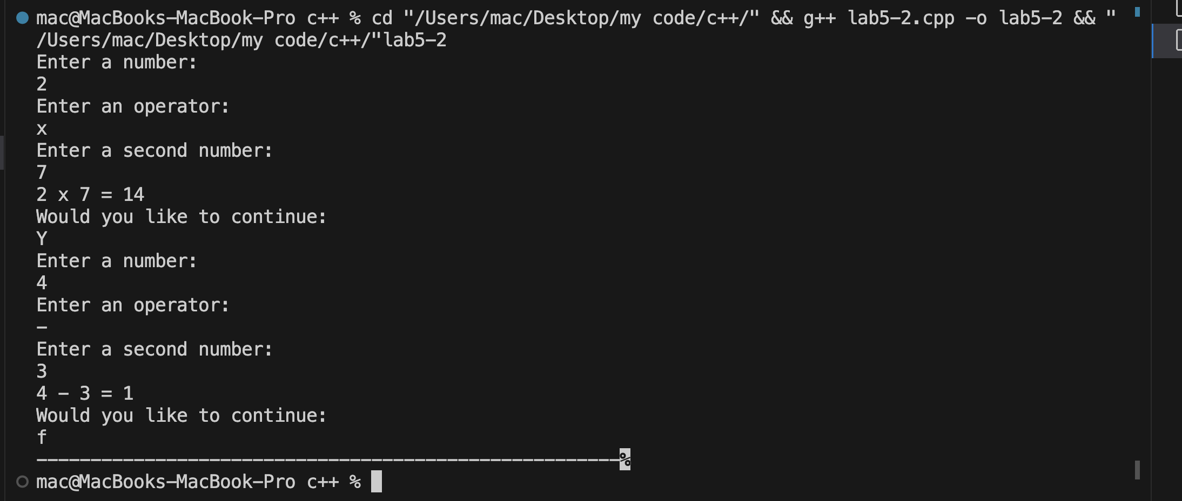

Q3) Write programs with while or do while loops that compute:

a. The sum of all even numbers between 2 and 100 (inclusive).

#include <iostream>

using namespace std;

int main()

{

//part a

//Computing sum of all even numbers from 2 to 100

int sum = 0;

int x = 2;

while (x < 101){

if (x % 2 == 0){

sum += x;

}

x++;

}

cout<<"The sum is "<<sum<<endl;

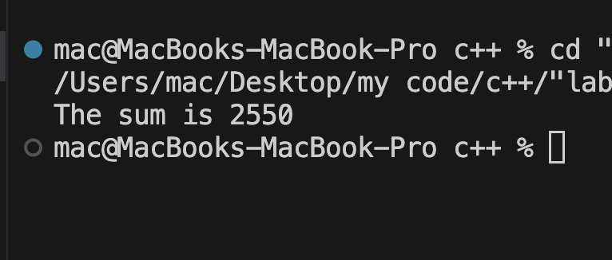

b. The sum of all squares between 1 and 100 (inclusive).

#include <iostream>

using namespace std;

int main(){

int x = 1;

int sum = 0;

while (x <= 10){

sum+=(x*x);

x++;

}

cout<<"The sum of all squares from 1 to 100 is "<<sum<<endl;

}

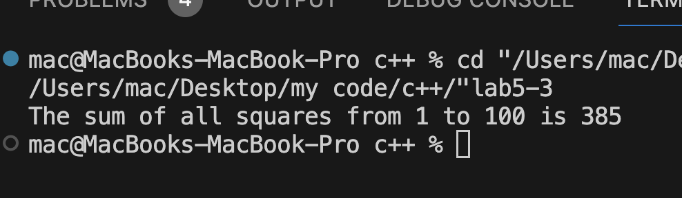

Q4. Write programs with while or do while loops that compute:

1. All powers of 2 from 20 up to 220.

#include <iostream>

using namespace std;

int main()

{

//Computing all powers of 2 ranging from 0 to 20

int x = 0;

while (x < 21){

int power = pow(2,x);

cout<<"2 ^ "<<x<<" = "<<power<<endl;

x++;

}

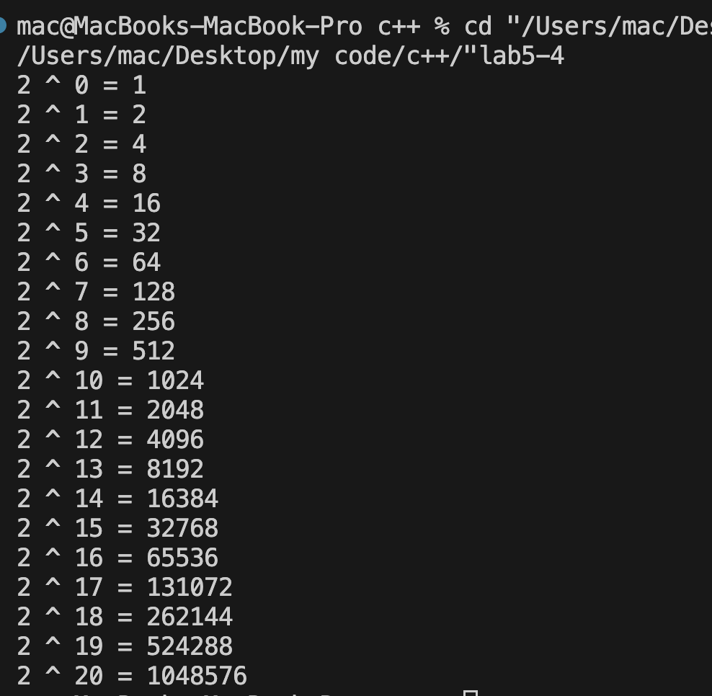

b.The sum of all odd numbers between a and b (inclusive), where a and b are inputs.

#include <iostream>

using namespace std;

int main()

{

int a,b,r,aa;

int sum = 0;

cout<<"Enter the value for 'a': "<<endl;

cin>>a;

cout<<"Enter the value for 'b': "<<endl;

cin>>b;

if (b<a){

r = a;

a = b;

b = r;

}

aa = a;

while (aa <= b){

if (aa%2!=0){

sum += aa;

}

aa++;

}

aa = a;

cout<<"The sum of all odd numbers from "<<a<<" to "<<b<<" is "<<sum<<endl;

}

