**Lab Manual 8**

**Name: Hassan Aun Ali**

**CMS: 463654**

**Section-B**

**Q1. Program to calculate average of numbers of array.**

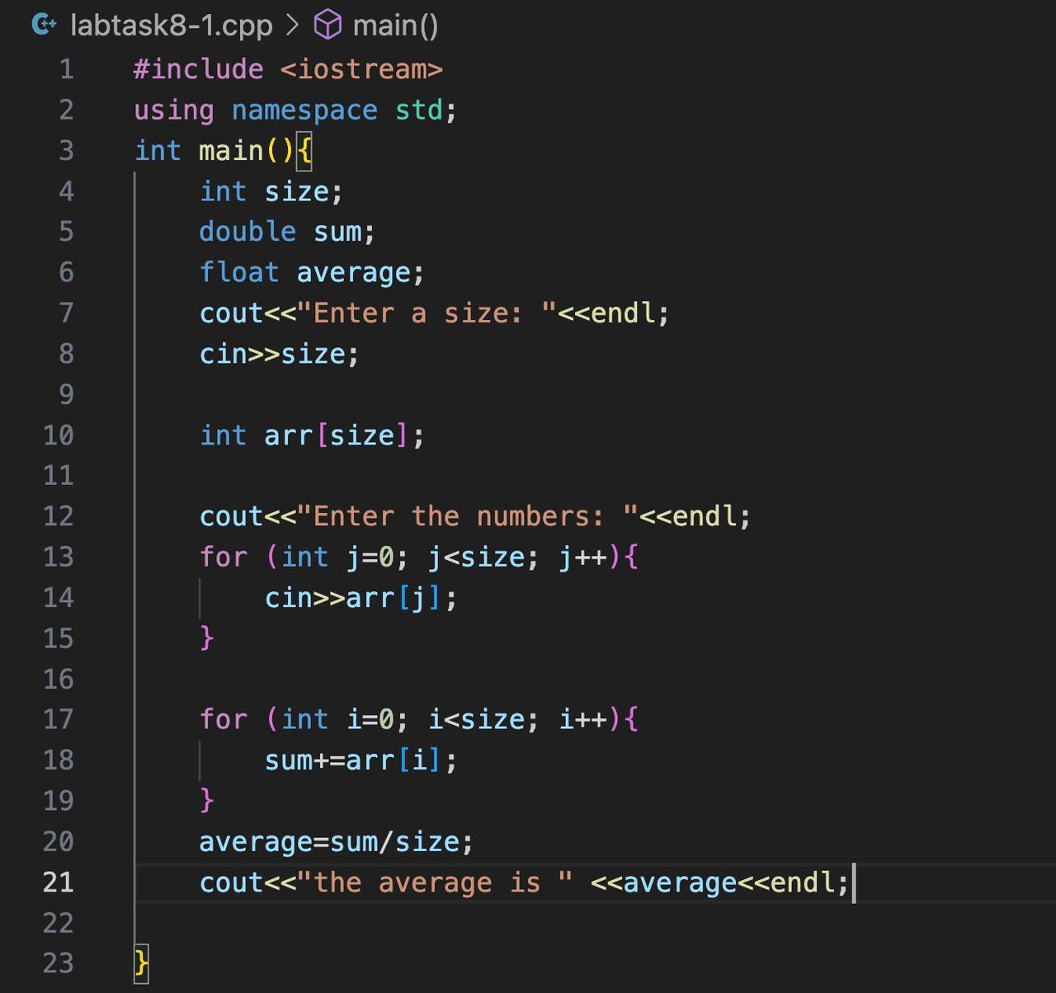

**Output:**

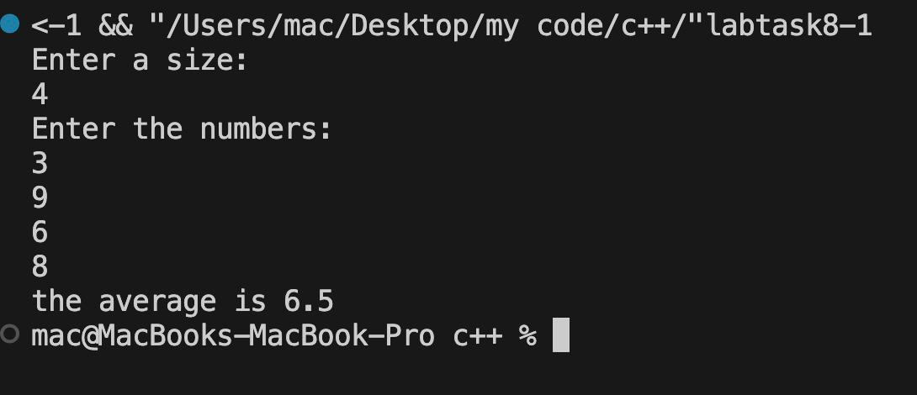

**Q2. Bubble sort on array of 5 integers.**

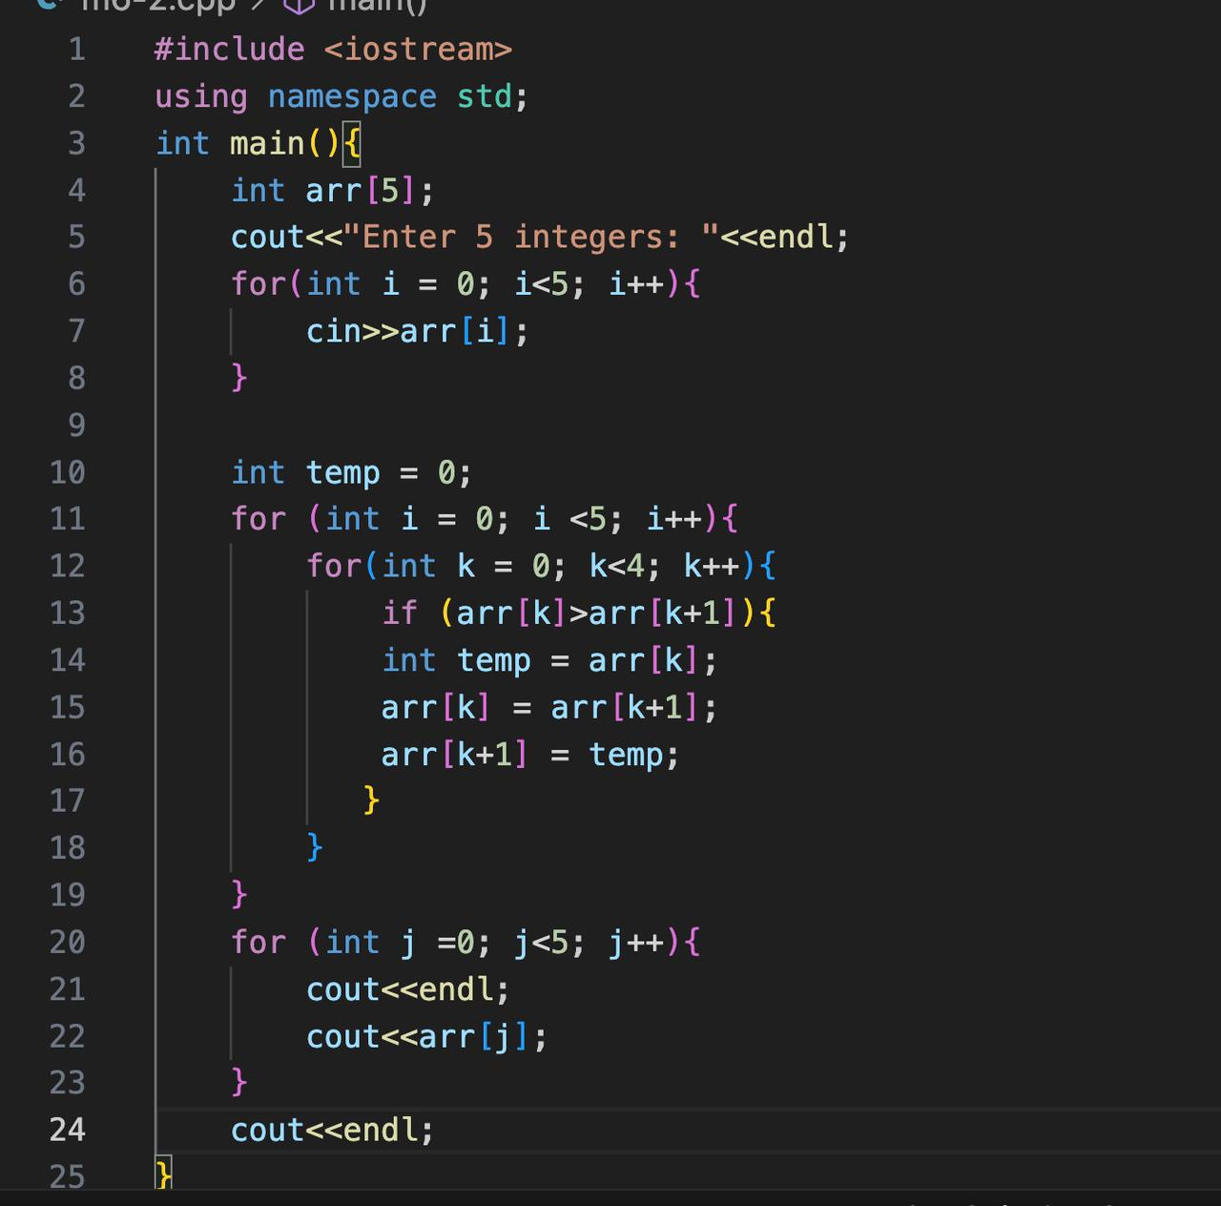

**Output:**

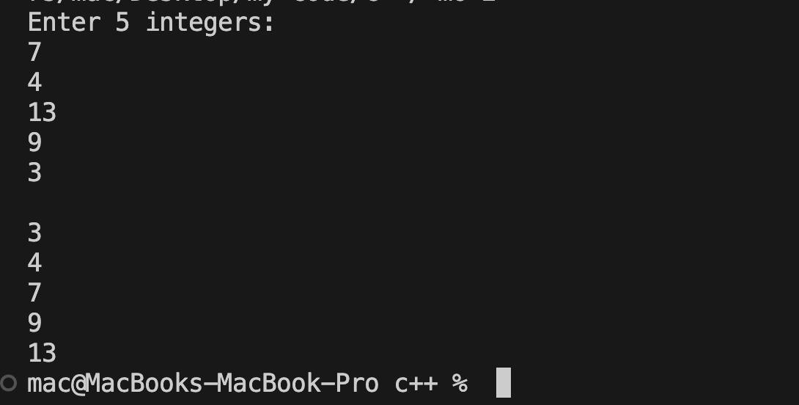

**Q3. Selection sort on array of 5 integers.**

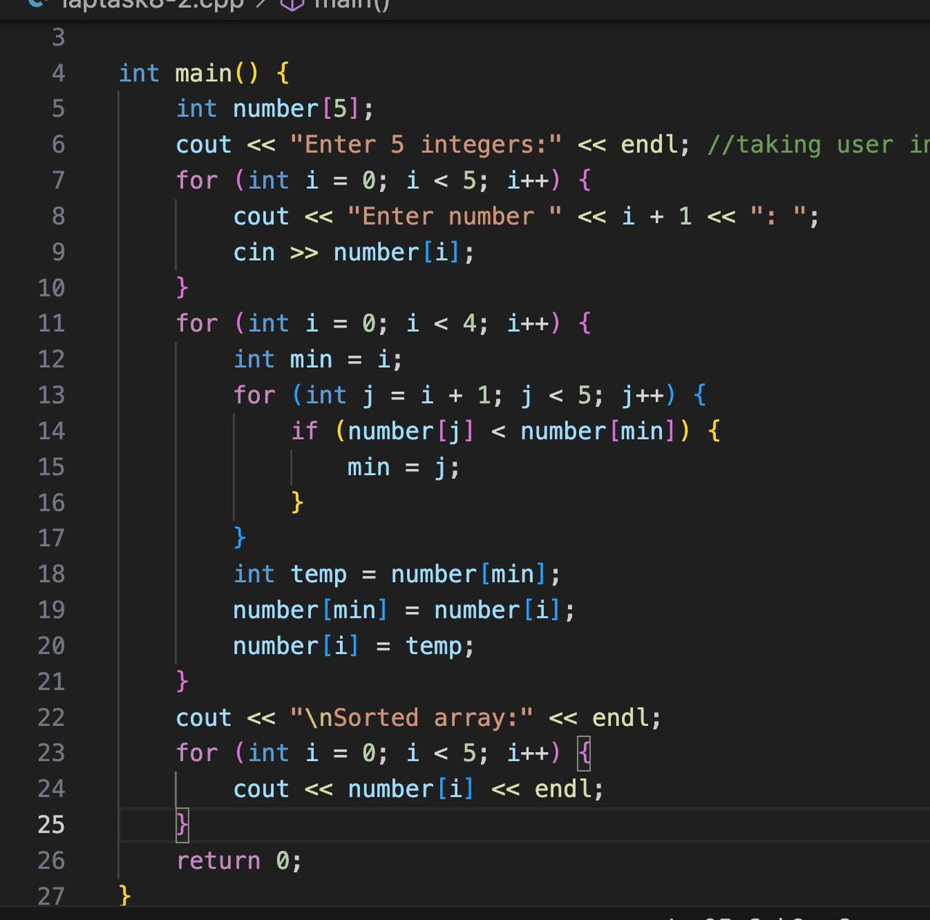

**Output:**

