3. What is the median of the frequency distribution shown below? 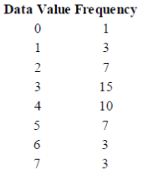 (A) 2 (B) 3 (C) 4 (D) 5 (E) Cannot be determined